AGRIVISION – DRONE-BASED CROP HEALTH MONITORING:
TRADITIONAL VS. DEEP-LEARNING APPROACH

A CAPSTONE PROJECT REPORT
Submitted in the partial fulfilment for the Course of
ITA0507– COMPUTER VISION
to the award of the degree of
BACHELOR OF ENGINEERING / TECHNOLOGY
IN
COMPUTER SCIENCE AND ENGINEERING(AI)
Submitted by
Narappagari Sravya(192472192)
K.kavya(192311345)
Arigela Jyothsna(192211459)
Under the Supervision of
Dr. V.R.Vimal


SIMATS ENGINEERING
Saveetha Institute of Medical and Technical Sciences
Chennai-602105
September 2026

Department of Computer Science and Engineering
ASSIGNMENT QUESTION

Name: | ARIGELA JYOTHSNA
Register Number: | 192211459
Course Code & Name: | ITA05 & Computer Vision
Assignment Title: | AgriVision – Drone-Based Crop Health Monitoring: Traditional vs.  Deep-Learning Approach
Bloom’s Taxonomy Level: | L3 – Apply; L4 – Analyse; L5 – Evaluate; L6 – Create
Course Outcome(s) – CO:
CO2: Apply image enhancement, filtering, segmentation, and feature extraction techniques to preprocess and analyze images.
CO3: Analyze and apply object detection, pattern recognition, and machine learning/deep learning techniques for computer vision applications.
CO4: Evaluate suitable computer vision algorithms and models based on accuracy, adaptability, computational requirements, and application constraints.
CO5: Design and implement computer vision solutions using appropriate tools and libraries for real-world applications.
SDG Mapping (SDG 1–17):
SDG 2 – Zero Hunger
SDG 9 – Industry, Innovation and Infrastructure
SDG 15 – Life on Land
Problem Statement:
An agri-tech startup is planning to deploy “AgriVision”, a drone-imagery-based crop health monitoring system, for mid-sized farms. The system must process aerial images captured periodically across the growing season to detect early signs of crop disease, identify weed infestation, and estimate overall field health/yield potential, with accuracy sufficient to guide targeted spraying and reduce pesticide overuse. Drone images vary in illumination (time of day, cloud cover), altitude/scale, and can be affected by motion blur and sensor noise, making reliable analysis challenging.
The engineering team is considering two approaches:
- Traditional Computer Vision Methods: Colour-space and texture-based segmentation to isolate leaf/canopy regions, followed by handcrafted feature extraction (colour indices, texture descriptors, edge/shape features) and rule-based or classical-classifier disease/weed identification — fast, low-power, and interpretable, but less adaptive to varied disease symptoms, crop types, and field conditions.
- Deep Learning Methods: CNN-based disease-classification models and YOLO-style detectors trained on labelled crop-disease/weed datasets — capable of higher accuracy and better generalization across crop varieties and field conditions, but requiring substantial labelled training data, computational resources for training, and careful validation before field deployment.
As a computer vision engineer, apply image enhancement, segmentation, and feature detection/matching techniques to preprocess the drone imagery; compare the traditional computer vision and deep learning approaches for crop-disease detection, weed identification, and field-health estimation; and evaluate which approach is most suitable given the farm's computational resources (edge device on the drone vs. cloud processing) and accuracy requirements. Analyze the trade-off between detection accuracy, adaptability to different crops/conditions, computational requirements, training-data availability, and real-world deployment constraints (battery life, connectivity, cost). Justify the selected approach based on performance versus adaptability, and design an end-to-end OpenCV-based solution explaining how it supports precision agriculture and sustainable farming practices.

Assessment Rubrics
Criteria (CO  Mapping) | Max Marks | Excellent | Good | Satisfactory | Needs Improvement
Problem  Understanding &  Vision-System  Requirements  (CO2) | 10 | Clearly identifies the drone-imagery cropmonitoring problem, accuracy/coverage requirements, and the role of enhancement, feature-based, and OpenCV-driven  vision techniques in the solution. | Identifies most requirements with minor gaps and demonstrates good understanding of the problem. | Basic understanding of the problem  is  demonstrated, but some requirements are unclear. | Problem requirements are misunderstood or incorrectly interpreted.
Image  Preprocessing,  Enhancement,  Segmentation &  Feature Extraction  (CO2) | 10 | Appropriately proposes preprocessing such as noise removal, illumination/haze correction, spatial/frequencydomain filtering, segmentation of leaf/canopy regions, and relevant feature extraction (edges, colour/texture, keypoints) for disease and weed analysis. | Appropriate preprocessing and featureextraction techniques are selected with minor gaps. | Basic preprocessing techniques are identified but their application is limited. | Preprocessing/featureextraction techniques are inappropriate or missing.
Comparison of Traditional CV and DeepLearning  Approaches  (CO3/CO4) | 15 | Provides a comprehensive comparison of classical (colour/texture thresholding, edge/region-based segmentation, template/feature matching) and deep- | Provides a relevant comparison covering most important factors. | Provides a basic comparison with limited analysis of performance and adaptability. | Comparison is incomplete, inaccurate, or lacks technical reasoning.

Criteria (CO  Mapping) | Max Marks | Excellent | Good | Satisfactory | Needs Improvement
learning (CNN-based disease classification,
YOLO-based
weed/pest detection) approaches based on accuracy, adaptability to field conditions, computational cost, training requirements, robustness, and deployment suitability.
Solution Design &  Model/Algorithm  Selection  (CO4/CO5) | 15 | Designs a suitable end-to-end OpenCV pipeline (image enhancement → segmentation → feature/disease detection → yield/health estimate) and selects the most suitable approach with strong justification, clearly addressing training/validation, integration, and field deployment on drone/edge hardware. | Appropriate solution and models are selected with reasonable justification. | Solution is partially developed or model selection has limited justification. | No suitable solution design or model selection is provided.
Analysis,  Evaluation &  Justification (CO4) | 15 | Critically evaluates the accuracy– adaptability– computational-cost | Provides good analysis and justification with minor | Provides general analysis but limited critical | Little or no meaningful analysis or justification.
Criteria (CO  Mapping) | Max Marks | Excellent | Good | Satisfactory | Needs Improvement
 |  | trade-off and convincingly justifies the selected approach using fielddeployment, cost, and reliability considerations relevant to farmers/agronomists. | limitations. | evaluation.
Implementation,  Results &  Visualization  (CO5) | 10 | Successfully implements the proposed OpenCV/vision  application; presents meaningful results, accuracy metrics, sample disease/weed detections, and visualizations (e.g., health maps, bounding boxes). | Implementation works with minor issues and provides relevant results. | Partial implementation with limited or inconsistent results. | Implementation is missing, nonfunctional, or results are not demonstrated.
Reflection,  Societal/Industrial  Relevance & SDG  Mapping | 5 | Provides thoughtful reflection on design decisions, challenges, learning outcomes, agricultural relevance, and clear SDG relevance. | Provides reasonable reflection and  SDG  connection. | Reflection is present but generic. | Reflection is missing or lacks meaningful connection to the problem.

Suggested Conversion to 50 Marks
Problem Understanding & Vision-System  Requirements | 6
Image Preprocessing, Enhancement & Feature  Analysis | 6
Comparison of Traditional and Deep Learning  Approaches | 9
Solution Design & Model/Algorithm Selection | 9
Analysis, Evaluation & Justification | 9
Implementation, Results & Visualization | 6
Reflection, Industrial/Societal Relevance & SDG  Mapping | 5
Total | 50

Deliverables
- Problem Analysis and Pseudocode – Include problem understanding, functional requirements, comparison of traditional vs. deep-learning approaches, selected approach, justification, and algorithm/pseudocode for the enhancement, segmentation, featuredetection, and disease/weed-recognition stages.
- Implementation & Results – Include source code, dataset description (drone/field crop images, public crop-disease dataset, or synthetically generated samples), preprocessing, detection/classification, training/testing where applicable, evaluation metrics, visualizations (e.g., health maps, bounding boxes), sample detections, and comparative analysis.
- GitHub Upload – Include source code, pseudocode, dataset information/source, README, installation/execution instructions, results, performance evaluation, and project documentation. GitHub repository link must be submitted with the assignment.

Assignment Learning Focus
The assignment enables students to apply, analyse, and evaluate computer vision techniques — image enhancement and segmentation, feature detection and matching, and object/pattern recognition — in a precision-agriculture scenario, while developing the ability to select and design an appropriate OpenCV-based solution based on accuracy, adaptability, computational requirements, and real-world field-deployment constraints.

1. Problem Statement and Problem Formulation
AgriVision is a proposed drone-imagery-based crop health monitoring system for midsized farms. It processes aerial images captured periodically to detect early signs of crop disease, identify weed infestation, and estimate overall field health and yield potential. Reliable analysis is difficult because illumination, cloud cover, altitude, scale, motion blur, and sensor noise can vary between images.
The engineering problem is to design a computer-vision pipeline that preprocesses aerial imagery, isolates vegetation, extracts meaningful visual information, recognizes disease or weeds, and converts the results into actionable field-health information.
- Input: RGB drone images I(x,y) of agricultural fields.
- Preprocessing: noise reduction, illumination normalization, contrast enhancement and resizing.
- Segmentation: estimate vegetation/canopy mask M(x,y) using colour information.
- Feature analysis: compute colour, texture, edge, shape and optional keypoint descriptors.
- Recognition: use traditional CV/classical ML or CNN/YOLO for disease and weed identification.
- Output: annotated images, vegetation/stress statistics and a field-health map.

2. Objective and Expected Outcomes

2.1 Objectives
- Develop an end-to-end OpenCV-based pipeline for drone crop images.
- Apply image enhancement, filtering, segmentation and feature extraction.
- Compare traditional computer vision with deep learning.
- Select a suitable deployment strategy considering accuracy, adaptability, computation, battery, connectivity and cost.
- Produce outputs that support precision agriculture and targeted intervention.

2.2 Expected Outcomes
- Improved image quality and reduced noise.
- Vegetation/canopy segmentation masks.
- Useful visual features for stressed-region analysis.
- Annotated disease/weed detections and field-level statistics.
- A justified hybrid edge–cloud solution.

3. Requirements, Constraints and Assumptions
Category | Details
Functional | Acquire images; preprocess; segment vegetation; extract features; detect disease/weed; estimate field health; visualize outputs.
Non-functional | Reasonable processing time, robustness, interpretability and scalable coverage.
Hardware | Drone camera; optional edge computer; workstation/cloud GPU for deep learning.
Software | Python 3.x, OpenCV, NumPy, Matplotlib; optional PyTorch/TensorFlow and YOLO.
Constraints | Battery, limited edge compute, variable weather, connectivity, labelled-data availability and cost.
Assumptions | Images are usable; crop classes are defined; representative labels are available for supervised models.

4. Application of Relevant Course Knowledge / Concepts
Concept | Application
Image enhancement | Contrast improvement and sharpening make crop symptoms more visible.
Filtering | Gaussian/median filtering reduces sensor
 | noise.
Colour spaces | HSV separates colour from brightness and supports vegetation masking.
Segmentation | Thresholding and morphology isolate crop/canopy regions.
Feature extraction | Colour, texture, edges, contours and ORB keypoints describe patterns.
Pattern recognition | Classical classifiers or deep networks recognize disease/weed patterns.
Object detection | YOLO-style detectors can localize weeds or disease regions.
Evaluation | Accuracy, precision, recall, F1, IoU, mAP and latency support selection.

5. Design / Proposed Solution / Methodology
The recommended design is hybrid. Lightweight OpenCV operations perform preprocessing, segmentation and quality checks near image acquisition. Deep-learning recognition is used when sufficient edge acceleration or cloud resources are available. A traditional CV fallback provides basic vegetation and stress analysis under limited connectivity.
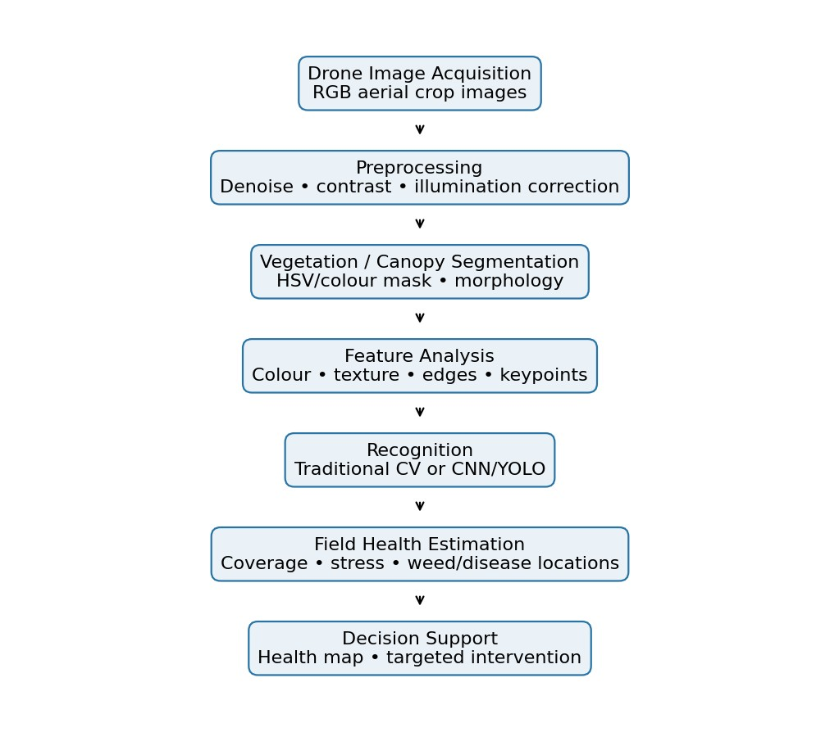
Figure 1. Proposed AgriVision end-to-end workflow.

6. Algorithm / Pseudocode / Flowchart

6.1 Pseudocode
Algorithm AGRIVISION_ANALYSIS(Image I)
- Read image I
- Resize I to a standard resolution
- Apply Gaussian/median filtering
- Convert image to HSV
- Improve contrast when required
- Create vegetation mask M using suitable colour thresholds
- Apply opening and closing morphology 8. Extract contours, area, edges and colour statistics
- If a validated deep-learning model is available:
run disease classifier / weed detector Else:
use handcrafted features and rule/classical classifier
- Estimate vegetation coverage and relative stress indicators
- Draw detections and generate summary output
- Save annotated image and metrics
END

7. Implementation / Source Code and Environment / Tools Used
Environment: Python 3.x, OpenCV, NumPy and Matplotlib. Optional deep-learning tools: PyTorch/TensorFlow and a validated CNN/YOLO implementation.
7.1 OpenCV Prototype Code import cv2 import numpy as np

img = cv2.imread("drone_crop.jpg") if img is None:
raise FileNotFoundError("Place drone_crop.jpg in the project folder")

img = cv2.resize(img, (800, 600)) blur = cv2.GaussianBlur(img, (5, 5), 0) hsv = cv2.cvtColor(blur, cv2.COLOR_BGR2HSV)

lower_green = np.array([25, 30, 20]) upper_green = np.array([95, 255, 255]) mask = cv2.inRange(hsv, lower_green, upper_green)

kernel = np.ones((5, 5), np.uint8)
mask = cv2.morphologyEx(mask, cv2.MORPH_OPEN, kernel) mask = cv2.morphologyEx(mask, cv2.MORPH_CLOSE, kernel)

edges = cv2.Canny(blur, 60, 150)
coverage = 100.0 * cv2.countNonZero(mask) / mask.size

result = img.copy()
contours, _ = cv2.findContours(mask, cv2.RETR_EXTERNAL, cv2.CHAIN_APPROX_SIMPLE) for c in contours: if cv2.contourArea(c) > 500:
x, y, w, h = cv2.boundingRect(c)
cv2.rectangle(result, (x,y), (x+w,y+h), (0,255,0), 2)

print(f"Vegetation coverage: {coverage:.2f}%") cv2.imwrite("annotated_output.jpg", result) cv2.imwrite("vegetation_mask.jpg", mask) cv2.imwrite("edge_output.jpg", edges)

8. Test Cases and Expected/Actual Results
Actual results must be filled with genuine observations after execution.
ID | Input | Expected Result | Actual Result
TC1 | Healthy crop image | Mask captures most canopy; low stress indication. | Record after execution
TC2 | Visible weed patches | Recognition stage marks candidate weed regions. | Record after execution
TC3 | Low illumination | Preprocessing improves visibility; segmentation remains usable. | Record after execution
TC4 | Noisy image | Filtering reduces small artefacts. | Record after execution
TC5 | Motion blur | Quality degradation identified; confidence may | Record after execution
 |  | decrease.
TC6 | Different altitude | Resize/validation handles scale changes. | Record after execution

9. Execution Screenshots / Outputs
Insert your team's genuine screenshots here after running the code:
- Original image.
- Preprocessed/enhanced image.
- Vegetation mask.
- Edge/feature output.
- Final annotated detection output.
- Terminal showing calculated metrics.
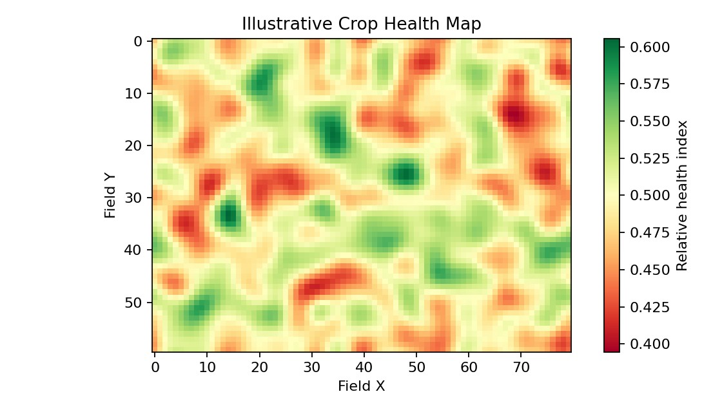
Figure 2. Illustrative field-health visualization format (not an experimental
measurement).

10. Results and Validation
Use labelled data not used during training for final validation. Report only measured values.
Metric | Meaning
Accuracy | Correct predictions / total predictions.
Precision | TP / (TP + FP).
Recall | TP / (TP + FN).
F1-score | Harmonic mean of precision and recall.
IoU | Predicted-region overlap divided by union.
mAP | Mean Average Precision for object detection.
Latency | Processing time per image/frame.
Vegetation coverage | Vegetation-mask pixels / total pixels × 100.
Do not present estimated or illustrative values as actual accuracy. Insert measured metrics after the experiment.

11. Analysis, Comparison, Trade-offs and Justification
Factor | Traditional CV | Deep Learning
Accuracy | Useful in controlled conditions; sensitive to rules. | Higher potential with representative training and validation.
Adaptability | Limited when crops/conditions change. | Potentially stronger generalization; depends on data diversity.
Interpretability | High. | Lower.
Compute | Low; edge-friendly. | Higher, especially for training/large detectors.
Training data | Can work with limited labelled data. | Needs substantial representative labelled data.
Deployment | Fast and inexpensive. | Better for complex recognition with adequate compute.
Main risk | Sensitivity to thresholds and field variation. | Overfitting/domain shift and data/compute cost.
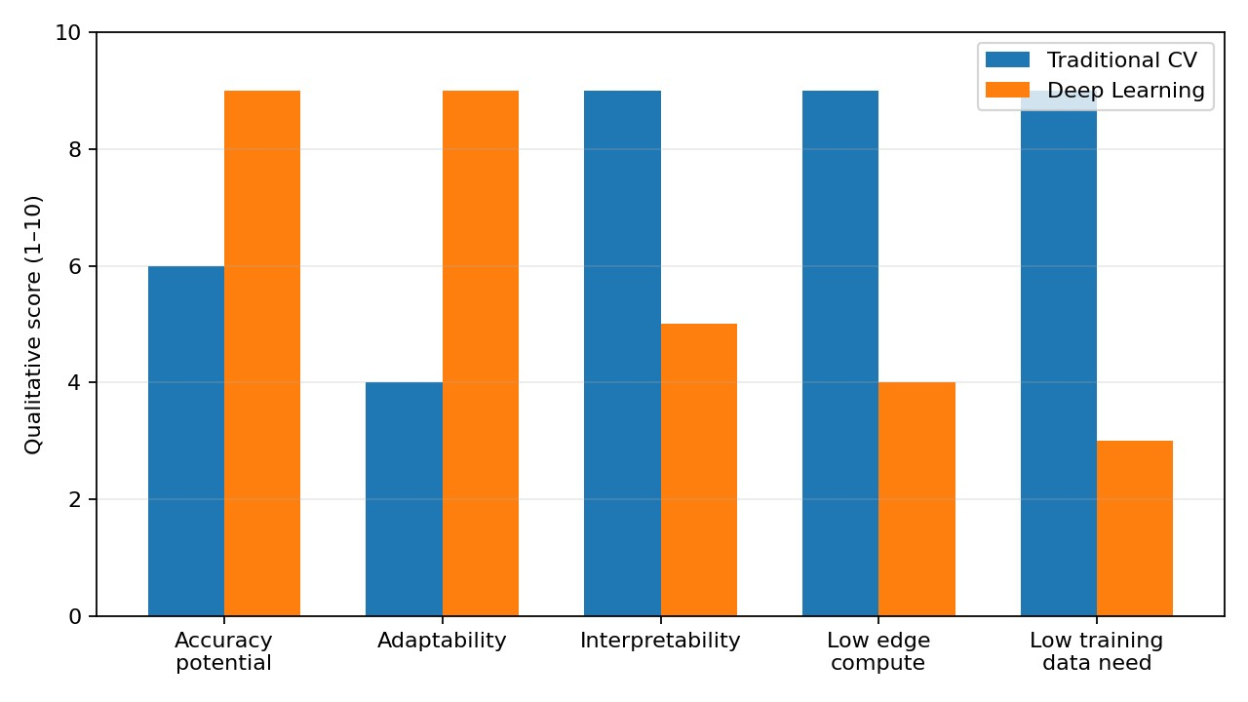
Figure 3. Qualitative design comparison; scores are not experimental measurements.
Final solution: a hybrid architecture is justified. OpenCV preprocessing, segmentation and basic statistics can run efficiently on edge hardware. CNN/YOLO recognition can be performed on an accelerator or in the cloud when representative data and computing resources are available. This balances accuracy, adaptability, battery use, bandwidth and cost.

12. Broader Considerations / SDG Relevance
- SDG 2 – Zero Hunger: supports earlier identification of crop stress and potential productivity improvement.
- SDG 9 – Industry, Innovation and Infrastructure: applies drones, computer vision and AI to agricultural infrastructure.
- SDG 15 – Life on Land: targeted intervention may reduce unnecessary pesticide use.
- Privacy: aerial imagery should be handled responsibly.
- Safety: drone operation must follow applicable regulations.
- Human oversight: results should support farmer/agronomist decisions.

13. Conclusion, Limitations and Possible Improvements
AgriVision applies image enhancement, segmentation, feature analysis and recognition to a precision-agriculture problem. Traditional CV is efficient and interpretable but less adaptable to highly variable field conditions. Deep learning can recognize more complex patterns but requires representative data and greater computing resources. A hybrid edge– cloud architecture provides the best balance for the stated scenario.

Limitations
- Performance depends on image quality and representative data.
- Colour thresholds can fail under unusual illumination.
- Models may suffer domain shift across farms, cameras and seasons.
- Yield estimation requires agronomic calibration and ground truth.
- Deployment is constrained by battery, connectivity and cost.

Possible Improvements
- Use multispectral imagery where suitable.
- Train on multi-season and multi-farm datasets.
- Apply data augmentation and domain adaptation.
- Integrate GPS/geospatial prescription maps.
- Quantize or prune models for edge deployment.
- Add confidence thresholds and human review.

14. Individual Contribution of Group Members
Member Name | Roll No. | Contribution
Kommi Kavya | 192311345 | Problem analysis, requirements gathering, project objectives, drone-image analysis,
 |  | methodology design, and overall system planning.
Narappagari Sravya | 192472192 | Traditional Computer Vision preprocessing, image enhancement, segmentation, vegetation feature extraction, and implementation of the traditional CV approach.
Arigela Jyothsna | 192211459 | Deep-learning approach comparison, evaluation plan, testing, performance analysis, visualizations, screenshots, and final system integration.

15. References
- ITA05 Computer Vision Assignment Brief, “AgriVision – Drone-Based Crop Health
Monitoring: Traditional vs. Deep-Learning Approach.”
- OpenCV Documentation, Open Source Computer Vision Library.
- J. Redmon et al., “You Only Look Once: Unified, Real-Time Object Detection,” 2016. Use the exact paper/version corresponding to the implemented model.
- PlantVillage or another public crop-disease dataset. Cite the exact dataset version and source actually used.
- Python Software Foundation, Python Documentation.
- NumPy Documentation.
Update dataset and software references with the exact versions and sources used by your team.
16. One-Page Individual Reflection

REFLECTION – MEMBER – 3
My contribution to the AgriVision project focused on the deep-learning comparison, evaluation planning, testing, visualizations, screenshots, and final integration of the system. My work helped the team understand the differences between the traditional Computer Vision approach and the deep-learning approach for drone-based crop health monitoring.

I first studied the role of deep learning in analyzing agricultural images. I focused on understanding how deep-learning models can automatically learn useful image features and how this differs from manually designed features used in traditional Computer Vision. I contributed to developing an evaluation plan for comparing the two approaches.

The evaluation process considered important factors such as accuracy, reliability, computational requirements, and overall performance. I helped organize the results so that the strengths and limitations of both approaches could be clearly identified. This comparison was important because the project was specifically designed to study Traditional CV versus Deep Learning for crop health monitoring.

I was also responsible for testing different parts of the system and checking whether the expected outputs were produced. When problems were identified, I worked with the other members to understand and resolve them. I prepared visualizations and screenshots to demonstrate the processing stages and final results of the AgriVision system.

Another important responsibility was final integration. Since each team member worked on different components, I helped bring the modules together and verify that they worked as a complete system. This gave me practical experience in debugging, testing, result interpretation, documentation, and project integration.

Through this project, I learned that developing an effective agricultural monitoring system requires more than simply applying a machine-learning model. The quality of the input data, preprocessing, feature extraction, model selection, testing, and evaluation all influence the final outcome.

Overall, AgriVision gave me valuable practical experience in deep-learning evaluation, Computer Vision testing, visualization, and system integration. It also improved my analytical thinking, problem-solving, communication, and teamwork skills.

17. Final Submission Checklist
- Replace all team-member placeholders.
- Run the code and insert genuine screenshots.
- Record actual measured metrics and dataset details.
- Add exact dataset/software references.
- Add the GitHub repository link and README.
- Proofread names, roll numbers and formatting before submission.

