Draftly Project Report
High-Level Design, Low-Level Design, Architecture, Workflow, and Security Overview
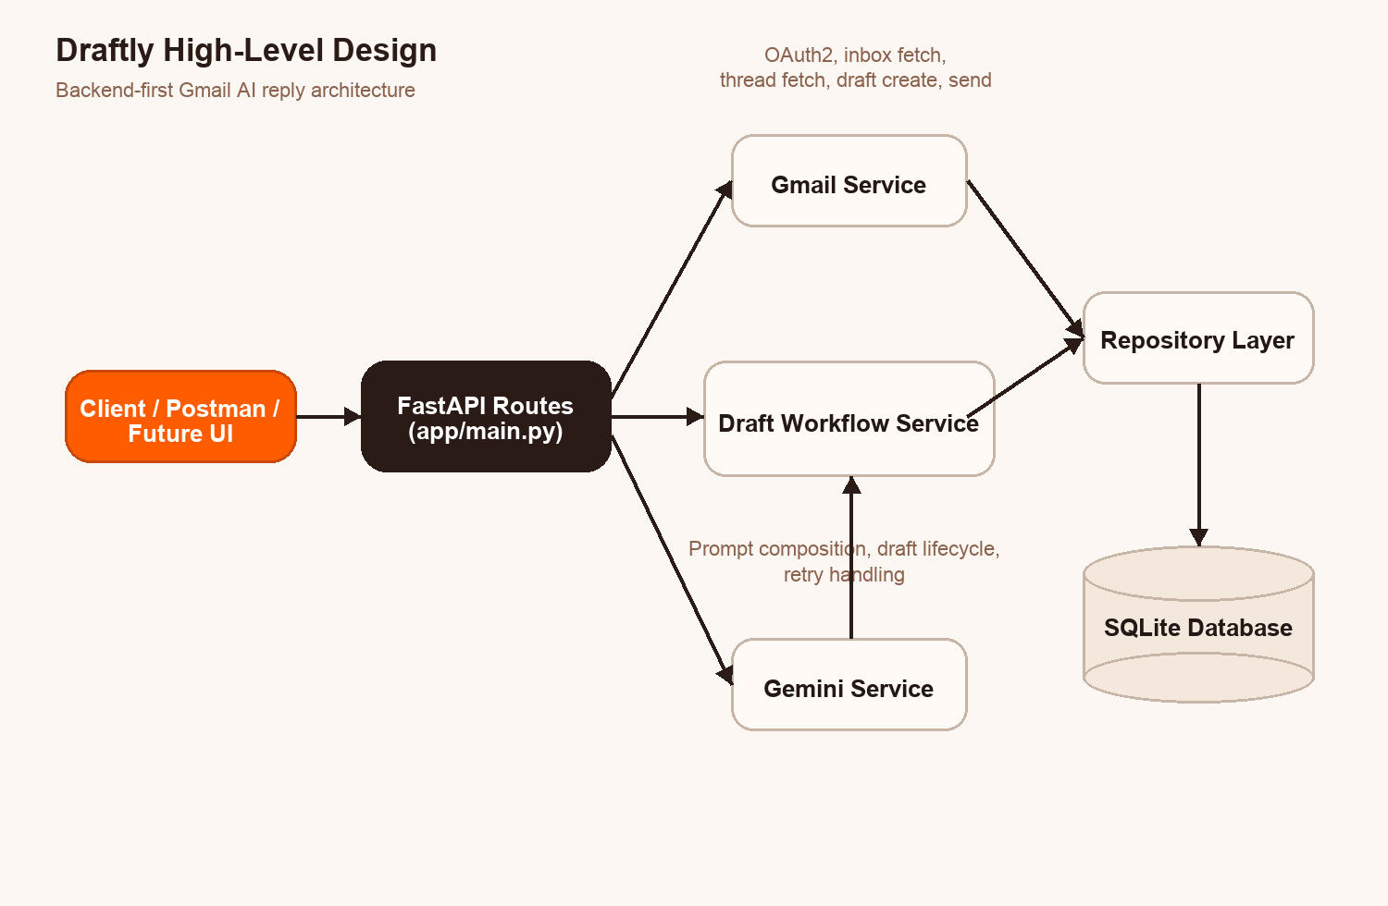
System snapshot: client, FastAPI services, Gemini, Gmail, and database flow
Project Overview
Draftly is a Gmail AI reply assistant built as a modular FastAPI backend. It connects to Gmail through OAuth2, reads email and thread context, generates tone-aware drafts with Gemini, stores workflow state in SQLite, and only sends replies after explicit user review and approval.
Report Highlights
- Problem statement, objectives, scope, and technology stack
- High-level architecture with service interaction flow
- Low-level design covering APIs, services, repositories, and entities
- End-to-end workflow for authentication, draft generation, review, and sending
- Security considerations, testing summary, and future enhancements
Core Stack: FastAPI, SQLAlchemy, SQLite, Gmail API, Google OAuth2, Gemini, Tenacity, Cryptography

1. Introduction
Draftly is a backend-first Gmail AI reply agent designed to reduce the time users spend drafting repetitive email responses. The system integrates with Gmail using OAuth2, reads inbox and thread context, generates tone-aware reply drafts using Gemini, stores the generated drafts and audit data in SQLite, and only sends replies after explicit user approval.
The project was implemented as a FastAPI service with a modular architecture so that the backend can later support a web dashboard, background workers, or analytics without major restructuring.

2. Problem Statement
Professionals often spend a significant amount of time writing routine responses such as follow-ups, acknowledgements, scheduling confirmations, and polite clarifications. Although these responses are repetitive, they still require context-awareness, correct threading, and appropriate tone. A practical AI email assistant must therefore do more than text generation:
- understand the current Gmail thread
- adapt to the user's tone and preferences
- preserve reply metadata such as thread IDs and headers
- keep the user in control before sending
- maintain operational safety with retries, logging, and auditability
Draftly addresses this gap through a backend workflow that combines Gmail integration, LLM-based drafting, persistence, review controls, and send reliability mechanisms.

3. Objectives
The primary objectives of the project were:
- connect securely to Gmail using OAuth2
- fetch inbox messages and thread context through REST APIs
- generate AI-assisted reply drafts using Gemini
- personalize drafts using tone, signature, and recent sent-email style patterns
- store drafts, preferences, and logs in a database
- require approve/edit/reject before sending
- send approved replies back through Gmail with correct thread continuity
- include idempotency and retry handling for send actions

4. Scope

In scope
- backend APIs for auth, inbox access, draft generation, review workflow, sending, and logs
- Gmail API integration
- Gemini API integration
- SQLite persistence
- encrypted storage for sensitive data
- report-level design documentation

Out of scope
- production-grade frontend
- background job system
- multi-user team dashboard
- deployment automation and cloud hosting
- advanced analytics and monitoring dashboards

5. Technology Stack
- **Backend framework:** FastAPI
- **Language:** Python 3.9
- **ORM / DB access:** SQLAlchemy
- **Database:** SQLite
- **LLM provider:** Google Gemini via `google-genai`
- **Email provider:** Gmail API via `google-api-python-client`
- **Auth:** OAuth2 using `google-auth-oauthlib`
- **Retry handling:** Tenacity
- **Secrets protection:** Fernet encryption from `cryptography`

6. Functional Requirements
- Connect a user’s Gmail account using OAuth2.
- Check whether a Gmail account is currently connected.
- Disconnect Gmail access and revoke the stored token.
- Fetch unread or recent emails from Gmail with relevant metadata.
- Fetch thread-level message history for a selected email.
- Save user preferences such as signature and preferred tone.
- Generate a reply draft using thread context and user preferences.
- Learn lightweight stylistic patterns from recent sent emails.
- Allow a user to approve, edit, or reject a generated draft.
- Send only approved or edited drafts.
- Record send attempts, draft status transitions, and audit logs.

7. Non-Functional Requirements
- Maintain separation between routing, business logic, and persistence layers.
- Store credentials and preferences securely.
- Keep sending idempotent to reduce duplicate replies.
- Retry send failures automatically for transient errors.
- Keep the codebase modular enough for future UI or worker integration.
- Provide traceability through logs and persisted draft states.

8. High-Level Design (HLD)

Figure 1. Draftly high-level architecture diagram

8.1 System Overview
At a high level, Draftly follows a service-oriented backend flow:
- A client calls FastAPI endpoints.
- The API layer validates requests and delegates work to service classes.
- The Gmail service handles mailbox access and reply sending.
- The Gemini service handles AI draft generation.
- The draft workflow service coordinates Gmail data retrieval, prompt composition, draft storage, and sending.
- Repository helpers interact with the database models.
- SQLite stores users, preferences, drafts, send attempts, and logs.

8.2 HLD Components
- **Client / Postman / Future UI**
Sends REST requests to the backend.
- **FastAPI Application**
Exposes endpoints for auth, preferences, emails, threads, drafts, send, and logs.
- **Gmail Service**
Manages OAuth2 flows, profile lookup, message listing, thread retrieval, draft creation, and send execution.
- **Gemini Service**
Builds prompts and calls the Gemini model for response generation.
- **Draft Workflow Service**
Coordinates end-to-end draft lifecycle logic from source email to sent reply.
- **Repository Layer**
Performs data persistence and status transitions using SQLAlchemy sessions.
- **Database**
Stores user accounts, OAuth state, drafts, send attempts, and audit logs.

8.3 HLD Diagram Summary
Client
-> FastAPI Routes
-> Gmail Service
-> Gemini Service
-> Draft Workflow Service
-> Repository Layer
-> SQLite Database
Draft Workflow Service also orchestrates Gmail Service + Gemini Service together.

9. Low-Level Design (LLD)
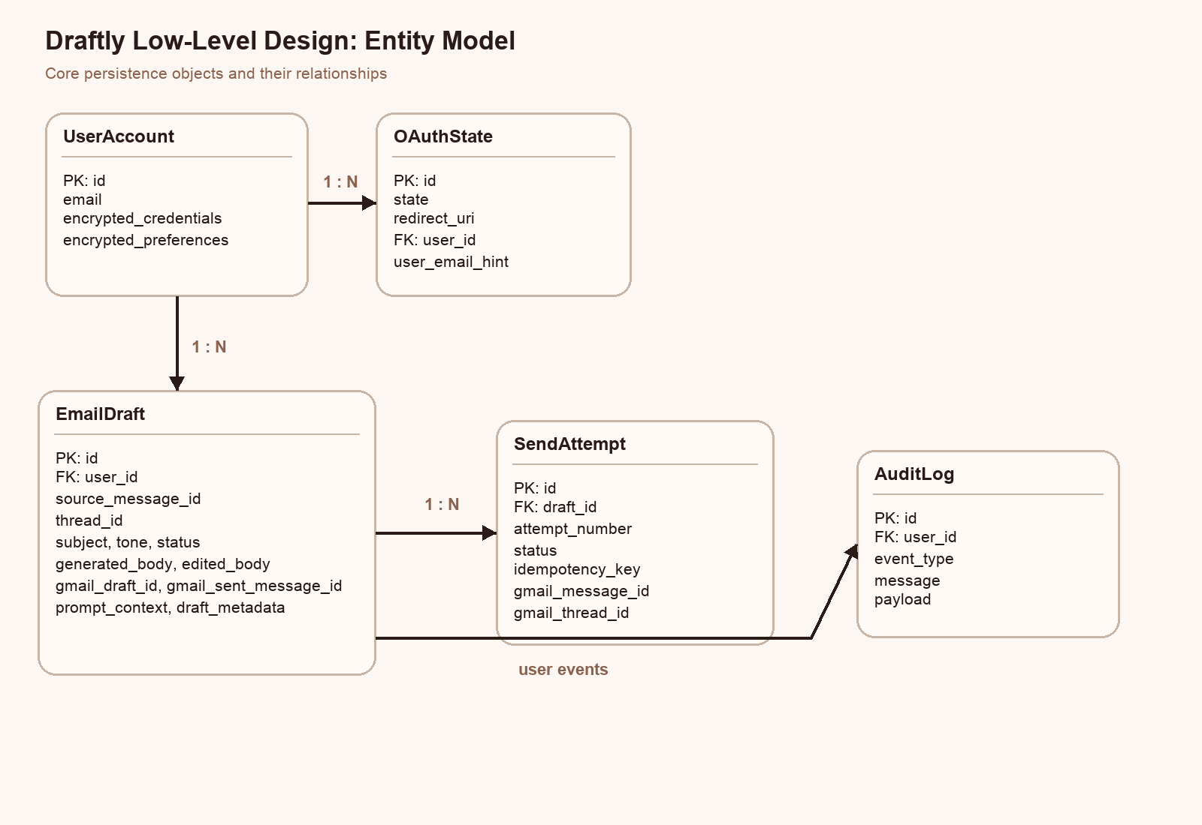
Figure 2. Draftly low-level entity design diagram

9.1 API Layer
The API layer is implemented in `app/main.py`.
Main endpoint groups:
- `/health`
- `/api/auth/...`
- `/api/preferences`
- `/api/emails`
- `/api/threads/{thread_id}`
- `/api/drafts/generate`
- `/api/drafts`
- `/api/drafts/{draft_id}`
- `/api/drafts/{draft_id}/review`
- `/api/drafts/{draft_id}/send`
- `/api/logs`
Responsibilities:
- request validation through Pydantic schemas
- dependency injection for database sessions
- error handling and HTTP status mapping
- serialization of ORM/domain objects to response models

9.2 Configuration Layer
`app/config.py` centralizes settings such as:
- app host and port
- database URL
- Gmail OAuth client path
- Gmail redirect URI
- Gemini API key
- Gmail fetch defaults
- encryption key resolution
This design keeps deployment/config changes out of business logic.

9.3 Database Layer
`app/db.py` sets up:
- SQLAlchemy engine
- session factory
- `Base` declarative model
- `get_db()` dependency for request-scoped sessions

9.4 Data Model Design
The project uses the following main entities:

UserAccount
- stores user email
- stores encrypted OAuth credentials
- stores encrypted preferences

OAuthState
- stores temporary OAuth state values for the auth callback flow

EmailDraft
- stores source message ID and thread ID
- stores generated and edited body
- stores review/sending status
- stores Gmail draft and sent message references
- stores prompt context and draft metadata

SendAttempt
- stores send-attempt history for idempotent and retry-aware sending

AuditLog
- stores important system events such as auth, draft generation, review, and sending

9.5 Repository Layer
`app/services/repositories.py` contains helper functions for:
- user lookup and upsert
- encrypting/decrypting credentials and preferences
- draft creation and retrieval
- review state updates
- send attempt creation and updates
- draft sent/failed transitions
- audit log creation and listing
This keeps persistence logic out of the route layer and reduces duplication.

9.6 Gmail Service Design
`app/services/gmail_service.py` encapsulates all Gmail-specific behavior:
- create OAuth flow
- generate authorization URL
- exchange auth code for credentials
- refresh credentials when needed
- build Gmail API client
- get user profile
- revoke credentials
- list inbox messages
- fetch individual messages
- fetch thread history
- sample recent sent emails for style learning
- create Gmail drafts
- send Gmail messages
Important implementation details:
- thread continuity is preserved using `threadId`
- reply semantics are preserved using `In-Reply-To` and `References`
- message content is normalized into a backend-friendly structure

9.7 Gemini Service Design
`app/services/gemini_service.py` is intentionally narrow:
- initializes a Gemini client lazily
- validates the presence of the API key
- builds a structured prompt using tone, latest message, thread summary, style samples, and extra instructions
- calls Gemini to generate a ready-to-send reply body
This module isolates prompt logic from routing and persistence logic.

9.8 Draft Workflow Design
`app/services/draft_service.py` is the orchestration core of the project.

Draft generation flow
- Compute or accept an idempotency key.
- Return an existing draft if the same generation request already exists.
- Load user credentials and preferences.
- Fetch the source Gmail message.
- Fetch thread history.
- Fetch recent sent emails for style learning.
- Build the Gemini prompt.
- Generate the draft.
- Persist the draft in the database.
- Create a Gmail-side draft.
- Record audit logs.

Send flow
- Verify draft status is approved/edited.
- Reuse existing successful send result if already sent.
- Create or reuse a send-attempt record.
- Mark draft as sending.
- Build reply payload from edited or generated content.
- Send through Gmail using retry logic.
- Persist send status and Gmail message IDs.
- Update draft status to sent or failed.
- Write audit log entry.

9.9 Utility and Security Design

`app/utils.py`
- idempotency key generation
- Gmail raw message encoding
- HTML-to-text cleanup
- timestamp conversion
- style sample compaction

`app/security.py`
- Fernet-based JSON encryption/decryption
- used for stored credentials and preferences

10. End-to-End Workflow

10.1 Authentication Workflow
- User calls `/api/auth/google/start`.
- Backend creates OAuth state and returns a Google consent URL.
- User completes consent.
- Google redirects to `/api/auth/google/callback`.
- Backend exchanges code for credentials and stores encrypted token data.

10.2 Draft Creation Workflow
- User fetches emails.
- User chooses a source message.
- User calls `/api/drafts/generate`.
- Backend fetches Gmail message + thread.
- Backend fetches recent sent messages.
- Gemini generates the reply body.
- Backend stores the draft and creates a Gmail draft.

10.3 Review Workflow
- User lists drafts.
- User opens one draft.
- User approves, edits, or rejects it through `/review`.
- Backend updates status and writes logs.

10.4 Sending Workflow
- User calls `/send` for an approved draft.
- Backend creates a send-attempt record.
- Gmail send is executed with retries.
- Draft and send-attempt statuses are updated.
- Logs capture the final result.

11. Security Design
Security-related decisions include:
- OAuth2-based Gmail access instead of raw credentials
- encrypted storage of user credentials and preferences
- explicit approval before send
- idempotency keys to reduce duplicate sends
- logout path with token revocation support
- audit logs for traceability
Current limitations:
- encryption key defaults to a local generated key if not configured
- CORS is currently permissive for development
- SQLite is suitable for development but not ideal for larger production deployments

12. Testing and Verification
The project was verified through:
- unit tests for core utilities
- FastAPI health check validation
- local server startup validation
- live Gemini smoke test
- Gmail OAuth start-route validation
Functional checks covered:
- API boot success
- health endpoint success
- Gemini response generation success
- OAuth start URL generation success once client secrets were configured

13. Challenges and Trade-offs

Challenge 1: Gmail threading correctness
Replies needed the correct thread and header metadata to maintain conversation continuity.

Challenge 2: Human control vs automation
Direct autonomous sending was intentionally avoided because the requirement emphasizes user approval.

Challenge 3: Personalization quality
Instead of building a heavy personalization engine, the project uses recent sent emails and stored preferences as lightweight style inputs.

Challenge 4: Simplicity vs production readiness
SQLite and synchronous request-driven logic keep implementation simple, but production systems would likely add queues, workers, and managed persistence.

14. Future Enhancements
- Add a frontend dashboard for inbox browsing and review
- Add background jobs for retries and token maintenance
- Introduce async processing or task queues
- Add observability dashboards and metrics
- Support richer prompt profiles and custom templates
- Add automated classification to identify emails worth drafting automatically
- Upgrade database and deployment architecture for production use

15. Conclusion
Draftly demonstrates a complete backend architecture for a practical Gmail AI reply assistant. The solution integrates Gmail, Gemini, review controls, encrypted persistence, and reliable send handling into a single cohesive workflow. From a design perspective, the project balances usability, modularity, and safety by keeping AI generation helpful while preserving explicit human approval before sending.
The implemented architecture is intentionally extensible: the current backend can serve as the foundation for a future frontend product, a productionized deployment pipeline, or richer email automation features.

