🎫
PROJECT IMPLEMENTATION
TicketPro — Support Ticket Management System
Java 21 · Spring Boot · React · MySQL · Docker
Submitted by: Jyotheeshwar Mangala
Repository: github.com/jyotheeshwar7989/Mini-project
Mini Project Submission — 2026

1. Introduction
This document describes the implementation of TicketPro, a full-stack Support Ticket Management System. It covers the development approach, module-wise implementation details, key code components, the database schema, and verified outputs of the working system. The system was implemented using Java/Spring Boot for the backend, React for the frontend, MySQL for persistence, and Docker for containerized deployment.

1.1 Objective
- Implement a secure, role-based ticketing system with JWT authentication.
- Build a layered backend (Controller–Service–Repository) following Spring Boot best practices.
- Develop a responsive React frontend with protected, role-aware routing.
- Maintain a complete audit trail for every ticket change.
- Containerize and deploy the full stack using Docker Compose.

1.2 Modules Implemented
- Module 1 — Authentication & Security (Register, Login, JWT, Role-based access)
- Module 2 — Ticket Management (Create, View, Filter, Status workflow)
- Module 3 — Comment System
- Module 4 — Admin Module (Ticket & User management, Audit trail)
- Module 5 — Deployment Module (Docker containerization)

2. System Implementation Overview

2.1 Implementation Environment
Component | Tool / Version
Language | Java 21
Framework | Spring Boot 3.4.5
Build Tool | Maven
Frontend | React (JavaScript)
Database | MySQL 8.0
IDE | IntelliJ IDEA
API Testing | Postman
Containerization | Docker, Docker Compose
Version Control | Git, GitHub

2.2 Layered Architecture
The backend was implemented using a standard layered architecture to maintain separation of concerns:
Controller → handles HTTP requests/responses
Service → contains business logic
Repository → Spring Data JPA database access
Entity → JPA-mapped database tables
DTO → request/response data contracts

3. Module 1 — Authentication & Security
This module handles user registration, login, JWT token generation/validation, and role-based authorization.

3.1 User Entity
@Entity
@Table(name = "users")
public class User implements UserDetails {
@Id
@GeneratedValue(strategy = GenerationType.IDENTITY)
private Long id;

private String fullName;
private String email;
private String password;

@Enumerated(EnumType.STRING)
private Role role; // ROLE_USER, ROLE_ADMIN

private boolean enabled = true;
...
}

3.2 JWT Generation & Validation (JwtService)
public String generateToken(UserDetails userDetails) {
return Jwts.builder()
.subject(userDetails.getUsername())
.issuedAt(new Date())
.expiration(new Date(System.currentTimeMillis() + expiration))
.signWith(getSignInKey())
.compact();
}

public boolean isTokenValid(String token, UserDetails userDetails) {
final String username = extractUsername(token);
return username.equals(userDetails.getUsername())
&& !isTokenExpired(token);
}

3.3 JWT Authentication Filter
Every request (except /api/v1/auth/**) is intercepted by JwtAuthenticationFilter, which extracts the Bearer token, validates it, and sets the Spring SecurityContext:
@Override
protected void doFilterInternal(HttpServletRequest request,
HttpServletResponse response, FilterChain filterChain) {

final String authHeader = request.getHeader("Authorization");
if (authHeader == null || !authHeader.startsWith("Bearer ")) {
filterChain.doFilter(request, response);
return;
}
final String jwt = authHeader.substring(7);
final String userEmail = jwtService.extractUsername(jwt);

if (userEmail != null) {
UserDetails userDetails = userDetailsService.loadUserByUsername(userEmail);
if (jwtService.isTokenValid(jwt, userDetails)) {
UsernamePasswordAuthenticationToken authToken =
new UsernamePasswordAuthenticationToken(
userDetails, null, userDetails.getAuthorities());
SecurityContextHolder.getContext().setAuthentication(authToken);
}
}
filterChain.doFilter(request, response);
}

3.4 Security Configuration
http
.csrf(AbstractHttpConfigurer::disable)
.authorizeHttpRequests(auth -> auth
.requestMatchers("/api/v1/auth/**").permitAll()
.requestMatchers("/api/v1/admin/**").hasAuthority("ROLE_ADMIN")
.anyRequest().authenticated())
.sessionManagement(s -> s
.sessionCreationPolicy(SessionCreationPolicy.STATELESS))
.addFilterBefore(jwtAuthFilter, UsernamePasswordAuthenticationFilter.class);

3.5 Password Hashing
Passwords are hashed using BCryptPasswordEncoder before being persisted, and never stored or logged in plain text:
@Bean
public PasswordEncoder passwordEncoder() {
return new BCryptPasswordEncoder();
}

3.6 Output — Login & Register Screens
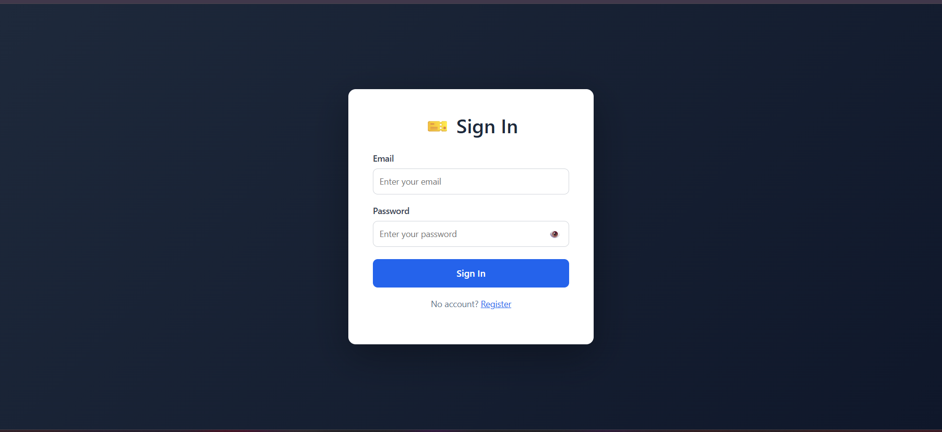
Figure 3.1 — Sign-in screen
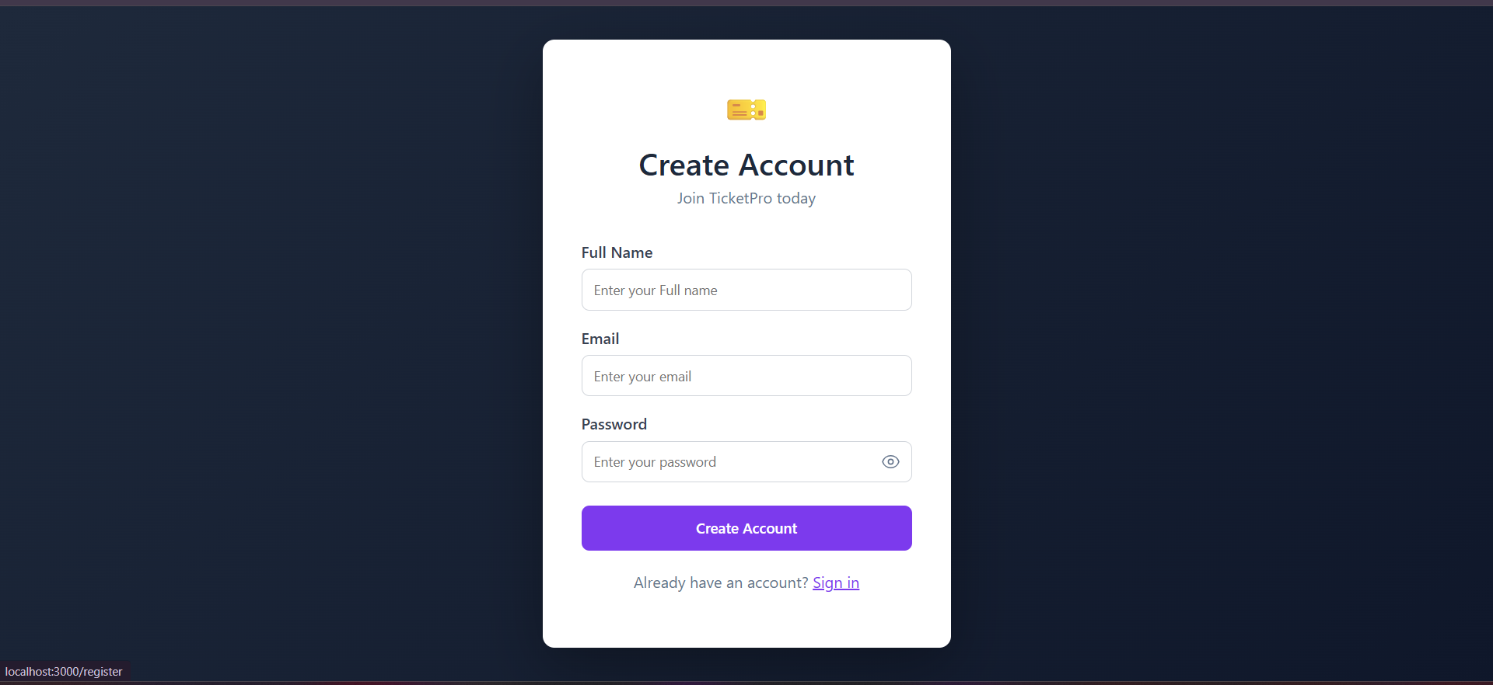
Figure 3.2 — Account registration screen

4. Module 2 — Ticket Management
This module allows authenticated users to create, view, and track support tickets.

4.1 Ticket Entity
@Entity
@Table(name = "tickets")
public class Ticket {
@Id @GeneratedValue(strategy = GenerationType.IDENTITY)
private Long id;

private String title;
private String description;

@Enumerated(EnumType.STRING)
private TicketStatus status; // OPEN, IN_PROGRESS, RESOLVED, CLOSED

@Enumerated(EnumType.STRING)
private TicketPriority priority; // LOW, MEDIUM, HIGH, CRITICAL

@ManyToOne
private User createdBy;

private LocalDateTime createdAt;
private LocalDateTime updatedAt;
}

4.2 Create Ticket — Controller Endpoint
@PostMapping("/tickets")
public ResponseEntity<ApiResponse<TicketResponse>> createTicket(
@Valid @RequestBody TicketRequest request,
Authentication authentication) {
TicketResponse response = ticketService.createTicket(request, authentication.getName());
return ResponseEntity.status(HttpStatus.CREATED)
.body(ApiResponse.success("Ticket created", response));
}

4.3 Get My Tickets
@GetMapping("/tickets/my-tickets")
public ResponseEntity<ApiResponse<List<TicketResponse>>> getMyTickets(
Authentication authentication) {
List<TicketResponse> tickets =
ticketService.getTicketsByUser(authentication.getName());
return ResponseEntity.ok(ApiResponse.success("Fetched", tickets));
}

4.4 Output — Dashboard & Create Ticket
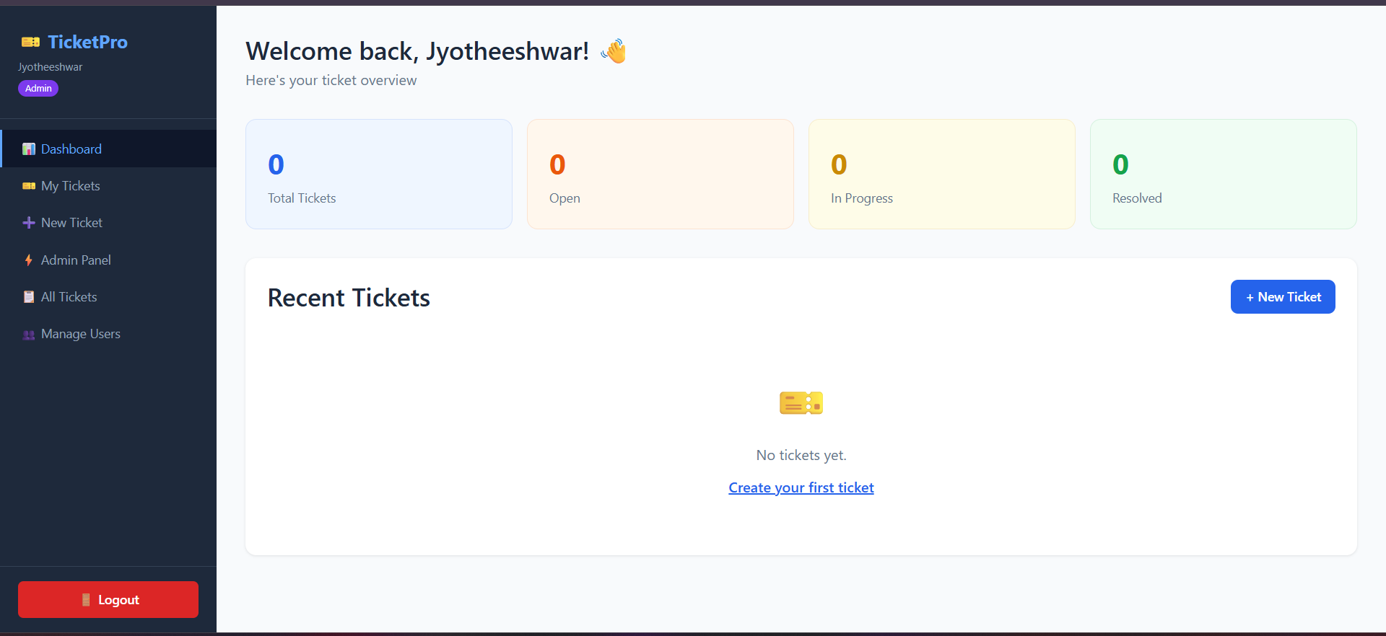
Figure 4.1 — User dashboard with ticket statistics
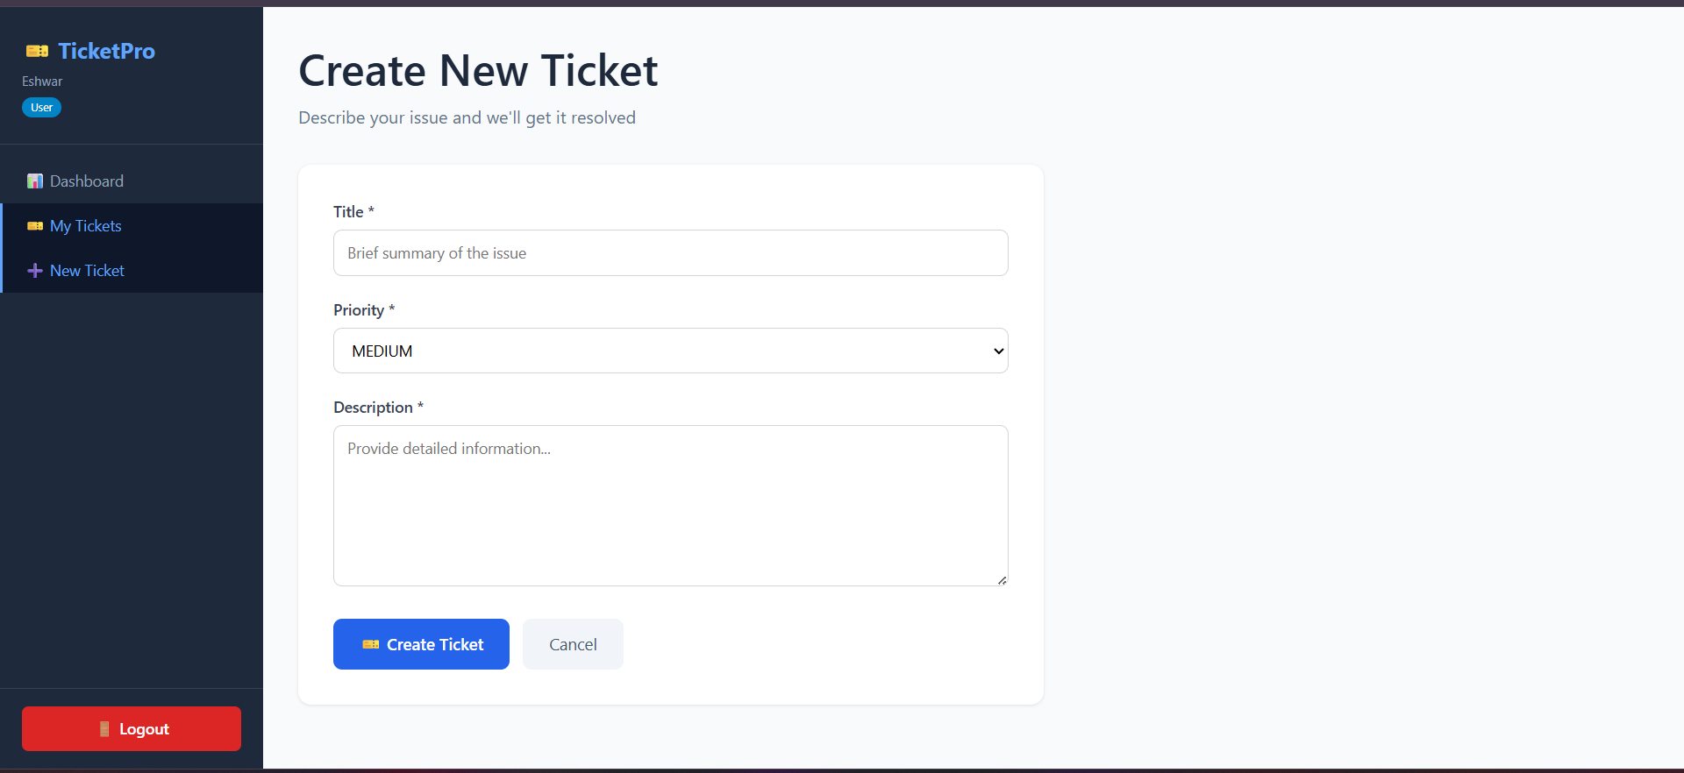
Figure 4.2 — Create new ticket form

5. Module 3 — Comment System
Users can add comments to a ticket to communicate updates. Each comment is linked to the ticket and the authoring user.

5.1 Comment Entity
@Entity
@Table(name = "comments")
public class Comment {
@Id @GeneratedValue(strategy = GenerationType.IDENTITY)
private Long id;

private String content;

@ManyToOne
private Ticket ticket;

@ManyToOne
private User author;

private LocalDateTime createdAt;
}

5.2 Add Comment Endpoint
@PostMapping("/tickets/{id}/comments")
public ResponseEntity<ApiResponse<CommentResponse>> addComment(
@PathVariable Long id,
@RequestBody CommentRequest request,
Authentication authentication) {
CommentResponse response = commentService.addComment(
id, request, authentication.getName());
return ResponseEntity.status(HttpStatus.CREATED)
.body(ApiResponse.success("Comment added", response));
}

6. Module 4 — Admin Module
Administrators have system-wide visibility and control over all tickets and users, plus access to a full audit trail.

6.1 Ticket History Entity (Audit Trail)
@Entity
@Table(name = "ticket_history")
public class TicketHistory {
@Id @GeneratedValue(strategy = GenerationType.IDENTITY)
private Long id;

@ManyToOne
private Ticket ticket;

private String fieldChanged;
private String oldValue;
private String newValue;

@ManyToOne
private User changedBy;

private LocalDateTime changedAt;
}

6.2 Logging a Status Change (Service Layer)
public TicketResponse updateStatus(Long ticketId, TicketStatus newStatus,
String adminEmail) {
Ticket ticket = ticketRepository.findById(ticketId)
.orElseThrow(() -> new ResourceNotFoundException("Ticket not found"));
String oldStatus = ticket.getStatus().name();

ticket.setStatus(newStatus);
ticketRepository.save(ticket);

TicketHistory history = new TicketHistory();
history.setTicket(ticket);
history.setFieldChanged("status");
history.setOldValue(oldStatus);
history.setNewValue(newStatus.name());
history.setChangedBy(userRepository.findByEmail(adminEmail).get());
history.setChangedAt(LocalDateTime.now());
historyRepository.save(history);

return mapToResponse(ticket);
}

6.3 Role-Based Authorization (Admin-Only Endpoint)
@GetMapping("/admin/tickets")
@PreAuthorize("hasAuthority('ROLE_ADMIN')")
public ResponseEntity<ApiResponse<List<TicketResponse>>> getAllTickets() {
return ResponseEntity.ok(
ApiResponse.success("Fetched", ticketService.getAllTickets()));
}

6.4 Output — Admin Dashboard & Ticket Management
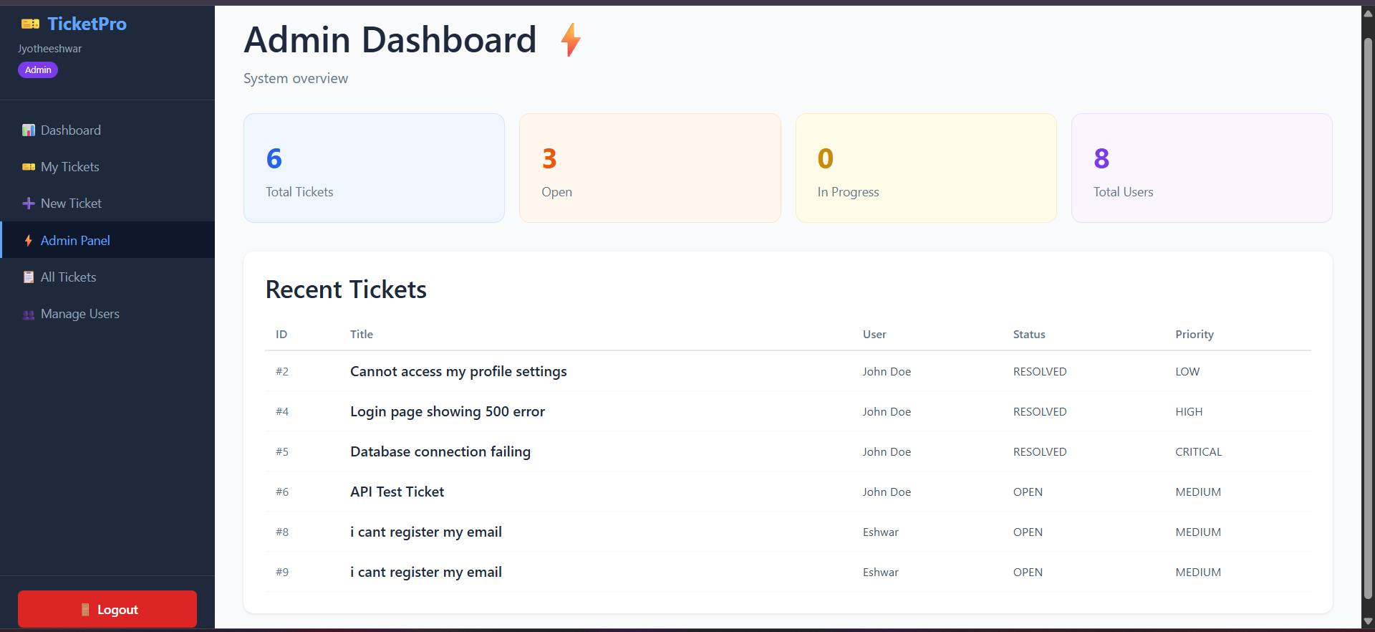
Figure 6.1 — Admin dashboard with system-wide statistics
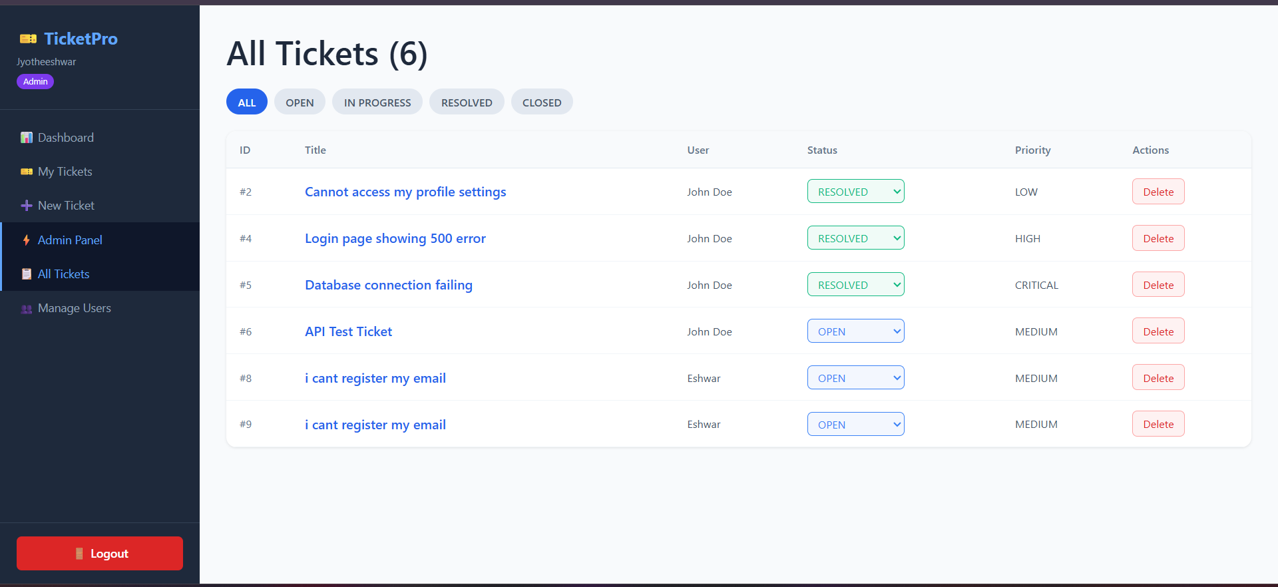
Figure 6.2 — Admin view of all tickets with status and delete controls

7. Module 5 — Deployment (Docker)
The complete application was containerized using Docker Compose, defining three services: MySQL, the Spring Boot backend, and the React frontend served via Nginx.

7.1 docker-compose.yml (Core Structure)
services:
mysql:
image: mysql:8.0
environment:
MYSQL_ROOT_PASSWORD: ${DB_ROOT_PASSWORD}
MYSQL_DATABASE: ${DB_NAME}
ports: ["3307:3306"]
healthcheck:
test: ["CMD", "mysqladmin", "ping", "-h", "localhost"]

backend:
build: ./backend
environment:
SPRING_DATASOURCE_URL: jdbc:mysql://mysql:3306/${DB_NAME}
APP_JWT_SECRET: ${JWT_SECRET_KEY}
depends_on:
mysql:
condition: service_healthy
ports: ["8080:8080"]

frontend:
build: ./frontend
ports: ["3000:80"]
depends_on: [backend]

7.2 Backend Dockerfile (Multi-Stage Build)
FROM maven:3.9.6-eclipse-temurin-21 AS build
WORKDIR /app
COPY pom.xml .
RUN mvn dependency:go-offline -B
COPY src ./src
RUN mvn clean package -DskipTests

FROM eclipse-temurin:21-jre-alpine
WORKDIR /app
COPY --from=build /app/target/*.jar app.jar
EXPOSE 8080
ENTRYPOINT ["java", "-jar", "app.jar"]

7.3 Secrets Management
Database credentials and the JWT signing key are externalized to a .env file (excluded from version control) and referenced in docker-compose.yml using ${VARIABLE} placeholders, ensuring no secrets are committed to GitHub.

8. Database Implementation
The schema was implemented across four related tables, managed via Hibernate's ddl-auto=update during development.
Table | Key Columns
users | id, full_name, email, password, role, enabled
tickets | id, title, description, status, priority, created_by_id
comments | id, content, ticket_id, author_id, created_at
ticket_history | id, ticket_id, field_changed, old_value, new_value, changed_by_id

9. Testing & Verification
The implementation was verified using a combination of Postman API testing and manual UI testing across the full feature set.
- Verified register, login, and logout cycles, including repeated login after logout.
- Verified ticket creation across all priority levels and confirmed correct status transitions.
- Verified comments persist and display correctly on the ticket detail view.
- Verified admin-only endpoints reject standard users with a 403 response.
- Verified the full Docker stack builds and runs with docker-compose up --build.

10. Conclusion
The implementation successfully delivers a secure, full-stack ticketing system with JWT-based authentication, role-based authorization, complete audit logging, and containerized deployment. Each module was implemented following standard layered design principles, and the system was verified end-to-end through both API-level and UI-level testing.

