***Codeathon***

***Employee Management System Documentation***

***Requirements:*** Python V 3.11.5

***Library:*** PyMongo 4.6.0

***Database:*** Mongo-Database (MongoDB Compass)

***1. Introduction***

The Employee Management System is a Python-based application that allows users to input and manage employee information, storing the data in a MongoDB database. This system facilitates the creation of employee records, including details such as employee number, name, organization, job role, hiring date, department number, and salary.

***2. Project Components***

***2.1 MongoDB Database***

The project utilizes a MongoDB database to store employee information. The connection to the MongoDB server is established using the pymongo library.

***2.2 Employee Class***

The Employees class represents individual employees within the system. Each employee has a name and a list of relationships, allowing for future expansion to include relationships between employees.

***2.3 Organization Class***

The Organization class represents the organization to which employees belong. Each organization has a name attribute.

***3. Usage***

***3.1 Input Employee Information***

Users can input employee information, including the number of employees (n), employee name, organization name, job role, hiring date, department number, and salary. This information is then inserted into the MongoDB database.

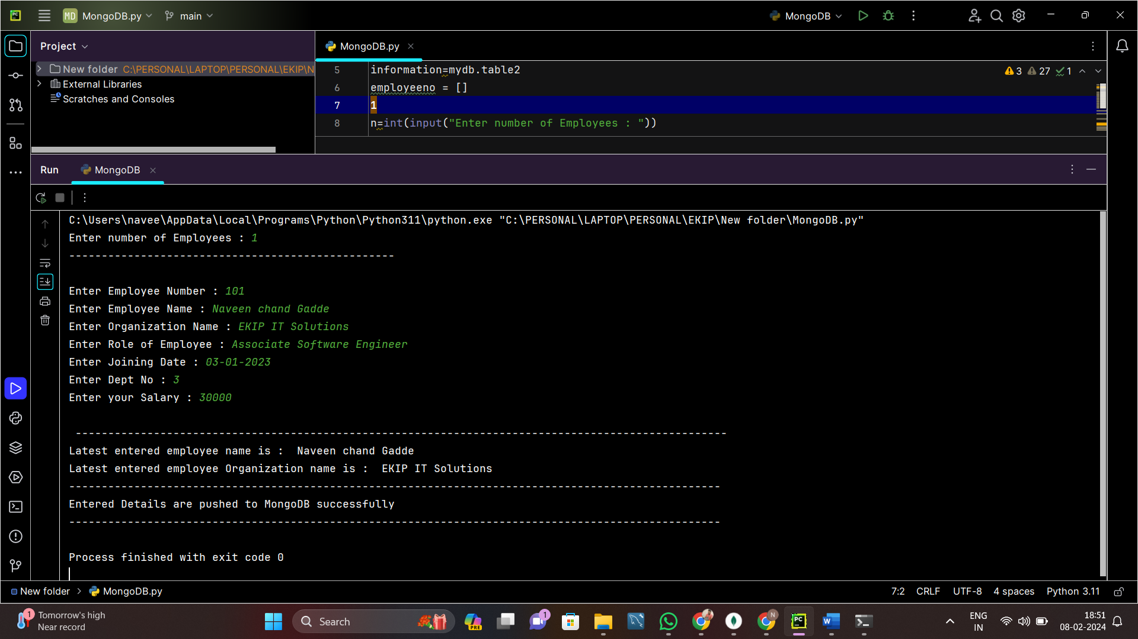

***3.2 Employee and Organization Classes***

Instances of the Employees and Organization classes are created using the provided information. The attributes of these instances are set based on user input.

***3.3 Output***

The system outputs the entered details, including employee and organization names, to the console. Additionally, a confirmation message indicates that the information has been successfully pushed to MongoDB.

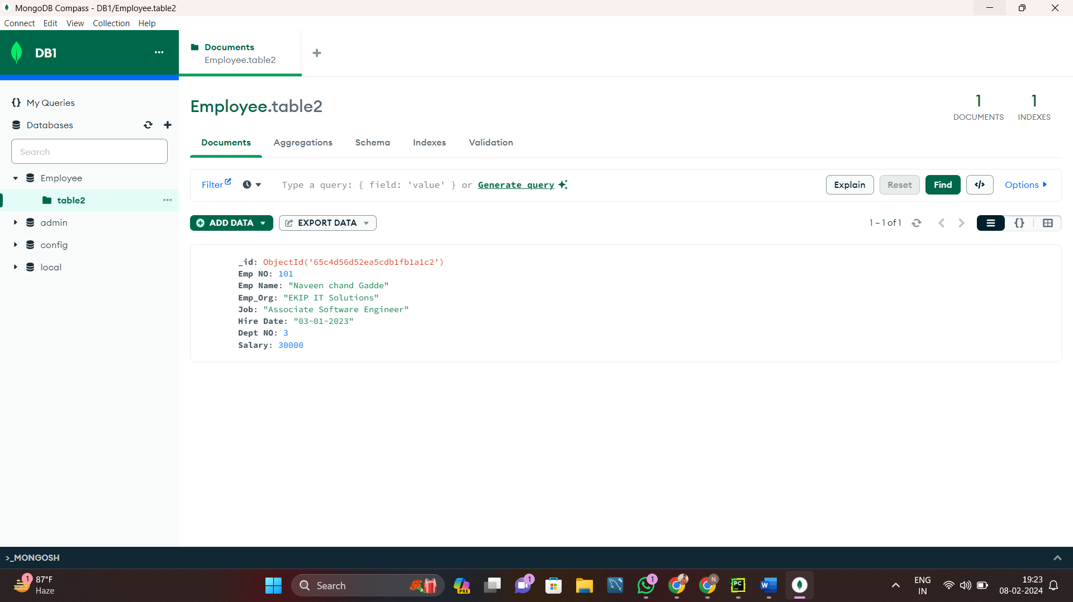

***Conclusion***

This script allows for the collection of employee information such as employee number, name, organization, job role, hiring date, department number, and salary. The collected information is then stored in a MongoDB database for further retrieval and analysis.

***Note***

Ensure that the MongoDB server is running and accessible at “ localhost:27017 “ before executing the script.