**Question 1**

using System;

class Triangle

{

static void Main(string[] args)

{

Console.WriteLine("Enter the height of the triangle:");

int height = Convert.ToInt32(Console.ReadLine());

PrintEquilateralTriangle(height);

}

static void PrintEquilateralTriangle(int height)

{

for (int i = 0; i < height; i++)

{

// Print spaces before printing asterisks

for (int j = 0; j < height - i - 1; j++)

{

Console.Write(" ");

}

// Print asterisks

for (int j = 0; j <= i; j++)

{

Console.Write("* ");

}

Console.WriteLine();

}

}

}

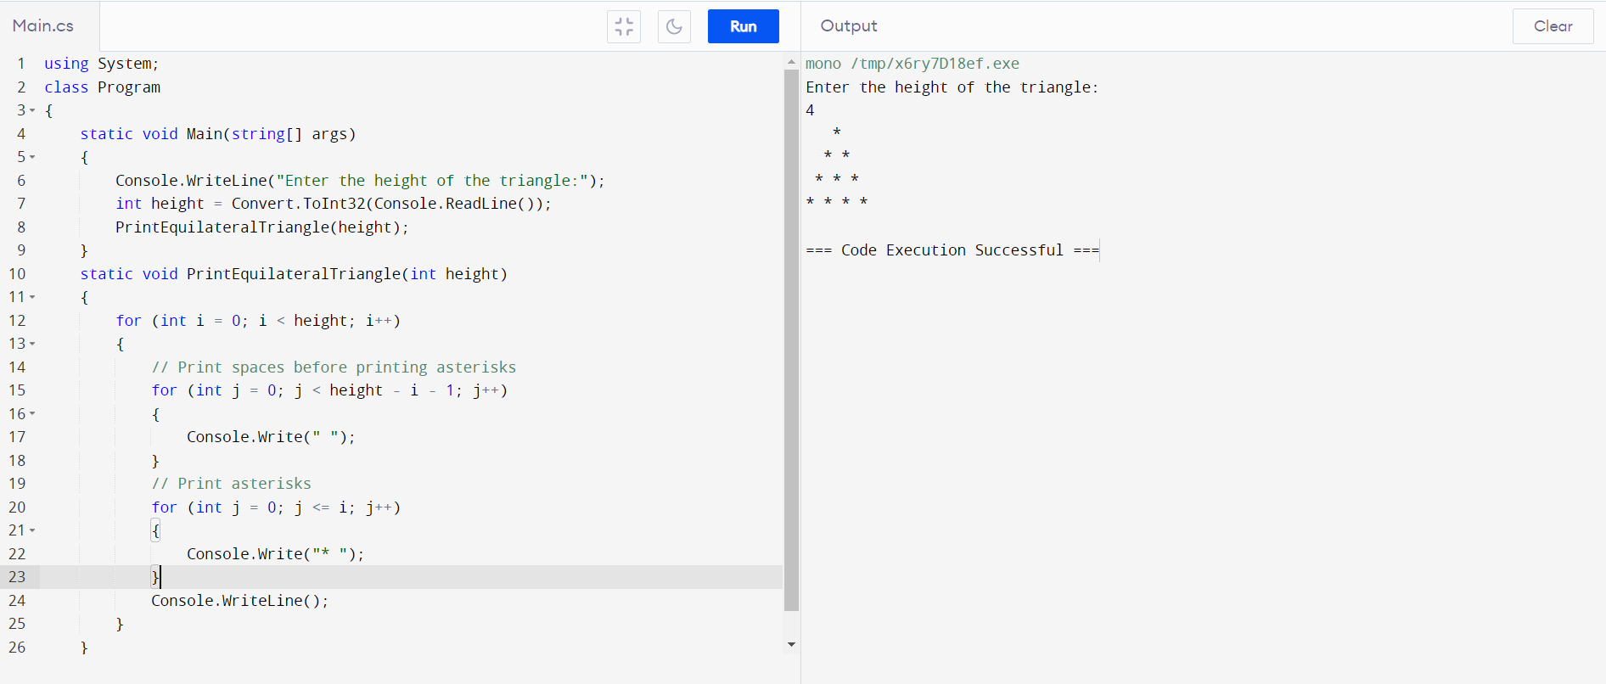

**Question 2**

using System;

using System.Text.RegularExpressions;

class Program

{

static void Main(string[] args)

{

Console.WriteLine("Enter a string:");

string input = Console.ReadLine();

string[] validDates = FindValidDatesInString(input);

Console.WriteLine("Valid dates found in the string:");

foreach (string date in validDates)

{

Console.WriteLine(date);

}

}

static string[] FindValidDatesInString(string inputString)

{

// Define the regular expression pattern to find valid dates (MMDDYYYY)

string DatePattern = @"\b(0[1-9]|1[0-2])(0[1-9]|[12][0-9]|3[01])(19|20)\d{2}\b";

// Create a regex object

Regex regex = new Regex(DatePattern);

// Find matches in the input string

MatchCollection matches = regex.Matches(inputString);

// Extract matched dates

string[] dates = new string[matches.Count];

for (int i = 0; i < matches.Count; i++)

{

dates[i] = matches[i].Value;

}

return dates;

}

}

