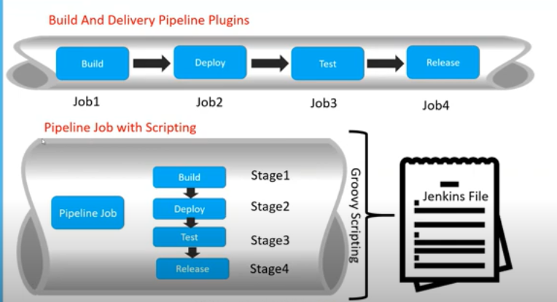

2 ways to create pipeline:

1. using plugins

2. using script

In pipeline job with scripting:

We have to create just 1 job and inside 1 job we can run multiple sub jobs.

We have to create script and execute

Goto Jenkins 🡪 create a new item 🡪 choose pipeline 🡪 click ok

Then goto configuration 🡪 build triggers🡪

For scripted type: choose Pipeline script🡪 type the script in Jenkins itself

For declarative type: choose Pipeline script from SCM🡪 create new Jenkinsfile with groovy script

Scripted pipeline:

node {

|  |  |
| --- | --- |
|  |  |
|  |  |
|  | stage('Build') |
|  | { |
|  | echo "Building the Project.........." |
|  | } |
|  |  |
|  | stage('Test') |
|  | { |
|  |  |
|  | echo "Testing the Project.........." |
|  | } |
|  |  |
|  | stage('Deploy') |
|  | { |
|  | echo "Deploying the Project.........." |
|  | } |
|  | } |

Declarative scripting:

|  |
| --- |
| pipeline{ |
|  | agent any |
|  | stages |
|  | { |
|  | stage('Build') |
|  | { |
|  | steps{ |
|  | echo "Building the Project.........."  bat “mvn clean” |
|  | } |
|  | } |
|  | stage('Test') |
|  | { |
|  | steps{ |
|  | echo "Testing the Project.........." |
|  | } |
|  | } |
|  | stage('Deploy') |
|  | { |
|  | steps{ |
|  | echo "Deploying the Project.........." |
|  | } |
|  | } |
|  | } |
|  | } |