Project No-2

Aim:-In this project we are going to design a calculator by using Arduino by taking Input from the 4×4 keypad and peform the basic arithmetic operations and Output will be display on the LCD screen.

Block diagram:-

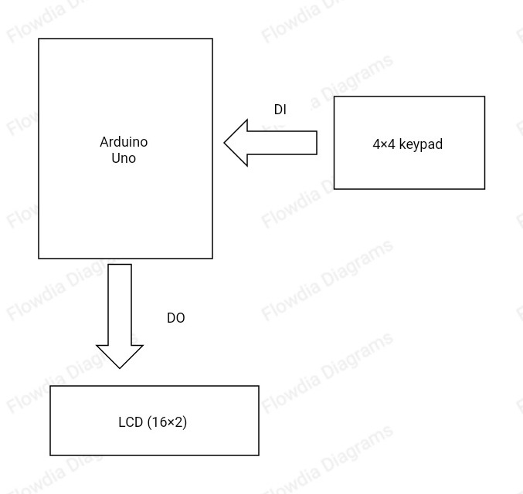

Input and output table:-

|  |  |  |  |  |
| --- | --- | --- | --- | --- |
| SN. No | Description | Name | Type | Specification |
| 1. | Keypad(4×4) |  | DI |  |
|  | OUTPUT |  |  |  |
| 1. | LCD display |  | DO |  |

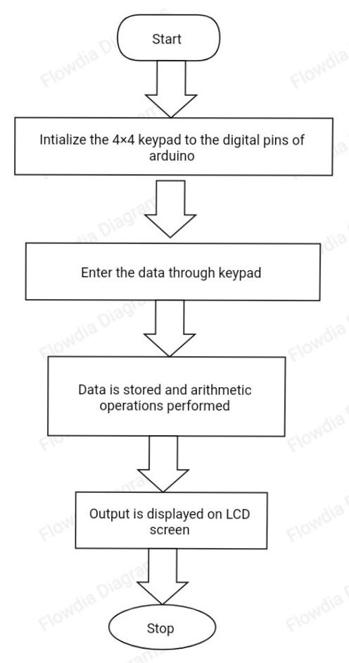Flow chart :-