TASK – 1

Stage 1: Reconnaissance – Information Gathering  
  
Reconnaissance is the first phase of the ethical hacking lifecycle. In this stage, I focused on gathering publicly available information about a target using open-source intelligence (OSINT) tools and techniques.  
  
Steps Followed:  
  
Step 1: Identified the Target Website or Domain  
- Selected a website or IP address to gather details about.

Step 1: Collected IP Address Information  
- Used tools like nslookup, ipinfo.io, and grabify.link to extract the IP and its location details.

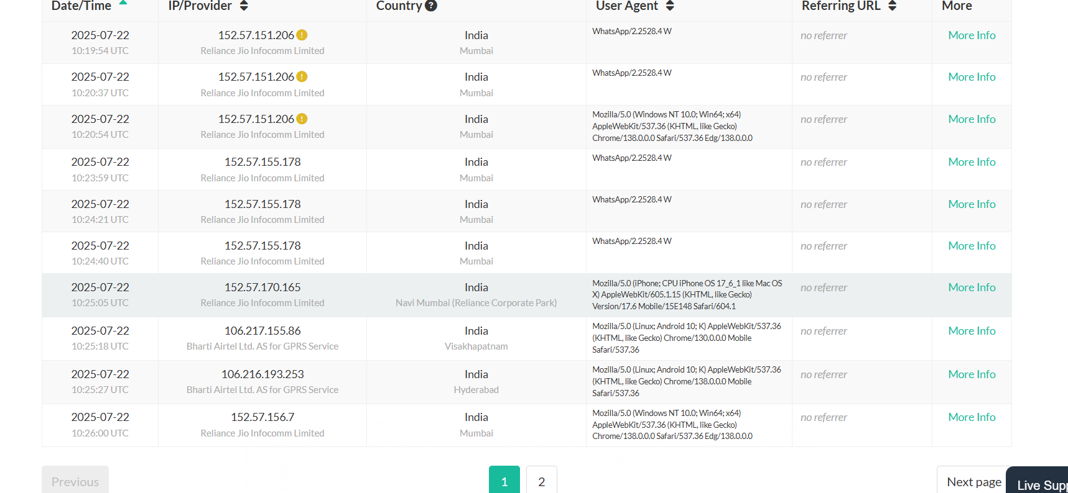

2 : Gathering Information by using image

Step -1 : Open google.com

Step -2 : click on google lens and upload an image which is need to search for .

Step - 3: we will get our information.

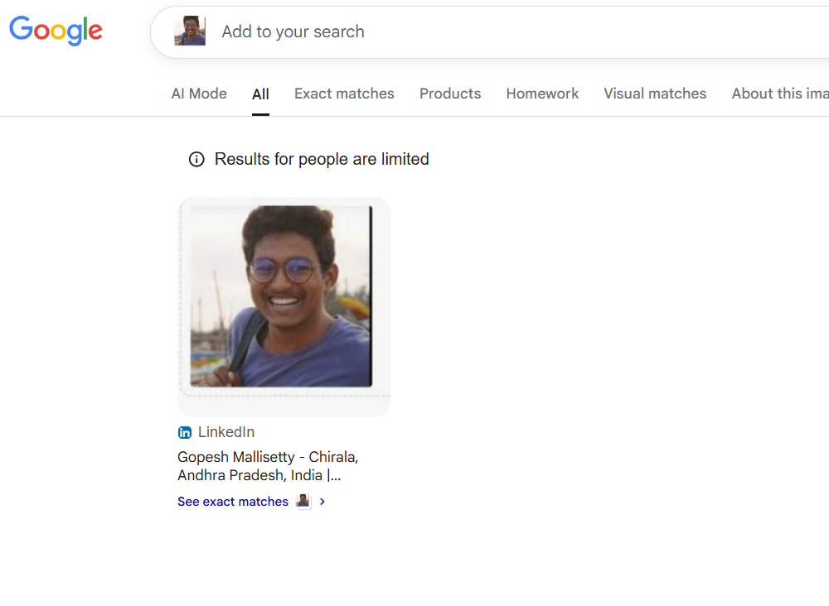

3: Gathering information by searching mobile number through google

Step-1: Open google.com

Step-2: search the number in google.

Step-3: you will get an information where that number is registered on any sites



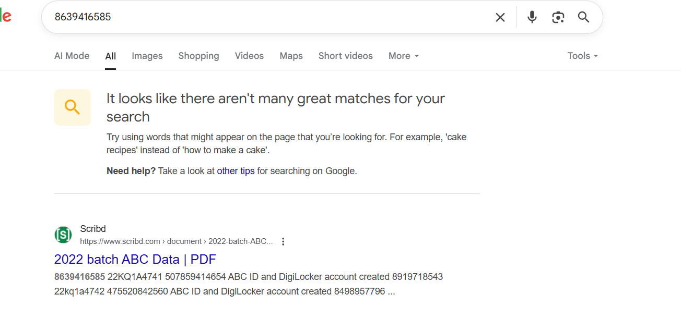

4. Gathering Information based on searching with name on google.

Step-1: Open google.com

Step-2: Search the name that you need to collect information

Step-3: you will get that personal details

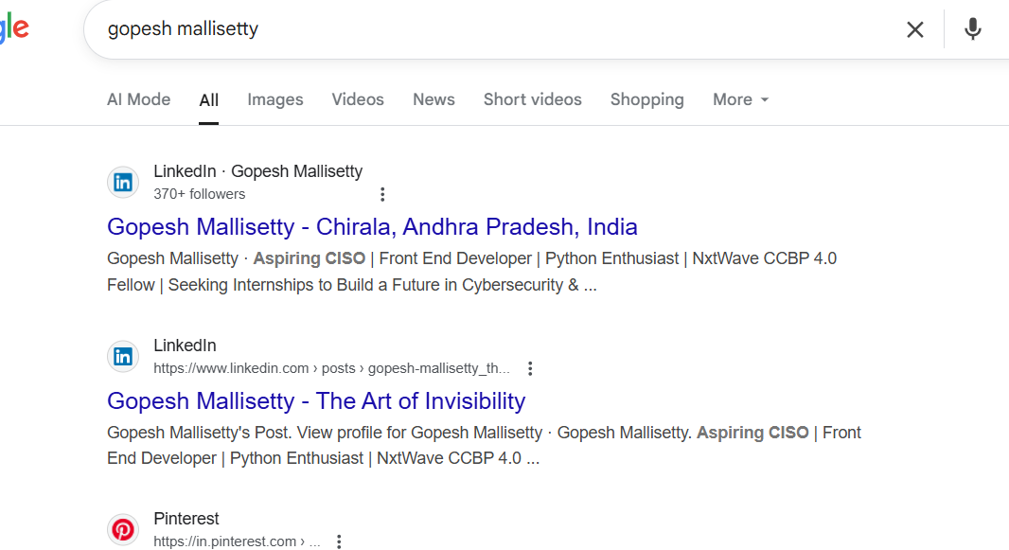

5. Gathering Information by their Aadhar number

Step-1: Go for google.com

Step -2: Search the Aadhar number on google.

Step-3: you will get their information based on their details.

