Task-2

1. Gathering Website detail like IP addresses ,created date, updated date ….register name etc.

Step-1:Go for google and search for the website called DomainTools.com or WhoIs.com

Step-2: Enter the Website name correctly that you want to know.

Step-3: then you will get all the details of a website.

Ex1.Ecap.pace.ac.in

IP address: 118.139.176.32

IP Location: Singapore - Central Singapore - Singapore - Virtual Private Hosting Service

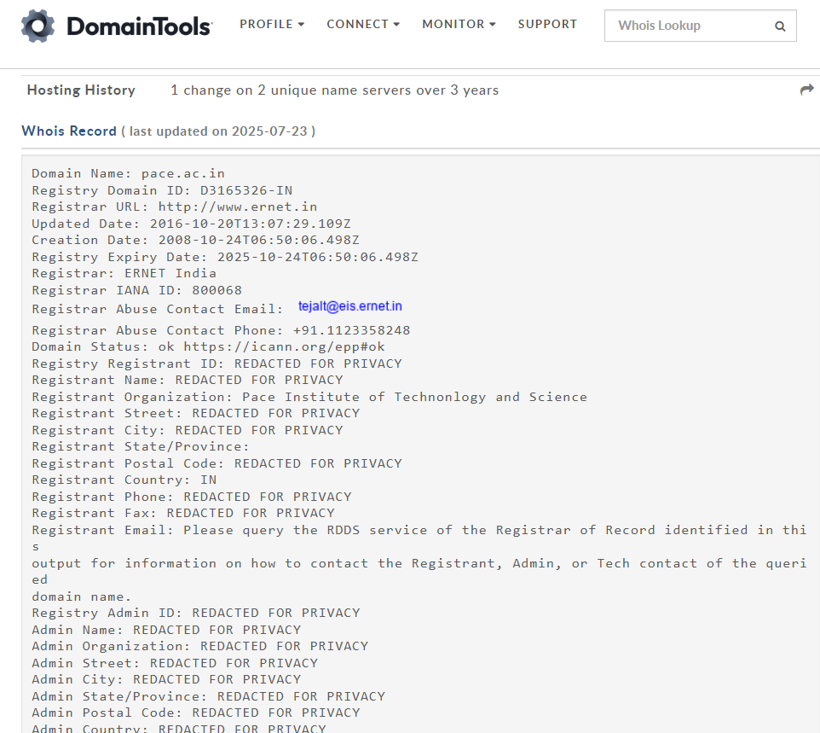

Ex2: Google.com

IP Address 142.250.217.99 - 128 other sites hosted on this server

IP Location United States - Washington - Seattle – Google

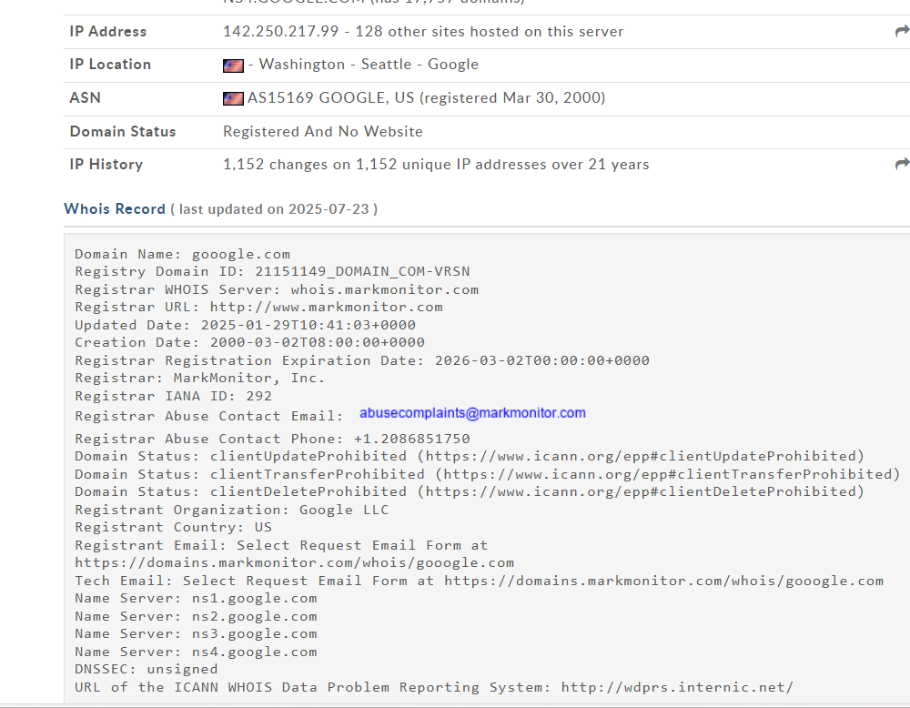

Ex-3: w3schools.com

IP Address 23.213.34.170 - 49 other sites hosted on this server

IP Location United States - Washington - Seattle - Akamai Technologies Inc.

