1. Wikipedia.com
2. Search the website "Wikipedia.com" and click the Wappalyzer icon from the Chrome toolbar.
3. Setup the Wappalyzer extension on Chrome.
4. Note the frameworks, security tools, analytics, and other technologies used by the website.
5. Observe the site’s technology stack using the Wappalyzer dropdown.

Security: HSTS

Web servers: Apache Traffic, server

Miscellaneous: Open graph



1. Manmatters.com
2. Step-2: Search the website "Manmatters.com" and click the Wappalyzer icon from the Chrome toolbar.
3. Step-1: Setup the Wappalyzer extension on Chrome.
4. Step-4: Note the frameworks, security tools, analytics, and other technologies used by the website.
5. Step-3: Observe the site’s technology stack using the Wappalyzer dropdown.

Security: HSTS

Web servers: Apache Traffic, server

Miscellaneous: Open graph

1. 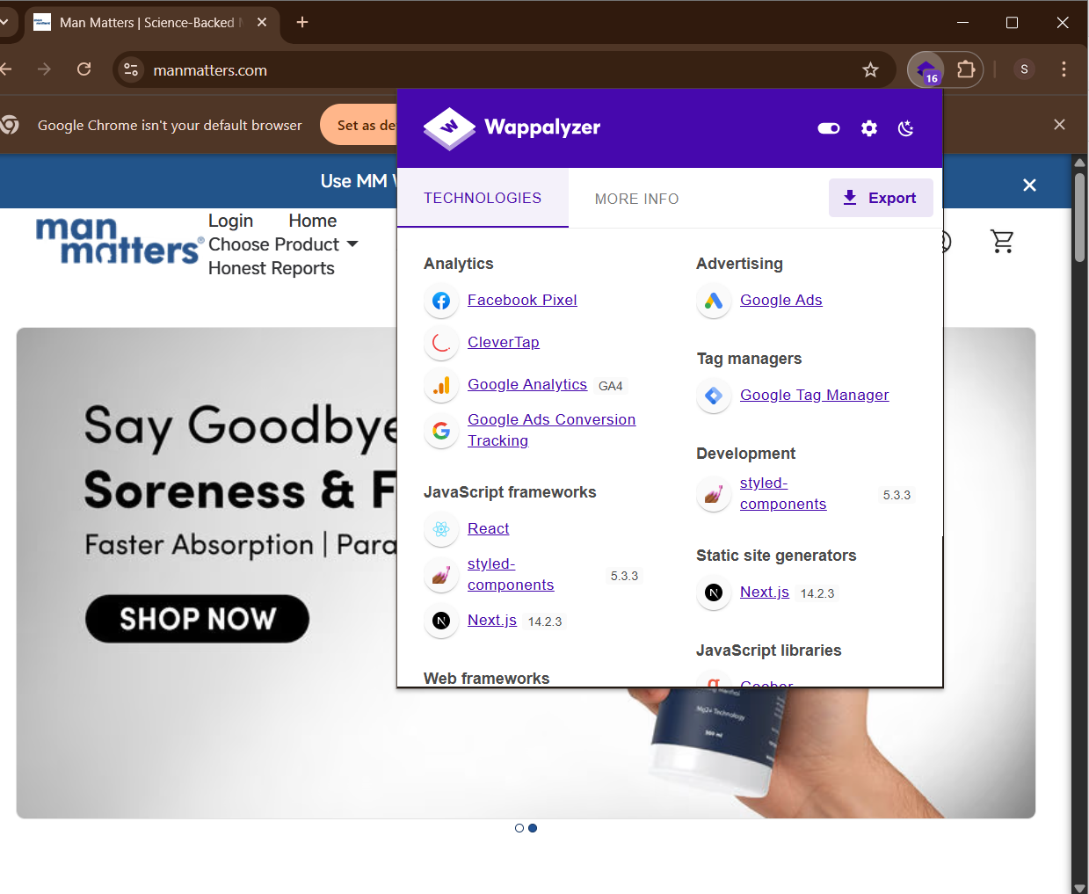

Samsung.com

Step-2: Search the website "Samsung.com" and click the Wappalyzer icon from the Chrome toolbar.

Step-1: Setup the Wappalyzer extension on Chrome.

Step-4: Note the frameworks, security tools, analytics, and other technologies used by the website.

Step-3: Observe the site’s technology stack using the Wappalyzer dropdown.

Analytics: facebook pixels, clever tap,

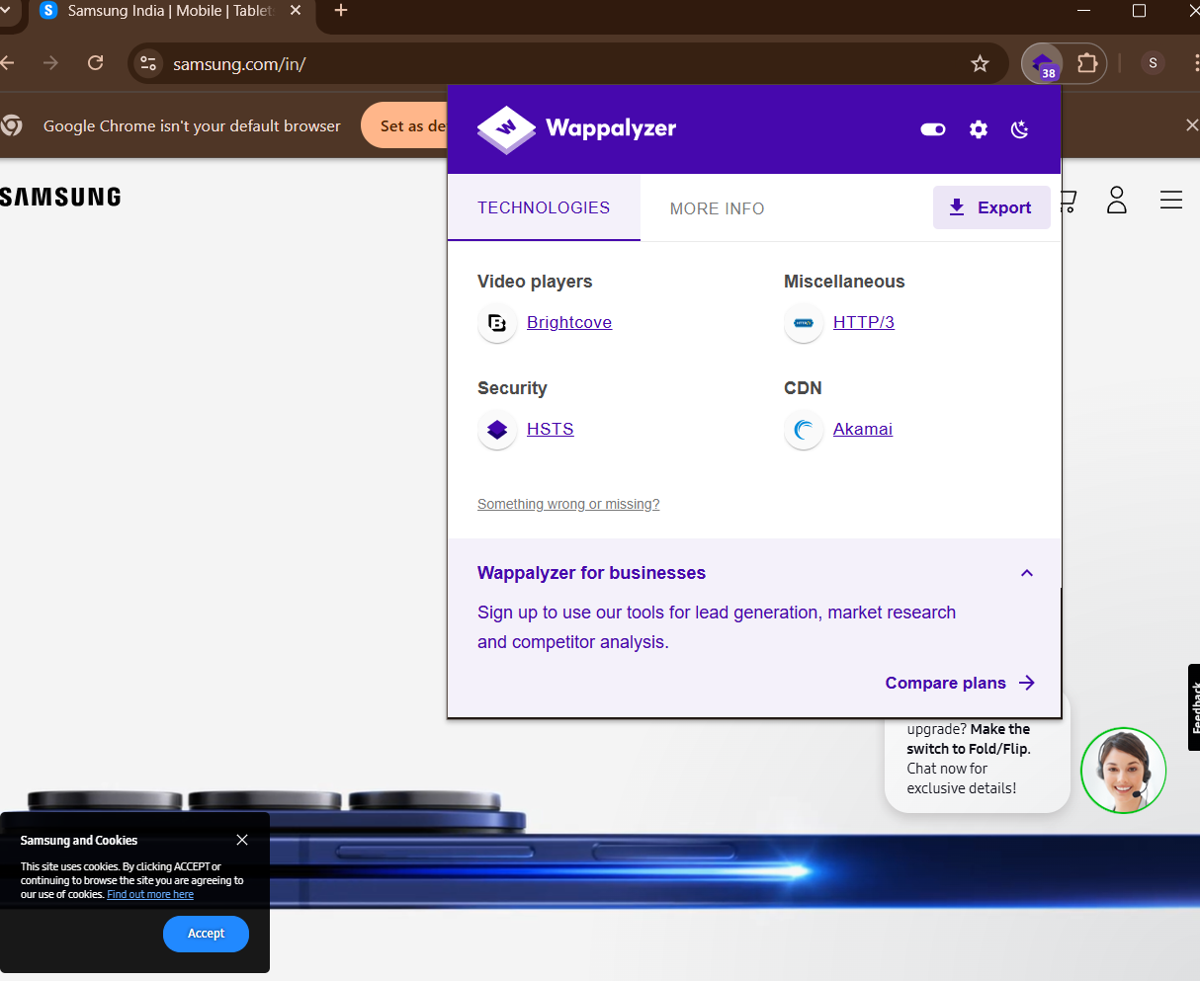

4.puma.com

Step-2: Search the website "4.puma.com" and click the Wappalyzer icon from the Chrome toolbar.

Step-1: Setup the Wappalyzer extension on Chrome.

Step-4: Note the frameworks, security tools, analytics, and other technologies used by the website.

Step-3: Observe the site’s technology stack using the Wappalyzer dropdown.



1. Wrogn.com
2. Step-2: Search the website "Wrogn.com" and click the Wappalyzer icon from the Chrome toolbar.
3. Step-1: Setup the Wappalyzer extension on Chrome.
4. Step-4: Note the frameworks, security tools, analytics, and other technologies used by the website.
5. Step-3: Observe the site’s technology stack using the Wappalyzer dropdown.

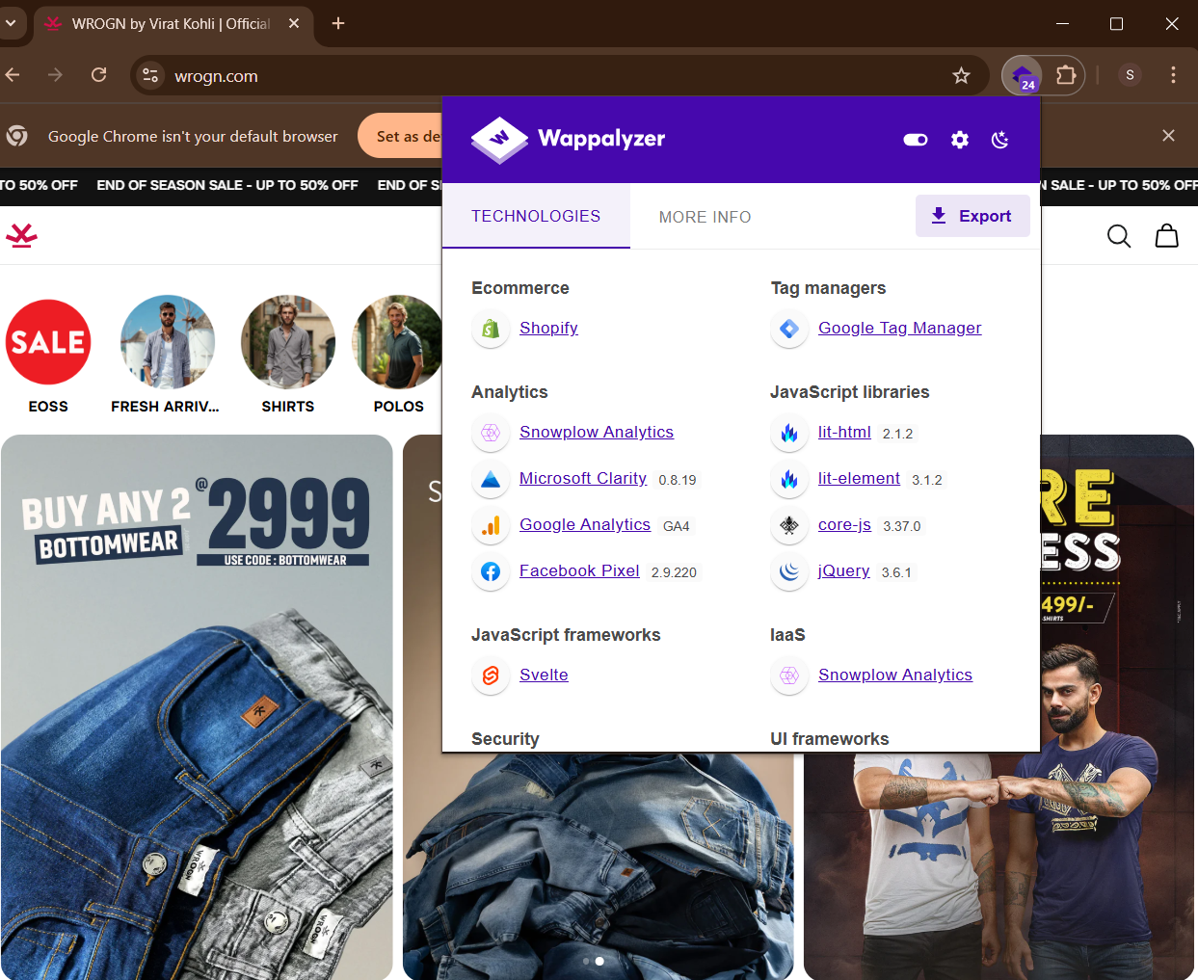

1. Lenovo.com
2. Step-2: Search the website "Lenovo.com" and click the Wappalyzer icon from the Chrome toolbar.
3. Step-1: Setup the Wappalyzer extension on Chrome.
4. Step-4: Note the frameworks, security tools, analytics, and other technologies used by the website.
5. Step-3: Observe the site’s technology stack using the Wappalyzer dropdown.



7.myntra.com

Step-2: Search the website "7.myntra.com" and click the Wappalyzer icon from the Chrome toolbar.

Step-1: Setup the Wappalyzer extension on Chrome.

Step-4: Note the frameworks, security tools, analytics, and other technologies used by the website.

Step-3: Observe the site’s technology stack using the Wappalyzer dropdown.

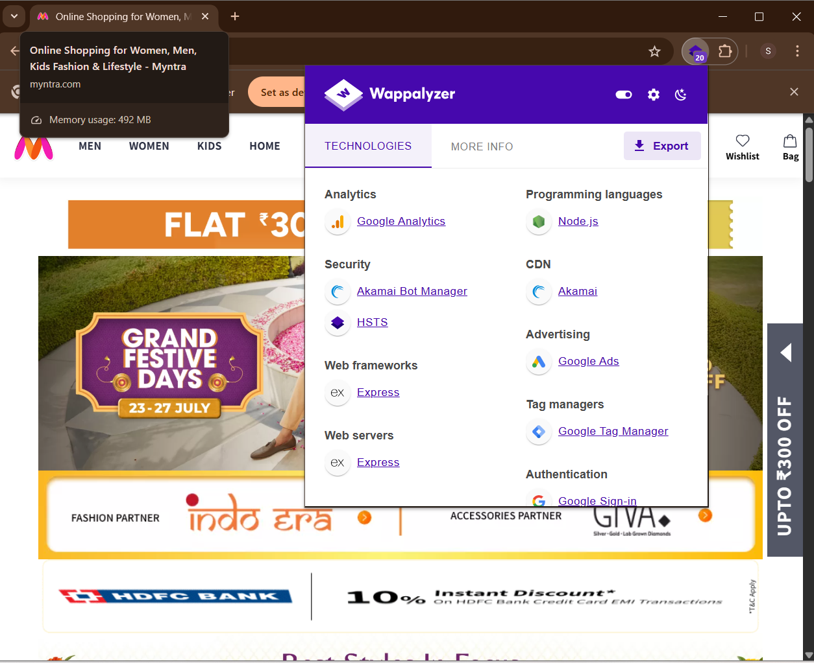

8.redbus.com

9. bookmyshow.com

Step-2: Search the website "8.redbus.com" and click the Wappalyzer icon from the Chrome toolbar.

Step-1: Setup the Wappalyzer extension on Chrome.

Step-4: Note the frameworks, security tools, analytics, and other technologies used by the website.

Step-3: Observe the site’s technology stack using the Wappalyzer dropdown.



Step-2: Search the website "9. bookmyshow.com" and click the Wappalyzer icon from the Chrome toolbar.

Step-1: Setup the Wappalyzer extension on Chrome.

\*\*Steps to Analyze Wikipedia.com using Wappalyzer

Step-4: Note the frameworks, security tools, analytics, and other technologies used by the website.

Step-3: Observe the site’s technology stack using the Wappalyzer dropdown.

