Task-5

=========

Installed Kali Linux on VirtualBox for safe and isolated testing

• Explored Kali’s role in the **Reconnaissance phase** of hacking

• Learned how to upgrade the system and activate admin/root access

• Installed tools using: `git clone <tool-url>`

• Listed installed tools using: `ls`

• Removed tools using: `rm -rf <tool_name>`

• Navigated folders using: `cd`, `../`, and other directory commands

1. Downloading sherlock

git clone <https://github.com/sherlock-project/sherlock.git>

1. Install it by clicking “Y”.
2. Then you can gather information where the are logged in websites.
3. We use command for searching “sherlock sivanagajyothi”
4. 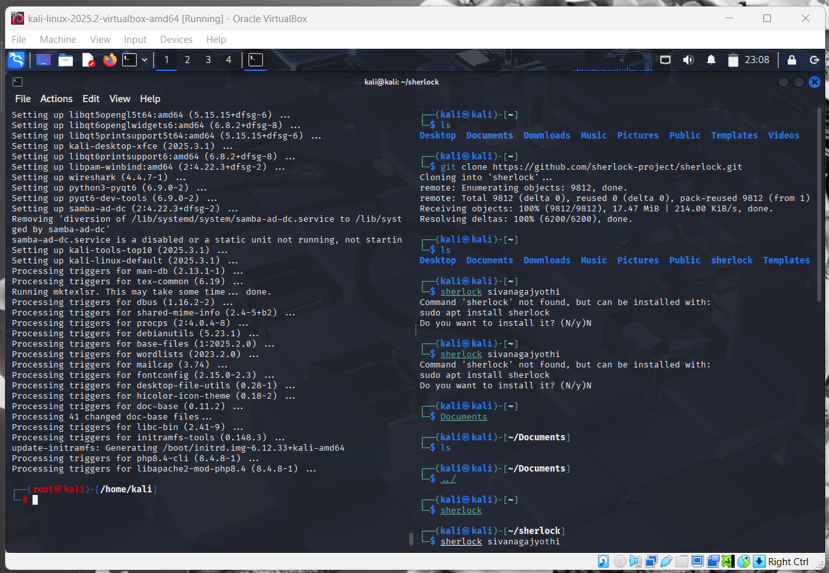
5. A screenshot of a computer

   AI-generated content may be incorrect.