Mission: Make Pizza AI-Ready

Project Overview :
This project demonstrates how a traditional OpenAPI-based pizza ordering system can be made AI-ready so that it can be consumed by AI agents instead of only human users.

Problem Statement :
AI agents such as ChatGPT and Copilot are becoming the new interface layer. Traditional applications are not designed for AI agents. The goal is to make pizza APIs discoverable and usable by AI agents using MCP-style, tool-driven APIs.

Solution Architecture :
User / AI Agent → AI-Ready API → Order Processing → Structured Response → Agent Coordination
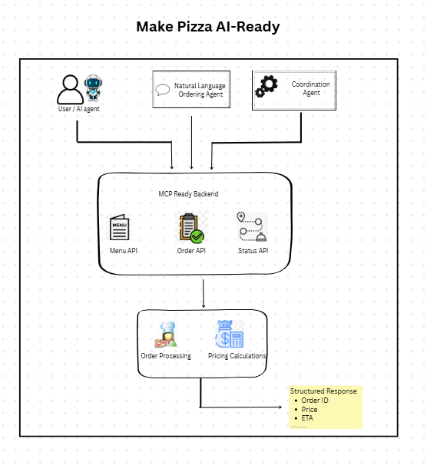
Core Components :
- server.py: AI-ready backend using FastAPI
- ordering_agent.py: Handles natural language pizza ordering
- scheduling_agent.py: Demonstrates agent-to-agent coordination(A2A)
- app.py: Streamlit UI for demo purposes

Pricing Logic :
Pricing is calculated on the backend using size-based multipliers.
Final Price = Base Price × Size Multiplier
Setup Instructions :
1. Install dependencies
2. Run backend server
3. Run UI
Conclusion :
This project focuses on AI-agent compatibility, clean architecture, and protocol-driven design rather than complex backend systems.

