Ability to Add/Edit Suppliers

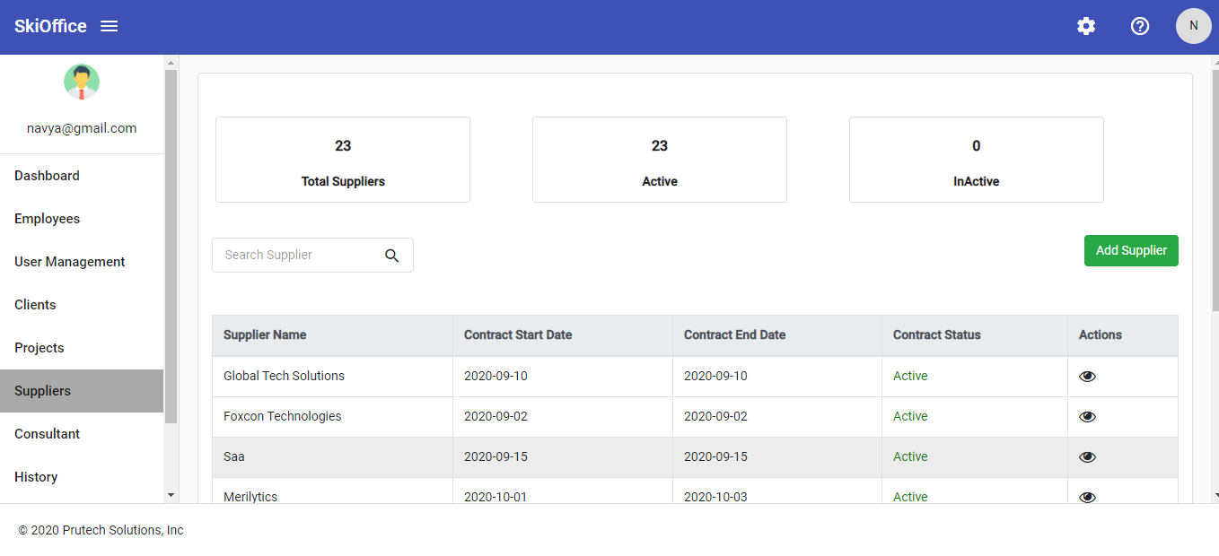

Add Supplier

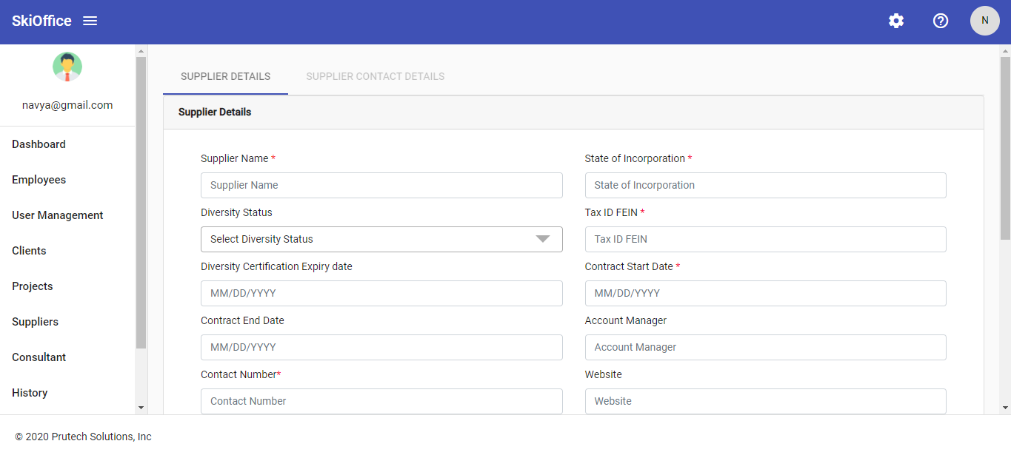

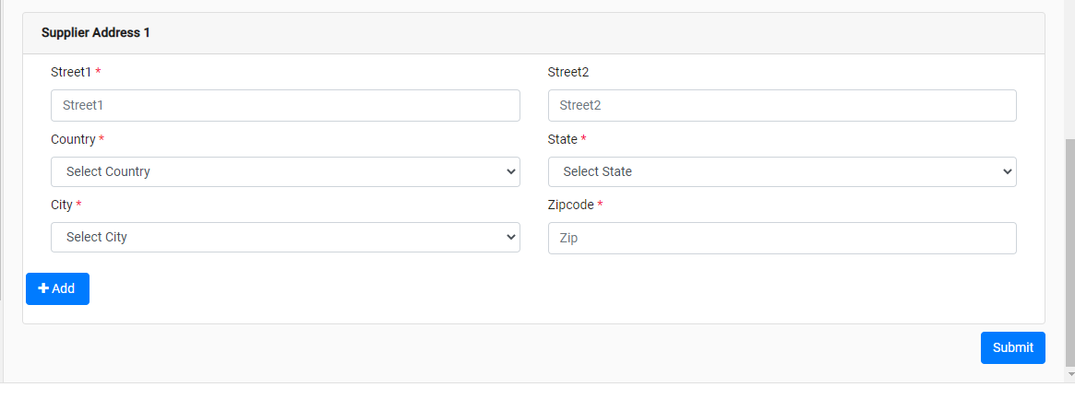

General Information

|  |  |
| --- | --- |
| **Summary:** | Ability to add and edit Suppliers |
| **Description**: | As a user we need to have an option to add and edit Suppliers as this information is used to have a detail view of contact details |
| **Users:** | Who have privilege to Add, Edit , and view Suppliers . |
| **Pre-condition**: | All the privilege regarding Suppliers need to be assigned in User management. |
| **Post condition:** | User need to view new Added/Edited Supplier |

Data Elements

|  |  |  |  |  |  |
| --- | --- | --- | --- | --- | --- |
| 3 | Contact Type | Dropdown | Mandatory |  | Please Choose a Contact Type |
| 4 | Contact Title | Text | Mandatory |  | Please Enter Contact Title |
| 5 | Email | Text | Mandatory |  | Please Enter Email |
| 6 | Contact Number | Text | Mandatory |  | Please Enter Contact Number |
| 7 | Save | Button |  | Button |  |
| 8 | Close | Button |  | Button |  |