PROFIT PREDICTION USING LINEAR REGRESSION ANALYSIS

1. Introduction
In today's competitive business environment, organizations need to understand how their investments influence profitability. Data analytics enables businesses to make informed decisions by analyzing historical data and identifying patterns that affect financial performance.
This project focuses on studying the relationship between three major expenditure categories, namely R&D Spend, Administration, and Marketing Spend, and their effect on the company's Profit. Multiple Linear Regression is used to build a predictive model that estimates future profits based on these factors. Furthermore, Power BI is used to create visualizations and derive meaningful business insights.

2. Problem Statement
The objective of this project is to determine how the company's expenditures on Research and Development, Administration, and Marketing influence profit generation.
The project aims to:
- Analyze the relationship between expenditures and profit.
- Identify the factors that contribute most significantly to profit.
- Build a regression model for profit prediction.
- Visualize the data using Power BI.
- Provide recommendations to improve profitability.

3. Objectives of the Study
The major objectives of this study are:
- To retrieve data from the database.
- To understand the characteristics of the dataset.
- To perform regression analysis using multiple independent variables.
- To predict profit values for new input data.
- To derive business insights from the visualizations.
- To provide recommendations based on analytical findings.

4. Dataset Description
The dataset consists of four variables:

4.1 R&D Spend
- Represents the amount invested in research and development activities. Investments in R&D generally contribute to innovation and business growth.

4.2 Administration
- Represents operational and administrative expenses incurred by the company. These expenses include management costs, office expenses, and other overhead costs.

4.3 Marketing Spend
- Represents the expenditure made on advertising and promotional activities to increase sales and brand awareness.

4.4 Profit
- Represents the overall earnings generated by the company after accounting for expenditures.

5. Data Source Confirmation
The dataset used in this project was obtained from the database using the provided credentials.
Source Type
Database
Features Used
- R&D Spend
- Administration
- Marketing Spend
- Profit
The retrieved data was further analyzed using Python and visualized using Power BI.

6. Multiple Linear Regression
Multiple Linear Regression is a statistical technique used to predict the value of a dependent variable based on multiple independent variables.
In this project:
Dependent Variable
Profit
Independent Variables
- R&D Spend
- Administration
- Marketing Spend
The regression model establishes the relationship between these variables and predicts future profit values.

7. Mathematical Model
The equation of Multiple Linear Regression is:
Profit = β₀ + β₁(R&D Spend) + β₂(Administration) + β₃(Marketing Spend) + ε
Where:
- β₀ = Intercept
- β₁ = Coefficient for R&D Sp end
- β₂ = Coefficient for Administration
- β₃ = Coefficient for Marketing Spend
- ε = Error term
The coefficients determine the contribution of each independent variable towards profit prediction.

8. Methodology
The methodology followed in this project consists of the following steps:
Step 1: Data Collection
Data was retrieved from the database.
Step 2: Data Preprocessing
Missing values and inconsistencies were checked to ensure data quality.
Step 3: Feature Selection
Three variables were selected as predictors:
- R&D Spend
- Administration
- Marketing Spend
Step 4: Model Building
A Multiple Linear Regression model was developed using Python.
Step 5: Prediction
The model was used to estimate profit for new values of expenditures.
Step 6: Visualization
Power BI was used to create dashboards and charts for analysis.
Step 7: Interpretation
Insights and recommendations were generated based on the results.

9. Power BI Visualization
Several visualizations were created to understand the relationship between expenditures and profit.
Scatter Plot: R&D Spend vs Profit
This visualization shows a strong positive relationship between R&D investment and company profit.
Clustered Column Chart
The chart compares the values of R&D Spend, Administration, Marketing Spend, and Profit.
KPI Cards
KPI cards display:
- Average R&D Spend
- Average Administration Cost
- Average Marketing Spend
- Average Profit
These visuals help management understand the company's expenditure pattern and profitability.

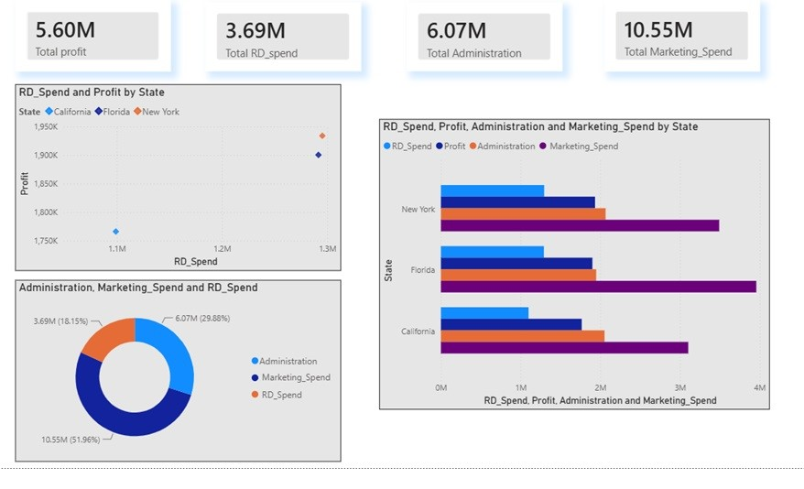
10. Regression Analysis Results
Regression analysis helps identify which variable has the greatest impact on profit.
The model predicts profit based on expenditure patterns and establishes relationships between the variables.
Generally, the analysis indicates that:
- R&D Spend has the strongest influence on profit.
- Marketing Spend contributes positively to profit.
- Administration expenses have comparatively lower impact.
The regression model can also be used for future forecasting and business planning.

11. Insights Derived from the Analysis
Several important insights were obtained:
Insight 1
Higher investments in Research and Development tend to increase profit significantly.
Insight 2
Marketing expenditure contributes to business growth and revenue generation.
Insight 3
Administration costs have limited impact on profitability and should be monitored carefully.
Insight 4
Balanced allocation of resources leads to better financial performance.
Insight 5
Data-driven decisions can improve operational efficiency and maximize returns.

