TASK 1
Create a program that can encrypt and decrypt text using the Caesar Cipher algorithm. Allow users to input a message and a shift value to perform encryption and decryption.

Code :

import tkinter as tk
from tkinter import messagebox

def encrypt():
text = entry_text.get()
shift = int(entry_shift.get())
result = ""

for char in text:
if char.isalpha():
if char.isupper():
result += chr((ord(char) - 65 + shift) % 26 + 65)
else:
result += chr((ord(char) - 97 + shift) % 26 + 97)
else:
result += char

output_label.config(text="Encrypted Text: " + result)

def decrypt():
text = entry_text.get()
shift = int(entry_shift.get())
result = ""

for char in text:
if char.isalpha():
if char.isupper():
result += chr((ord(char) - 65 - shift) % 26 + 65)
else:
result += chr((ord(char) - 97 - shift) % 26 + 97)
else:
result += char

output_label.config(text="Decrypted Text: " + result)

# GUI Window
root = tk.Tk()
root.title("Caesar Cipher")
root.geometry("400x300")

tk.Label(root, text="Enter Text:").pack()
entry_text = tk.Entry(root, width=40)
entry_text.pack()

tk.Label(root, text="Enter Shift Value:").pack()
entry_shift = tk.Entry(root, width=10)
entry_shift.pack()

tk.Button(root, text="Encrypt", command=encrypt).pack(pady=5)
tk.Button(root, text="Decrypt", command=decrypt).pack(pady=5)

output_label = tk.Label(root, text="")
output_label.pack(pady=10)

root.mainloop()

Output :

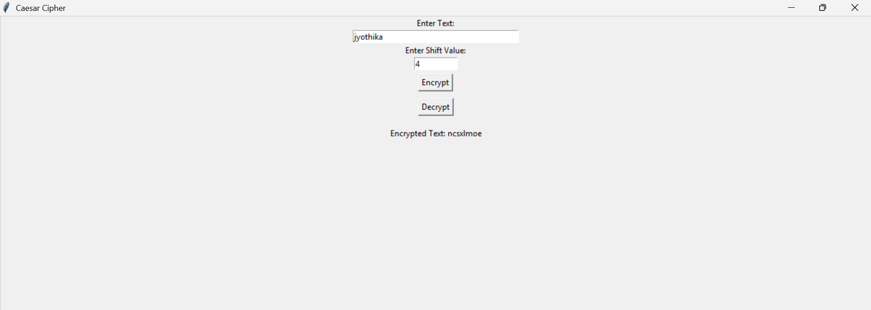

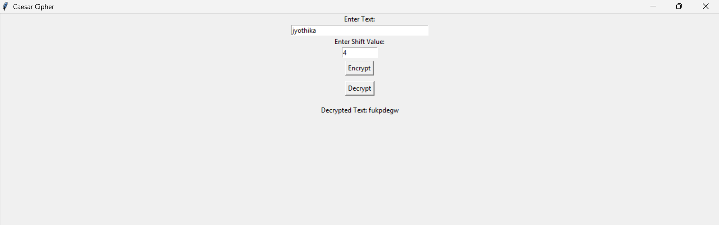

Explanation :

Python has been used to meet the requirements of the task and to complete the program.

1. Importing Library
The program uses the Tkinter library to create a graphical user interface (GUI).

2. Encrypt Function
- It takes the text and shift value entered by the user.
- It goes through each character in the text.
- If the character is a letter, it shifts it forward in the alphabet by the given shift value.
- It uses modulo 26 to wrap around the alphabet if needed.
- The encrypted result is displayed in the GUI.

3. Decrypt Function
- It also takes the text and shift value.
- Instead of shifting forward, it shifts the letters backward.
- The decrypted text is then displayed on the screen.

4. GUI Components
- A main window is created.
- Input fields are provided for text and shift value.
- Two buttons are added: one for encryption and one for decryption.
- A label is used to display the output.

5. Main Loop
The main loop keeps the window running so the user can interact with it until it is closed.

