**PROJECT: Trend.Nxt Informatica ETL Testing L1 - set 1**

**Scenario 1:**

**Source Table: SPORTS_EXPENXSTABLE**

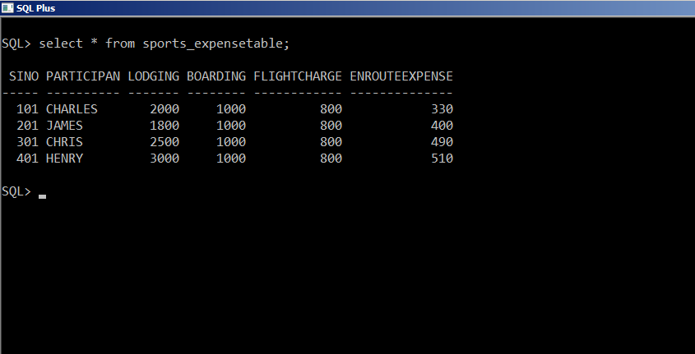 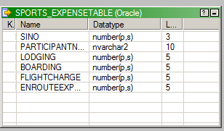

**TARGET TABLE: TARGET_EXPENSE**

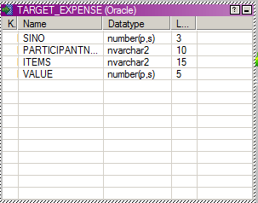

**TRANSFORMATIONS AND THEIR MAPPINGS:**

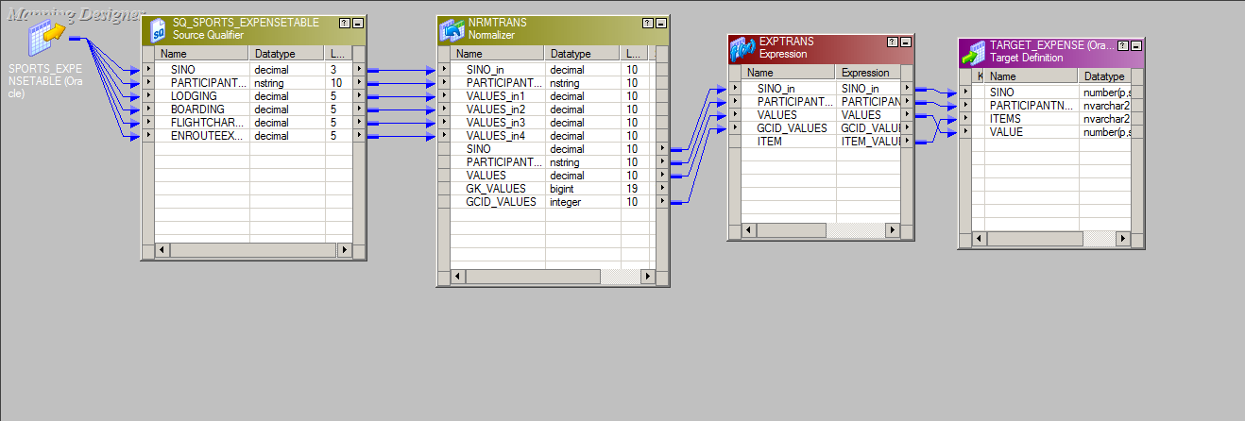

**NORMALIZER TRANSFORMATION:**

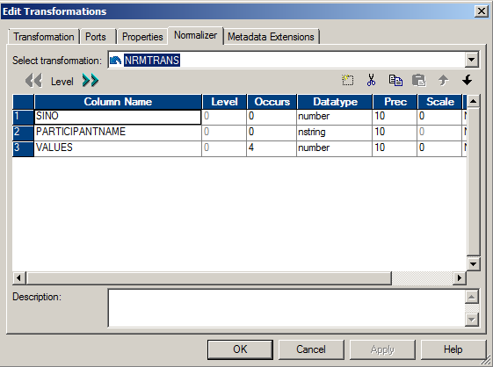

**EXPRESSION TRANSFORMATION:**

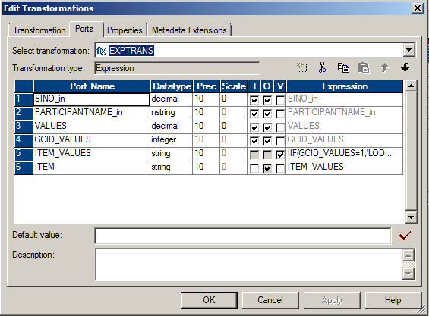

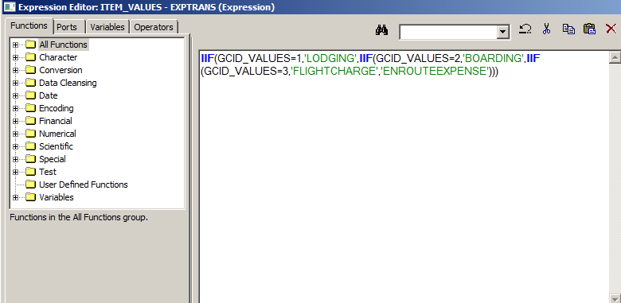

**OUTPUT:**

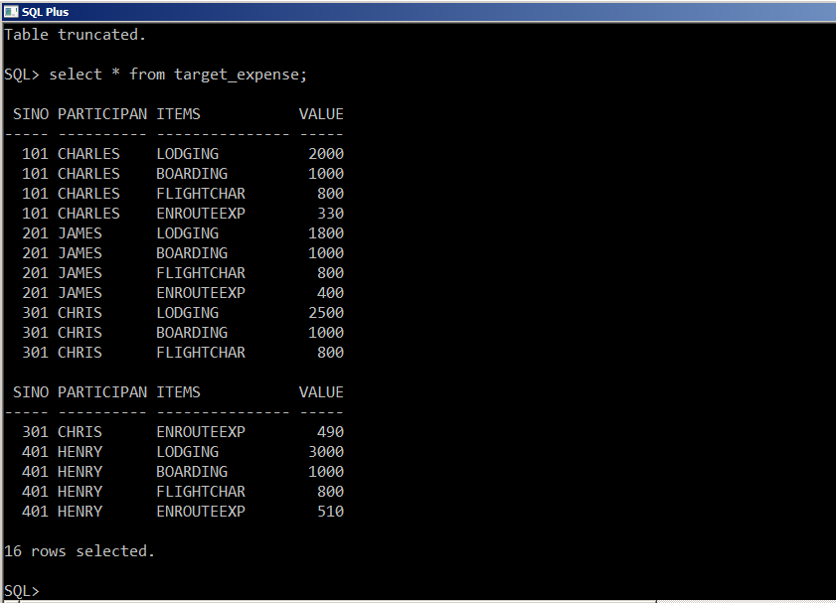

**SCENARIO 2:**

**SOURCE TABLE: WENGI**

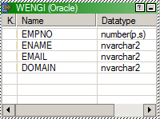

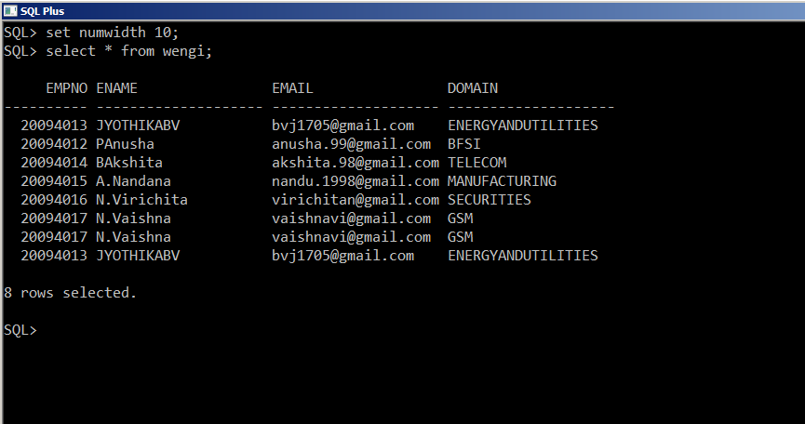

**TARGET TABLES: ENU, GSM, TELECOM, MANUFACTURING, SECURITIES, BFSI**

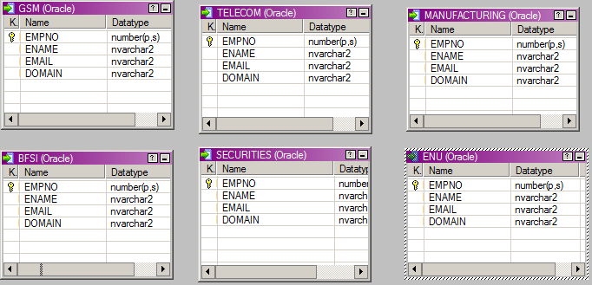

**TRANSFORMATIONS AND THEIR MAPPINGS:**

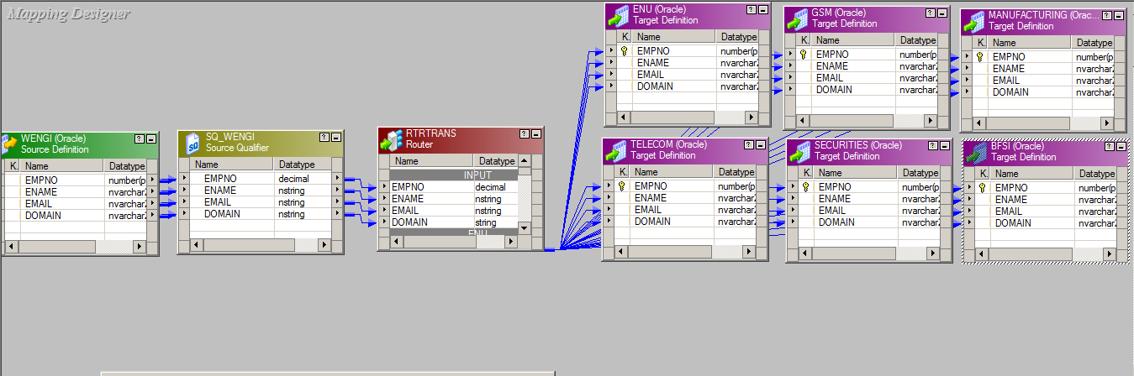

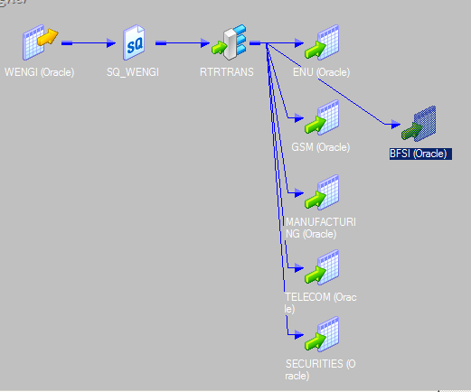

**ROUTER TRANSFORMATION:**

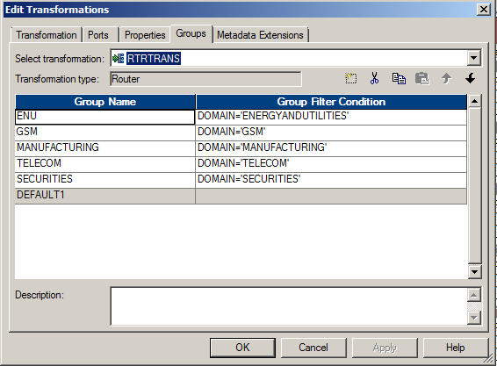 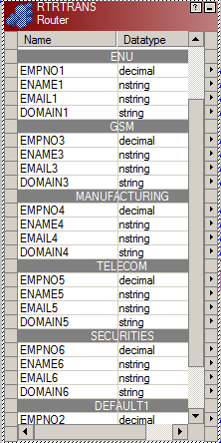

**OUTPUT:**

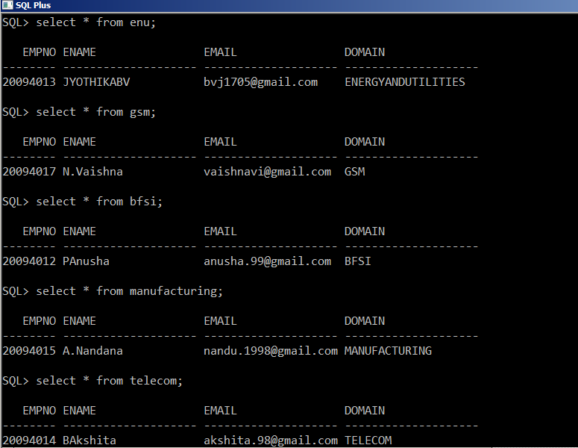

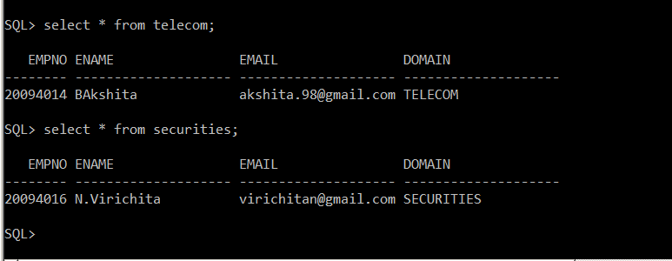

**SCENARIO 3:**

**SOURCE FILE (FLAT FILE): OSCAR FEMALE**

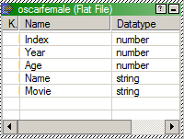

**TARGET TABLES: TABLEA, TABLEB, TABLEC**

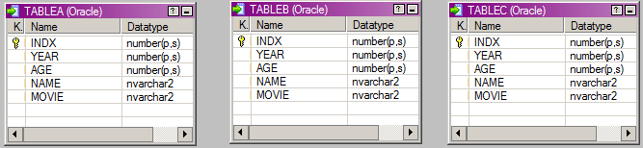

**TRANSFORMATIONS AND THEIR MAPPINGS:**

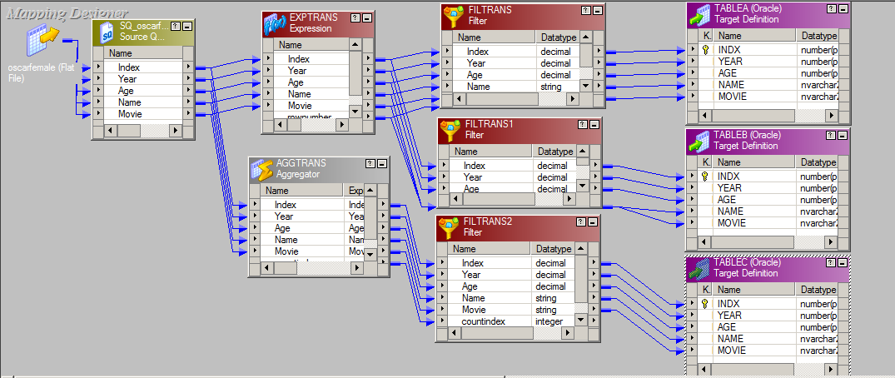

**EXPRESSION TRANSFORMATION:**

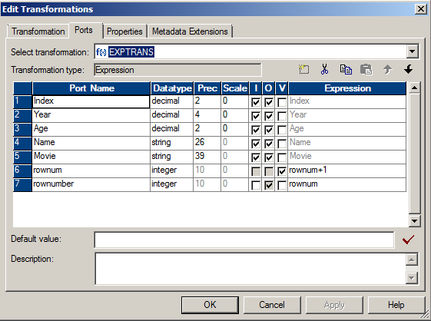

**AGGREGATOR TRANSFORMATION:**

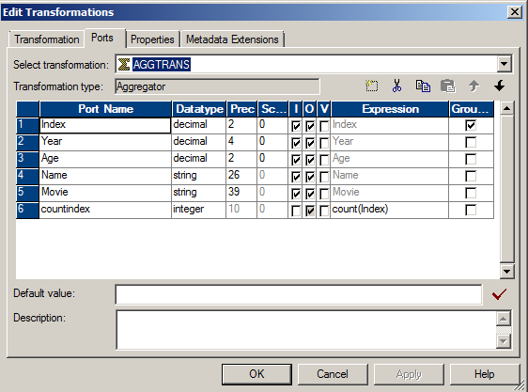

**FILTER CONDITION FOR TABLEA:**

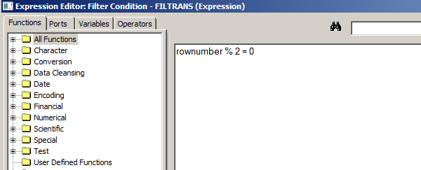

**FILTER CONDITION FOR TABLEB:**

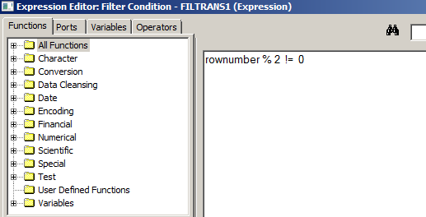

**FILTER CONDITION FOR TABLEC:**

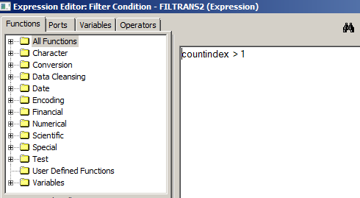

**OUTPUT OF TABLEA:**

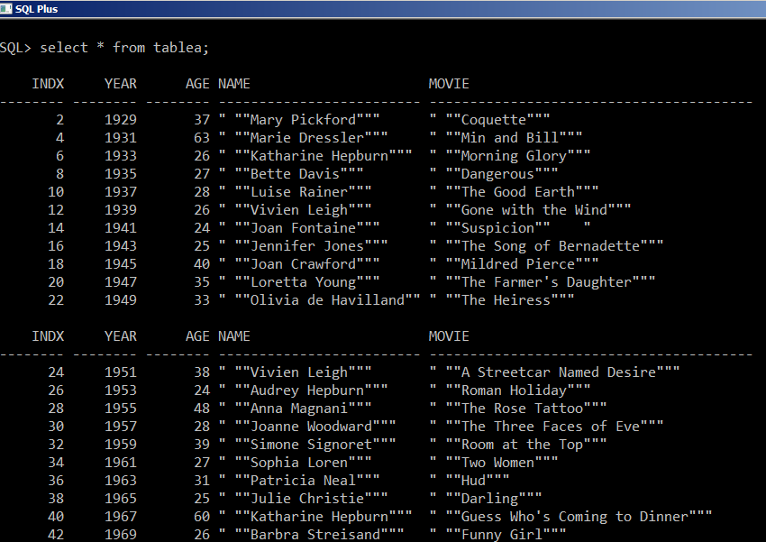

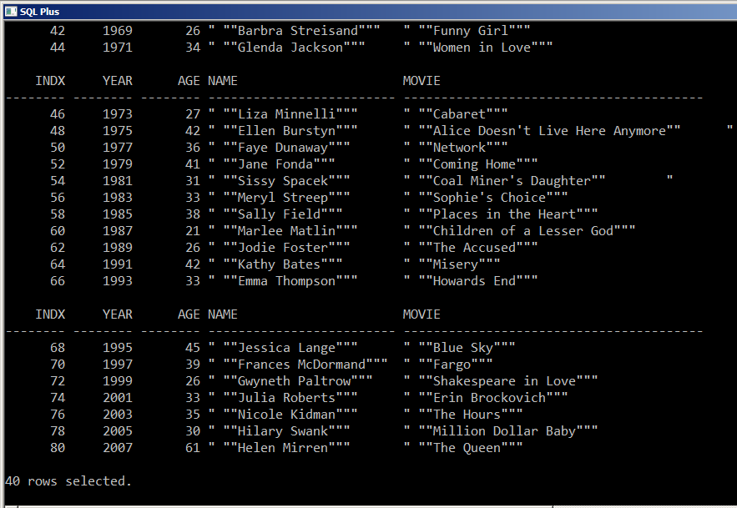

**OUTPUT OF TABLEB:**

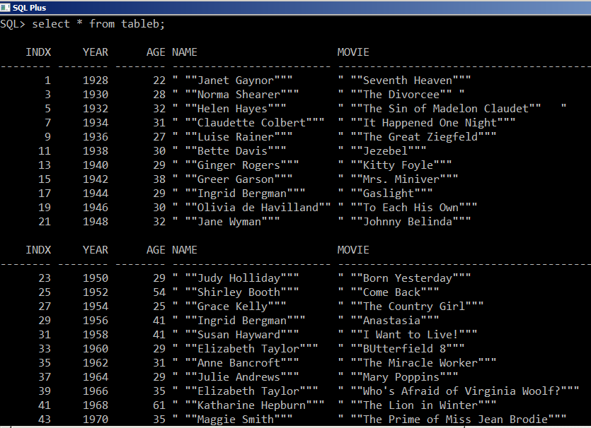

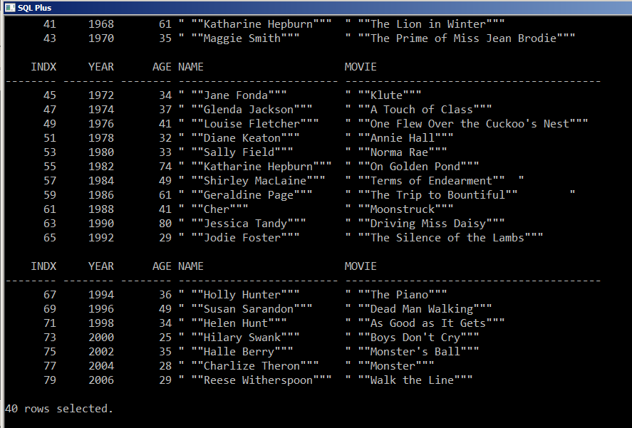

**OUTPUT OF TABLEC:**

