1) List the emps who are senior to their own manager.

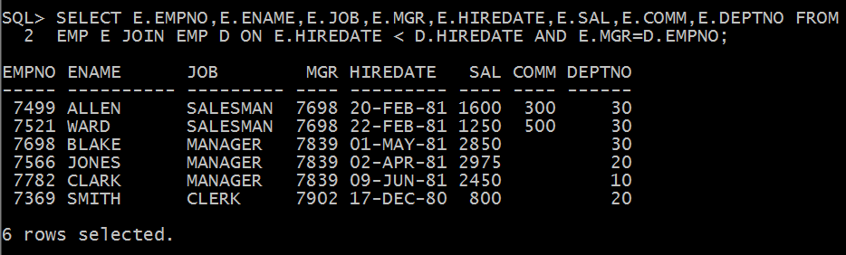

2) List the emps whose sal greater than blakes sal.

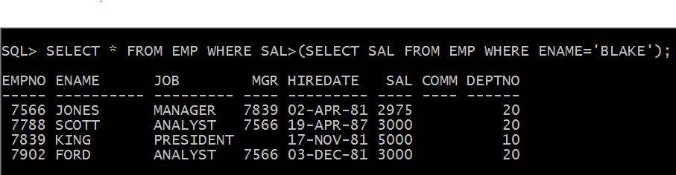

3)List the dept 10 emps whose sal>allen sal.

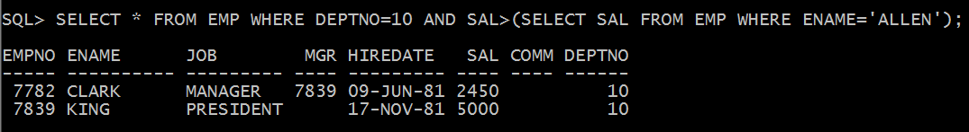

4) List the mgrs who are senior to king and who are junior to smith.

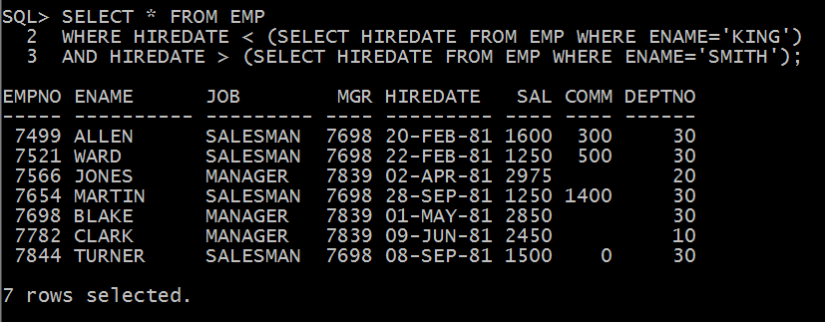

5) List the empno,ename,loc,sal,dname,loc of the all the emps belonging to king dept.

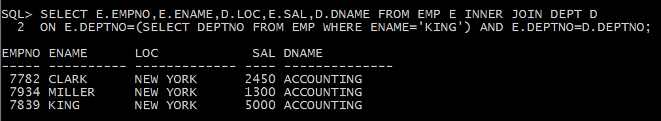

6) List the emps whose salgrade are greater than the grade of miller.

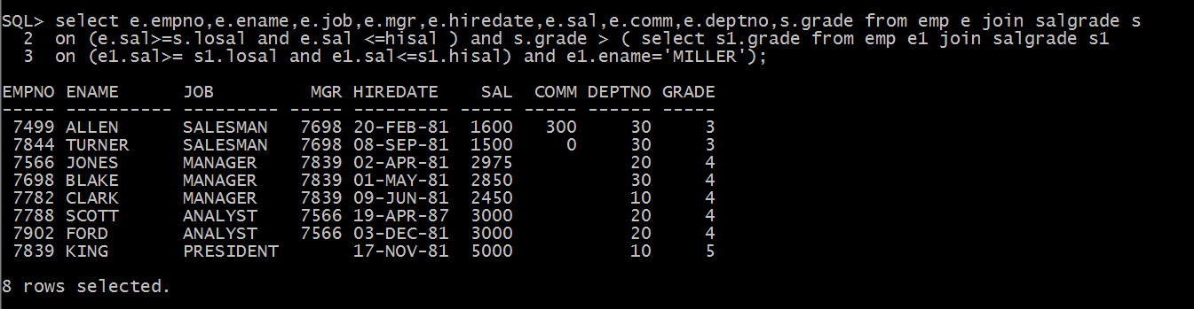

7) List the emps who are belonging dallas or Chicago with the grade same as adamsor exp more than smith.

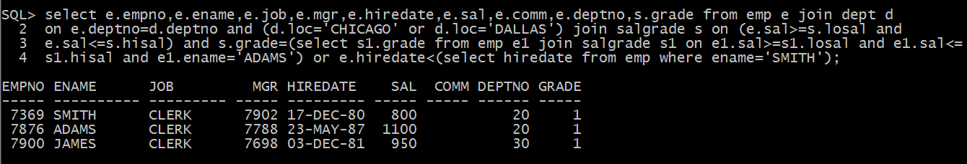

8) List the emps whose sal is same as ford or blake.

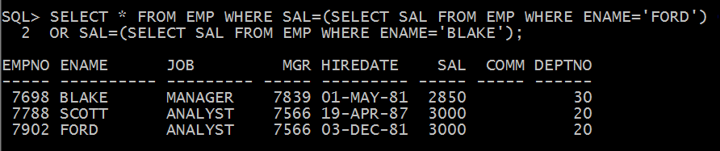

9) List the emps whose sal is same as any one of the following.

a) Sal of any clerk of emp1 table.

b) Any emp of emp2 joined before 82.

c) The total remuneration (sal+comm.) of all sales person of Sales dept belonging to emp3 table.

d) Any Grade 4 emps Sal of emp 4 table.

e) Any emp Sal of emp5 table.

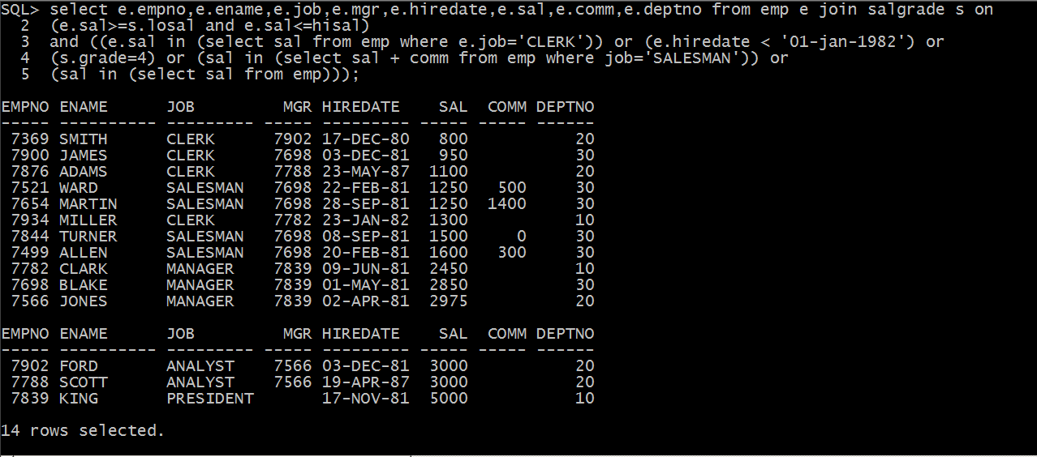

10) List the details of most recently hired emp of dept 30.

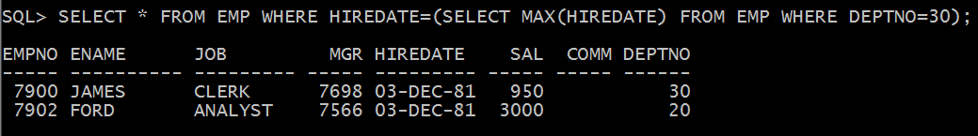

11) List the highest paid emp of Chicago joined before the most recently hired emp of grade 2.

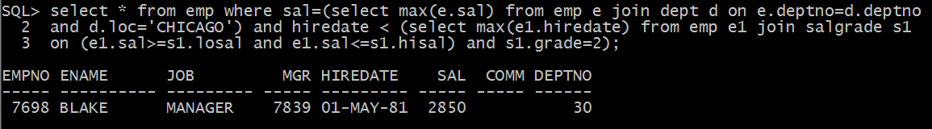

12) List the highest paid emp working under king.

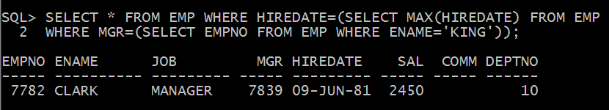

13) List the empno,ename,deptno,loc of all the emps.

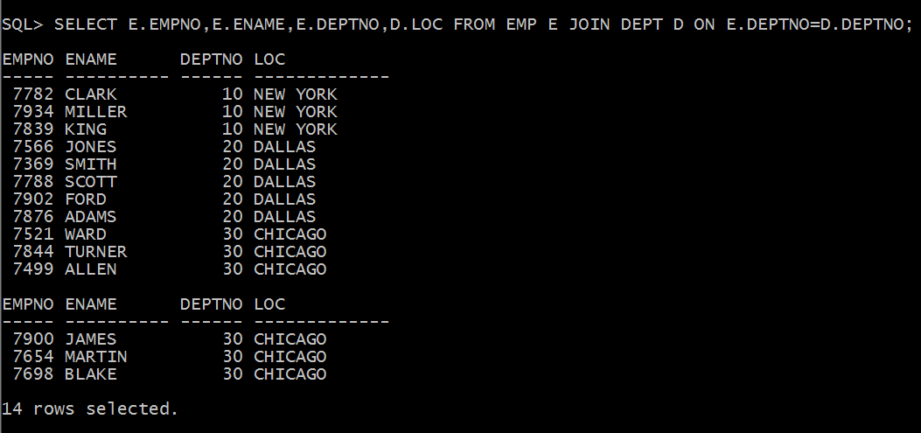

14) List the empno, ename, loc, dname of the depts.,10 and 20.

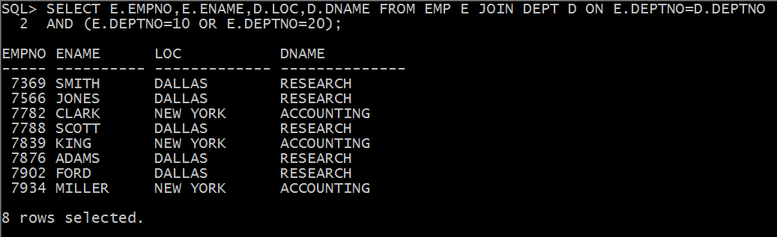

15) List the empno, ename, sal, loc of the emps working at Chicago dallas with an exp>6ys.

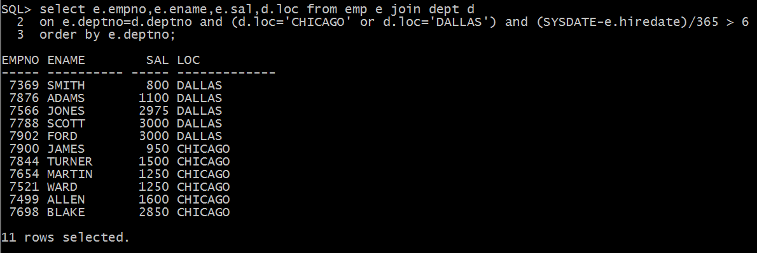

16) List the emps along with loc of those who belongs to dallas ,newyork with sal ranging from 2000 to 5000 joined in 81.

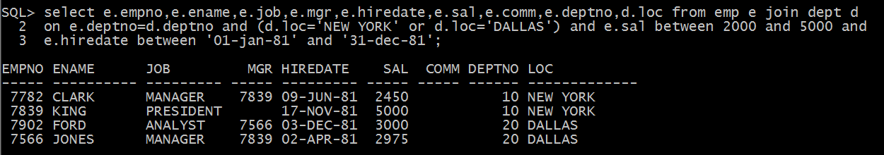

17) List the empno, ename, sal, grade of all emps

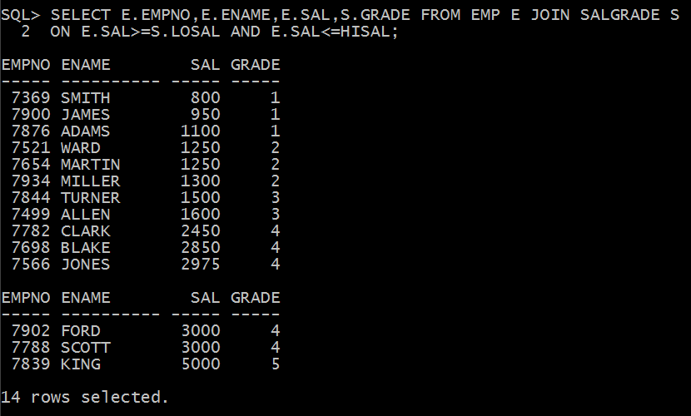

18) List the grade 2 and 3 emp of Chicago

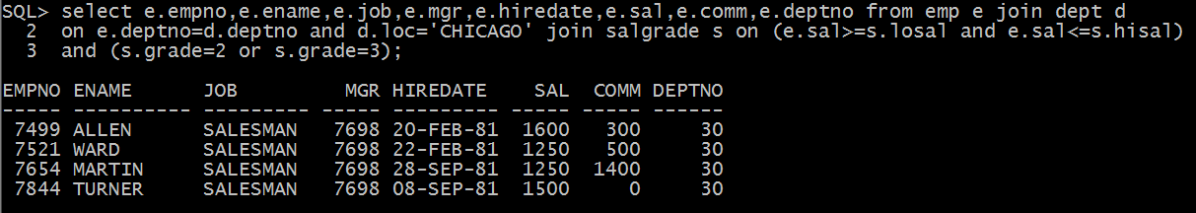

19) List the emps with loc and grade of accounting dept or the locs dallas or Chicago with the grades 3 to 5 &exp >6years.

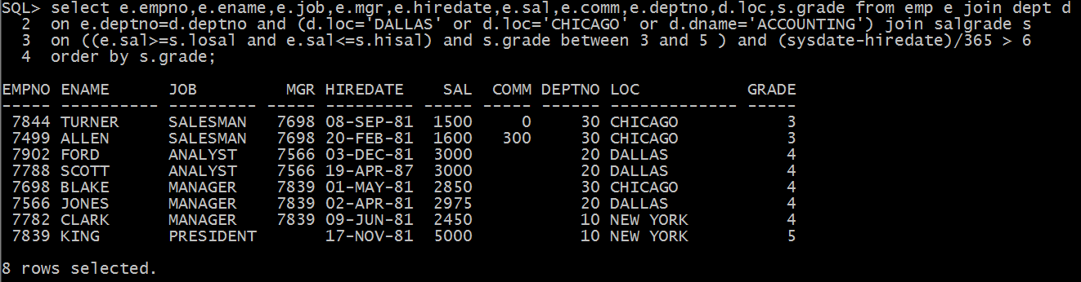

20) List the grades 3 emps of research and operations depts.. joined after 1987 and whose names should not be either miller or allen.



21) List the emps whose job is same as smith.

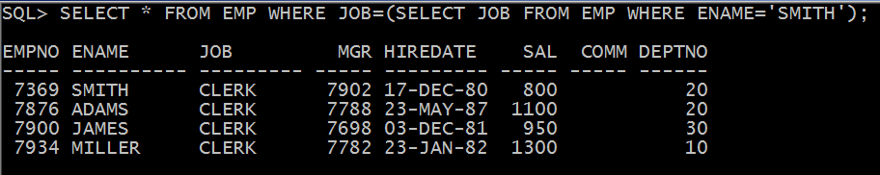

22) List the emps who are senior to miller.

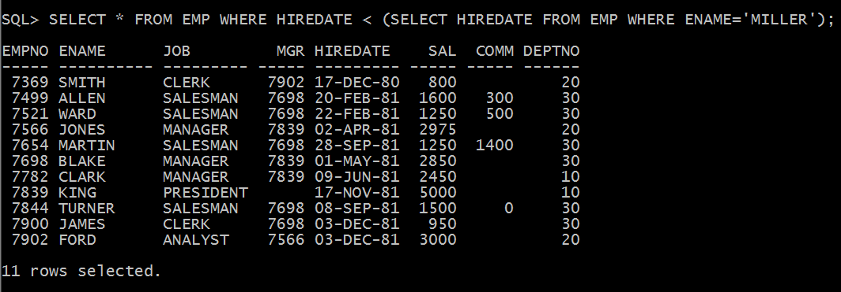

23) List the emps whose job is same as either allen or sal>allen

