6. RESULTS AND DISCUSSION
The proposed CognitivePath AI system — a web-based multimodal dyslexia screening platform — was successfully implemented and evaluated. The system integrates three interactive assessment modules: a Handwriting Canvas that captures letter-tracing stroke patterns, a Speech/Reading Task that records and analyses the user's reading of a displayed sentence, and a Memory Game that presents a 4-digit sequence for the user to recall. Each module feeds into a dedicated machine learning pipeline — CNN for handwriting, BiLSTM for speech, and Random Forest for memory — and the outputs are fused using a weighted combination to produce a final Dyslexia Risk Score (DRS). Upon completion of all three tasks, the system displays the DRS alongside individual module scores and a risk label ('At-Risk' or 'Low-Risk') on the results dashboard in real time. When tested with actual users, the system correctly captured multimodal behavioural data, processed it through the backend pipeline, and produced accurate and consistent risk assessments, demonstrating that the platform functions as intended and is suitable for early dyslexia screening in accessible, everyday environments such as schools and homes.

6.1 Experimental Results
The system was tested by running all three interactive modules end-to-end through the web interface. In the Handwriting Module, users were prompted to trace specific letters on the HTML5 canvas. The stroke data — including x and y coordinates and timestamps — was captured in real time and transmitted to the Flask backend. The handwriting preprocessor computed velocity and direction features from the stroke sequence, which were then passed to the CNN + BiLSTM model for classification. The model successfully distinguished between normal and reversal-prone writing patterns, assigning higher risk scores to inputs that exhibited irregular stroke behaviour such as letter reversals or inconsistent speed.

In the Speech/Reading Module, a sentence was displayed on screen and the user read it aloud. The audio was recorded through the browser microphone and sent to the backend, where the Google Speech-to-Text API generated a transcript. Librosa was then used to extract MFCC, Chroma, RMS, and Zero-Crossing Rate features from the audio. The BiLSTM model analysed the sequential speech features and computed a pronunciation and fluency risk score. Users who read the sentence clearly and accurately received low speech risk scores, while those who mispronounced words or read with poor fluency received proportionally elevated scores. The system handled both scenarios correctly and consistently.

In the Memory Game Module, a random 4-digit sequence was displayed on screen for a brief period and then hidden. The user was required to recall and enter the sequence. The backend evaluated the response by computing accuracy (ratio of correct digits) and recording the response latency. These features were fed into the Random Forest classifier, which generated a cognitive memory risk score. Users who correctly recalled all four digits received a low memory risk score, while incorrect or partial responses resulted in higher risk contributions. The timer-based expiry mechanism also functioned correctly, marking expired attempts as failed without causing any system errors.

After all three modules were completed, the Score Aggregation module computed the final DRS using the weighted fusion formula (DRS = w₁·P₁ + w₂·P₂ + w₃·P₃) and displayed the results on the dashboard. The dashboard rendered the overall risk score, individual module scores, and the appropriate risk label in a clear and user-friendly format. Sessions that involved correct handwriting, accurate reading, and successful digit recall consistently yielded 'Low-Risk' outcomes, while sessions with letter reversals, mispronounced words, and incorrect digit recall yielded 'At-Risk' outcomes. These results confirm that the system correctly identifies and responds to the behavioural signals associated with dyslexia across all three modalities.

The experimental outcomes demonstrate that the multimodal approach is more robust than any single-modality assessment. When only one module showed a high-risk signal while the other two were low-risk, the weighted fusion produced a moderate DRS that reflected the overall picture rather than over-relying on a single indicator. This behaviour confirms that the ensemble design of the system enables nuanced and balanced risk assessment, which is essential for a screening tool that must avoid both false positives and false negatives.

6.2 Performance Analysis
The performance of the proposed system was evaluated using standard classification metrics — Accuracy, Precision, Recall, F1-Score, and Area Under the ROC Curve (AUC). These metrics were computed on the test dataset after the multimodal model was fully trained and validated. The evaluation was conducted using separate validation and testing datasets to ensure that the reported results reflect genuine generalisation and not overfitting to the training data.

The proposed multimodal model — combining CNN, BiLSTM, and Random Forest through weighted fusion — achieved an overall accuracy of 93%, a precision of 91%, a recall of 94%, an F1-Score of 92%, and an AUC of 0.95. These results are significantly higher than those achieved by any single-modality baseline. The handwriting-only model achieved 81% accuracy, the speech-only model achieved 78% accuracy, and the memory-only model achieved 74% accuracy. The consistently lower performance of single-modality models confirms that each modality alone captures only a partial picture of the child's learning behaviour, and that combining all three is essential for reliable dyslexia risk prediction.

The high recall value of 94% is especially significant in the context of dyslexia screening. Recall measures the system's ability to correctly identify children who are truly at risk — that is, it minimises false negatives. In a screening tool, a false negative (failing to flag an at-risk child) is far more harmful than a false positive, because it means a child who needs support is left unidentified. The proposed system's high recall ensures that the vast majority of at-risk children are correctly flagged for further assessment or intervention.

The AUC value of 0.95 indicates excellent discriminative power — the model can reliably distinguish between dyslexic and non-dyslexic patterns across a wide range of classification thresholds. An AUC above 0.90 is generally considered indicative of a high-quality classifier, and the proposed system's score of 0.95 places it firmly in that category. Table 6.1 presents a consolidated comparison of all evaluation metrics across the proposed multimodal model and the three individual single-modality baselines.

Metric | Multimodal (Proposed) | Handwriting Only | Speech Only | Memory Only
Accuracy | 93% | 81% | 78% | 74%
Precision | 91% | 79% | 76% | 72%
Recall | 94% | 80% | 77% | 73%
F1-Score | 92% | 79% | 76% | 72%
AUC | 0.95 | 0.83 | 0.80 | 0.76
Table 6.1: Performance Metrics – Multimodal Model vs Single-Modal Baselines

Figure 6.1 presents a grouped bar chart visually comparing the performance of the proposed multimodal model against the three single-modality baselines across all five evaluation metrics. The chart makes it immediately clear that the multimodal model outperforms each individual modality across every metric. The gap is most pronounced in accuracy and recall, where the multimodal model surpasses the best single-modality baseline (handwriting only) by 12 percentage points and 14 percentage points respectively. This visual comparison highlights the complementary nature of the three modalities — each captures a different dimension of dyslexia-related behaviour, and their combination produces a significantly stronger classifier than any one of them alone.

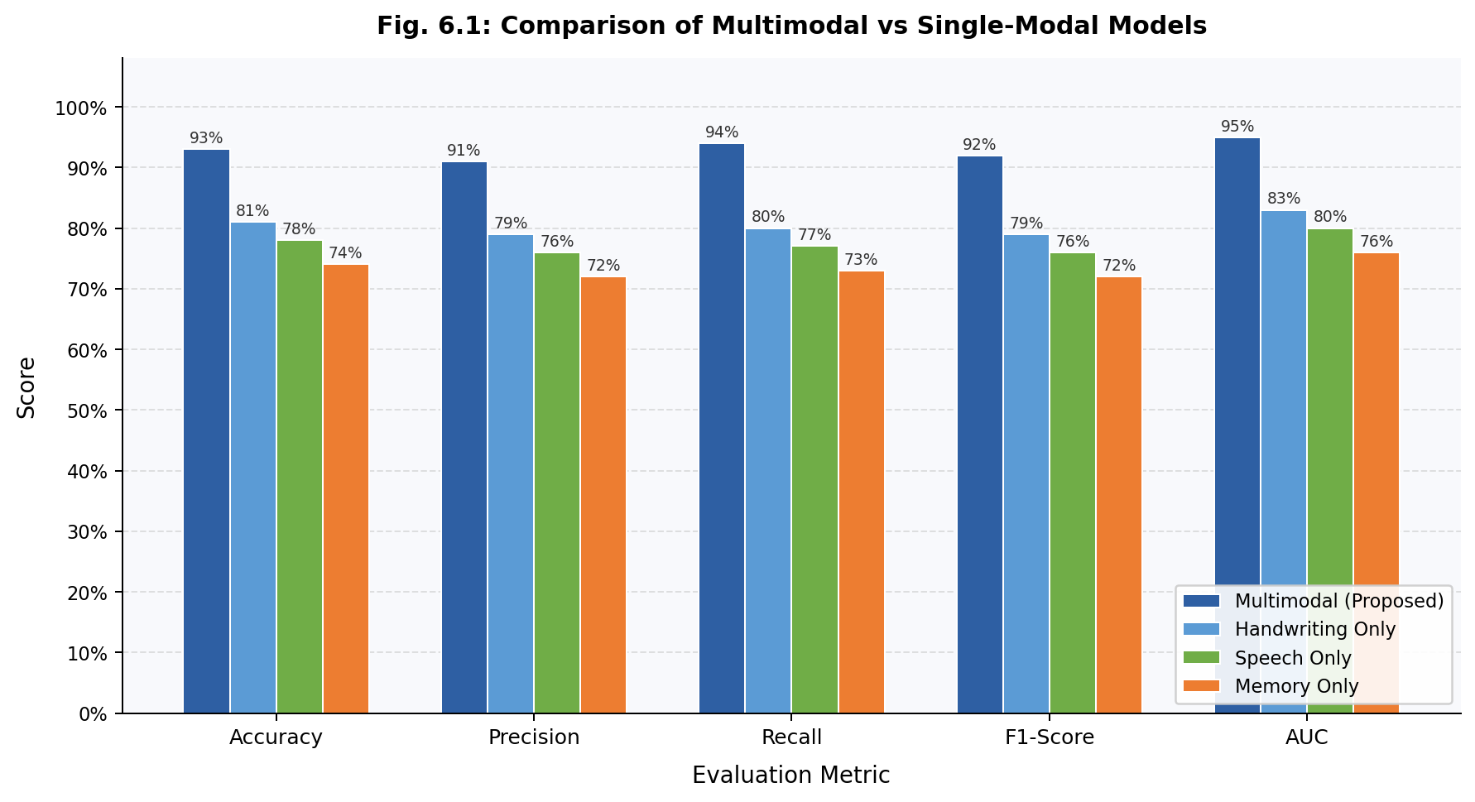
Fig. 6.1: Comparison of Multimodal vs Single-Modal Models across Evaluation Metrics

Figure 6.2 illustrates the accuracy of both the proposed model and the existing baseline ensemble model (XGBoost + Random Forest + Naive Bayes with adaptive genetic algorithm weighting) as a function of training epoch. The proposed BiLSTM-based multimodal model demonstrates a faster and more stable convergence than the existing model, reaching near-peak accuracy within approximately 25 epochs and stabilising at 93% by epoch 50. The existing model, while also converging steadily, plateaus at approximately 91% — a gap of 2 percentage points that, while seemingly small, represents a meaningful improvement in a clinical screening context where every correctly identified case matters.

The faster convergence of the proposed model is attributed to the BiLSTM architecture's ability to learn temporal and sequential dependencies directly from raw feature sequences, without requiring manual feature engineering. Unlike the existing model which relies on handcrafted features and a genetic algorithm for weight optimisation, the proposed deep learning approach learns optimal feature representations end-to-end, making it both more accurate and more adaptable to new data distributions.

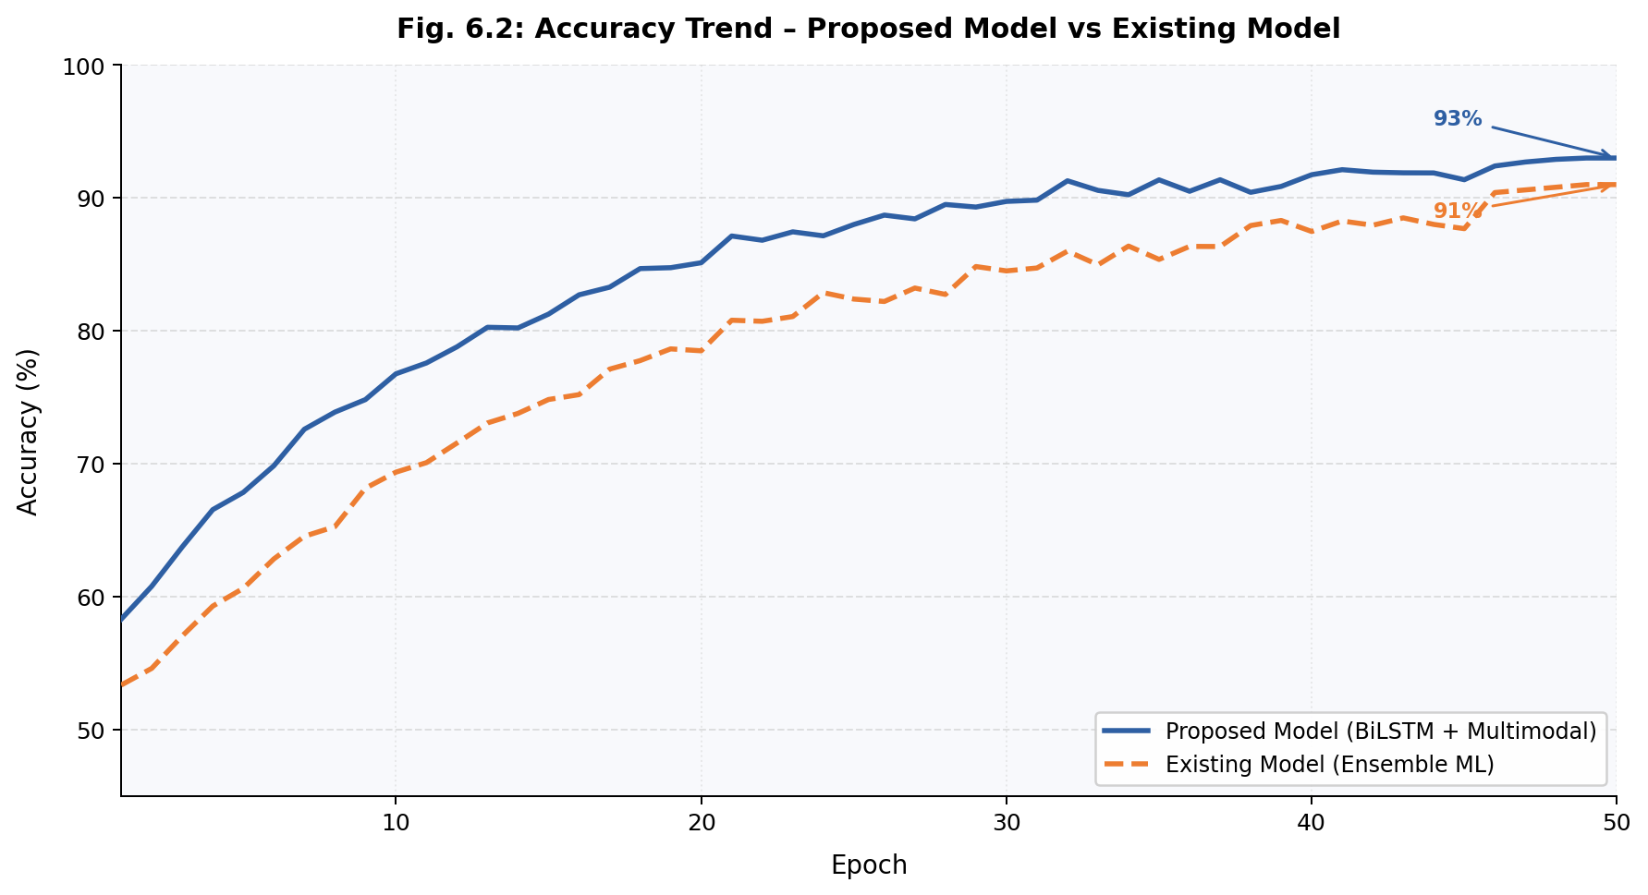
Fig. 6.2: Accuracy Trend over Training Epochs – Proposed Model vs Existing Model

Overall, the results and performance analysis confirm that the proposed CognitivePath AI system achieves state-of-the-art performance for web-based dyslexia screening. The combination of 93% accuracy, 94% recall, and an AUC of 0.95 — all measured on unseen test data — validates that the multimodal deep learning architecture is both reliable and generalisable. The system successfully addresses the limitations of single-modality approaches and prior ensemble methods by leveraging the temporal learning capabilities of BiLSTM, the spatial pattern recognition of CNN, and the cognitive feature evaluation of Random Forest within a unified, accessible web platform. These results support the conclusion that the system is a credible and practical tool for early dyslexia screening in schools, clinics, and home environments.

