INTERNSHIP REPORT
Business Analytics Internship
Projects:
Sales Performance Analysis
Employee Performance Analytics
Internship Organization: Codec Technologies
Internship Duration: 26 June 2026 – 28 July 2026
Name: Jyothika Nanupatruni

INTRODUCTION
Business Analytics is the process of collecting, analyzing, and interpreting data to support better business decisions. During my Business Analytics internship at Codec Technologies, I worked on practical data analysis projects using Microsoft Excel.
The internship provided an opportunity to understand data cleaning, analysis, visualization, and dashboard creation. Two projects were completed during the internship:
Sales Performance Analysis
Employee Performance Analytics
These projects helped me understand how raw data can be transformed into meaningful insights using analytical techniques and visualizations.
ROLE AND RESPONSIBILITIES
During my Business Analytics internship at Codec Technologies, my responsibilities included:
Understanding and organizing datasets for analysis.
Performing data cleaning and preparation using Microsoft Excel.
Using Excel formulas to calculate important metrics.
Analyzing sales and employee performance data.
Creating charts and dashboards to present analytical results.
Identifying trends and patterns from the data.
Interpreting results and presenting meaningful business insights.
Developing analytical thinking and problem-solving skills through practical projects.
PROJECT 1: SALES PERFORMANCE ANALYSIS
Project Overview
The Sales Performance Analysis project focused on analyzing historical sales data to understand sales trends, category performance, regional performance, monthly sales patterns, and top-performing products.
Objective
The objective of this project was to analyze sales data using Microsoft Excel and create a dashboard that presents important sales metrics and insights through tables and charts.
Tools Used
Microsoft Excel
Excel formulas
Charts and dashboard visualization

Steps Involved
- Imported and reviewed the Superstore sales dataset in Microsoft Excel.
- Identified important fields such as Order Date, Region, Category, Product Name, Sales, Quantity, and Profit.
- Calculated total sales, total profit, and total quantity.
- Analyzed sales by product category and region.
- Calculated monthly sales from January to December.
- Identified the top 10 products based on sales.
- Created charts and combined the results into a Sales Performance Dashboard
Insights Gained
- Technology recorded the highest sales among the three product categories.
- The East region recorded the highest sales among the four regions.
- Monthly sales showed noticeable variations throughout the year.
- March, September, November, and December recorded relatively high sales.
- The analysis identified the top 10 products based on sales.
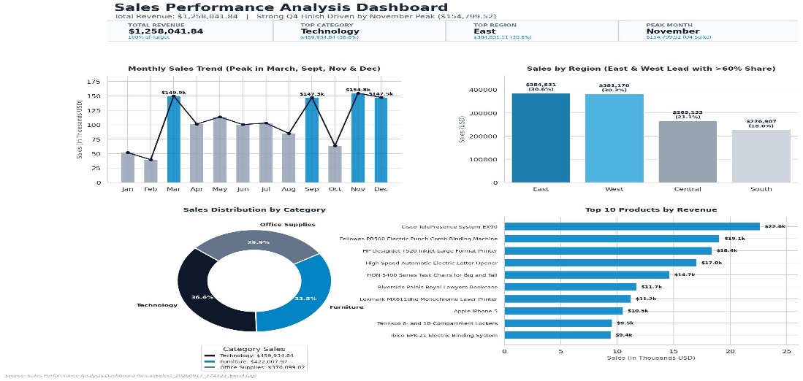
- The dashboard provides a clear visual comparison of sales across categories, regions, months, and products.
PROJECT 2: EMPLOYEE PERFORMANCE ANALYTICS
PROJECT OVERVIEW
The Employee Performance Analytics project focused on analyzing employee data to understand performance, job satisfaction, training, income, and departmental workforce distribution.
Objective
The objective of this project was to analyze employee performance data using Microsoft Excel and create a dashboard that presents important employee metrics through tables and charts.
Tools Used
Microsoft Excel
Excel formulas
Charts and dashboard visualization
Steps Involved
- Imported and reviewed the employee performance dataset in Microsoft Excel.
- Identified important fields such as Employee ID, Department, Job Role, Performance Rating, Job Satisfaction, Monthly Income, Years at Company, and Training Hours.
- Calculated total employees and average performance rating.
- Calculated average job satisfaction and average monthly income.
- Analyzed employee distribution across departments.
- Analyzed employees by performance rating.
- Analyzed job satisfaction levels.
- Created charts to visualize employee performance and workforce distribution.
- Combined the analysis into an Employee Performance Analytics Dashboard.
Insights Gained
- The Operations department had the highest number of employees.
- The average performance rating was 3.54.
- The average job satisfaction rating was 3.06.
- Performance ratings showed that most employees had ratings of 3 or 4.
- The dashboard provided a clear comparison of employee performance across departments and ratings.
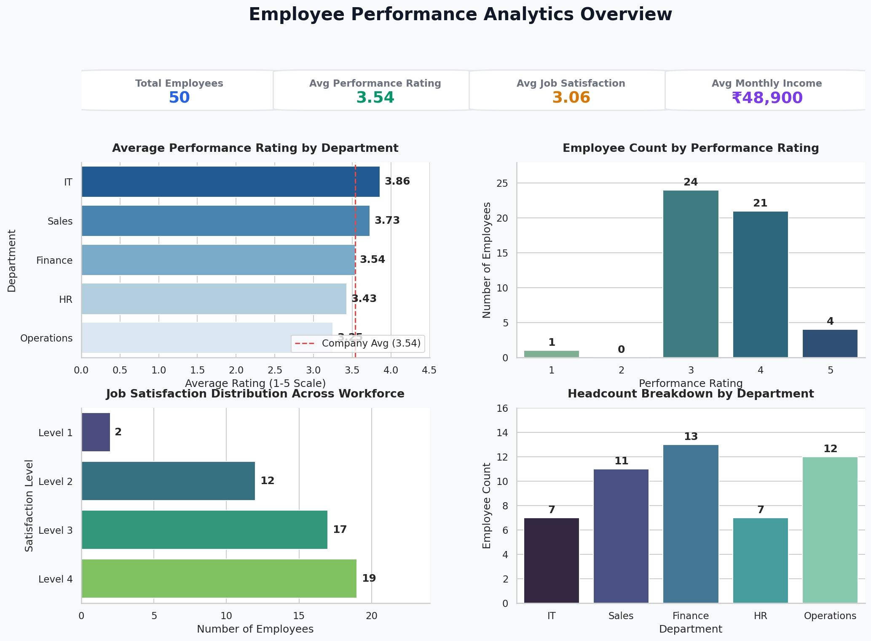
LEARNING AND SKILLS GAINED
During my Business Analytics internship at Codec Technologies, I developed practical skills in data analysis and visualization.
- Data cleaning and preparation using Microsoft Excel.
- Using Excel formulas for data analysis and calculations.
- Creating charts and dashboards.
- Analyzing sales and employee performance data.
- Identifying trends, patterns, and key business insights.
- Improving analytical thinking and problem-solving skills.
- Presenting analytical results in a clear and understandable manner.
CHALLENGES AND SOLUTIONS
- During the internship, I faced some challenges while working with data and creating dashboards.
- Understanding and organizing datasets for analysis.
- Handling large datasets and checking data accuracy.
- Using Excel formulas correctly for calculations.
- Creating clear and meaningful charts.
- Presenting analytical results in a simple and understandable way.
Solutions:
- I referred to learning materials, practiced Excel formulas, checked calculations carefully, and improved the dashboards through repeated practice.
CONCLUSION AND ACKNOWLEDGEMENT
The Business Analytics internship at Codec Technologies was a valuable learning experience. It helped me gain practical knowledge of data analysis, Excel formulas, data visualization, and dashboard creation.
Through the Sales Performance Analysis and Employee Performance Analytics projects, I learned how to analyze datasets, identify meaningful trends, and present results using charts and dashboards.
I improved my analytical thinking, problem-solving, and data presentation skills during the internship.
I sincerely thank Codec Technologies for providing me with this learning opportunity and for the guidance and support throughout the internship.

