

**SIMATS SCHOOL OF ENGINEERING**

**SAVEETHA INSTITUTE OF MEDICAL AND TECHNICAL SCIENCES**

**CHENNAI-602105**

**CSA4385-Internet Programming For Green App**

**A CAPSTONE PROJECT REPORT**

“ONLINE BIKE BOOKING SYSTEM”

*Submitted in the partial fulfillment for the award of the degree of*

**BACHELOR OF ENGINEERING**

**IN**

**COMPUTER SCIENCE AND ENGINEERING**

**Submitted by**

**V.Jyothika (192210604)**

**G.Asif(192211247)**

**Under the Supervision of**

**N.Venkatraman.**

**JUNE 2024**

**DECLARATION**

We **Asif.G,Jyothika.V** students of **Bachelor of Engineering in Information Technology**, Department of Computer Science and Engineering, Saveetha Institute of Medical and Technical Sciences, Saveetha University, Chennai, hereby declare that the work presented in this Capstone Project Work entitled **“Online Bike Booking System”** is the outcome of our own bonafide work and is correct to the best of our knowledge and this work has been undertaken taking care of Engineering Ethics.

(Asif.G,192211247)

(Jyothika.V,192210604))

Date:

Place:

**CERTIFICATE**

This is to certify that the project entitled “**Online Bike Booking System”** submitted by **Asif.G,Jyothika.V** has been carried out under my supervision. The project has been submitted as per the requirements in the current semester.

Teacher-in-charge

N.Venkatraman.

**Table of Contents**

|  |  |
| --- | --- |
| **S.NO** | **TOPICS** |
| 1 | **Abstract** |
| 2 | **Introduction** |
| 3 | **Project Description**t |
| 4 | **Problem Description** |
| 5 | **Tool Description** |
| 6 | **Operations** |
| 7 | **Approach / Module Description / Functionalities** |
| 8 | **Implementation** |
| 9 | **Output** |
| 10 | **Conclusion**    **References** |

**Abstract**

This project entails the development of an online bike booking system using HTML, CSS, and PHP. The aim is to create a digital platform that simplifies the bike rental process for both users and rental service providers. The system provides a user-friendly interface for browsing available bikes, making reservations, and managing bookings. It features secure user registration and login, real-time availability updates, and integration with payment gateways for seamless transactions. By leveraging web technologies, the project aims to enhance user convenience, improve operational efficiency, and provide a robust solution for managing bike rentals.

### Introduction

In today's fast-paced world, convenience and efficiency are critical, especially in the transportation sector. Traditional bike rental methods often involve significant manual effort, paperwork, and in-person interactions, making the process time-consuming and cumbersome. With the increasing adoption of digital solutions, there is a growing demand for online platforms that simplify and streamline these processes.

The online bike booking system is designed to address these challenges by providing a comprehensive digital solution for bike rentals. This system leverages modern web technologies—HTML, CSS, and PHP—to create a user-friendly platform that facilitates easy and convenient bike reservations. Users can browse through a catalog of available bikes, view detailed descriptions, and make reservations from the comfort of their homes.

The system supports user registration and authentication, ensuring secure access to personal accounts and booking history. It also includes an administrative module for rental service providers to manage bike listings, monitor bookings, and update availability in real-time. By integrating secure payment gateways, the system ensures a smooth and safe transaction process for users.

Overall, the online bike booking system aims to enhance user experience and operational efficiency for bike rental businesses. It reduces the need for physical interactions, minimizes paperwork, and provides real-time updates on bike availability, thereby improving customer satisfaction and streamlining rental operations.

### Project Description

The online bike booking system is a web-based application designed to streamline the process of renting bikes. Developed using HTML, CSS, and PHP, this system provides a digital platform for users to browse available bikes, make reservations, and manage their bookings. The project aims to offer a seamless user experience while enabling rental service providers to efficiently manage their bike inventory and bookings.

#### **Key Features**

**User Registration and Authentication**

* 1. Users can create an account by providing their personal information.
  2. Secure login and logout functionality to access personal accounts and booking history.

**Bike Listings**

* 1. Detailed catalog of available bikes, including specifications, rental rates, and images.
  2. Real-time updates on bike availability to prevent overbooking.

**Booking Management**

* 1. Users can view bike details and make reservations for a specified duration.
  2. Users can manage their bookings, including viewing past reservations and current bookings.

**Admin Module**

* 1. Admins can add, update, and delete bike listings.
  2. Administrative control over bookings, including monitoring and updating reservation status.

**Payment Processing**

* 1. Integration with secure payment gateways to handle online transactions.
  2. Users receive confirmation of successful payments and bookings.

**Notification System**

* 1. Automated notifications for booking confirmations, reminders, and updates via email or SMS.

**Search and Filter Option**

* 1. Advanced search functionality to find bikes based on criteria such as type, model, and rental price.
  2. Filters to narrow down search results for easier selection.

#### System Architecture

* **Frontend**: Developed using HTML, CSS, and JavaScript to create a responsive and intuitive user interface.
* **Backend**: Implemented using PHP for server-side scripting and MySQL for database management.
* **Database**: Designed to store user information, bike details, and booking data securely and efficiently.
* **Web Server**: Hosted on a reliable web server such as Apache or Nginx to ensure high availability and performance.
* **Payment Gateway**: Integrated with APIs from providers like PayPal or Stripe to facilitate secure online payments.

#### Benefits

**User Convenience**

* + Simplifies the process of finding and booking bikes.
  + Provides a hassle-free rental experience with secure online payments.

**Operational Efficiency**

* + Reduces manual effort and paperwork for rental businesses.
  + Streamlines inventory and booking management with real-time updates.

**Enhanced User Experience**

* + Intuitive interface and advanced search options improve user satisfaction.
  + Automated notifications keep users informed about their bookings.

**Scalability and Flexibility**

* + Designed to handle a growing number of users and bike listings.
  + Flexible architecture allows for easy updates and addition of new features.

### Tool Description

To develop the online bike booking system, a combination of various tools and technologies will be utilized. Each tool plays a critical role in ensuring the system's functionality, usability, security, and performance.

#### Frontend Technologies

**HTML (Hypertext Markup Language)**

* 1. **Purpose**: HTML is the standard markup language used to create the structure and content of web pages.
  2. **Usage**: It will be used to design the web pages, including the registration forms, bike listings, booking interfaces, and user dashboards.

**CSS (Cascading Style Sheets)**

* 1. **Purpose**: CSS is used to style and layout web pages.
  2. **Usage**: It will be used to enhance the appearance of the web pages, ensuring a responsive and visually appealing interface. CSS frameworks like Bootstrap may also be used for faster development and better design.

**JavaScript**

* 1. **Purpose**: JavaScript is a programming language that allows you to implement complex features on web pages.
  2. **Usage**: It will be used for interactivity and dynamic content updates, such as form validations, real-time availability checks, and enhancing user interactions.

#### Backend Technologies

**PHP (Hypertext Preprocessor)**

* 1. **Purpose**: PHP is a server-side scripting language designed for web development.
  2. **Usage**: It will be used to handle server-side logic, process form data, manage user sessions, interact with the database, and execute backend operations.

**MySQL**

* 1. **Purpose**: MySQL is a relational database management system.
  2. **Usage**: It will be used to store and manage all data related to the system, including user information, bike details, booking records, and transaction history.

#### Web Server

1. **Apache/Nginx**
   1. **Purpose**: Both Apache and Nginx are popular web servers used to serve web applications.
   2. **Usage**: The web server will host the application, handling HTTP requests from users and delivering web pages to their browsers.

#### Development Tools

**Integrated Development Environment (IDE)**

* 1. **Examples**: Visual Studio Code, PhpStorm
  2. **Purpose**: IDEs provide a comprehensive environment for coding, debugging, and testing applications.
  3. **Usage**: Used for writing and managing the codebase, providing features like syntax highlighting, code completion, and integrated debugging tools.

**Version Control System**

* 1. **Example**: Git
  2. **Purpose**: Version control systems help manage changes to the codebase over time.
  3. **Usage**: Git will be used to track code changes, collaborate with team members, and manage different versions of the application.

#### Payment Gateway Integration

1. **Payment Gateway APIs**
   1. **Examples**: PayPal, Stripe
   2. **Purpose**: Payment gateways facilitate secure online transactions.
   3. **Usage**: These APIs will be integrated to handle payment processing, ensuring secure and smooth transactions for bike rentals.

#### Notification System

1. **Email/SMS APIs**
   1. **Examples**: Twilio (SMS), SendGrid (Email)
   2. **Purpose**: These services enable sending automated notifications.
   3. **Usage**: Integrated to send booking confirmations, reminders, and updates to users via email or SMS.

### Approach / Module Description / Functionalities

To build a comprehensive and efficient online bike booking system, the project is divided into several modules, each responsible for specific functionalities. These modules work together to provide a seamless user experience and efficient management of bike rentals.

#### 1. User Module

**Functionalities**:

* **Registration**: Allows new users to create an account by providing personal information such as name, email, and password.
* **Login/Logout**: Enables users to securely log in to their accounts using their credentials and log out when done.
* **Profile Management**: Allows users to view and update their personal information, including contact details and password.

**Approach**:

* Use HTML forms for registration and login.
* Validate inputs using JavaScript and PHP.
* Store user data securely in the MySQL database.
* Implement session management for logged-in users.

#### 2. Bike Management Module

**Functionalities**:

* **Bike Listing**: Admins can add new bikes to the inventory, providing details such as bike model, specifications, rental price, and availability status.
* **Update/Delete Bikes**: Admins can modify or remove existing bike listings.
* **View Bikes**: Users can browse through the available bikes, view detailed descriptions, and see images.

**Approach**:

* Create forms for adding and updating bike details.
* Store bike information in the MySQL database.
* Display bike listings using HTML and CSS, with dynamic content loading through PHP.

#### 3. Search and Filter Module

**Functionalities**:

* **Search Bikes**: Users can search for bikes using keywords related to bike model, type, or other criteria.
* **Filter Results**: Users can apply filters to narrow down search results based on bike type, rental price, availability, etc.

**Approach**:

* Implement a search bar with auto-suggestion using JavaScript.
* Use PHP and SQL queries to fetch and filter bike data from the database.
* Display filtered results dynamically on the webpage.

#### 4. Booking Module

**Functionalities**:

* **Make Reservation**: Users can select a bike and specify the rental period to make a reservation.
* **View Bookings**: Users can view their current and past bookings.
* **Cancel Booking**: Users can cancel an existing booking if needed.

**Approach**:

* Use HTML forms to capture booking details.
* Validate booking requests using PHP.
* Update booking information in the MySQL database.
* Ensure real-time availability updates to prevent double bookings.

#### 5. Payment Module

**Functionalities**:

* **Payment Processing**: Integrate secure payment gateways to handle online transactions for bike rentals.
* **Payment Confirmation**: Provide users with confirmation and receipts for their payments.

**Approach**:

* Use payment gateway APIs (e.g., PayPal, Stripe) to process transactions.
* Ensure secure handling of payment data.
* Update booking status upon successful payment.

#### 6. Notification Module

**Functionalities**:

* **Booking Confirmations**: Send confirmation emails or SMS to users upon successful booking.
* **Reminders and Updates**: Notify users of upcoming rental periods or any changes to their bookings.

**Approach**:

* Integrate email/SMS APIs (e.g., SendGrid, Twilio) to send automated notifications.
* Trigger notifications based on booking status changes.

#### 7. Admin Module

**Functionalities**:

* **Dashboard**: Provides an overview of current bookings, bike inventory, and user activity.
* **Manage Users**: Admins can view and manage user accounts, including deactivating or deleting accounts if necessary.
* **Manage Bookings**: Admins can view all bookings, update booking statuses, and handle cancellations or modifications.

**Approach**:

* Design an admin dashboard with relevant statistics and controls.
* Implement CRUD (Create, Read, Update, Delete) operations for users and bookings.
* Secure admin access with additional authentication measures.

### Overall Approach

**Planning and Design**:

* + Define project requirements and create wireframes for the user interface.
  + Design the database schema to efficiently store and manage data.

**Frontend Development**:

* + Develop the user interface using HTML, CSS, and JavaScript.
  + Ensure responsive design for compatibility across devices.

**Backend Development**:

* + Implement server-side logic using PHP.
  + Develop APIs for interaction between the frontend and backend.

**Database Integration**:

* + Set up MySQL database and create necessary tables.
  + Implement database queries for CRUD operations.

**Payment and Notification Integration**:

* + Integrate payment gateways for secure transactions.
  + Set up email/SMS APIs for sending notifications.

**Testing and Deployment**:

* + Conduct thorough testing to identify and fix bugs.
  + Deploy the application on a web server and perform final testing.

**Implemenetation Code:Login page**

**<!DOCTYPE html>**

**<html lang="en">**

**<head>**

**<meta charset="UTF-8">**

**<meta name="viewport" content="width=device-width, initial-scale=1.0">**

**<title>Welcome</title>**

**<style>**

**body {**

**font-family: 'Arial Black', sans-serif;**

**background-image: url("1.jpg");**

**background-size: cover;**

**background-repeat: no-repeat;**

**display: flex;**

**justify-content: center;**

**align-items: center;**

**height: 100vh;**

**margin: 0;**

**color: #fff;**

**}**

**.container {**

**background: rgba(0, 0, 0, 0.7);**

**padding: 20px;**

**border-radius: 10px;**

**text-align: center;**

**}**

**h1 {**

**margin-bottom: 20px;**

**}**

**a {**

**color: #4CAF50;**

**text-decoration: none;**

**font-size: 20px;**

**border: 1px solid #4CAF50;**

**padding: 10px 20px;**

**border-radius: 5px;**

**display: inline-block;**

**transition: background-color 0.3s, color 0.3s;**

**}**

**a:hover {**

**background-color: #4CAF50;**

**color: white;**

**}**

**</style>**

**</head>**

**<body>**

**<div class="container">**

**<h1>For bookings..</h1>**

**<p>Enter your login credentials:</p>**

**<form id="loginForm" action="login.php" method="POST">**

**<label for="username">Username:</label>**

**<input type="text" id="username" name="username" required>**

**<br><br>**

**<label for="password">Password:</label>**

**<input type="password" id="password" name="password" required>**

**<br><br>**

**<button type="submit">Login</button>**

**</form>**

**<p>If you are a new user, <a href="details.html">click here</a> to provide your details.</p>**

**</div>**

**</body>**

**</html>**

**LOGIN PAGE:Output**

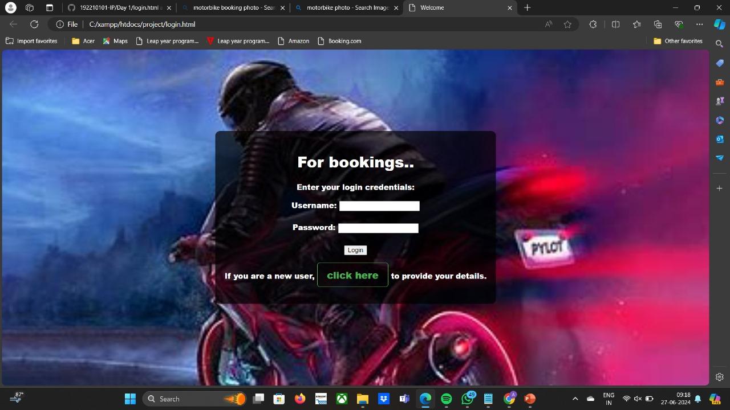

**<!DOCTYPE html>**

**<html lang="en">**

**<head>**

**<meta charset="UTF-8">**

**<meta name="viewport" content="width=device-width, initial-scale=1.0">**

**<title>New User Details</title>**

**<style>**

**body {**

**font-family: 'Arial', sans-serif;**

**background-color: #f4f4f4;**

**margin: 0;**

**padding: 0;**

**}**

**.container {**

**max-width: 600px;**

**margin: 20px auto;**

**background: #fff;**

**padding: 20px;**

**border-radius: 5px;**

**box-shadow: 0 0 10px rgba(0, 0, 0, 0.1);**

**}**

**h2 {**

**text-align: center;**

**margin-bottom: 20px;**

**}**

**label {**

**font-weight: bold;**

**}**

**input[type="text"],**

**input[type="email"],**

**input[type="password"],**

**input[type="date"],**

**select {**

**width: 100%;**

**padding: 10px;**

**margin: 8px 0;**

**border: 1px solid #ccc;**

**border-radius: 5px;**

**}**

**button {**

**background-color: #4CAF50;**

**color: white;**

**padding: 10px 20px;**

**border: none;**

**border-radius: 5px;**

**cursor: pointer;**

**}**

**button:hover {**

**background-color: #45a049;**

**}**

**.error {**

**color: red;**

**font-weight: bold;**

**}**

**</style>**

**</head>**

**<body>**

**<div class="container">**

**<h2>New User Details</h2>**

**<form action="submit_details.php" method="POST" onsubmit="return validateForm()">**

**<label for="fullname">Full Name:</label>**

**<input type="text" id="fullname" name="fullname" required>**

**<label for="email">Email:</label>**

**<input type="email" id="email" name="email" required>**

**<label for="username">Username:</label>**

**<input type="text" id="username" name="username" required>**

**<label for="password">Password:</label>**

**<input type="password" id="password" name="password" required>**

**<label for="dob">Date of Birth:</label>**

**<input type="date" id="dob" name="dob" required>**

**<label for="gender">Gender:</label>**

**<select id="gender" name="gender" required>**

**<option value="">Select Gender</option>**

**<option value="male">Male</option>**

**<option value="female">Female</option>**

**<option value="other">Other</option>**

**</select>**

**<button type="submit">Submit</button>**

**</form>**

**<p id="ageError" class="error" style="display:none;">You must be at least 18 years old to register.</p>**

**</div>**

**<script>**

**function validateForm() {**

**var dob = document.getElementById('dob').value;**

**var today = new Date();**

**var birthDate = new Date(dob);**

**var age = today.getFullYear() - birthDate.getFullYear();**

**var m = today.getMonth() - birthDate.getMonth();**

**if (m < 0 || (m === 0 && today.getDate() < birthDate.getDate())) {**

**age--;**

**}**

**if (age < 18) {**

**document.getElementById('ageError').style.display = 'block';**

**return false;**

**} else {**

**document.getElementById('ageError').style.display = 'none';**

**return true;**

**}**

**}**

**</script>**

**</body>**

**</html>**

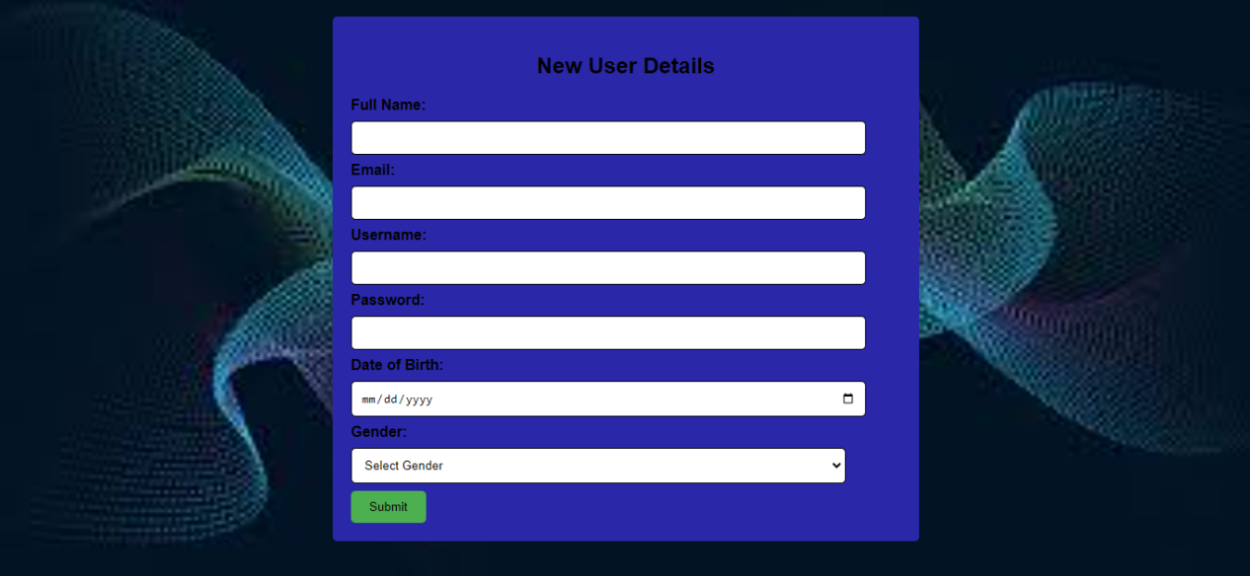

**<!DOCTYPE html>**

**<html lang="en">**

**<head>**

**<meta charset="UTF-8">**

**<meta name="viewport" content="width=device-width, initial-scale=1.0">**

**<title>New User Details</title>**

**<style>**

**body {**

**font-family: 'Arial', sans-serif;**

**background-color: #f4f4f4;**

**margin: 0;**

**padding: 0;**

**}**

**.container {**

**max-width: 600px;**

**margin: 20px auto;**

**background: #fff;**

**padding: 20px;**

**border-radius: 5px;**

**box-shadow: 0 0 10px rgba(0, 0, 0, 0.1);**

**}**

**h2 {**

**text-align: center;**

**margin-bottom: 20px;**

**}**

**label {**

**font-weight: bold;**

**}**

**input[type="text"],**

**input[type="email"],**

**input[type="password"],**

**input[type="date"],**

**select {**

**width: 100%;**

**padding: 10px;**

**margin: 8px 0;**

**border: 1px solid #ccc;**

**border-radius: 5px;**

**}**

**button {**

**background-color: #4CAF50;**

**color: white;**

**padding: 10px 20px;**

**border: none;**

**border-radius: 5px;**

**cursor: pointer;**

**}**

**button:hover {**

**background-color: #45a049;**

**}**

**.error {**

**color: red;**

**font-weight: bold;**

**}**

**</style>**

**</head>**

**<body>**

**<div class="container">**

**<h2>New User Details</h2>**

**<form action="submit_details.php" method="POST" onsubmit="return validateForm()">**

**<label for="fullname">Full Name:</label>**

**<input type="text" id="fullname" name="fullname" required>**

**<label for="email">Email:</label>**

**<input type="email" id="email" name="email" required>**

**<label for="username">Username:</label>**

**<input type="text" id="username" name="username" required>**

**<label for="password">Password:</label>**

**<input type="password" id="password" name="password" required>**

**<label for="dob">Date of Birth:</label>**

**<input type="date" id="dob" name="dob" required>**

**<label for="gender">Gender:</label>**

**<select id="gender" name="gender" required>**

**<option value="">Select Gender</option>**

**<option value="male">Male</option>**

**<option value="female">Female</option>**

**<option value="other">Other</option>**

**</select>**

**<button type="submit">Submit</button>**

**</form>**

**<p id="ageError" class="error" style="display:none;">You must be at least 18 years old to register.</p>**

**</div>**

**<script>**

**function validateForm() {**

**var dob = document.getElementById('dob').value;**

**var today = new Date();**

**var birthDate = new Date(dob);**

**var age = today.getFullYear() - birthDate.getFullYear();**

**var m = today.getMonth() - birthDate.getMonth();**

**if (m < 0 || (m === 0 && today.getDate() < birthDate.getDate())) {**

**age--;**

**}**

**if (age < 18) {**

**document.getElementById('ageError').style.display = 'block';**

**return false;**

**} else {**

**document.getElementById('ageError').style.display = 'none';**

**return true;**

**}**

**}**

**</script>**

**</body>**

**</html>**

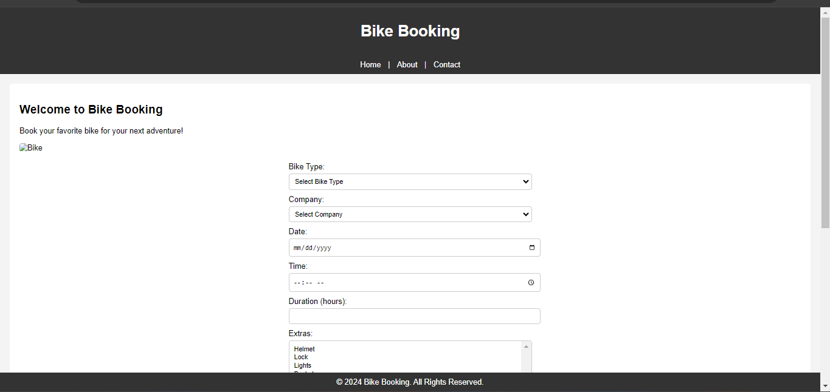

**LOGIN DB:**

**<?php**

**$servername = "localhost";**

**$username = "root";**

**$password = "";**

**$dbname = "bookings_db";**

**// Create connection**

**$conn = new mysqli($servername, $username, $password, $dbname);**

**// Check connection**

**if ($conn->connect_error) {**

**die("Connection failed: " . $conn->connect_error);**

**}**

**// Prepare and bind SQL statement**

**$stmt = $conn->prepare("INSERT INTO bookings (bike_type, company, date, time, duration, extras, comments) VALUES (?, ?, ?, ?, ?, ?, ?)");**

**$stmt->bind_param("ssssiss", $bikeType, $company, $date, $time, $duration, $extras, $comments);**

**// Set parameters and execute**

**$bikeType = $_POST['bike-type'];**

**$company = $_POST['company'];**

**$date = $_POST['date'];**

**$time = $_POST['time'];**

**$duration = $_POST['duration'];**

**$extras = isset($_POST['extras']) && is_array($_POST['extras']) ? implode(", ", $_POST['extras']) : '';**

**$comments = $_POST['comments'];**

**$stmt->execute();**

**echo "Booking stored successfully.";**

**$stmt->close();**

**$conn->close();**

**?>**

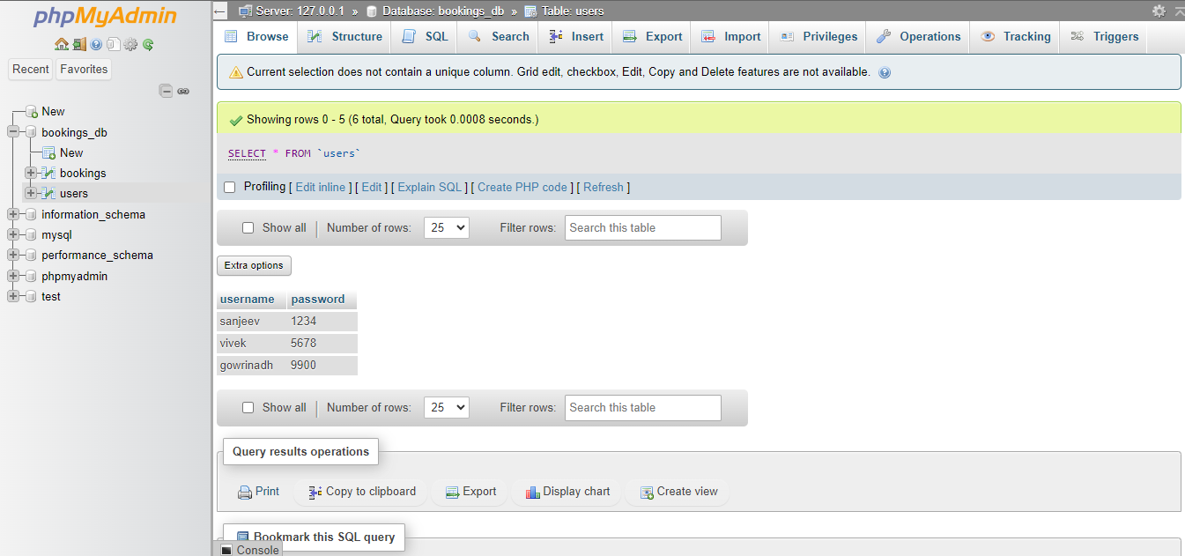

### Conclusion

The development of the online bike booking system using HTML, CSS, PHP, and MySQL marks a significant step towards modernizing the bike rental industry. By leveraging web technologies, this project aims to provide a seamless and efficient platform for both users and rental service providers. Here are key points that summarize the project's goals, achievements, and future considerations.

In conclusion, the online bike booking system not only meets current market demands for digital solutions but also sets a foundation for innovation and growth in the bike rental sector. By embracing technology, the system aims to improve efficiency, accessibility, and customer satisfaction in bike rentals.