MODULE-II
CONTROL STATEMENTS
Module II

OPERATORS
- Operators are the symbols which operates on operands (value or a variable).
- C language has wide range of operators to perform various operations.
These are classified as:
- Arithmetic
- Relational
- Logical
- Assignment
- Bitwise
- Conditional
- Increment and decrement.

- Arithmetic operators: These are used to perform mathematical calculations .
For example, ’+’ is an operator to perform addition.
Operator | Description
+ | Addition or unary plus
- | Subtraction or unary minus
/ | division
* | multiplication
% | Remainder after division

For example, a+b
Here a,b are operands and ‘+’ is an operator.
Program: (a+b)
#include<stdio.h>
main()
{
int a,b,c;
printf(“enter a&b values:”);
scanf(“%d%d”,&a,&b);
c=a+b;
printf(“the sum of a&b is %d”,c);
c=a-b;
c=a*b
printf(“a*b=%d”,c);
c=a/b
printf(“a/b=%d”,c);
}
- Relational operators: These operators checks relation b/w 2 operants .if the relation is true it returns value 1 otherwise it returns o.
Ex:-a>b
Here ‘>’ is a relational operator.
- Relational operators are used in decision making and loops in c program.

Operator | meaning | Example
> | Greater than | 5>3(returns 1)
< | Less than | 5<3(returns 0)
== | Equal to | 5==3(returns 0)
!= | Not equal to | 5!=3(returns1)
>= | Greater than equal to | 5>=3(returns1)
<= | Less than equal to | 5<=3(returns0)
- logical operators: These are used to combine expressions containing relational operators .
In ‘c’ there are 3 logical operators.
Operator | meaning | Example
&& | Logical AND | If c=5 and d=2 then,((c==5&&(d>5))  Returns false.
|| | Logical OR | If c=5 and d=2 then,((c==5||(d>5))  Returns true.
! | Logical NOT | If c=5 then (c!=5)  Returns false.

- Assignment operator:
Most common assignment operator is ‘equal to’(=).this operator assigns the value in right side to left side.
For example, a=5; /* here 5 is a value assigned to ‘a’*/
5=a; /*error occurs*/
Operator | Example | Same as
= | a=b | a=b
+= | a+=b | a=a+b
-= | a-=b | a=a-b
*= | a*=b | a=a*b
/= | a/=b | a=a/b
%= | a%=b | a=a%b

- Bitwise operators: These are used to perform bit level operations on each bit of data.
Operator | meaning
& | Bitwise AND
| | Bitwise OR
^ | Exclusive OR
~ | Bitwise complement
<< | Shift left
>> | Shift right

Example:
P | q | p&q | p|q | p^q
0 | 0 | 0 | 0 | 0
0 | 1 | 0 | 1 | 1
1 | 0 | 0 | 1 | 1
1 | 1 | 1 | 1 | 0

Program:
#include<stdio.h>
main()
{
int a,b,c;
printf(“enter a and b values:”);
scanf(“%d%d”,&a,&b);
c=a&b;
printf(“bitwise AND of a&b is %d”,c);
c=a|b;
printf(“bitwise OR of a&b is %d”,c);
c=a^b;
printf(“bitwise exclusive OR of a&b is %d”,c);
}

6. Conditional operators:
- These are used for decision making in c programming .it takes 3 operands and consists of 2 symbols (? And : ).
- It executes different statements according to test condition whether it is either true or false.
- Syntax: conditional expression? expression 1:expression 2;
If the test condition is true, expression 1 is returned and if false, expression 2 is returned.
Example:

C=(a>b)?a:b;

C=(c>0)?10:10;
Comma operator:
A set of expression separated by comma is a valid constant in the C language. For example i and j are declared by the statements
int i , j;
i=(j=10, j+20);
In the above declaration, right hand side consists of two expressions separated by comma. The first expression is j=10 and second is j+20. These expressions are evaluated from left to right. ie first the value 10 is assigned to j and then expression j+20 is evaluated so the final value of i will be 30.

Size of operator:
It is a unary operator which is used in finding the size of data types, constants, arrays, structures, etc
Program:
#include<stdio.h>
main()
{
int a;
float b;
double c;
char ch;
printf(“sizeof int=%d bytes \n”,sizeof(a));
printf(“sizeof float=%d bytes \n”,sizeof(b));
printf(“sizeof double=%d bytes \n”,sizeof(c));
printf(“sizeof char=%d bytes \n”,sizeof(d));
}

7.Increment and decrement operators:

In ‘c’, “++” is called as an increment operator and “- - “ is called as an decrement operator .
They are classified into 2 types.
1. Pre-increment and post-increment.
2. Pre-decrement and post-decrement
Pre-increment:
In this first, the variable is incremented by 1 and only after that, any operation is performed on variable.
Syntax: ++variable;
Example: ++i or ++a;
int a,i=2;
a=++i;
In the above example, first ‘i’ is incremented to 1, i.e, ‘i’ becomes 3 and after that ‘i’ will be assigned to a.
Post-increment:
In this first, the operator is performed on variable and only after that, variable is incremented by 1.
Syntax: variable++;
Example: i ++or a++;
int a,i=2;
a=i++;
in the above example ,first ‘i’ is assigned to a and after that ‘i’ will be incremented by 1.
Pre-decrement:
In this first, the variable is decremented by 1 and only after that, any operation is performed on variable.
Syntax: - -variable;
Example:
- -i or - -a;
int a,i=2;
a=- -i;
In the above example, first ‘i’ is decremented to 1 and only after that ‘i’ will be assigned to a.

Post-decrement:
In this first, the operator is performed on variable and only after that, variable is decremented by 1.
Syntax: variable- -;
Example: i - -or a- -;
int a,i=2;
a=i- -;
In the above example, first ‘i’ is assigned to a and only after that ‘i’ will be decremented by 1.
EXPRESSIONS

An expression is a combination of variable, constants and operators.
Ex: SI=P*T*R/100
(a+b) c/d;
a*b+c (d+x);
5*a+b+b*c;
(a+b)*(x+y);
Evaluation of expressions:
An expression can be evaluated based on presidency of operators, after the evaluation of expression, the value of the expression is assigned to the variable.
Ex: SI=P*T*R/100
Precedence of operators:
Operator precedence determines which operator will be performed first in a group of operators with different precedence. For instance 5 + 3 * 2 is calculated as 5 + (3 * 2), giving 11, and not as (5 + 3) * 2, giving 16.
Operator Name | Associativity | Operators
Primary scope resolution | left to right | ::
Primary | left to right | () [ ] . -> dynamic_cast typeid
Unary | right to left | ++ -- + - ! ~ & * (type_name) sizeof new delete
C++ Pointer to Member | left to right | .*->*
Multiplicative | left to right | * / %
Additive | left to right | + -
Bitwise Shift | left to right | << >>
Relational | left to right | < > <= >=
Equality | left to right | == !=
Bitwise AND | left to right | &
Bitwise Exclusive OR | left to right | ^
Bitwise Inclusive OR | left to right | |
Logical AND | left to right | &&
Logical OR | left to right | ||
Conditional | right to left | ? :
Assignment | right to left | = += -= *= /= <<= >>= %= &= ^= |=
Comma | left to right | ,

- The order of priority in which the operations can perform in an expression is called presidency.
- An arithmetic expression without parenthesis will be executed from left to right using the rules of presidency of operators.

Highest Presidency :(,),*, /, %
Lowest Presidency: +, -

- The basic evaluation procedure includes two passes from left to right through the expression.
- During the first pass the highest priority operator (if any) are applied as they are encountered.
- Whenever parenthesis are used in the expressions, within parenthesis assumes highest priority.
- If two or more sets of parenthesis appear one after the another as 9-12/(3+3)*(2-1). The expression contained in the left most set is evaluated first and the right most set in the last.
Ex: 9-12/ (3+3)*(2-1)
9-12/6*1
9-2*1
9-2
7
- If the parenthesis is nested and in such cases evaluation of the expression will process outwards from the inner most set of the parenthesis.

Ex: A) 9-(12/ ((3+3)*2)-1
9-(12/6*2)-1
9-(2*2)-1
9-4-1
5-1
4

B) 9-((12/3) +3*2)-1
9-(4+3*2)-1
9-(4+6)-1
9-10-1
-1-1
-2
Program 1:-
#include<stdio.h>
#include<conio.h>
main()
{
int a=20;
int b=10;
int c=15;
int d=5;
int e;
e=(a+b)*c/d;
printf("\n Value of (a+b)*c/d is : %d\n",e);
e=((a+b)*c)/d;
printf("\n Value of ((a+b)*c/d) is : %d\n",e);
e=(a+b)*(c/d);
printf("\n Value of (a+b)*(c/d) is : %d\n",e);
e=a+(b*c)/d;
printf("\n Value of a+(b*c)/d is : %d\n",e);
getch();
}

TYPE CONVERSIONS:

Generally the data type conversions or the type casting can be possible in the following three ways.

1. Automatic Conversion using assignment operator
2. Conversion to higher type in expressions (implicit)
3. Using cast operator (Explicit)

1. AUTOMATIC CONVERSION USING ASSIGNMENT OPERATOR:

If we are using the assignment operator the right side value can be automatically converted into left side.
Ex -1: int x=5; Ex-2: int x;
float y; float y=3.5;
y=x; x=y;

2. CONVERSION TO HIGHER TYPE IN EXPRESSIONS (IMPLICIT):
If we are using an arithmetic expression that contains different types of data then the resultant value type is equal to the higher type data of the expression. Automatically converts lower type to higher type before the operation performed by the compiler and ultimately the result in the form of higher type is known as implicit conversion.
Ex: int a;
float b;
double c, x;

x=a*b+c;
3. USING CAST OPERATOR (EXPLICIT):
We can also perform type conversion explicitly by using a cast operator in the following way.
Syntax: (Type name) expression;
OR
(Type name) variable;
Where, type name is any of c data types and expression may be a constant, variables or any arithmetic expressions.
Ex-1: a= (int) 8.65; Ex-2: x= (float) 7;
It returns a=8 It returns x=7.000000

Ex-3: y= (int) 6.5/ (int) 2.3;
y=int (6/2);
It returns y=3
Program 1:-
#include<stdio.h>
main()
{
int cum=17,count=5;
double mean;
mean=(double)sum/count;
printf(“\n Value of mean is : %f\n”,mean);
}
Program 2:-
#include<stdio.h>
main()
{
int i=17;
char c=’c’;
int sum;
sum=i+c;
printf(“\n The value of sum is : %d\n”,sum);
}

CONTROL STATEMENTS
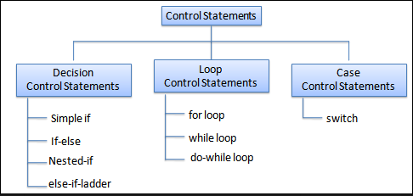
C provides two styles of flow control:
- Branching
- Looping

Branching is deciding what actions to take and looping is deciding how many times to take a certain action.
if statement:
This is the simplest form of the branching statements. It takes an expression in parenthesis and a statement or block of statements. if the expression is true then the statement or block of statements gets executed otherwise these statements are skipped.
Flowchart:
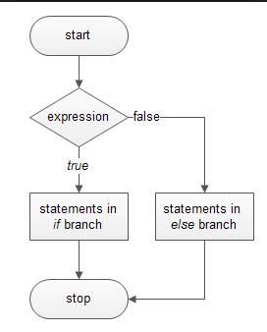

Syntax:

if (expression)
statement;

or

if (expression)
{
Block of statements;
}

or

if (expression)
{
Block of statements;
}
else
{
Block of statements;
}

or

if (expression)
{
Block of statements;
}
else if(expression)
{
Block of statements;
}
else
{
Block of statements;
}

Example 1:
#include <stdio.h>
main()
{
int number;
printf("Enter an integer: ");
scanf("%d", &number);
// Test expression is true if number is less than 0
if (number < 0)
{
printf("You entered %d.\n", number);
}

printf("The if statement is easy.");
}

Example 2:
#include <stdio.h>
main()
{
int number;
printf("Enter an integer: ");
scanf("%d",&number);

// True if remainder is 0
if( number%2 == 0 )
printf("%d is an even integer.",number);
else
printf("%d is an odd integer.",number);
}
Nested if….else statement:
The if...else statement executes two different codes depending upon whether the test expression is true or false. Sometimes, a choice has to be made from more than 2 possibilities. The nested if...else statement allows you to check for multiple test expressions and execute different codes for more than two conditions.
Flowchart:
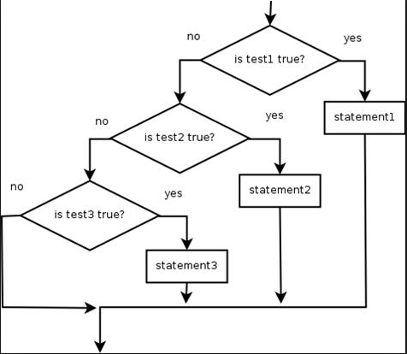
Syntax of nested if...else statement:

if (testExpression1)
{
// statements to be executed if testExpression1 is true
}
else if(testExpression2)
{
// statements to be executed if testExpression1 is false and testExpression2 is true
}
else if (testExpression 3)
{
// statements to be executed if testExpression1 and testExpression2 is false and testExpression3 is true
}
.
.
else
{
// statements to be executed if all test expressions are false
}

Example:
#include <stdio.h>
main()
{
int number1, number2;
printf("Enter two integers: ");
scanf("%d %d", &number1, &number2);

//checks if two integers are equal.
if(number1 == number2)
{
printf("Result: %d = %d",number1,number2);
}

//checks if number1 is greater than number2.
else if (number1 > number2)
{
printf("Result: %d > %d", number1, number2);
}

// if both test expression is false
else
{
printf("Result: %d < %d",number1, number2);
}}

Switch statement

The switch statement is much like a nested if .. else statement. Its mostly a matter of preference which you use, switch statement can be slightly more efficient and easier to read.
Syntax:
switch( expression )
{
case constant-expression1: statements1;
[case constant-expression2: statements2;]
[case constant-expression3: statements3;]
[default : statements4;]
}
Example:
#include <stdio.h>
main()
{
int Grade = 'A';

switch( Grade )
{
case 'A' : printf( "Excellent\n" );
case 'B' : printf( "Good\n" );
case 'C' : printf( "OK\n" );
case 'D' : printf( "Mmmmm....\n" );
case 'F' : printf( "You must do better than this\n" );
default : printf( "What is your grade anyway?\n" );
}
}

Using break keyword

If a condition is met in switch case then execution continues on into the next case clause also if it is not explicitly specified that the execution should exit the switch statement. This is achieved by using break keyword.

break Statement

The break statement terminates the loop immediately when it is encountered. The break statement is used with decision making statement such as if...else.
Syntax: break;

Example:
# include <stdio.h>
main()
{
int i;
double number, sum = 0.0;

for(i=1; i <= 10; ++i)
{
printf("Enter a n%d: ",i);
scanf("%lf",&number);

// If user enters negative number, loop is terminated
if(number < 0.0)
{
break;
}
sum += number; // sum = sum + number;
}
printf("Sum = %.2lf",sum);
}

Continue Statement

The continue statement skips some statements inside the loop. The continue statement is used with decision making statement such as if...else.

Syntax of continue Statement

continue;
Example:
# include <stdio.h>
main()
{
int i;
double number, sum = 0.0;
for(i=1; i <= 10; ++i)
{
printf("Enter a n%d: ",i);
scanf("%lf",&number);
if(number < 0.0)
{
continue;
}
sum += number; // sum = sum + number;
}
printf("Sum = %.2lf",sum);
}

Goto Statement
The goto statement branches unconditionally from one point to another in the block. In other words the goto statement transfers execution to another label within the statement block.
The goto requires a label to identify the place where the branch is to be made to. A label is any valid identifier and must be followed by a colon. The label is placed immediately before the statement where the control is to be transferred. The goto statement can transfer the control to any place in a program.

Syntax :

goto label;
... .. ...
... .. ...
... .. ...
label:
statement;
The label is an identifier. When goto statement is encountered, control of the program jumps to label: and starts executing the code.
Forward and backward jump:
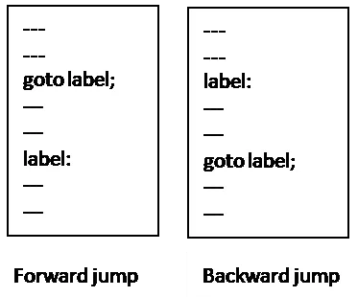
As shown in the above syntax, if the label is after the goto statement, then it is known as forward jump and if the label is before the goto statement, it is known as backward jump.
Example:

void fun(int x)
{
back:
if( condition1)
{
x++;
goto next;
}
else if( condition 2)
{x=x+2;
goto back;
}
x=x+3;
next:
printf(“%d”,x);
if (!done)
goto back;
}

ITERATION AND REPETITIVE EXECUTION (WHILE, FOR AND DO-WHILE)

- Selection and iteration statements are the basic tools of designing a logical process.

1.1 Concept of a Loop

- A loop allows one to execute a statement or a lock of statements repeatedly. It never stops.

- We definitely do o twat this to happen. We want our loop to end when work is done.

- To make sure that it ends, we must have a condition that control the loop i.e., it ends either before or after iteration, if it is not doe, the loop repeats one more time; if it is done, the loop terminates.

- This test is known as loop control expression.

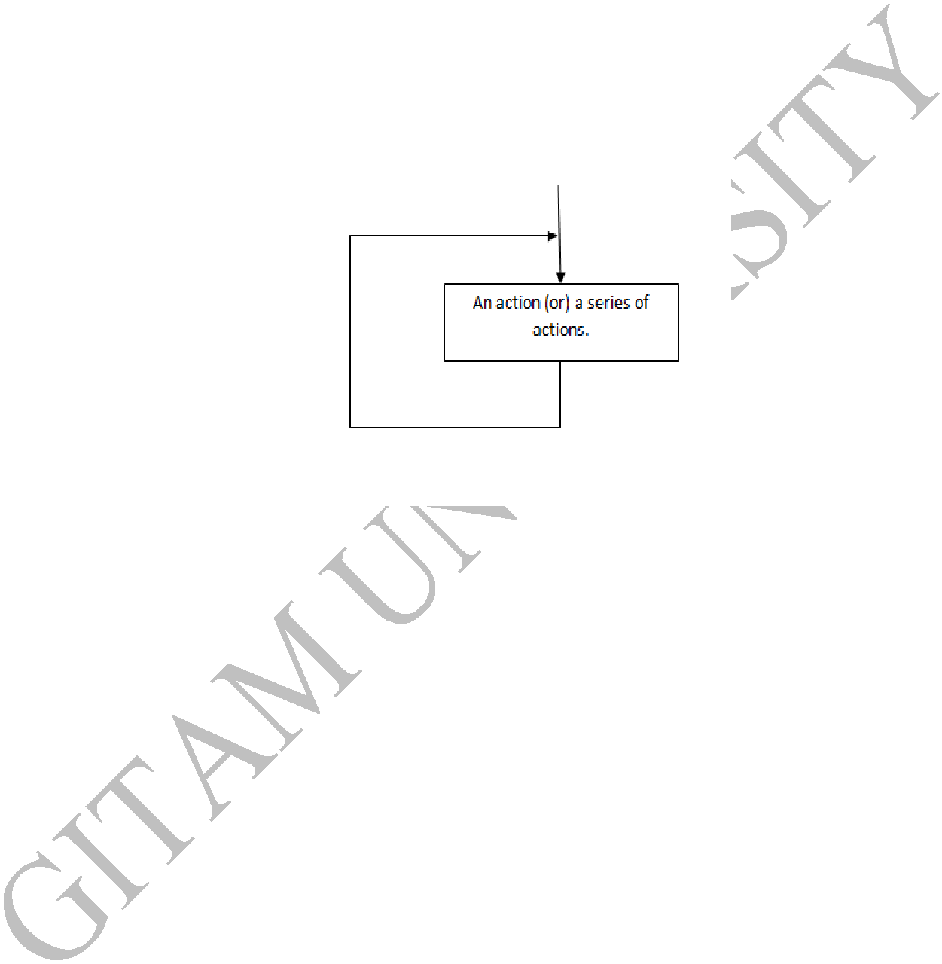

Figure 3.1: Concept of a loop

  - Two types of iteration/loops are

    - Unbounded iteration/ loop

    - Bounded iteration/loop

- Unbounded iteration / Unbounded Loop

  - When one doesn’t know, how many iterations may be required ahead of time, such cases require unbounded loops.

  - Two types of such loops are

- while

    - do_while

  - These loops are also known as indeterminate or indefinite loop.

- Bounded iteration / Bounded loop

  - When we know, how many times we need to loop; such cases are called as bounded loops.

  - For loop is the example of this type.

3 Dept. of CSE & IT GIT, GU.

1.2 Pre-test ad Post-test Loops

- Pre-test Loop

  - The condition is checked before we start and at the beginning of each iteration.

  - If the test condition is true, we execute the code; if the test condition is false, we terminate the loop

  - The statements associated with this type of construct may not be executed even once.

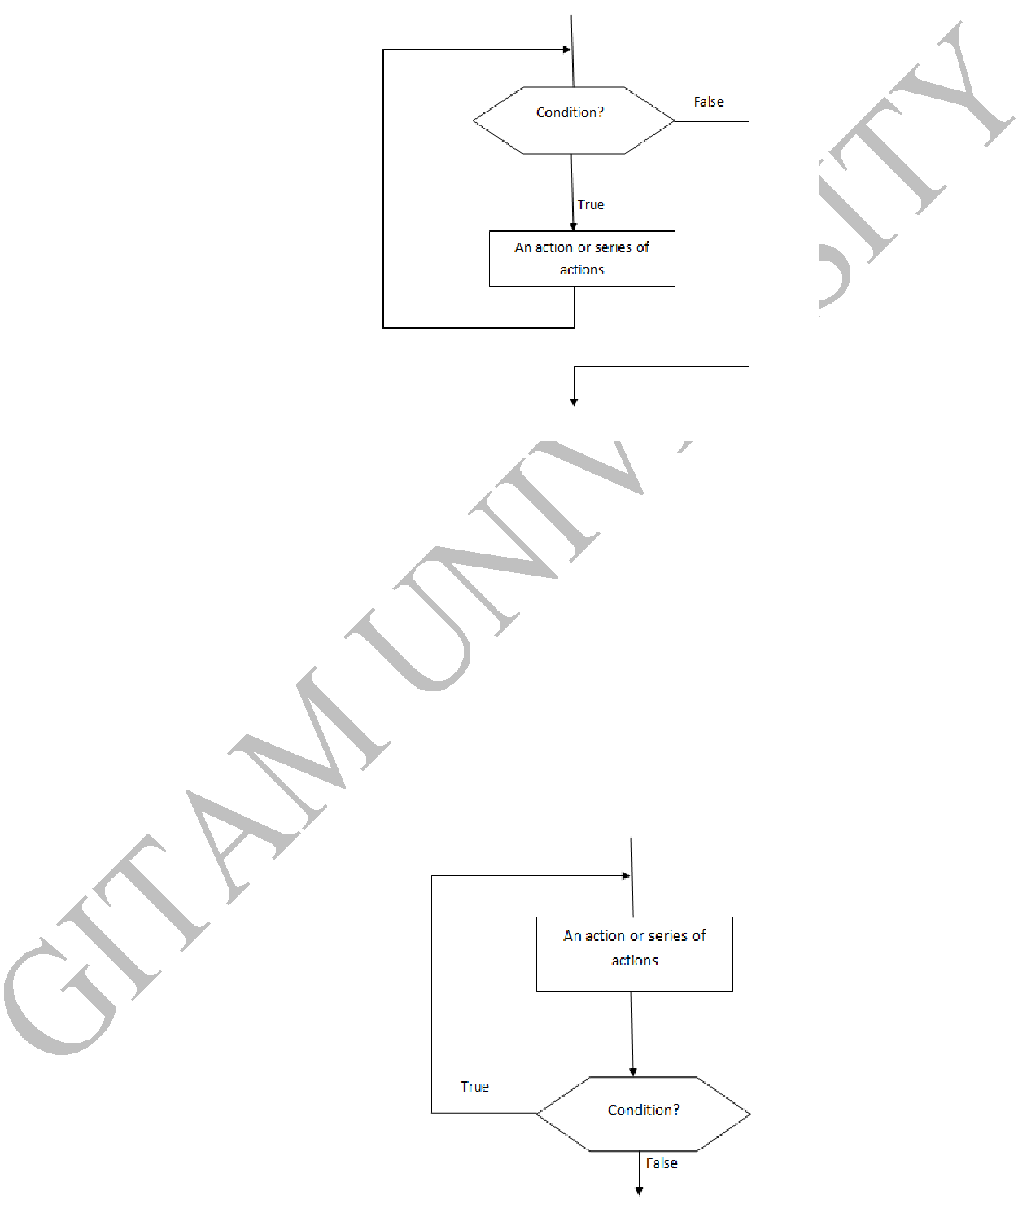

Figure 3.2: Pretest Loop

- Post-test Loop

  - The condition is tested ad if the expression is true, the loop repeats, if the expression (condition) is false, the loop terminates.

  - But, before the condition is tested for the first time, the actions are executed at least once.

  - The statements associated with this construct may be executed at least once.

Figure 3.3: Post-Test Loop

4 Dept. of CSE & IT GIT, GU.

1.3 Initialization and Updating

1.3.1 Loop initialization

- Loop initialization is the preparation doe before a loop starts.

- It must be done before the first execution of the loop body.

- The initialization may be explicit or implicit.

- When the initialization is explicit, we include code to set the beginning values of key loop variables.

- Implicit initialization provides no direct initialization code, rather, it relies on pre-existing situation to control the loop.

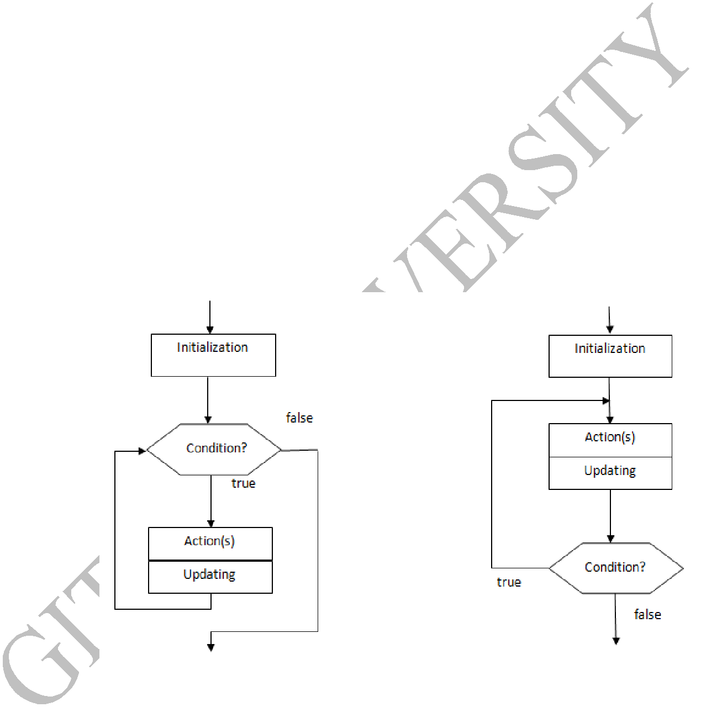

•

1.3.2 Loop Update

- To not to go into an infinite loop, we must change something inside the body of the loop so as to change the condition.

- The actions that cause change in the loop are known as loop update.

- Updating is done in each iteration, if the body of the loop is repeated n times, then the updating is also done n times.

Figure 3.4: Pre-test and Post-test Loop

1.4 Loop Comparison

- The number of iterations of a loop is given as n.

- In a pre-test loop, when we come out of the loop the limit test has been executed n+1 times.

- In a post-test loop, when we come out of the loop the limit test has been executed only n times.

5 Dept. of CSE & IT GIT, GU.

 |  |  |  | Pre-test Loop |  |  | Post-test Loop
 | Initialization |  |  | 1 |  |  | 1
 | Number of tests |  |  | n+1 |  |  | n
 | Action(s) executed |  |  | n |  |  | n
 | Updating executed |  |  | n |  |  | n
 | Minimum iterations |  |  | 0 |  |  | 1

Table 3.1: Loop Comparisons

1.5 Loops in C

- C has three loop statements o while

o for

o do_while

- while and for are pre-test loops, do_while is a post-test loop.

- All the three loops continue when the condition is true and terminates when it is false.

1.6. The While Loop

- The while loop is a pre-test loop.

- It tests the condition before every iteration of the loop.

Syntax:

while (condition)

{

statements(s);

}

Example Programs

1. Write a C program to print first ‘n’ natural numbers.

#include<stdio.h>

main()

{

int i=1,n;

printf(“ Enter limit\n”);

scanf(“%d”,&n);

6 Dept. of CSE & IT GIT, GU.

while (i<=n)

{

printf(“%d”, i);

i++;

}

printf(“ end of the program”);

}

Ouput

Enter the limit
10
1 | 2 | 3 | 4 | 5 | 6 | 7 | 8 | 9 | 10

end of the program

2. Write a program to print the even numbers in a given range

#include<stdio.h>

main()

{

int 1=0,n=0;

printf(“enter min and max values \n”); scanf(“%d%d”,&i,&n);

if(i%2==1)

{

i=i+1;

}

while (i<=n)

{

printf((“%d\t”,i)’

i=i+2;

}

printf(“end of the program”);

}

Output

Enter min and max values

2 8

2 4 6 8

end of the program

1.7. The For Loop

- The for statement is a perfect loop that uses three expression.

- The first expression contains initialization, the second contains the condition, and the third contains the updating expression.

Syntax:

for ( expr1;expr2;expr3)

{

statement(s);

}

expr1: initialization

expr2: condition

expr3: updating expression

- Expr1 is executed when the for starts, expr2 is the condition and is tested before every iteration and if the condition fails, the body is not executed.

- Finally expr3 is the update expression and is executed at the end of each loop/ iteration.

- Never use statements such as return inside the for statement and it doesn’t need ‘;’ at the end of the statement.

Eg: for(i=0;i<=10;i++) ---right for(i=0;i<=10;i++);---wrong

8 Dept. of CSE & IT GIT, GU.

- C allows the loop condition to be controlled inside the for statement itself i.e., updating the condition can be done in the body of the for statement(Not recommended structured programming concept).

“A for loop is used when a loop is to be executed a known number of times. We can do the same thing with a while loop, but the for loop is easier to read and more natural for counting loops.”

1. Program to print even values up to the limit using for loop

#include<stdio.h>

main()

{

intm,y;

printf("\n Enter the limit (m): ");

scanf("%d",&m);

printf("\n");

for(y=2;y<=m;y=y+2)

printf("%d\t",y);

printf("\n%d values printed\n\n",m/2);

}

9 Dept. of CSE & IT GIT, GU.

Output

Enter the limit (m): 10

2 4 6 8 10

5 values printed

- Write a C program to find the sum of the digits of the given number using for loop


#include<stdio.h>

main()

{

intm,i=1,k=0,y,p;

printf("\nEnter the any value : ");

scanf("%d",&m);

for(i=1;i<=m;i)

{

y=m%10;

k=k+y;

m=m/10;

}

printf("%d\n\n",k);

}

Output

Enter the any value: 123

6

3. Program to print multiplication table using for loop

#include<stdio.h>

main()

{

10 Dept. of CSE & IT GIT, GU.

int m,y,k;

printf("\n Enter the required table (m): ");

scanf("%d",&m);

printf("\n");

for(y=1;y<=12;y++)

{

printf("\n%d * %d = %d",m,y,m*y);

}

printf("\n\n table %d is printed \n\n",m);

}

Output

Enter |  | the required table (m): 6
6 | * 1 | = 6
6 | * 2 | = 12
6 | * 3 | = 18
6 | * 4 | = 24
6 | * 5 | = 30
6 | * 6 | = 36
6 | * 7 | = 42
6 | * 8 | = 48
6 | * 9 | = 54
6 | * 10 |  | = 60
6 | * 11 |  | = 66
6 | * 12 |  | = 72
table |  | 6 is printed

11 Dept. of CSE & IT GIT, GU.

- Write a C program to find whether the entered number is palindrome or not using for loop

#include<stdio.h>

main()

{

Int m,i=1,k=0,y,p;

printf("\nEnter any value : ");

scanf("%d",&m);

p=m;

for(i=1;i<=m;i)

{

y=m%10;

k=k*10+y;

m=m/10;

}

if(k==p)

printf("\nThe entered number %d is palindrome \n",p); else

printf("\nThe entered number %d is not a palindrome number\n",p);

}

Output

Enter any value : 1221

he entered number 1221 is palindrome

1.8. The do_while Loop

- This is a post-test loop which is closely related to for and while loops.

- This loop statement tests the condition after the execution of the body of the loop block.

12 Dept. of CSE & IT GIT, GU.

- The do key word is placed on the line of code at the beginning of the loop, and a block of statements follows it with a test condition enclosed within a while statement.

- Here, the test condition has to be evaluated to true for this construct to iterate after the first time of execution of the block of statements.

- The main difference between while and do-while is regarding the position of test condition. Since the do-while has the test condition at the end of the loop, it is guaranteed that the body of the loop would be executed for at least one time.

- In contrast with the while, it is possible to enter into the loop/block only if the condition is true.
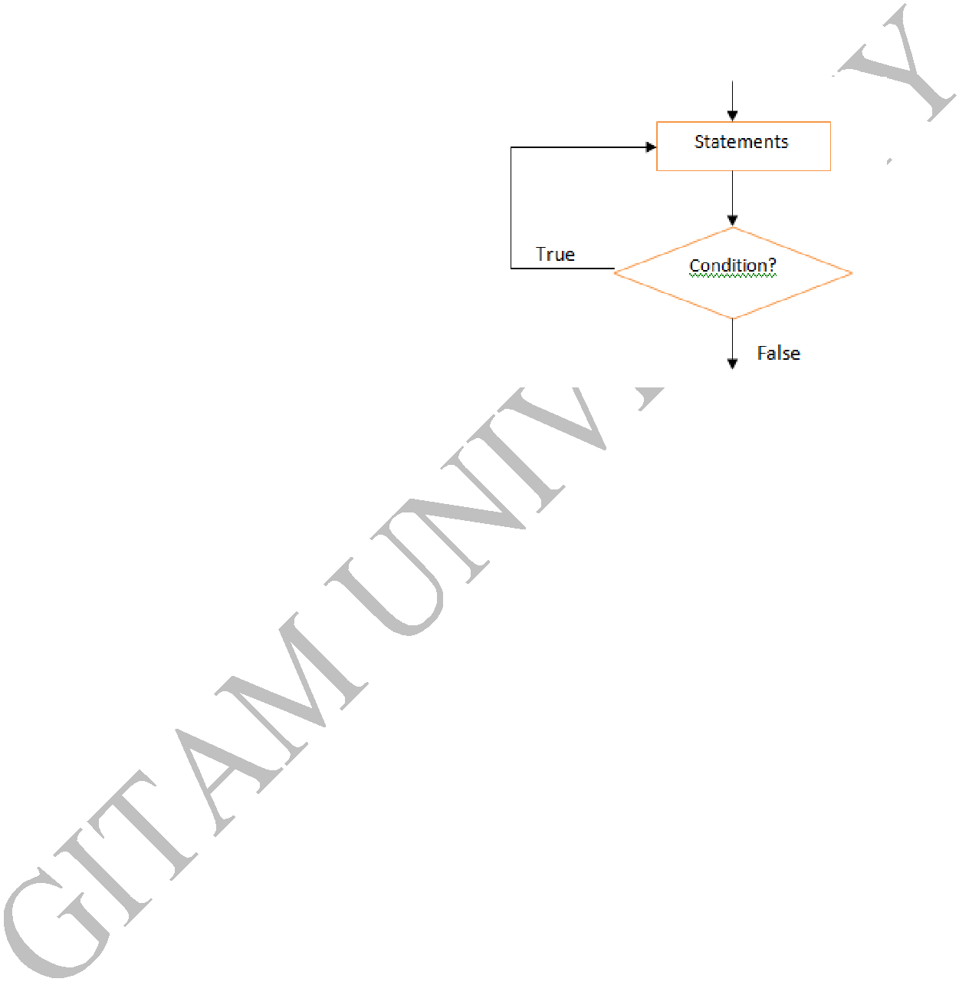

Syntax:

do

{

Statement(s);

} while (condition);

Example Programs

1. Write a C program to add numbers until user enters zero

#include <stdio.h>

int main()

{

double number, sum = 0;

loop body is executed at least once

do

{

printf("Enter a number: ");

scanf("%lf", &number);

sum += number;

}while(number != 0.0);

printf("Sum = %.2lf",sum);

return 0;

13 Dept. of CSE & IT GIT, GU.

}

Output

Enter a number: 1.5

Enter a number: 2.4

Enter a number: -3.4

Enter a number: 4.2

Enter a number: 0

Sum = 4.70

- Write a C program to print all the leap years from 2010 to 2016.

#include<stdio.h>

main()

{

int m=2010, n=2016;

do

{

if(m%4==0)

printf(“\n %d is a leap year”,m); else

printf(“\n %d is not a leap year”,m); m=m+1;

} while (m<=n);

}

Output

......

2012 is a leap year

2013 is not a leap year

14 Dept. of CSE & IT GIT, GU.

......

2016 is a leap year

1.9. Nested Loops

- A nested loop refers to a loop that is continued within another loop.

- If the program has to repeat a loop more than once, the nested loop is preferably used.

- In nested loops, the inner loop executes until the loop condition fails and once the condition of the inner loop is failed then it comes out of that loop.

- Thereby, the outer loop variable changes its initial value making it feasible for the next iteration.

- This process continues until the condition mentioned in the outer loop goes wrong. Hence the total number of iterations in case of nested loops is given by the product of number of iterations of inner loop with number of iterations of outer loop.

- The possible skeletal syntaxes of nested loops are as given below:

For nested in for loop:

for( ; ;)

{

for( ; ;)

{

Statements of the inner loop;

}

}

For nested in while loop:

while(condition)

{

for( ; ;)

{

Statements of the inner loop;

}

}

For while nested in for loop:

15 Dept. of CSE & IT GIT, GU.

for( ; ;)

{

while(condition)

{

Statements of the inner loop;

}

}

- The nesting of loops concept can be applied in a variety of forms such as while loop within a while, while within do-while etc depending upon the application to be developed.

Example Programs

1.Write a C program to print the following pattern

*

* *

* * *

* * * *

#include<stdio.h>

main()

{

int i,j:

for(i=1;i<=4;i++)

{

for(j=1;j<=i;j++)

{

printf(“*\t”);

}

printf(“\n”);

}

16 Dept. of CSE & IT GIT, GU.

}

Output

*

* *

* * *

* * * *

- Write a C program to print the following pattern

- 2

- 3 3

- 4 4 4

#include<stdio.h>

main()

{

int i,j,n,a=1;

printf(“Enter the number of rows:\t”); scanf(“%d”,&n);

for(i=1;i<=n;i++)

{

for(j=1;j<=i;j++)

{

printf(“%d”,a);

a++;

}

printf(“\n”);

}

17 Dept. of CSE & IT GIT, GU.

}

Output

1

- 2

- 3 3

- 4 4 4

- Write a C program to print the pyramid using ‘*’

*

    - * *

  - * * * *

#include<stdio.h>

main()

{

int i,j,space,k=0:

printf(“Enter the number of rows:”);

scanf(“%d”,&j);

for(i=1;i<=j;i++)

{

for(space=1;space=j-i;space++)

{

printf(“ “);

}

while(k!=2*i-1)

{

printf(“*”);

k++;

18 Dept. of CSE & IT GIT, GU.

}

printf(“\n”);

}

}

Output

*

* * *

* * * * *

