**USER INTERFACE DESIGN**

Jyothi John M.P

S5 MCA LE

Roll NO:34

**TABLE DESIGN**

**Table no:1**

**Table : tbl_Login**

**Primary key : Log_id**

**Foreign key : Reg_id**

**Table description :To state all user login details**

|  |  |  |  |
| --- | --- | --- | --- |
| SL No | Field name | Data type | Description |
| 1 | Log_id | Int(20) | Primary key to identify each login |
| 2 | Reg_id | Int(20) | Id to identify each user |
| 3 | Username | Varchar(30) | User name of the user |
| 4 | Password | Varchar(30) | Password of the user |
| 5 | Status | Tiny int | Status of the user |
| 6 | Role | Int(20) | Role of the user |

**Table no:2**

**Table : tbl_Registration**

**Primary key : Reg_id**

**Foreign key : Add_id**

**Table description :To state all user registration details**

|  |  |  |  |
| --- | --- | --- | --- |
| SL No | Field name | Data type | Description |
| 1 | Reg_id | Int(20) | Primary key to identify each registration |
| 2 | Name | Varchar(30) | Name of the user |
| 3 | Add_id | Varchar(50) | Id to identify the address of the user |
| 4 | Phone | Int(20) | Phone number of the user |
| 5 | e-mail | Varchar(50) | e-mail address of the user |
| 6 | Status | Tiny int | Status of the user |

**Table no:3**

**Table : tbl_Comment**

**Primary key : Comment_id**

**Foreign key : Reg_id**

**Foreign key : Item_id**

**Foreign key : Package name**

**Table description :To state all user feedback**

|  |  |  |  |
| --- | --- | --- | --- |
| SL No | Field name | Data type | Description |
| 1 | Comment_id | Int(20) | Primary key to identify each user comments |
| 2 | Reg_id | Int(20) | Id to identify each user |
| 3 | Package name | Varchar(50) | To identify the package name user selected |
| 4 | Item_id | Int(20) | Id to identify the item each user selected |
| 5 | Comments | Varchar(50) | Comments of each user |
| 6 | Status | Tiny int | Status of the user |

**Table no:4**

**Table : tbl_Get for Quotation**

**Primary key : Quotation_id**

**Foreign key : Reg_id**

**Foreign key : Item_id**

**Foreign key : Add_id**

**Table description :To state all registered user details**

|  |  |  |  |
| --- | --- | --- | --- |
| SL No SLNo | Field name | Data type | Description |
| 1 | Quotation_id | Int(20) | Primary key to identify each user quotation |
| 2 | Reg_id | Int(20) | Id to identify each user |
| 3 | Item_id | Int(20) | Id to identify the item each user selected |
| 4 | Religion | Varchar(30) | Religion of the person whom getting married |
| 5 | Date | Date | Date for the function |
| 6 | Time | Time | Time for the function |
| 7 | Phone | Int(20) | Phone number of the user |
| 8 | Add_id | Int(20) | Address id of the user |
| 9 | Location | Varchar(30) | Location of the function |
| 10 | Status | Tiny int | Status of the user |

**Table no:5**

**Table : tbl_Package**

**Primary key : P_id**

**Table description :To state all package details**

|  |  |  |  |
| --- | --- | --- | --- |
| SL No | Field name | Data type | Description |
| 1 | P_id | Int(20) | Primary key to identify package |
| 2 | Package name | Varchar(30) | Available package name |
| 3 | Status | Tiny int | Status of the user |

**Table no:6**

**Table : tbl_Item**

**Primary key : Item_id**

**Table description :To state all item details**

|  |  |  |  |
| --- | --- | --- | --- |
| SL No | Field name | Data type | Description |
| 1 | Item_id | Int(20) | Primary key to identify all item |
| 2 | P_id | Int(20) | Key to identify package |
| 3 | Item description | Varchar(100) | Description about the item |
| 4 | Rate | Int(20) | Rate for the item |
| 5 | Status | Tiny int | Status of the user |

**Table no:7**

**Table : tbl_Address**

**Primary key : Add_id**

**Table description :To state all users address details**

|  |  |  |  |
| --- | --- | --- | --- |
| SL No | Field name | Data type | Description |
| 1 | Add_id | Int(20) | Primary key to identify users address |
| 2 | Line1 | Varchar(100) | Address |
| 3 | Line2 | Varchar(100) | Address |
| 4 | Line3 | Varchar(100) | Address |
| 5 | City | Varchar(100) | City name of users |
| 6 | Pin | Int(20) | Pin number |

**Table no:8**

**Table : tbl_Account**

**Primary key : Acc_id**

**Table description :To state all users account details**

|  |  |  |  |
| --- | --- | --- | --- |
| SL No | Field name | Data type | Description |
| 1 | Acc_id | Int (20) | Primary key to identify users bank account |
| 2 | Acc no | Varchar(30) | Account number of the user |
| 3 | Pin | Int(20) | Pin number of the user |
| 4 | Card no | Varchar(30) | Card number of the user |
| 5 | Balance | Int(20) | Balance amount of the user account |
| 6 | Status | Tiny int | Status of the user |

**Table no:9**

**Table : tbl_Bank details**

**Primary key : Bank_id**

**Table description :To state all users bank details**

|  |  |  |  |
| --- | --- | --- | --- |
| SL No | Field name | Data type | Description |
| 1 | Bank_id | Varchar(30) | Primary key to identify users bank details |
| 2 | Bank name | Varchar(30) | Bank name of the user have accont |
| 3 | Branch name | Varchar(30) | Branch name of the bank |
| 4 | IFSC code | Varchar(30) | IFSC code of the bank |

**Table no:10**

**Table : tbl_Payment types**

**Primary key : Pay_id**

**Table description :To state all users payment type details**

|  |  |  |  |
| --- | --- | --- | --- |
| SL No | Field name | Data type | Description |
| 1 | Pay_id | Int(20) | Primary key to identify users payment details |
| 2 | Payment types | Varchar(30) | Type of payment of the user |

**Table no:11**

**Table : tbl_Payment details**

**Primary key : Details_id**

**Foreign key: Pay_id**

**Foreign key: Bank_id**

**Foreign key: Item_id**

**Foreign key: Reg_id**

**Table description :To state all users payment details**

|  |  |  |  |
| --- | --- | --- | --- |
| SL No | Field name | Data type | Description |
| 1 | Details_id | Int (20) | Primary key to identify users payment details |
| 2 | Pay_id | Int(20) | Id to identify users payment |
| 3 | Bank_id | Int(20) | Id to identify users bank details |
| 4 | Item_id | Int(20) | Id to identify item details |
| 5 | Reg_id | Int(20) | Id to identify users registration details |
| 6 | Date | Date | To identify date of payment |
| 7 | Amount | Int(20) | Amount details |

**Table no:12**

**Table : tbl_Add to cart**

**Primary key : Cart_id**

**Foreign key: Log_id**

**Foreign key: Item_id**

**Table description :To state all selected items details to cart**

|  |  |  |  |
| --- | --- | --- | --- |
| SL No | Field name | Data type | Description |
| 1 | Cart_id | Int (20) | Primary key to identify add to cart details |
| 2 | Log_id | Int(20) | Id to identify users login details |
| 3 | Item_id | Int(20) | Id to identify item details |
| 4 | Quantity | Int(20) | To identify quantity of item selected |
| 5 | Cost | Float | To identify cost of items |
| 6 | Status | Tiny int | Status of the user |

FORM DESIGN

Login

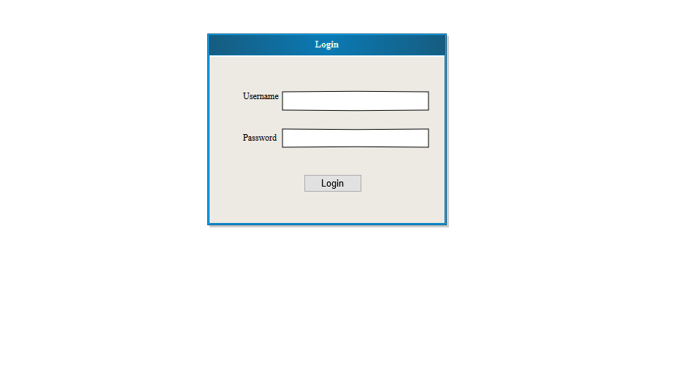Rgistration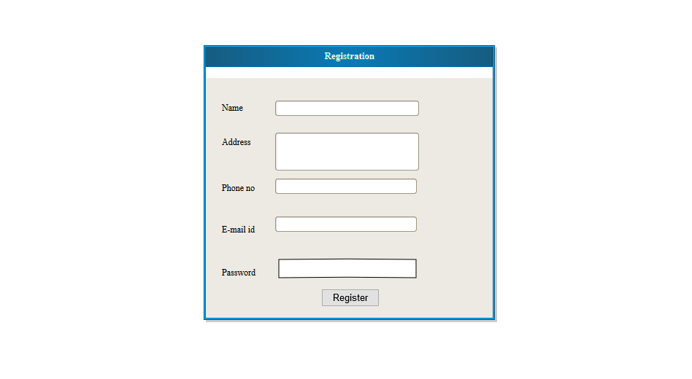

Add-on

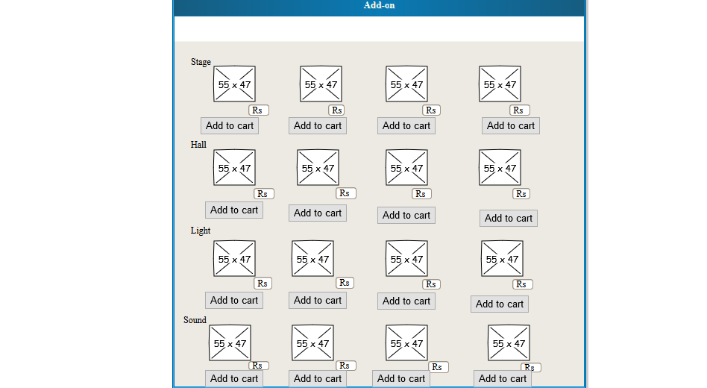

Catering

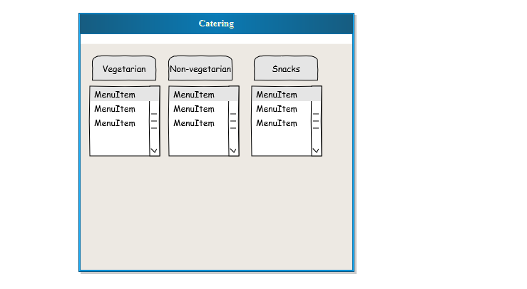

Sadya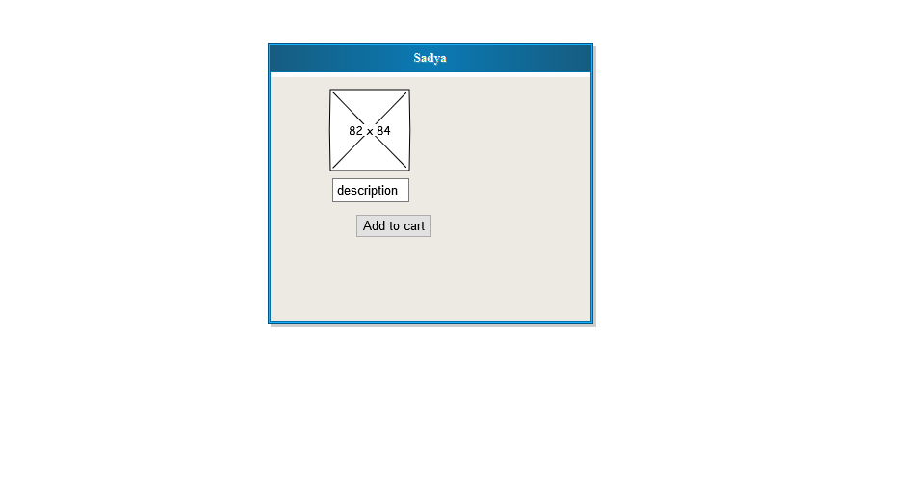

Get for Quotation

