📄 JYSKRA SHOPPING APPLICATION
(Online E-Commerce System)
A Course Project Report
Submitted in the partial fulfillment of the completion of the course
23CS002PC304-AI Assisted Coding
In III Year II Semester B. Tech-CSE

Submitted by
N.Jyothi Rao
2303A52115

Under the supervision of the faculty
Mr.MD.Salauddin
Assistant Professor, SoCS & AI
Academic Year 2025-2026


Department of Computer Science & Artificial Intelligence
SR University
Warangal, Telangana, India

INDEX

- Introduction…………………………………………………..3
- Project Objectives……………………………………………3
- Problem Statement…………………………………………...3
- Literature Review…………………………………………….4
- Methodology / System Design……………………………….4
- Architecture Overview……………………………………….7
- Implementation………..……………………………………..7
- Promts………………………………………………………..8
- Output and Visualization …………………………………….9
- Performance analysis……………………………………….14
- Advantages……………………………………………………14
- Limitations……………………………………………………15
- Future Enhancements…………………………………………15
- Conclusion…………………………………………………….15

1. INTRODUCTION
E-commerce has revolutionized the way people buy and sell products by enabling online transactions and digital interactions. Traditional shopping methods require physical presence and are time-consuming.
JYSKRA Shopping is a web-based e-commerce application developed to provide a seamless and efficient online shopping experience. The system allows users to browse products, add them to a cart, and place orders securely.
This project uses modern web technologies to create a scalable, user-friendly, and efficient platform for online shopping.

2. PROJECT OBJECTIVES
The main objectives of this project are:
- To develop a user-friendly shopping platform
- To enable secure user authentication
- To implement cart and order management
- To provide efficient product browsing
- To ensure scalable and cloud-based deployment
- To maintain secure session handling

3. PROBLEM STATEMENT
Traditional shopping systems face issues such as:
- Limited accessibility
- Time-consuming processes
- Lack of convenience
- Manual billing and tracking
The aim is to develop a system that provides a fast, secure, and convenient online shopping experience.

4. LITERATURE REVIEW
Modern e-commerce systems emphasize:
- Web-based platforms for accessibility
- Cloud deployment for scalability
- Secure authentication mechanisms
- Database-driven applications for efficient data handling
These concepts inspired the development of the JYSKRA Shopping system.
5. METHODOLOGY / SYSTEM DESIGN
The JYSKRA Shopping system is designed using a three-tier architecture, which separates the application into three independent layers: presentation layer, application layer, and data layer. This approach improves scalability, maintainability, and performance of the system.
i )Frontend Layer (Presentation Layer)
The frontend of the application is developed using HTML, CSS, JavaScript, and React. It provides a responsive and interactive user interface that allows users to interact with the system efficiently.
The user interface is designed to be simple, intuitive, and accessible across different devices such as desktops and mobile phones.
Key Features:
- Display of products with images and details
- User authentication (Login and Signup pages)
- Shopping cart interface for adding and managing items
- Smooth navigation between different pages
- Responsive design for better user experience
ii)Backend Layer (Application Layer)
The backend is implemented using Node.js and Express.js, which handle the business logic and API requests of the system.
This layer acts as a bridge between the frontend and the database, ensuring secure and efficient data processing.
Responsibilities:
- Handling user authentication and session management
- Managing product-related operations (add, update, delete)
- Processing cart operations and order placement
- Creating and managing RESTful APIs
- Handling errors and ensuring secure communication
iii) Database Layer (Data Layer)
The database layer uses MongoDB Atlas, a cloud-based NoSQL database, to store and manage application data.
MongoDB is chosen due to its flexibility, scalability, and ability to handle large amounts of data efficiently.
Data Stored:
- User information (name, email, password)
- Product details (name, price, description, images)
- Cart data (selected items and quantities)
- Order details (user orders and history)

System Workflow
The working of the JYSKRA Shopping system follows a sequential process to ensure smooth interaction between the user and the system.
Step-by-Step Workflow:
- UserAuthentication
The user logs into the system using valid credentials. If the user is new, they can register by creating an account.
- ProductBrowsing
After successful login, the user can view and browse the available products displayed on the platform.
- CartManagement
The user selects desired products and adds them to the shopping cart. The cart allows users to update quantity or remove items.
- OrderPlacement
Once the user finalizes the cart, they proceed to place an order. The system processes the request and confirms the order.
- DataStorage
All order details, including user information and product data, are securely stored in the database for future reference.

Flow chart

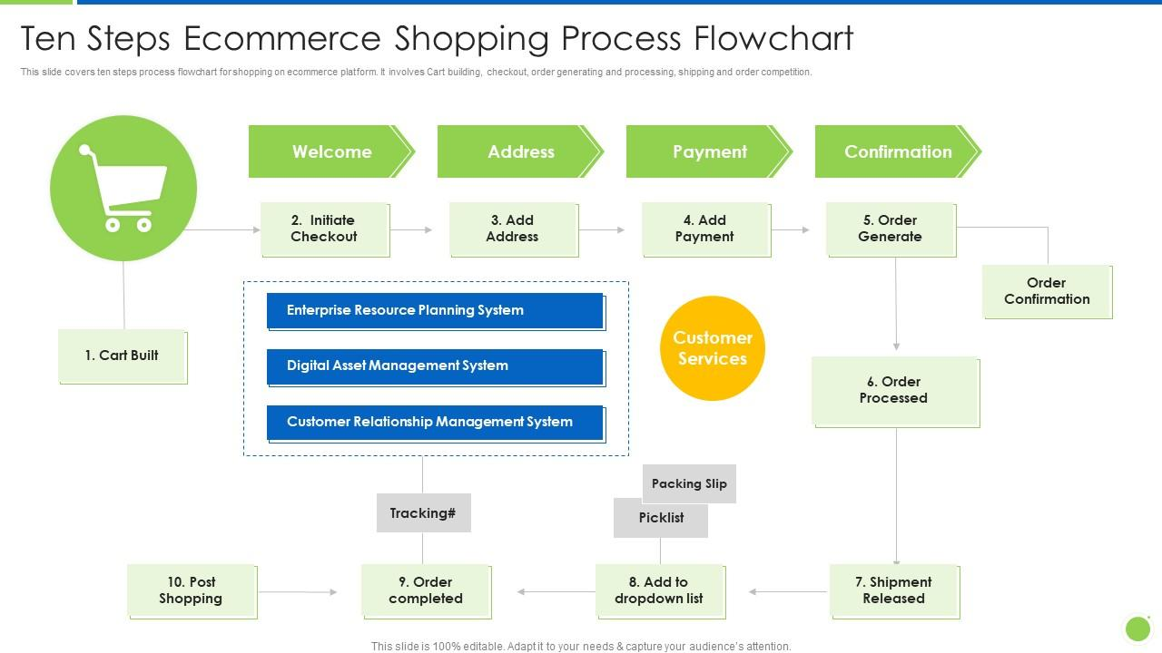

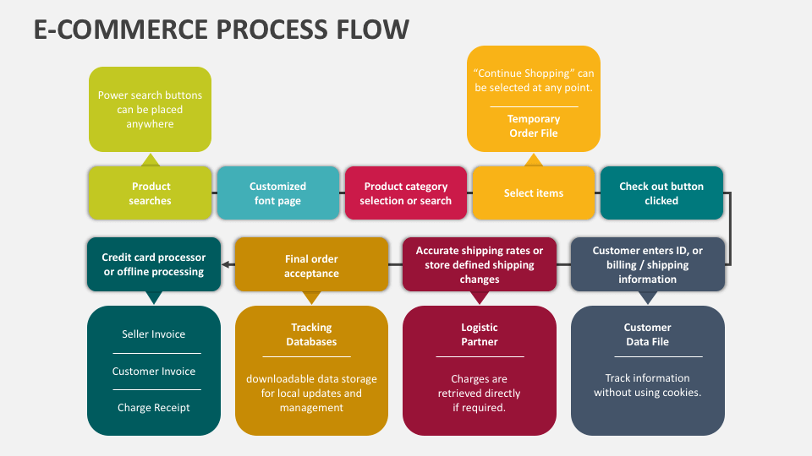
6.Architecture Overview
The JYSKRA Shopping system follows a structured client–server architecture, which ensures efficient communication between different components of the application.
The system follows this flow:

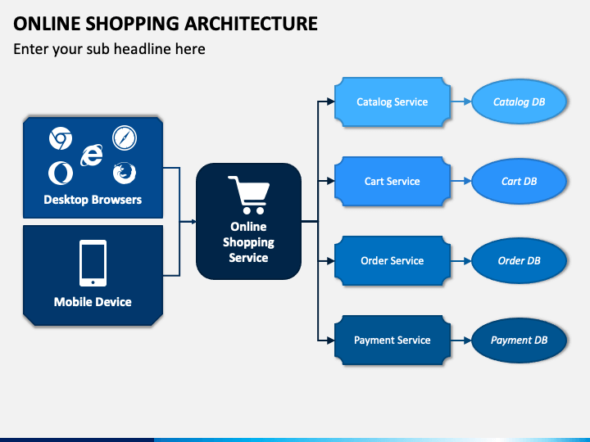
This ensures:
- Scalability
- Security
- Easy maintenan
7. IMPLEMENTATION
The implementation phase involves converting the system design into a fully functional application using modern web technologies. The system is divided into frontend, backend, and database components.
Frontend Implementation
The frontend of the application is developed using React, which provides a dynamic and responsive user interface.
Key Features:
- Responsive design for different devices
- Interactive user interface
- Integration with backend APIs for real-time data
Backend Implementation
The backend is developed using Node.js and Express.js, which handle the application logic and API processing.
Key Features:
- RESTful APIs for communication
- Session-based authentication for secure access
- Efficient request and response handling
Modules
The system is divided into the following functional modules:
- Authentication Module: Handles user registration and login
- Product Module: Manages product details and listings
- Cart Module: Handles adding, updating, and removing items
- Order Module: Processes user orders and maintains order history

Database Implementation
The system uses MongoDB for data storage.
Collections:
- Users: Stores user information
- Products: Stores product details
- Orders: Stores order records
- Cart: Stores user cart data
Deployment
- The application is deployed using cloud platforms:
- Backend is deployed on Railway
- Frontend is deployed on Vercel
- This ensures scalability, availability, and easy access to the application.

8.PROMTS
During the development of the JYSKRA Shopping application, various prompts were used to guide the implementation and improve functionality. These prompts helped in generating code, fixing issues, and enhancing system features.
- “Build an e-commerce shopping website with frontend and backend integration”
- “Create backend APIs for product management and cart functionality”
- “Implement user authentication system with login and registration features”
- “Connect the application to MongoDB database for data storage”
- “Deploy the backend application using Railway”
- “Deploy the frontend application using Vercel”
- “Fix CORS issues and ensure proper API communication between frontend and backend”
Explanation
These prompts were used iteratively during development to:
- Generate initial project structure
- Build and integrate different modules
- Debug errors and fix deployment issues
- Optimize performance and improve user experience
9. OUTPUT AND VISUALIZATION
The JYSKRA Shopping system generates structured outputs through different interfaces and modules. These outputs provide users with clear information, real-time updates, and an efficient shopping experience.
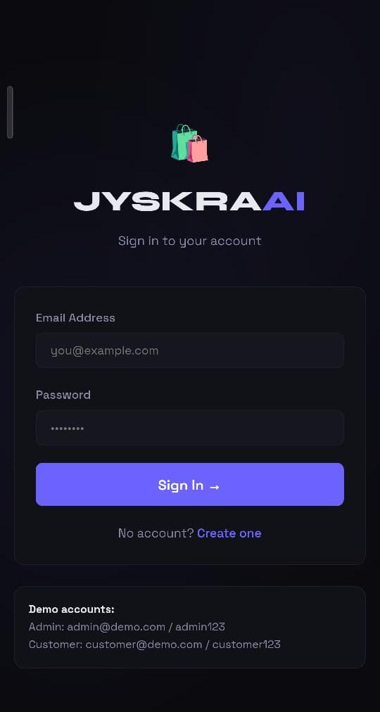
1. Admin Dashboard Output
The Admin Dashboard acts as the central control panel of the JYSKRA Shopping system. It provides a comprehensive overview of all system activities and enables efficient management of users, products, and orders.
Key Outputs:
- Total number of registered users
- Available products and stock details
- Order statistics and transaction records
- System activity logs
Admin Functionalities:
- Add, update, or remove users
- Manage product listings and stock quantities
- Monitor orders and user activities
- Analyze system performance
This dashboard ensures centralized control, transparency, and efficient management of the entire e-commerce system.


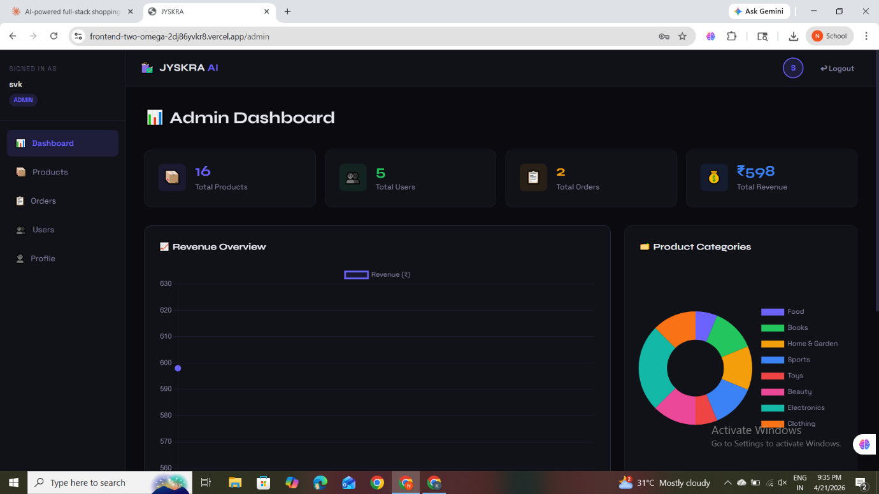

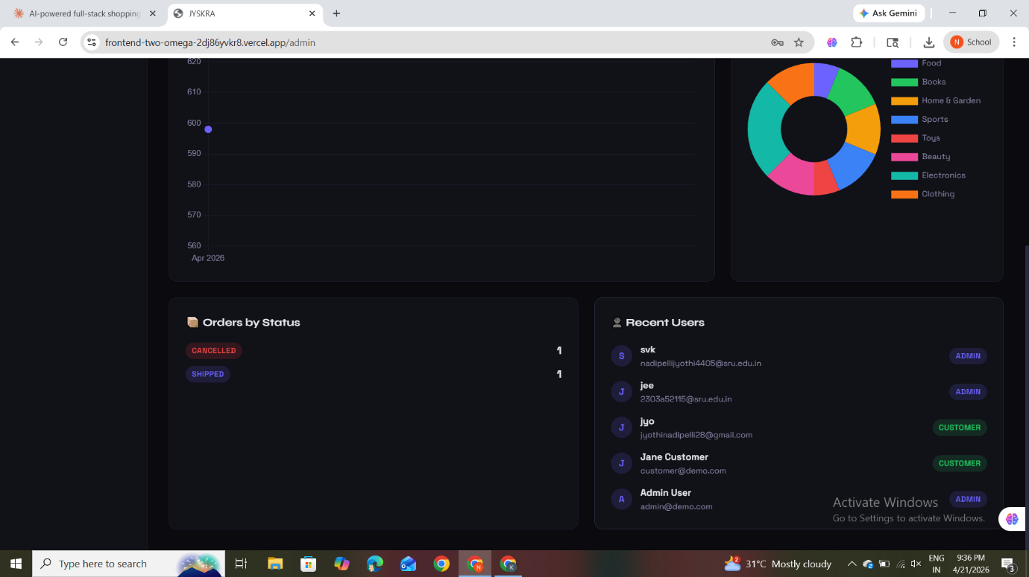

2. Customer Dashboard Output
The Customer Dashboard provides users with a personalized interface to interact with the JYSKRA Shopping system. It allows customers to browse products, manage their cart, and track orders efficiently.
Key Outputs:
- List of available products with details
- User-specific cart items
- Order history and purchase details

Functional Outputs:
- Selection of products for purchase
- Adding and removing items from the cart
- Updating product quantities
- Placing orders securely
- Viewing past orders and order status
This dashboard improves user experience by providing easy navigation, real-time updates, and efficient order management, reducing manual effort and ensuring smooth online shopping.
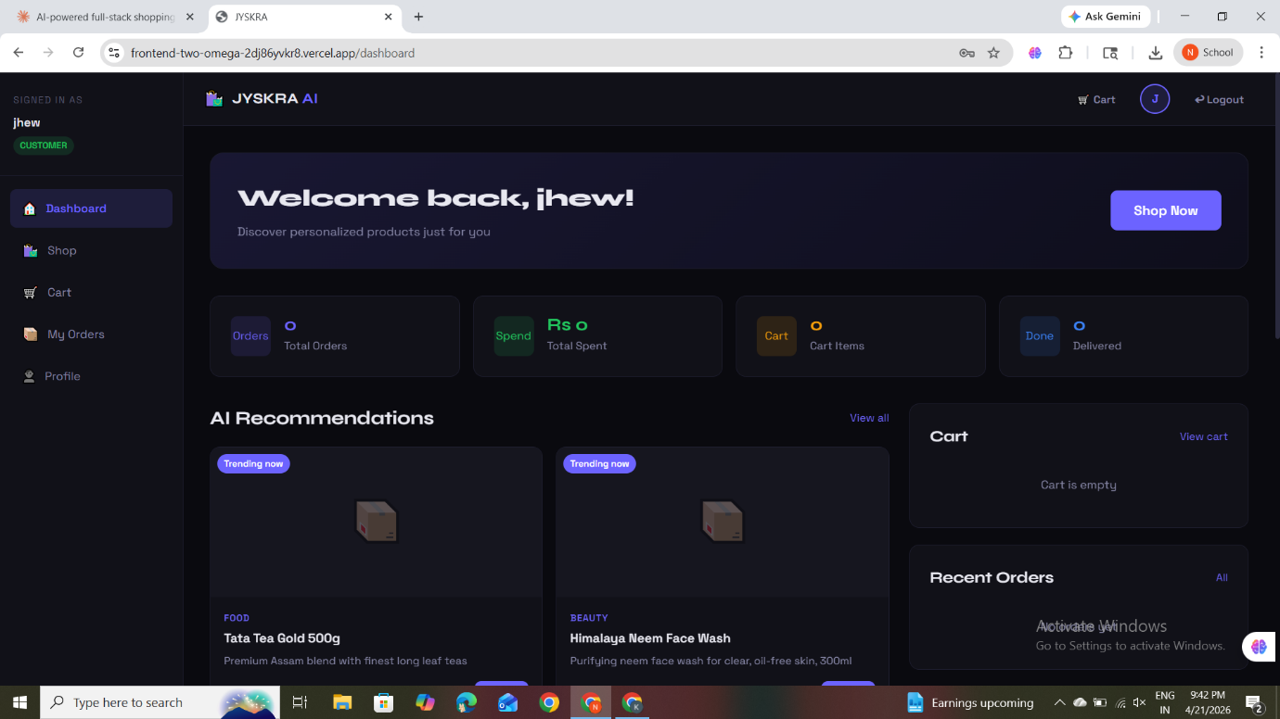

3. Beneficiary Interface Output
The Customer Interface provides personalized information to users regarding their shopping activities in the JYSKRA Shopping system.
Key Outputs:
- Order history of the user
- Details of purchased products
- Status of orders (pending, shipped, delivered)
Functional Outputs:
- View previous transactions
- Track current order status
- Access detailed information about purchased items
This interface enhances transparency and user convenience by allowing customers to track their orders and verify purchase details without relying on manual processes.

.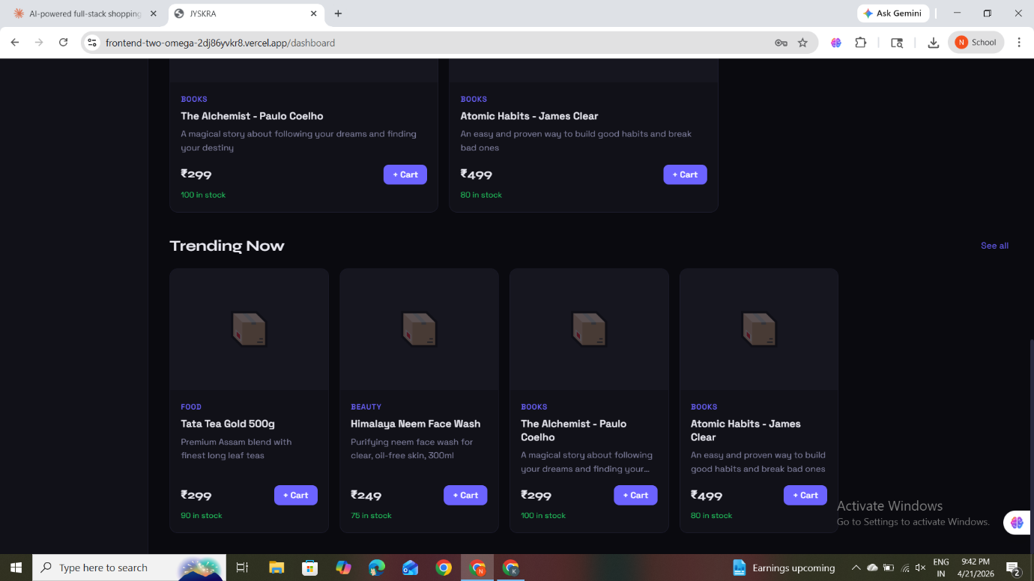

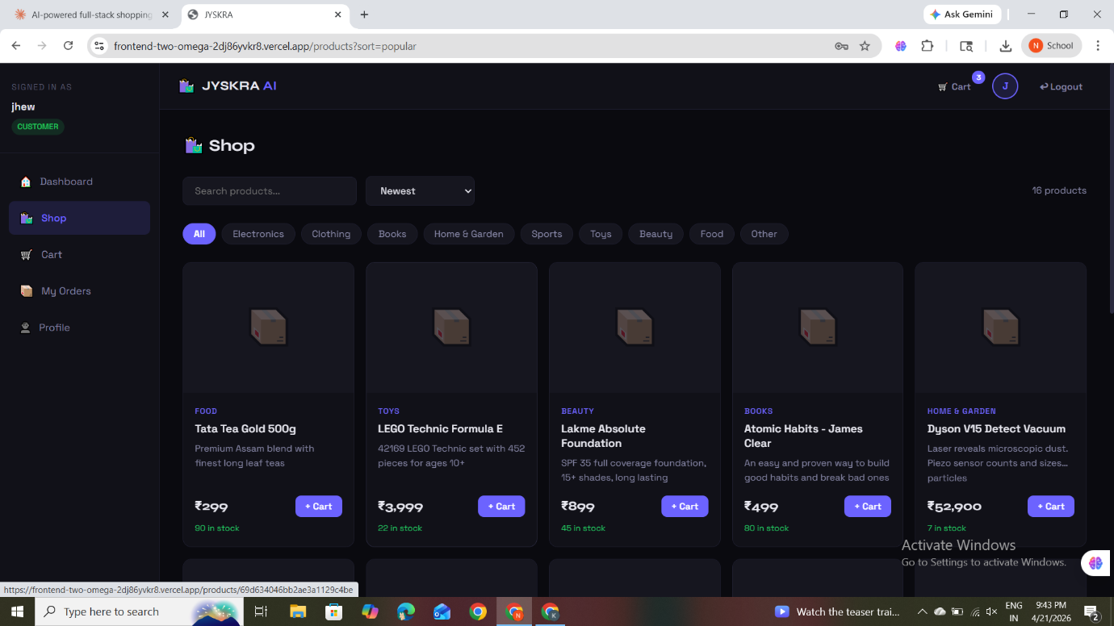

4. Transaction Logs
The system maintains a detailed record of all user transactions within the JYSKRA Shopping application. These logs help in tracking user activity, monitoring system performance, and ensuring data accuracy.
Key Details Stored:
- User ID and user information
- Date and time of each transaction
- Products purchased and quantity
- Total order amount
Purpose:
- Maintain complete transaction history
- Track user activities and purchases
- Support auditing and analysis
- Ensure transparency and data consistency
All transaction records are securely stored in MongoDB and can be retrieved whenever required for monitoring, reporting, and analysis purposes.

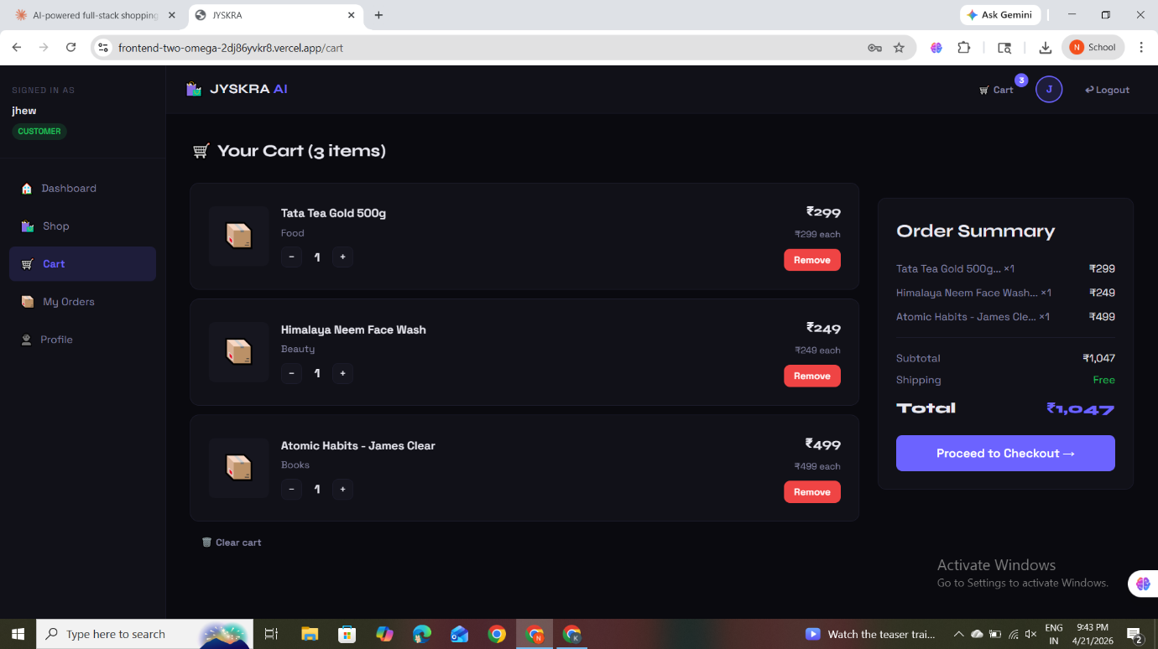
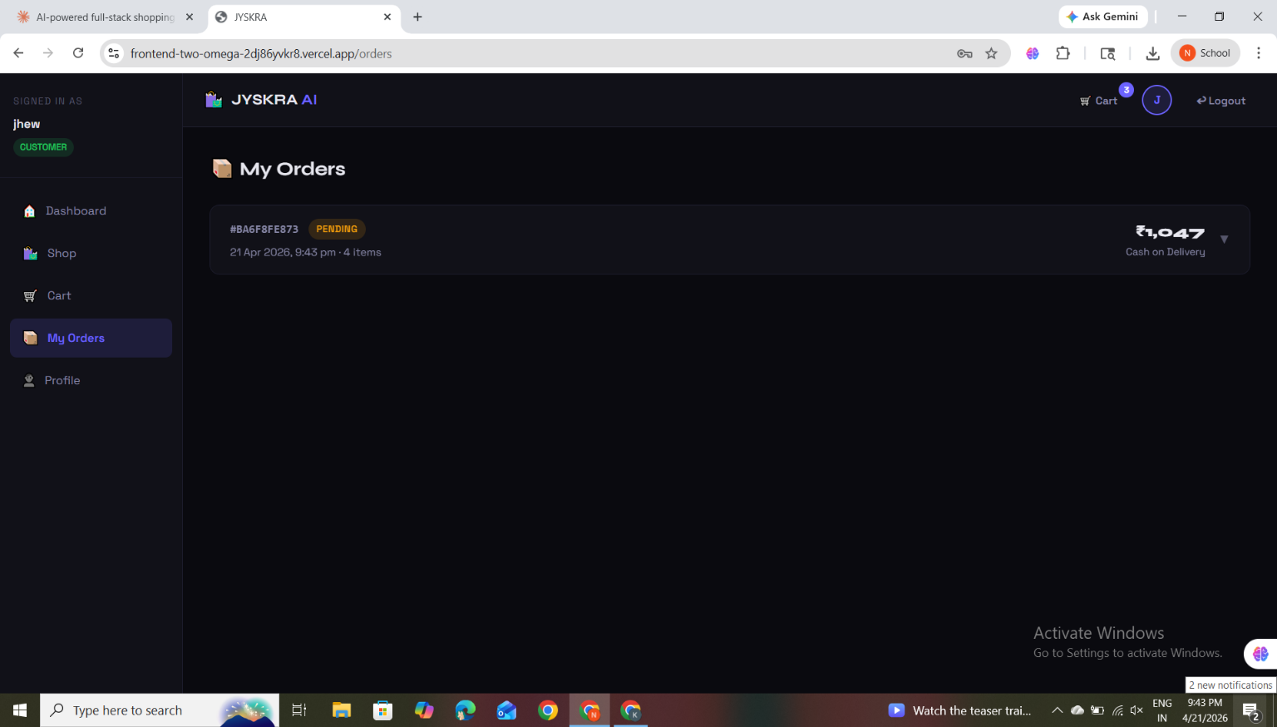
10. PERFORMANCE ANALYSIS
The performance of the JYSKRA Shopping system is evaluated based on the following parameters:
a) Response Time
The system provides fast response times due to:
- Efficient backend processing using Node.js and Express
- Optimized database queries in MongoDB
- Smooth API communication between frontend and backend
b) Scalability
With cloud deployment, the system can:
- Handle multiple users simultaneously
- Scale resources dynamically based on user demand
- Support future expansion without performance degradation
c) Reliability
- Data is securely stored in MongoDB Atlas
- System ensures consistency of transactions
- Proper error handling ensures stable performance
d) Efficiency
Automation in the system reduces:
- Manual workload
- Processing time
- Human errors
11. ADVANTAGES
The JYSKRA Shopping system offers several advantages:
- User-Friendly: Simple and intuitive interface
- Efficiency: Automates shopping and order processes
- Accuracy: Reduces manual errors
- Scalability: Cloud-based architecture supports growth
- Security: Secure authentication and session handling
- Accessibility: Users can access the system anytime, anywhere

12. LIMITATIONS
Despite its advantages, the system has some limitations:
- Requires stable internet connectivity
- Dependent on cloud services for deployment
- Limited offline functionality
- Payment gateway may not be fully integrated (if not implemented)

13. FUTURE ENHANCEMENTS
The system can be further improved by:
- Integrating online payment gateways (Stripe/Razorpay)
- Developing a mobile application
- Adding AI-based product recommendation system
- Implementing real-time notifications (SMS/Email)
- Creating advanced analytics dashboards
- Supporting multi-language interfaces

14. CONCLUSION
The JYSKRA Shopping application successfully demonstrates the development of a full-stack e-commerce system using modern technologies.
By implementing features such as product browsing, cart management, order processing, and secure authentication, the system provides a seamless online shopping experience.
The use of cloud deployment and scalable architecture ensures that the application is efficient, secure, and adaptable to future enhancements. This project highlights the importance of digital platforms in transforming traditional shopping into a convenient and accessible experience

