**A)**

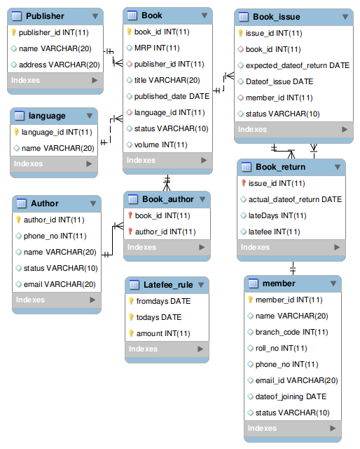

**B)**

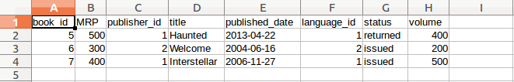

mysql> select * from Book;

+---------+------+--------------+--------------+----------------+-------------+----------+--------+

| book_id | MRP | publisher_id | title | published_date | language_id | status | volume |

+---------+------+--------------+--------------+----------------+-------------+----------+--------+

| 1 | 500 | 2 | Keralam | 2012-05-25 | 2 | issued | 100 |

| 2 | 300 | 1 | Aarachar | 2020-08-21 | 2 | issued | 200 |

| 4 | 200 | 2 | Heaven | 2005-05-25 | 1 | issued | 400 |

| 5 | 500 | 1 | Haunted | 2013-04-22 | 1 | returned | 400 |

| 6 | 300 | 2 | Welcome | 2004-06-16 | 2 | issued | 200 |

| 7 | 400 | 1 | Interstellar | 2006-11-27 | 1 | issued | 500 |

| 10 | 100 | 1 | My life | 2003-03-20 | 1 | issued | 300 |

| 11 | 100 | 1 | The shallows | 2003-03-20 | 1 | issued | 300 |

| 101 | 600 | 2 | Journey | 2018-07-22 | 2 | issued | 300 |

| 123 | 200 | 1 | Journey | 2021-02-05 | 1 | returned | 20 |

+---------+------+--------------+--------------+----------------+-------------+----------+--------+

**C)**

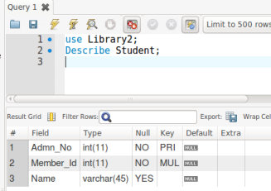

**D)**

LOAD DATA LOCAL INFILE '/home/student/Documents/mock.csv' into TABLE Student FIELDS TERMINATED BY ','LINES TERMINATED BY '\n' IGNORE 1 ROWS(Admn_No,Member_id,Name);

mysql> select * from Student;

+---------+-----------+---------+

| Admn_No | Member_Id | Name |

+---------+-----------+---------+

| 2 | 1 | Susan |

| 3 | 15 | Ramesh |

| 4 | 15 | kingpin |

| 5 | 1 | Susan |

| 6 | 99 | jammy |

| 7 | 15 | Smith |

| 8 | 15 | Adam |

| 9 | 99 | Arun |

| 14 | 10 | Ozil |

| 16 | 15 | Son |

| 17 | 99 | Ming |

| 24 | 1 | Susan |

| 25 | 10 | Rohit |

| 26 | 5 | |

| 36 | 5 | |

+---------+-----------+---------+

**E)**

CREATE INDEX Member_id ON Book_issue(member_id);

CREATE INDEX Book_id ON Book_issue(book_id);

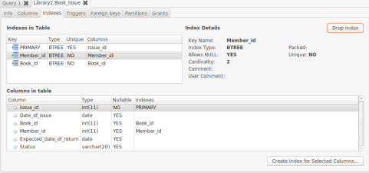

**F)**

UPDATE `Library2`.`Student` SET `Branch`='CS' WHERE `Member_id`='1';

UPDATE `Library2`.`Student` SET `Branch`='Civil' WHERE `Member_id`='99';

UPDATE `Library2`.`Student` SET `Branch`='EC' WHERE `Member_id`='5';

mysql> select * from Student;

+---------+-----------+---------+--------+

| Admn_No | Member_Id | Name | Branch |

+---------+-----------+---------+--------+

| 2 | 1 | Susan | NULL |

| 3 | 15 | Ramesh | NULL |

| 4 | 15 | kingpin | NULL |

| 5 | 1 | Susan | NULL |

| 6 | 99 | jammy | Civil |

| 7 | 15 | Smith | NULL |

| 8 | 15 | Adam | NULL |

| 9 | 99 | Arun | Civil |

| 14 | 10 | Ozil | NULL |

| 16 | 15 | Son | NULL |

| 17 | 99 | Ming | Civil |

| 24 | 1 | Susan | CS |

| 25 | 10 | Rohit | NULL |

| 26 | 5 | | EC |

| 36 | 5 | | EC |

+---------+-----------+---------+--------+

**G)**

UPDATE Student SET Name = 'Susan' WHERE member_id = 1;

DELETE FROM member WHERE member_id = 5;

mysql> select * from Student;

+---------+-----------+---------+--------+

| Admn_No | Member_Id | Name | Branch |

+---------+-----------+---------+--------+

| 2 | 1 | Susan | NULL |

| 3 | 15 | Ramesh | NULL |

| 4 | 15 | kingpin | NULL |

| 5 | 1 | Susan | NULL |

| 6 | 99 | jammy | Civil |

| 7 | 15 | Smith | NULL |

| 8 | 15 | Adam | NULL |

| 9 | 99 | Arun | Civil |

| 14 | 10 | Ozil | NULL |

| 16 | 15 | Son | NULL |

| 17 | 99 | Ming | Civil |

| 24 | 1 | Susan | CS |

| 25 | 10 | Rohit | NULL |

| 26 | NULL | | EC |

| 36 | NULL | | EC |

+---------+-----------+---------+--------+

**H)**

DROP table Student;