**MYSQL PROCEDURES**

**1.FIBONACCI SERIES**

delimiter $$

truncate fib;

CREATE PROCEDURE fibonacci(in n int)

begin

declare i int;

declare n1 int;

declare n2 int;

declare next int;

set n1 = 0;

set n2 = 1;

set next = n1+n2;

if(n=0) then

insert into fib values(n1);

elseif(n=1) then

insert into fib values(n1);

insert into fib values(n2);

else

insert into fib values(n1);

insert into fib values(n2);

set i = 3;

while i<n do

insert into fib values(next);

set n1 = n2;

set n2 = next;

set next = n1+n2;

set i = i+1;

end while;

end if;

end

$$

call fibonacci(9);

select * from fib;

**OUTPUT**

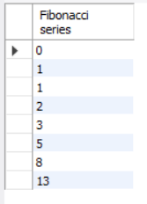

**PALINDROME**

CREATE PROCEDURE palindrome(in s varchar(15))

begin

declare r varchar(15);

declare a int;

set r = reverse(s);

set a = strcmp(s,r);

if a = 0 then

select 'Palindrome' as result;

else

select 'Not Palindrome' as result;

end if;

end

**OUTPUT**

call palindrome('car');



call palindrome('malayalam');

