Name: Jyothiradithya Neti
Contact Number: 9963831217
Email Id: jyothiradithya23@gmail.com
Assignment-2:
import java.util.Scanner; // Importing Scanner class for taking user input
// Main class definition
public class ceaser_cipher {
public static void main(String[] args) {
// Create a Scanner object to take input from user
Scanner sc = new Scanner(System.in);
// Boolean variable to control the while loop
boolean val = true;
// Loop runs continuously until user chooses to exit (option 3)
while (val) {
// Display the available menu options
display();
// Ask user to enter an option
System.out.println("Enter the option (1.Encrypt, 2.Decrypt, 3.Exit): ");
int s = sc.nextInt(); // Takes numeric option input
sc.nextLine(); // Consumes the leftover newline character
// Switch case based on user’s choice
switch (s) {
case 1: // Case for encryption
System.out.println("Enter the text to encrypt: ");
String text = sc.nextLine(); // Read the full text (can include spaces)
System.out.println("Enter the key (single digit): ");
int key = sc.nextInt(); // Read the key (shift value)
sc.nextLine(); // Consume leftover newline
// Call the encryption function
String encrypt = encrypted(text, key);
// Display the encrypted result
System.out.println("Encrypted String: " + encrypt);
System.out.println("--------");
break;
case 2: // Case for decryption
System.out.println("Enter the text to decrypt: ");
String text1 = sc.nextLine(); // Read the encrypted text
System.out.println("Enter the key (single digit): ");
int key1 = sc.nextInt(); // Read the same key used for encryption
sc.nextLine(); // Consume leftover newline
// Call the encrypted text
String encText = encrypted(text1, key1);
// Call the decryption function
String decrypt = decrypted(encText, key1);
// Display the decrypted result
System.out.println("Encrypted String: " + encText);
System.out.println("Decrypted String: " + decrypt);
System.out.println("--------");
break;
case 3: // Case to exit the program
val = false; // Set loop variable to false → loop stops
System.out.println("Exiting... Goodbye!");
break;
default: // Handles invalid option input
System.out.println("Invalid option! Try again.");
}
}
// Close the scanner to free resources
sc.close();
}

// ------------------- ENCRYPTION FUNCTION -------------------
public static String encrypted(String text, int key) {
String result = ""; // String to store the final encrypted text
// Loop through each character of the input text
for (int i = 0; i < text.length(); i++) {
char c = text.charAt(i); // Extract each character
// If character is uppercase (A–Z)
if (Character.isUpperCase(c)) {
// Shift within A–Z range using modulo to wrap around after Z
c = (char) (((c - 'A' + key) % 26) + 'A');
}
// If character is lowercase (a–z)
else if (Character.isLowerCase(c)) {
// Shift within a–z range using modulo
c = (char) (((c - 'a' + key) % 26) + 'a');
}
// Non-alphabetic characters (spaces, digits, punctuation) remain unchanged
result += c;
}
// Return the final encrypted string
return result;
}

// ------------------- DECRYPTION FUNCTION -------------------
public static String decrypted(String text, int key) {
String result = ""; // String to store final decrypted text
// Loop through each character in the encrypted text
for (int i = 0; i < text.length(); i++) {
char c = text.charAt(i); // Extract character
// If character is uppercase
if (Character.isUpperCase(c)) {
// Reverse the shift (subtract key) and wrap using modulo
c = (char) (((c - 'A' - key + 26) % 26) + 'A');
}
// If character is lowercase
else if (Character.isLowerCase(c)) {
// Reverse shift for lowercase letters
c = (char) (((c - 'a' - key + 26) % 26) + 'a');
}
// Non-letter characters remain the same
result += c;
}
// Return the final decrypted text
return result;
}
// ------------------- DISPLAY MENU FUNCTION -------------------
public static void display() {
// This method displays the menu options every time the loop runs
System.out.println("Welcome to Caesar Cipher Algorithm");
System.out.println("Available Options:");
System.out.println("1. Encrypt a message");
System.out.println("2. Decrypt a message");
System.out.println("3. Exit");
System.out.println(); // Print a blank line for spacing
}
}
Output:
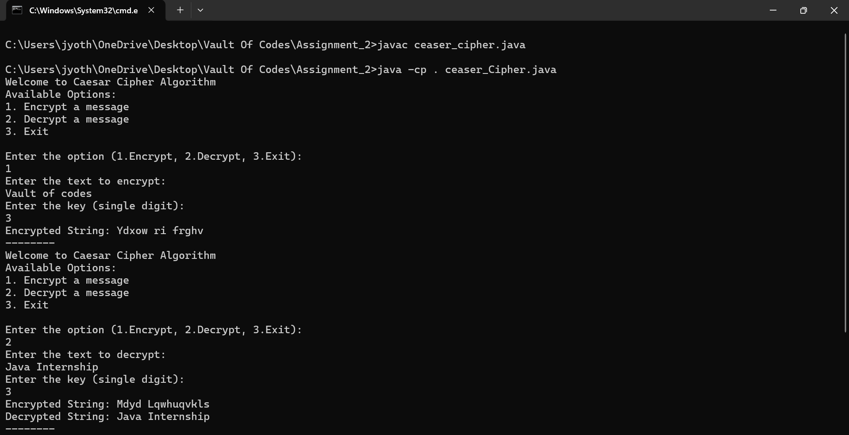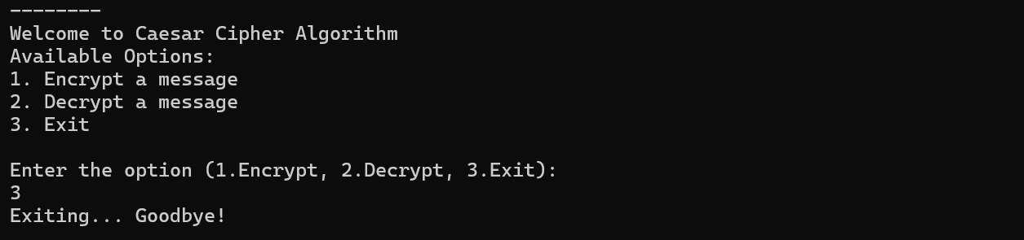

Github Link: https://github.com/jyothiradithya-2345/Internship

