**SMART SALINE SYSTEM**

**Project Report**

**By: -**

**Jyothi Raju (11612830) (29)**

Under the Guidance of

Mr. Manoj Kumar Shukla



School of Electrical and Electronics

Lovely Professional University

Punjab

May-2018

**Introduction**

The main theme of the project is to make the hosipitals a digital one. The secondary theme is save life of the people while injecting the saline into the patients . The process includes GSM module, which can give the message alrets to hosipital ward management people .and also with relay is a backup whenever there is any sms failed conditions then there will be bulb on the top of the bed that will glow green means everything is good ,if it glows red then there is something wrong in the system. The process will be saline weight will be calculated and when it comes to last 20% of the bottle then it will send message to nurse about the situation and if she not appeared then it will automatically reduces the speed using servo motor then when it comes to 10% then it will be send the message again and it reduces the flow of saline , and it can accept commands from the admin at any time if said to force stop then whole system will turned off . The can operate the entire system from their phone by giving single message from phone.then the servo motor can come online and makes the saline to turn off.

**Abstract**

The process will be saline weight will be calculated and when it comes to last 20% of the bottle then it will send message to nurse about the situation and if she not appeared then it will automatically reduces the speed using servo motor then when it comes to 10% then it will be send the message again and it reduces the flow of saline , and it can accept commands from the admin at any time if said to force stop then whole system will turned off . The can operate the entire system from their phone by giving single message from phone.then the servo motor can come online and makes the saline to turn off.

**Algorithm**

The algorithm we used in this to calculate the weight using load sensor is averaging weight calculation and then we use AT commands to send sms from gsm module and we make our own algorithm the understand the whole process then built the code as per the situation it needed and in the code we used so many Arduino library ‘s , inbuild functions and loops

**For calculating weight we used algorithm** :

count=count+1;

val=((count-1)/count)*val + (1/count)*cell.read();

val = cell.read();

estimatedWeight=(val-136601)/119.848f;

**For calculating percentage we used algorithm :**

percentage= map( estimatedWeight,0,500,0,100);

**For sending message we used algorithm :**

AT+CMGF=1

AT+CMGS=\"+919877614163\"\r

AT+CNMI=2,2,0,0,0

ATD+919877614163;

**Components**

**Arduino :**

The Arduino UNO is a widely used open-source microcontroller board based on the ATmega328P microcontroller and developed by Arduino. The board is equipped with sets of digital and analog input/output (I/O) pins that may be interfaced to various expansion boards (shields) and other circuits

The board features 14 Digital pins and 6 Analog pins. It is programmable with the Arduino IDE  (Integrated Development Environment) via a type B USB cable. It can be powered by a USB cable or by an external 9 volt battery, though it accepts voltages between 7 and 20 volts.

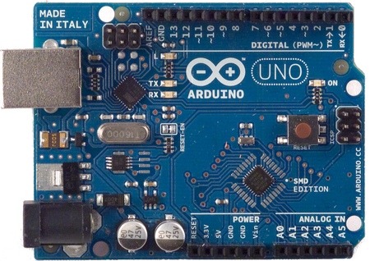

**Load Cell Sensor :**

Load cell is a type of transducer which performs the functionality of converting force into an electric output which can be measured. You can find load cell at the heart of any weighing machine or electric scales.

This type of transducer is highly accurate which provides user with required information that is difficult to obtain by other technology owing to certain commercial

It produces output in (mv) where Arduino can’t read the values in mv so we use HX711 (amplifier) which amplifies the small level signal to high level signal where Arduino can able to read .

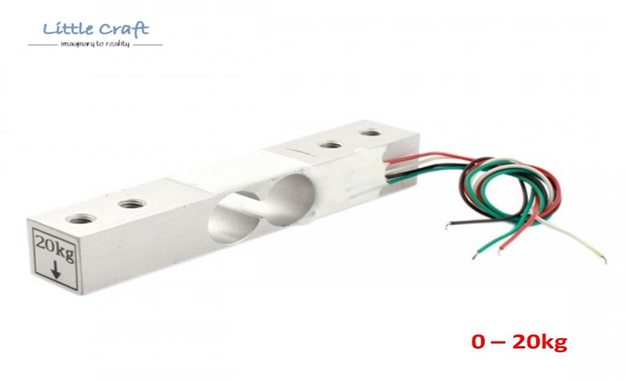

**HX711 (Amplifier) :**

HX711 is a precision 24-bit analogto-digital converter (ADC) designed for weigh scales and industrial control applications to interface directly with a bridge sensor.

HX711 Load Cell Amplifier Module uses 24 high-precision ADC converter chip hx711, is designed for high-precision electronic scale and design, with two analog input channels, the internal programmable gain amplifier integrated multiplier 128.The HX711 uses a two wire interface (Clock and Data) for communication.

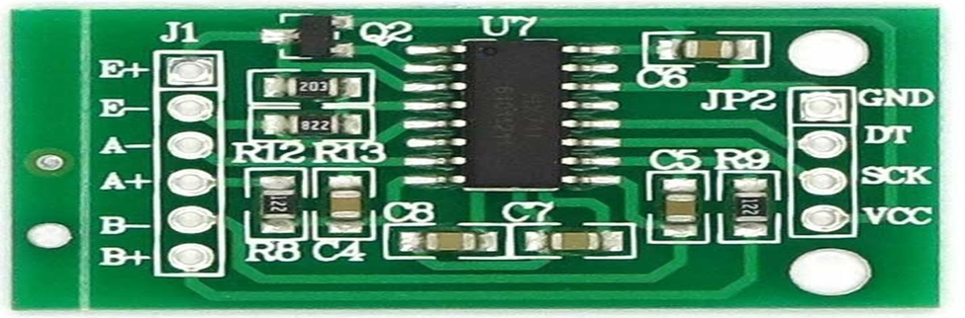

**GSM Module :**

A GSM modem is a device which can be either a mobile phone or a modem device which can be used to make a computer or any other processor communicate over a network.

A GSM modem requires a SIM card to be operated and operates over a network range subscribed by the network operator.  It can be connected to a computer through serial, USB .

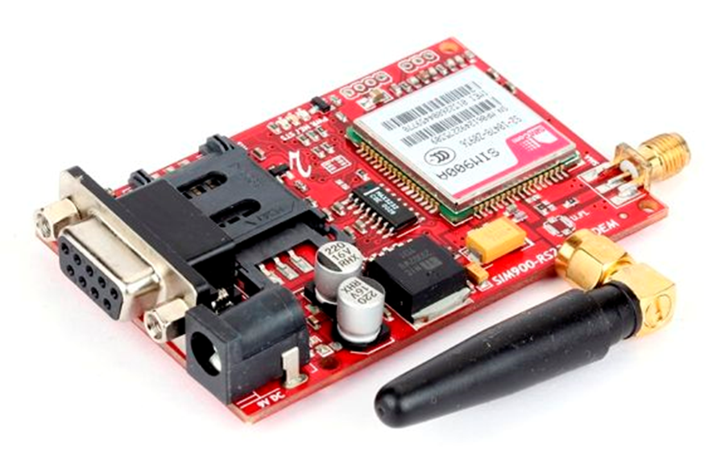

**Servo Motor :**

Tiny and light weight with high output power

Servo can rotate approximately 180 degrees(90 degrees in each direction), and works like standard kinds but smaller

A **servomotor** is a rotary actuator or linear actuator that allows for precise control of angular or linear position, velocity and acceleration. It consists of a suitable motor coupled to a sensor for position feedback. It also requires a relatively sophisticated controller, often a dedicated module designed specifically for use with servomotors.

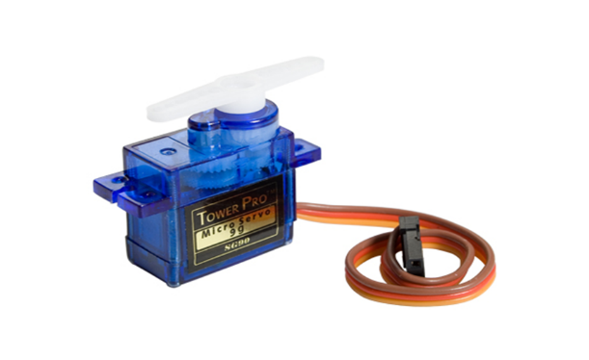

**Relay module:**

Relays are switches that open and close circuits electromechanically or electronically. Relays control one electrical circuit by opening and closing contacts in another circuit. As relay diagrams show, when a relay contact is normally open (NO), there is an open contact when the relay is not energized.

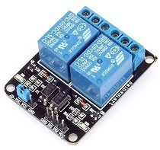

And many more like : Jumper Wires , Saline Bottle , Saline Wire , wood board , leds ,Bread board , etc..

**Working**

The process will be saline weight will be calculated and when it comes to last 20% of the bottle then it will send message to nurse about the situation and if she not appeared then it will automatically reduces the speed using servo motor then when it comes to 10% then it will be send the message again and it reduces the flow of saline , and it can accept commands from the admin at any time if said to force stop then whole system will turned off . The can operate the entire system from their phone by giving single message from phone.then the servo motor can come online and makes the saline to turn off.

**Connections Of System :**

**Load cell to HX711**

. red wire – E+

. black wire – E-

. white wire – A-

. green wire – A+

**HX711 to Arduino**

. Gnd – Gnd

. data pin – ard pin 2

. clk pin -- ard pin 3

. vcc – vcc

**GSM Module to Arduino**

. Gnd – Gnd

. TX – ard pin 1

. RX -- ard pin 0

**Servo Motor to Arduino**

. Gnd – Gnd

. Signal pin – ard pin 11

. vcc – vcc

**Relay to Arduino**

. Gnd – Gnd

. IN 1 – ard pin 5

. IN 2 -- ard pin 6

. vcc – vcc

**SMART SALINE SYSTEM**

**Code**

#include"HX711.h"

#include<Servo.h>

#include<SoftwareSerial.h>

#define RELAY1 5

#define RELAY2 6

SoftwareSerial mySerial(9,10);

HX711 cell(3,2);

Servo myServo;

long val=0;

float count=0;

int actualWeight=0;

int percentage=0;

int estimatedWeight=0;

char msg=0;

void setup()

{

Serial.begin(9600);

myServo.attach(11);

mySerial.begin(9600);

pinMode(RELAY1,OUTPUT);

pinMode(RELAY2,OUTPUT);

delay(100);

}

void loop()

{

count=count+1;

//val=((count-1)/count)*val + (1/count)*cell.read();

val = cell.read();

estimatedWeight=(val-136601)/119.848f;

Serial.print(" estimated Weight : ");

Serial.print(estimatedWeight);

percentage= map( estimatedWeight,0,500,0,100);

Serial.print(" ");

Serial.print(" percentage : ");

Serial.println(percentage);

if(percentage>30)

{

myServo.write(142);

delay(1000);

Serial.print(" now the saline is at : ");

Serial.println(percentage);

digitalWrite(RELAY1,HIGH);

digitalWrite(RELAY2,LOW);

delay(1000);

}

else if(17<percentage<=25)

{

myServo.write(149);

delay(1000);

Serial.print(" now the saline is at : ");

Serial.println(percentage);

digitalWrite(RELAY1,LOW);

digitalWrite(RELAY2,HIGH);

delay(1000);

if(percentage==20)

{

Serial.println(" your saline at about to end. its at 20% ");

sendMessage1();

}

}

else if(10<percentage<=17)

{

myServo.write(158);

delay(1000);

Serial.print(" now the saline is at : ");

Serial.println(percentage);

digitalWrite(RELAY1,LOW);

digitalWrite(RELAY2,HIGH);

delay(1000);

if(percentage==15)

{

Serial.println(" your saline at about to end. its at 15% ");

warning();

}

}

else if(5<percentage<=10)

{

myServo.write(168);

delay(1000);

Serial.print(" now the saline is at : ");

Serial.println(percentage);

digitalWrite(RELAY1,LOW);

digitalWrite(RELAY2,HIGH);

delay(1000);

if(percentage==8)

{

Serial.println(" your saline at about to end. its at 8% ");

FinalWarning();

}

}

else if(percentage<=5)

{

myServo.write(170);

delay(1000);

Serial.print(" now the saline is at : ");

Serial.println(percentage);

digitalWrite(RELAY1,LOW);

digitalWrite(RELAY2,HIGH);

delay(1000);

if(percentage==4)

{

Serial.println(" your saline at about to end. its at less than 5% ");

Warningwarning();

}

}

}

void sendMessage1()

{

mySerial.println("AT+CMGF=1");

delay(1000);

mySerial.println("AT+CMGS=\"+919877614163\"\r");

delay(1000);

mySerial.println("your saline at about to end. its at 20% , plz be in ward to change the saline ");

delay(1000);

mySerial.println((char)26);

delay(1000);

}

void warning()

{

mySerial.println("AT+CMGF=1");

delay(1000);

mySerial.println("AT+CMGS=\"+919877614163\"\r");

delay(1000);

mySerial.println("your saline at about to end. its at 15% , plz be in ward to change the saline or ' if you want stop the saline replay yes ' ");

delay(1000);

mySerial.println((char)26);

delay(1000);

for(int i=0;i<=60;i++)

{

msg = mySerial.println("AT+CNMI=2,2,0,0,0"); // AT Command to recieve a live SMS

if(msg=="yes")

{

myServo.write(170);

exit(0);

}

delay(1000);

}

}

void FinalWarning()

{

mySerial.println("AT+CMGF=1");

delay(1000);

mySerial.println("AT+CMGS=\"+919877614163\"\r");

delay(1000);

mySerial.println("your saline at about to end. its at 8% , plz be in ward to change the saline or ' if you want stop the saline replay (yes) or it will be automatically stoped ' ");

delay(1000);

mySerial.println((char)26);

delay(1000);

for(int i=0;i<=60;i++)

{

msg = mySerial.println("AT+CNMI=2,2,0,0,0"); // AT Command to recieve a live SMS

if(msg=="yes")

{

myServo.write(170);

exit(0);

}

if(i==10)

{

mySerial.println("ATD+919877614163;"); // ATDxxxxxxxxxx; -- watch out here for semicolon at the end!!

delay(100);

}

delay(1000);

}

}

void Warningwarning()

{

mySerial.println("AT+CMGF=1");

delay(1000);

mySerial.println("AT+CMGS=\"+919877614163\"\r");

delay(1000);

mySerial.println("its critical saline is automatically shutdown ");

delay(1000);

mySerial.println((char)26);

delay(1000);

myServo.write(170);

delay(1000);

exit(0);

}

**APPLICATIONS**

* Smart Saline system
* To make whole hospital devices connected with internet

**CONCLUSIONS**

This autonomous technology will make the future now , so coming days we have everything digitalised in every field . Smart Saline System will help some people to save their lifes . this technology will make a difference with other ones .

**A word of thanks**

I would like to thank my mentor Mr. Manoj Kumar Sukla sir for guiding us to complete our project in time and providing a chill learning experience and I would also like to thank Architecture department for allowing me to design and cut my own chassis in their block.

**References**

Load Cell : <https://learn.sparkfun.com/tutorials/getting-started-with-load-cells>

Load Cell tut : <https://www.youtube.com/watch?v=nGUpzwEa4vg&t=15s>