PROJECT REPORT
NEWS ARTICLE CLASSIFICATION
USING NATURAL LANGUAGE PROCESSING
AND MACHINE LEARNING

Submitted by

M Gopi Chand - 231FA23074
Ch Jyothirmai – 231FA23076
M Harshini Kavya Sri – 231FA23078
G Jagan – 231FA23079

B.Tech – Advanced Computer Science and Engineering (Data Science)
2023–2027

Vignan’s Foundation for Science, Technology & Research
(Deemed to be University)
Andhra Pradesh, India
Academic Year: 2026–2027

Abstract
News articles are published in large volumes across digital platforms, making it difficult for readers and content-management systems to manually organize them. This project develops a machine-learning-based system that automatically classifies a news article into one of five categories: business, entertainment, politics, sport, or tech. The workflow includes exploratory data analysis, text cleaning, stop-word removal, stemming, TF-IDF feature extraction, model training, evaluation, and deployment through a Streamlit web interface.
The dataset contains 2,225 labelled news articles. After preprocessing, TF-IDF is used to represent the text numerically with a maximum of 5,000 features. The dataset is split into 1,780 training samples and 445 testing samples. Multinomial Naive Bayes, Logistic Regression, and Support Vector Machine (SVM) models are compared. The SVM model is selected as the best-performing model, achieving a reported test accuracy of 98.2%. The trained model is integrated into a Streamlit application where a user can enter an article and receive a predicted category.
Keywords: News classification, Natural Language Processing, TF-IDF, text preprocessing, machine learning, SVM, Streamlit.

Table of Contents
- 1. Introduction
- 2. Problem Statement
- 3. Objectives
- 4. Literature Survey
- 5. Dataset Description
- 6. Tools and Technologies
- 7. Methodology
- 8. System Architecture
- 9. Implementation Details
- 10. Results and Discussion
- 11. Testing
- 12. Advantages and Limitations
- 13. Future Enhancements
- 14. Conclusion
- 15. References

1. Introduction
The rapid growth of the internet and digital media has resulted in a huge amount of news content being published every day. News articles cover different topics such as business, politics, sports, entertainment, and technology. Organizing these articles manually into their respective categories requires time and effort.
Natural Language Processing (NLP) is a branch of Artificial Intelligence that enables computers to understand, process, and analyze human language. It is widely used in applications such as text classification, sentiment analysis, language translation, chatbots, and information retrieval.
News Article Classification is an NLP-based application that automatically identifies the category of a news article based on its textual content. Machine Learning algorithms are trained using previously labelled articles to learn the patterns associated with each category. Once trained, the model can predict the category of a new article.
In this project, a machine-learning-based news classification system is developed using the BBC News dataset. The dataset contains 2,225 news articles belonging to five categories: Business, Entertainment, Politics, Sport, and Tech.
The text data is cleaned and processed using NLP techniques such as lowercasing, removal of special characters, stop-word removal, and stemming. TF-IDF (Term Frequency–Inverse Document Frequency) is used to convert the processed text into numerical features.
Three machine-learning algorithms are used: Multinomial Naive Bayes, Logistic Regression, and Support Vector Machine (SVM). Their performance is compared, and the SVM model is selected based on the reported test accuracy of 98.2%.
A Streamlit-based web application is developed to allow users to enter news article text and obtain its predicted category.

1.1 Motivation
The main motivation behind this project is to reduce the manual effort required to organize large collections of news articles. Automatic classification helps users identify the topic of an article quickly and supports efficient content management.

1.2 Overview
The project combines Natural Language Processing and Machine Learning to classify news articles into predefined categories. It includes data exploration, text preprocessing, feature extraction, model training, evaluation, and deployment through a simple web interface.

2. Problem Statement
A large number of news articles are published daily on websites and digital platforms. Manually reading and categorizing every article is time-consuming and difficult when the amount of data increases.
The main problem is to develop an automated system that can analyze the textual content of a news article and classify it into the correct predefined category.
The system should be capable of:
- Accepting news article text as input.
- Cleaning and preprocessing the text.
- Converting text into numerical features.
- Applying trained machine-learning algorithms.
- Predicting the appropriate news category.
- Displaying the predicted category through a user-friendly interface.
The proposed system aims to classify news articles into five categories: Business, Entertainment, Politics, Sport, and Tech.

3. Objectives
The major objectives of this project are:
- To understand and apply Natural Language Processing techniques for text classification.
- To explore and analyze the BBC News dataset.
- To preprocess raw news article text by removing unnecessary characters and stop words.
- To apply stemming to reduce words to their root forms.
- To convert textual data into numerical representations using TF-IDF.
- To train multiple machine-learning classification algorithms.
- To compare the performance of Naive Bayes, Logistic Regression, and Support Vector Machine.
- To evaluate the trained models using test data and a confusion matrix.
- To save the best-performing model for future predictions.
- To develop a Streamlit application that predicts the category of a user-provided news article.

4. LITERATURE SURVEY
A literature survey helps us understand the existing research and techniques related to automatic text classification. Several researchers have studied document classification, text representation, and machine-learning algorithms. The following studies provide the theoretical foundation for this project.

4.1 Machine Learning in Automated Text Categorization
Fabrizio Sebastiani (2002), in the research paper “Machine Learning in Automated Text Categorization,” discussed different machine-learning approaches used to classify text documents into predefined categories.
The study explains the important stages of text categorization, including document representation, classifier training, and performance evaluation. It also discusses the use of supervised learning techniques for automatically organizing large collections of documents.
This research provides the basic foundation for the proposed news article classification system.
explore.metascienceobservatory.org

4.2 Term Weighting Approaches in Automatic Text Retrieval
Gerard Salton and Christopher Buckley (1988), in their paper “Term-Weighting Approaches in Automatic Text Retrieval,” studied different methods of assigning numerical weights to terms in documents.
Their research explains how the importance of individual terms can be represented using numerical values. This concept is closely related to TF-IDF, which assigns importance to words based on their frequency in a document and their distribution across the document collection.
The present project uses TF-IDF to convert cleaned news articles into numerical feature vectors for machine-learning algorithms.

4.3 A Comparison of Event Models for Naive Bayes Text Classification
Andrew McCallum and Kamal Nigam (1998), in their research paper “A Comparison of Event Models for Naive Bayes Text Classification,” compared different probabilistic models used in Naive Bayes text classification.
The research discusses how word occurrence information can be used to estimate the probability that a document belongs to a particular category. It highlights the usefulness of the Multinomial Naive Bayes approach for text classification.
Based on this concept, Multinomial Naive Bayes is included as one of the classification algorithms in this project.

4.4 Text Categorization with Support Vector Machines
Thorsten Joachims (1998), in the paper “Text Categorization with Support Vector Machines: Learning with Many Relevant Features,” studied the application of Support Vector Machines to text classification.
The research explains that SVMs are suitable for text classification because text documents are often represented using high-dimensional feature vectors. SVM attempts to identify an effective decision boundary between different classes.
This research supports the use of a linear Support Vector Machine in the proposed project. The SVM model achieved the highest reported test accuracy among the three algorithms evaluated in this implementation.

4.5 BBC News Dataset
The BBC News dataset is a commonly used dataset for text classification and machine-learning research. It contains 2,225 news articles published during 2004–2005 and divided into five categories: Business, Entertainment, Politics, Sport, and Tech.
The dataset is suitable for evaluating supervised text-classification methods because each article is associated with a predefined category. The same dataset is used in this project to train and evaluate the classification models.

4.6 Summary of Literature Survey
The reviewed research provides the foundation for the techniques used in this project. Previous studies explain the importance of text representation, term weighting, probabilistic classification, and Support Vector Machines.
Based on these concepts, this project implements a complete news classification workflow using text preprocessing, TF-IDF feature extraction, and multiple machine-learning algorithms.

5. Dataset Description
The project dataset contains 2,225 news articles and two columns: category and text. The category column stores the target label, while the text column contains the article content. Five categories are present.
Category | Number of articles
Sport | 511
Business | 510
Politics | 417
Tech | 401
Entertainment | 386
Total | 2,225

Sport and business have the highest number of samples, while entertainment has the lowest. The class distribution is reasonably spread across the five labels, although the counts are not exactly equal.
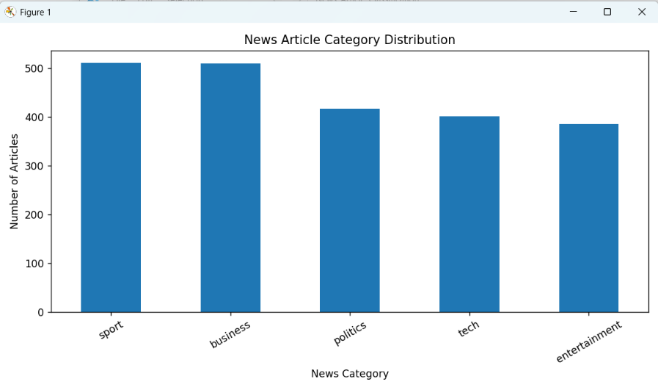
Figure 1. Distribution of news articles across the five categories.
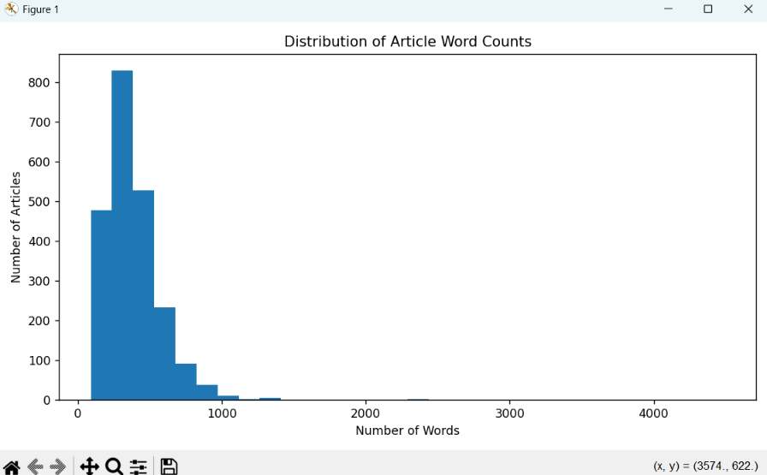
Figure 2. Distribution of article word counts; most articles are concentrated in the lower word-count ranges.

5.2 Dataset Preprocessing
The original dataset is loaded using the Pandas library. The dataset is inspected to understand its structure, column names, category distribution, and data quality.
A cleaned dataset is also generated with an additional column named cleaned_text, which contains the preprocessed version of each article.

5.3 Data Quality Analysis
The dataset is checked for missing values, duplicate records, and empty text entries.
The observations from the supplied dataset inspection are:
- Total records: 2,225
- Missing values: 0
- Duplicate records detected: 99
- Empty cleaned articles: 0
The duplicate count is recorded as an inspection result. The available project evidence does not confirm that all duplicate records were removed before model training.

6. Tools and Technologies
Tool / Library | Purpose
Python | Programming language used to implement the workflow.
Pandas and NumPy | Dataset loading, tabular data handling, and numerical operations.
Matplotlib | Visualizing category distribution, word counts, model comparison, and evaluation results.
NLTK | Stop-word removal and Porter stemming for text preprocessing.
Scikit-learn | TF-IDF vectorization, dataset splitting, model training, and evaluation.
Streamlit | Building the interactive web interface for article classification.
VS Code | Development environment used to create and run the Python scripts.

7. Methodology

7.1 Exploratory Data Analysis
The dataset is first loaded and inspected to verify its dimensions, column names, sample records, and category counts. A bar chart is generated to visualize the number of articles in each category. Article word counts are also examined using a histogram to understand the distribution of document lengths.

7.2 Text Preprocessing
Raw news text may contain inconsistent casing, punctuation, common words, and different grammatical forms of the same word. Preprocessing reduces this noise and helps the model focus on informative terms. The implemented preprocessing pipeline includes:
- Convert text to lowercase.
- Remove punctuation and unwanted non-alphabetic characters according to the cleaning logic.
- Tokenize the text into words.
- Remove common English stop words using the NLTK stop-word list.
- Apply Porter stemming to reduce words to their stem forms.
For example, words such as “playing”, “played”, and “plays” may be reduced to a common stem. The cleaned dataset is saved for the next stage.

7.3 TF-IDF Feature Extraction
Machine-learning algorithms require numerical input. Term Frequency–Inverse Document Frequency (TF-IDF) converts each article into a vector whose values reflect the importance of terms within a document relative to the complete collection. The implementation uses a maximum of 5,000 features and includes unigrams and bigrams.
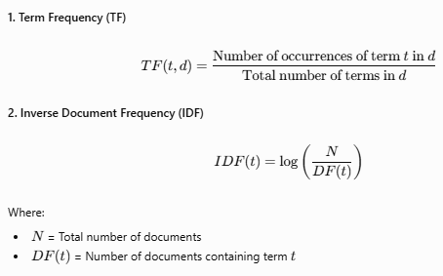
The training feature matrix has 1,780 rows and 5,000 columns, while the testing feature matrix has 445 rows and 5,000 columns. Each row represents one article and each column represents a vocabulary feature.

7.4 Dataset Splitting
The dataset is divided into training and testing subsets. The training subset contains 1,780 articles (80%), and the testing subset contains 445 articles (20%). The implementation uses a stratified split with a fixed random state so that the class proportions are maintained as closely as possible and the split can be reproduced.

7.5 Model Training
Three supervised classification algorithms are trained using the TF-IDF feature vectors:
- Multinomial Naive Bayes: a probabilistic classifier commonly used for text classification.
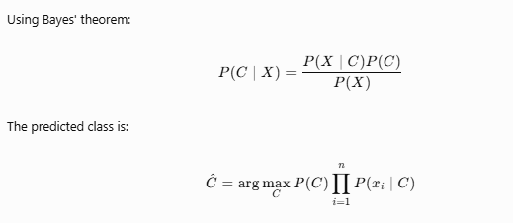
- Logistic Regression: a linear classification algorithm that estimates class probabilities.

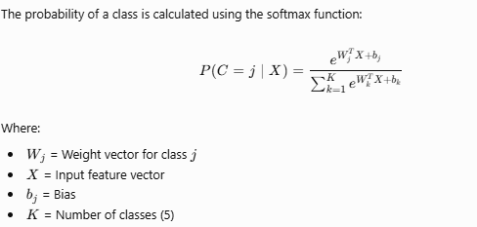

- Support Vector Machine (SVM): a classifier that finds decision boundaries separating classes; the project uses a linear SVM approach.
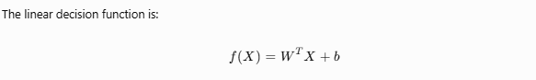

The models are compared using the held-out test set. The SVM model is selected as the best model based on the reported evaluation accuracy.

8. System Architecture
The system follows a sequential NLP and machine-learning pipeline:
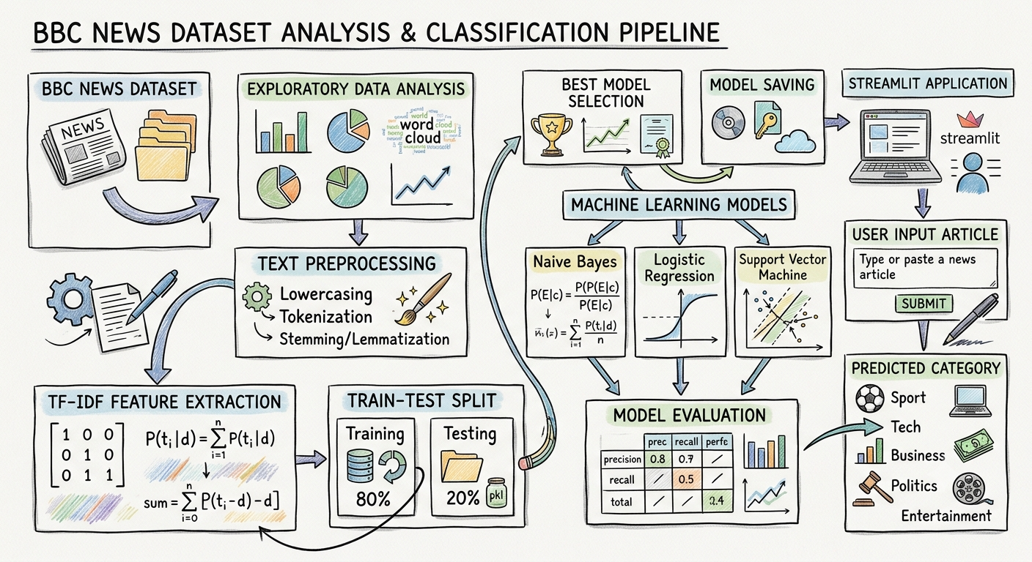
During prediction, the article entered by the user is passed through the same preprocessing and TF-IDF transformation used during training. The saved classifier then predicts one of the five supported categories. Reusing the fitted vectorizer is essential because the prediction text must be represented using the same feature vocabulary as the training data.

8.1 Working of the System
Initially, the BBC News dataset is loaded and analyzed. The article text is then cleaned using NLP preprocessing techniques.
The cleaned text is converted into numerical features using TF-IDF. The dataset is divided into training and testing sets, and three machine-learning models are trained.
After evaluating their performance, the best-performing SVM model is selected and saved.
During prediction, the Streamlit application accepts a new article from the user. The same preprocessing steps are applied, and the saved TF-IDF vectorizer transforms the text into numerical features. Finally, the trained model predicts the category and displays the result.

9. Implementation Details
Script / Component | Responsibility
check_dataset.py | Loads the dataset and prints sample rows, shape, column names, and category distribution.
eda.py | Generates visualizations for category counts and article word-count distribution.
preprocess.py | Cleans article text, removes stop words, applies stemming, and saves the cleaned dataset.
tfidf.py | Splits the data and creates TF-IDF feature matrices with 5,000 features.
train.py | Trains and compares the three classifiers, evaluates the selected model, plots results, and saves the best model.
Streamlit application | Accepts article text, applies the saved preprocessing/vectorization/model pipeline, and displays the predicted category.

The training output reports SVM as the best model with a test accuracy of 98.2%, and confirms that the best model was saved successfully. The Streamlit application displays the selected model and test accuracy, accepts article text, and shows the predicted category along with an option to view preprocessed text.

10. Results and Discussion
The project successfully completed dataset inspection, exploratory analysis, text preprocessing, feature extraction, model comparison, evaluation, and application deployment.
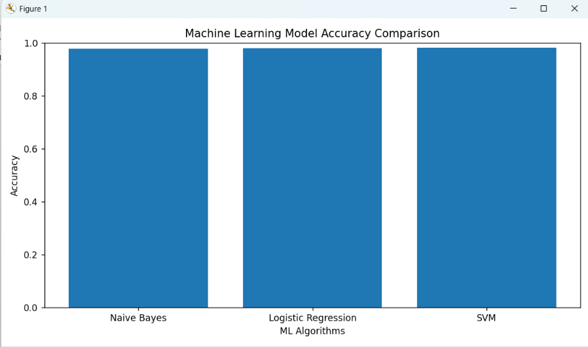
Figure 3. Accuracy comparison of Naive Bayes, Logistic Regression, and SVM.
The supplied comparison chart shows the three model results visually. Exact numerical values for Naive Bayes and Logistic Regression were not available in the terminal output or readable chart labels, so they are intentionally not reported here.
The training terminal output identifies SVM as the best model and reports 98.2% test accuracy. This corresponds to approximately 437 correctly classified articles out of 445, subject to rounding of the reported percentage.
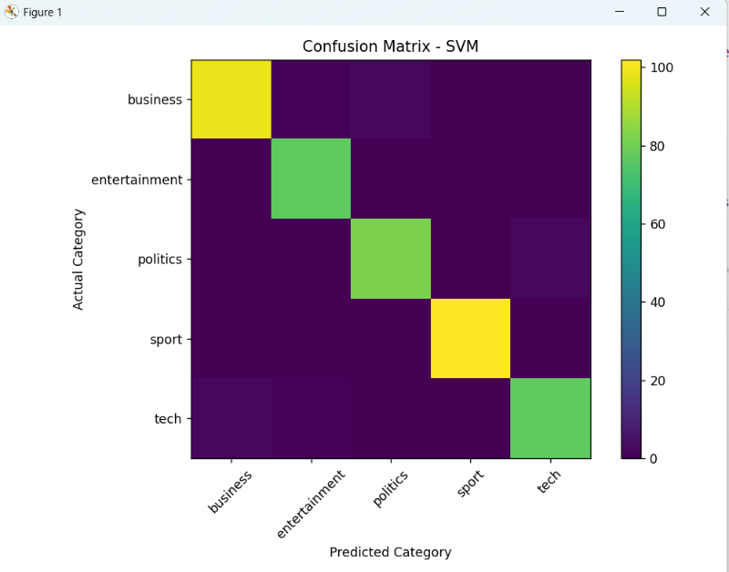
Figure 4. Confusion matrix for the selected SVM classifier.
The confusion matrix shows strong diagonal values, indicating that most test articles were assigned to their correct categories. Off-diagonal cells represent misclassifications between categories. The matrix supports the conclusion that the classifier performs well across the five classes.
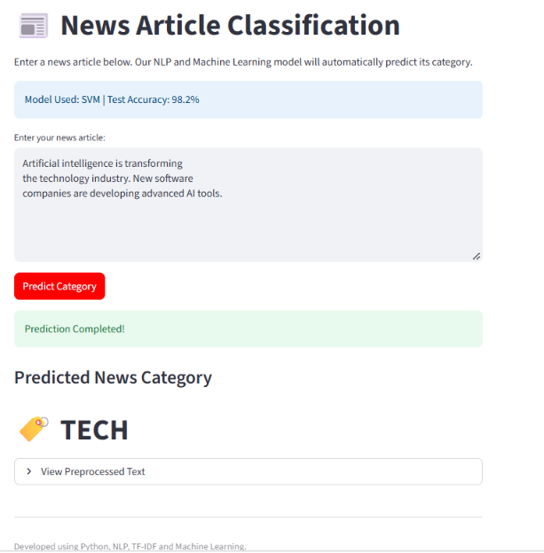
Figure 5. Streamlit application displaying a sample news article prediction.
The application screenshot shows the model information, article input area, prediction button, successful prediction message, and predicted category. In the displayed example, the article is classified as BUSINESS.

11. Testing
The following functional checks can be used to verify the application. The expected result is that the interface returns one of the five supported labels for valid news text.
Test case | Input / Action | Expected result
TC-01 | Launch the Streamlit application. | The application page loads without an error.
TC-02 | Enter a business-related article and click Predict Category. | A category prediction is displayed.
TC-03 | Enter a sports-related article. | The result is one of the supported category labels.
TC-04 | Submit an empty text field. | The application should request valid article text or prevent an empty prediction, if this validation is implemented.
TC-05 | Expand View Preprocessed Text. | The cleaned version of the entered article is displayed, if the section is selected.

The supplied screenshot confirms a successful prediction for one sample input. For a formal submission, test all five categories and record the actual input text and observed output for each test.

12. Advantages and Limitations

12.1 Advantages
- Automatically categorizes news articles and reduces manual sorting effort.
- Uses a straightforward and reproducible NLP pipeline.
- Compares multiple machine-learning algorithms before selecting a model.
- Provides a simple browser-based interface through Streamlit.
- Achieves a reported test accuracy of 98.2% on the held-out test set.

12.2 Limitations
- The classifier is limited to the five categories represented in the training dataset.
- Performance may decrease on articles from different sources, writing styles, or time periods.
- TF-IDF mainly captures term frequency patterns and does not fully understand context or word meaning.
- The system is designed for English text and may not work reliably for other languages.
- The dataset is relatively small compared with the volume of news available online.

13. Future Enhancements
- Expand the dataset with more recent articles and a wider range of publishers.
- Add more categories and support multilingual news classification.
- Evaluate precision, recall, F1-score, and per-class performance in addition to accuracy.
- Experiment with advanced language representations such as Word2Vec, GloVe, or transformer-based models.
- Improve the interface with prediction confidence, article history, and batch upload.
- Deploy the application to a cloud hosting platform and monitor performance on new data.

14. CONCLUSION
The project “News Article Classification Using Natural Language Processing and Machine Learning” successfully demonstrates an automated approach for classifying news articles into predefined categories.
The system uses the BBC News dataset containing 2,225 labelled articles belonging to five categories: Business, Entertainment, Politics, Sport, and Tech.
Various NLP preprocessing techniques, including lowercasing, special character removal, tokenization, stop-word removal, and stemming, are applied to prepare the textual data.
TF-IDF is used to convert the cleaned text into numerical feature vectors. Three machine-learning algorithms—Multinomial Naive Bayes, Logistic Regression, and Support Vector Machine—are trained and compared.
Based on the supplied evaluation results, the SVM model achieved the highest reported test accuracy of 98.2%. The selected model and fitted TF-IDF vectorizer are saved using Joblib.
A Streamlit application is also developed to provide an interactive interface for users. It accepts news article text, processes the input, and displays the predicted category.
Overall, the project demonstrates how Natural Language Processing and Machine Learning can be combined to build an effective news article classification prototype. It also provides practical experience in data analysis, text preprocessing, feature extraction, model training, evaluation, and application development.

15. REFERENCES
1. F. Sebastiani, “Machine Learning in Automated Text Categorization,” ACM Computing Surveys, vol. 34, no. 1, pp. 1–47, 2002. DOI: 10.1145/505282.505283.
2. G. Salton and C. Buckley, “Term-Weighting Approaches in Automatic Text Retrieval,” Information Processing & Management, vol. 24, no. 5, pp. 513–523, 1988. DOI: 10.1016/0306-4573(88)90021-0.
3. A. McCallum and K. Nigam, “A Comparison of Event Models for Naive Bayes Text Classification,” AAAI-98 Workshop on Learning for Text Categorization, AAAI Press, 1998, pp. 41–48.
4. T. Joachims, “Text Categorization with Support Vector Machines: Learning with Many Relevant Features,” European Conference on Machine Learning, 1998, pp. 137–142. DOI: 10.1007/BFb0026683.
5. D. Greene and P. Cunningham, “Practical Solutions to the Problem of Diagonal Dominance in Kernel Document Clustering,” Proceedings of the 23rd International Conference on Machine Learning (ICML), 2006.
6. Scikit-learn Developers, “Feature Extraction: Text Feature Extraction,” Scikit-learn Documentation. Available: https://scikit-learn.org/stable/modules/feature_extraction.html
7. NLTK Project, “Natural Language Toolkit Documentation.” Available: https://www.nltk.org/
8. Streamlit, “Streamlit Documentation.” Available: https://docs.streamlit.io/
9. Joblib Developers, “Joblib Documentation.” Available: https://joblib.readthedocs.io/
10. Derek Greene, “BBC News Dataset.” Available: https://github.com/derekgreene/bbc-datasets

