**ESTIMATING BODY MASS INDEX FROM FACIAL IMAGES**

**Dr. O. Aruna1**, Associate Professor, Department of CSE,

Vasireddy Venkatadri Institute of Technology, Nambur, Guntur Dt., Andhra Pradesh.

**M.V.N.L.S. Bhavya Sri2**, **R. Jyothirmai3**, **P. Charitha Sri4**, **M. Mano Teja5,**

**N. Vamsi Krishna6**

2,3,4,5,6 UG Students, Department of CSE,

Vasireddy Venkatadri Institute of Technology, Nambur, Guntur Dt., Andhra Pradesh.

**E-Mail ID:** [**arunasri52@gmail.com**](mailto:arunasri52@gmail.com)**1,** [**munagalabhavyasri29@gmail.com**](mailto:munagalabhavyasri29@gmail.com)**2,** [**jyothirmai318@gmail.com**](mailto:jyothirmai318@gmail.com)**3,** [**charithasri3112@gmail.com**](mailto:charithasri3112@gmail.com)**4,** [**manoteja1507@gmail.com**](mailto:manoteja1507@gmail.com)**5, vamsinarukullapati18@gmail.com6**

**Abstract**

A person's health status may have a significant impact on many aspects of their life, from mental health to lifespan to financial security. The health of a person can be calculated by a value which is called Body Mass Index (BMI), it uses both the height and weight of a person. Numerous variables, including physical health, mental health, and popularity, have been linked to BMI. With the increasing number of people being obese, self-diagnostic solutions for healthy weight monitoring are grabbing significant attention. Calculating BMI using the statistical formula requires precise measurements of the height and weight of a person and is time-consuming. The main objective of this study is to predict the BMI of a person by giving the image as input. While developing Fitness apps, we can use this system to detect the BMI of a person daily and suggest suitable exercises. The developed system can also be used to find whether a person is suffering from malnutrition and some other diseases that can be detected using BMI. The models used in this study are FaceNet, Ridge Linear Regression, Random Forest Regression, Support Vector Regression, and ensemble of regression models.

**Keywords:** BMI, FaceNet, Random Forest, Ridge Linear, Support Vector Regression, Ensemble learning.

**1. Introduction**

Due to people's indoor lifestyle, disregard for physical fitness, and subsequent binge eating during the covid pandemic, obesity and overweight have recently emerged as serious global health challenges[14]. Excess weight and Body Mass Index have recently attracted a lot of attention in applications for weight loss and health monitoring. Body mass index, or BMI, is an abbreviation for a numerical value that indicates a person's level of health.

Obesity, which is typically measured by a Body Mass Index (BMI), is affected by a combination of a high intake of calorie-dense foods and lack of exercise[12]. A person's mental and financial health might be affected in addition to their physical health[1]. A number of diseases related to heart, liver, kidney, and some other diseases such as diabetes, stroke, cancer, hypertension, depression, and pregnancy issues have been linked to higher BMI, according to recent studies[20]. Earlier, in order to collect BMI, a person had to either accurately self-report their height and weight or visit a doctor to have it measured by substituting the data in a formula i.e weight in kilograms divided by the square of height in meters[13]. Researchers found that there is a relationship between facial measurements and body weight of a person until a certain level. BMI is strongly related with the structure of eye or it uses features anterior corneal curvature (ACD) and intraocular pressure(IOP), neck circumference, and physical measurements of the face, including ratios like width to height, perimeter to area, and cheek to jaw width which are measured manually[18]. To automate this process, Some academic research [2]–[11] claim that machine and human-readable facial pictures can be used to determine BMI.

In this paper, we demonstrate how BMI may be computed from a face image and other features with the help of a dataset that was constructed by scraping information from the internet. To recognise and extract features from an image that is provided as input, we use FaceNet architecture. Machine Learning models like Random Forest Regressor, Support Vector Regressor, Ridge regression and ensemble model are used to predict BMI.

**2. Literature Review**

Guo, Guodong et al. in [2] is the first study that demonstrated that an image of a person is sufficient to identify the person's BMI. They used Active Shape Model(ASM) to extract features from face images and a statistical approach using statistical methods like the Gaussian process and the least squares estimation was used to learn more about how BMI is connected with face attributes. Raktim Ranjan Nath et al. in [3] demonstrated that the HOG (histogram of oriented gradient) algorithm, which did not involve data preprocessing, was employed to identify faces in an input image. Later, HOG was used along with CLAHE which took a lot of time but accuracy has increased. Atul Sharmaa et al. in [4], proved that CNN has a 94% accuracy rate when used to classify images, which is why it is a widespread technique today. Yousaf, Nadeem et al. [5], their solution used the Xception Network as the backbone for BiseNet's Face semantic segmentation. Semantic face segmentation is used to create each face area mask, which is then element-wise multiplied by a feature map to give various face regions larger weights. To obtain the final characteristics in the form of vectors, they next carried out region aware global average pooling (Reg-GAP). Performance is measured using MAE, RMSE, and Pearson Coefficient.

Google created the Facenet architecture to recognise and identify faces in images. I. William et al. [6], justified that face net provides more accuracy than CASIA-WebFace and VGGFace2, when they are compared. For testing, they made use of publicly accessible data sets like YALE, JAFFE, AT&T, Georgia Tech, and Essex. Kocabey, Enes et al. [7], used VGG-Net and VGG-Face for features extraction and Support Vector Regression for final BMI prediction. They generated a dataset using progress pictures of their body from various Reddit users which they named VisualBMI. Pearson correlation coefficient is used for performance measurement. Compared to VGG-Net, VGG-Face performed better. Noora Shrestha et al. [8], used the measurements of neck circumference and waist-to-height ratio as part of a study employing binary regression analysis to find the influence of gender, physical activity index, and physical measurements on the chance that the user falls into the overweight category. Chittathuru, Dhanamjayulu et al. [9], first preprocessed the pictures. Face detection is performed using MTCNN (Multi-task Cascaded Convolutional Networks), while BMI prediction is performed using RestNet50. The dataset was created through web scraping photographs and the data that goes with them.

H. Siddiqui et al. [10], justified their research using a unique end-to-end CNN network to predict BMI. For feature extraction, they also used a variety of pre-trained CNN models, including VGG, ResNet, DenseNet, MobileNet, and light CNN. For predicting BMI, Support Vector Regression and Ridge Regression are used. Performance is measured using MAE. Pretrained models outperformed the end-to-end CNN model marginally better. Huang, and Shuai [11], collected data from people from different countries using a survey on a web platform. Using the procedure to determine the BMI and the parameters for defining obesity, all of the participants were classified as either obese or not obese depending on their height and weight. Random forest demonstrated the highest accuracy in this study comparing the results of logistic regression, support vector machines, and random forest.

**3. Problem Identification**

After going through different research papers in our literature survey, we got to know that there are no publicly available datasets and deep learning models help in feature extraction from images. In these studies[2]-[11], CNN and some other Pre-trained deep learning models like BiseNet, VGGFace, FaceNet, DenseNet, MobileNet, etc are used for extraction of features from images and Support Vector Regression was used for training the model using extracted features. This project provides comparison of different regression techniques along with ensemble models after features are extracted from images using the Facenet model. This comparison helps in developing an effective model to estimate the body mass index from a face image.

**4. Proposed Methodology**

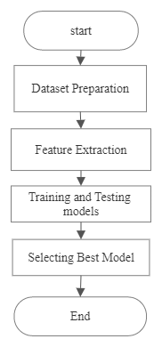

**Figure 1:** Flow Chart

**4.1 Dataset Preparation**

We obtained our data from the web. We collected 846 images, 408 of which are male and 438 of which are female. We included images from various BMI categories, such as Normal(18.5-25), Underweight(18.5), Overweight(25-30), and Severely Obese(>30). Along with the images, we manually collected the person's height and weight in a CSV file and mapped it to the image in the image dataset using the image ID. Figure2 is a sample part of our dataset.

**Figure 2:** Dataset

**4.2 Feature Extraction**

FaceNet is a pre-trained deep learning model used for extraction of features from image dataset. Facenet architecture is widely used for face recognition and detection and is developed by google. This architecture is most popular among developers as it uses Euclidean distance to determine similarities in the input image[6]. In this architecture, each layer takes an input feature map from the preceding layer’s output. The convolutional layers extracts low-level features from input images, which are then processed by multiple normalization and pooling layers that use various filters to extract more complex features. The last layer is connected to the L2 normalization layer to give final embeddings. Using Facenet, features are extracted in the form of a vector for each image in the dataset constructed by us.

**4.3 Training and Testing Models**

Models are fitted using the retrieved features, height, weight, and BMI values[15]-[17]. Several regression methods, including Random Forest Regression, Ridge Linear Regression, Support Vector Regression, and an ensemble of all these regression methods, are used in this research. To determine each model's competence, performance indicators like accuracy, variance score, mean absolute error, and symmetric mean absolute percentage error are calculated.

**4.3.1 Random Forest Regression**

Random Forest Regressor is an ensemble of decision trees where the mean of predictions from each tree is given as final output. It can manage outliers and missing values as well as high-dimensional datasets and non-linear connections by randomly selecting characteristics for each decision tree and combining the results. Hyperparameter tuning using RandomizedSearchCV is used for finding the best combination of parameters based on the dataset. This can also be used to improve accuracy by adjusting the hyperparameters such as the number of trees, the maximum depth of the trees and the amount of features sampled.

**4.3.2 Ridge Regression**

Ridge regression, also called as L2 Regularization differs slightly to simple linear regression. It has an additional penalty term which is added to the cost function to prevent overfitting.

The following cost function is minimised in order to fit the model:

*cost* = ||y - Xw - b||2 + alpha * ||w||2, where:

||y - Xw - b||2 : L2 norm of the vector

||w||2 : L2 norm of the coefficients

alpha: regularization parameter

**4.3.3 Support Vector Regression**

Finding the optimum line or hyperplane that can incorporate as many data points as feasible within a specific margin or error is the main aim of this model. The goal is to keep as large a margin as possible while minimising the difference between the anticipated values and the actual values. The area adjoining the hyperplane without any data points is referred to as the margin. SVR aims to improve generalisation performance on unknown data by increasing the margin.

**4.3.4 Ensemble Learning**

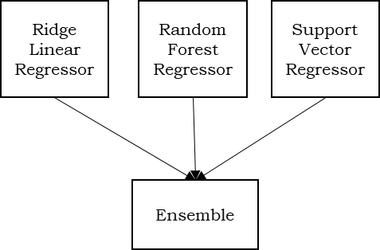

**Figure 3:** Ensemble Learning

In ensemble learning for regression, multiple regression models are trained on different subsets of the training data, and their predictions are combined by finding the average or mean of them. Figure 3 represents the ensemble of regression models we used.

Finally, the model that performs best is chosen for the final prediction of BMI.

**5. Implementation**

After Dataset preparation is done, it is analyzed. Figure 4 is plot showing height and weight values for all the people in dataset.

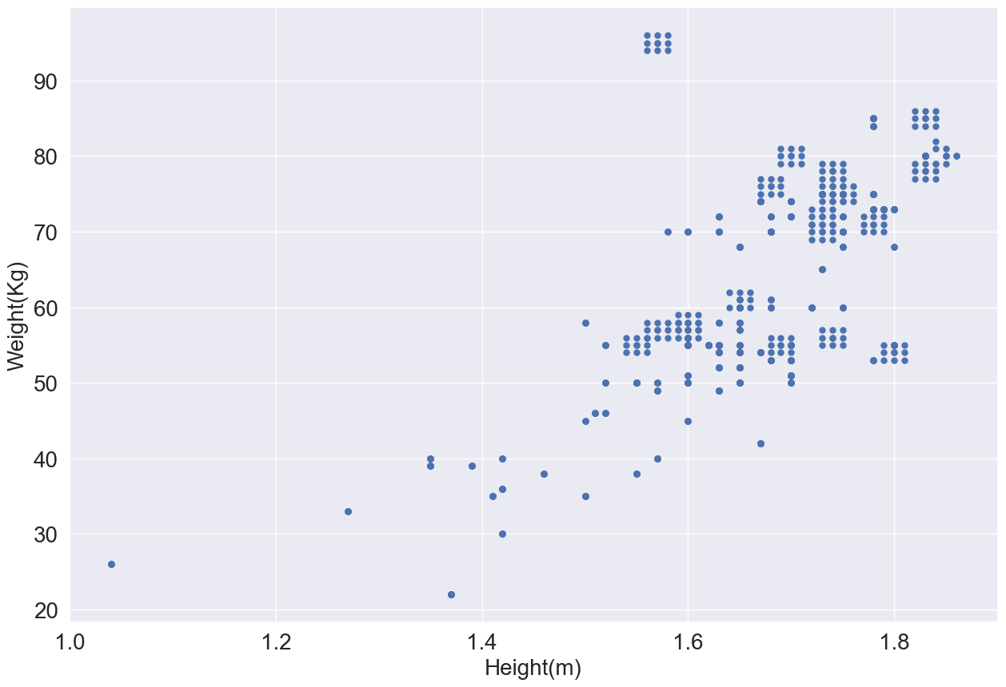

**Figure 4:** Height vs Weight Plot

Features are first extracted using Facenet model. The following are the steps to extract features using FaceNet:

1. Load the pre-trained FaceNet model and weights.
2. Load the input image and detect faces.
3. Resize them to the input size of the FaceNet model.
4. Pass the preprocessed face images through the FaceNet model to extract facial feature vectors.

For each image in the dataset, features are extracted using the facenet model. These features are mapped with height, weight and BMI values using image ID to create the final data set. This dataset is splitted into training(80%) and testing(20%) data.

The training data is used to fit different regression models. For implementing all the mentioned regression models firstly respective regressor must be imported from python machine learning library, and then the following steps are followed

1. Initialize an object for each regressor with parameters.
2. Fit the object with the training set X and target values y using the fit() method.
3. Obtain the model f(x) that can be used for prediction.
4. Evaluate the performance.

To implement the ensemble learning,

1. Instances of Random Forest, Ridge Linear, SVR with their respective parameters are created.
2. The objects are passed as a list to estimators parameter of VotingRegressor along with weights for each object as list.
3. VotingRegressor object is fitted by using training set X and target values y.
4. Evaluate the performance.

After the models were implemented, we created an application using Python Flask Framework, MySQL database, HTML and CSS. This application also has diet plans for both weight loss and gain on the left navigation menu along with BMI chart.

**6.** **Results and Conclusions**

The below Table 1 contains the performance measurements obtained for models Ridge Regression, Random Forest with Hyperparameter tuning, Support Vector Regression and Ensemble model,

each represented as M1, M2, M3, and M4 respectively.

|  |  |  |  |  |
| --- | --- | --- | --- | --- |
| Metric | M1 | M2 | M3 | M4 |
| Accuracy | 94.3 | 95.1 | 94.2 | 98.12 |
| R2 Score | 0.56 | 0.67 | 0.5 | 0.74 |
| SMAPE | 2.59 | 1.87 | 2.8 | 1.8 |
| MAE | 0.08 | 0.06 | 0.09 | 0.06 |

**Table 1:** Performance Metrics for all the models implemented

Ensemble model performs better when compared to other models when we compare all models with respect to their accuracy and r2 score.

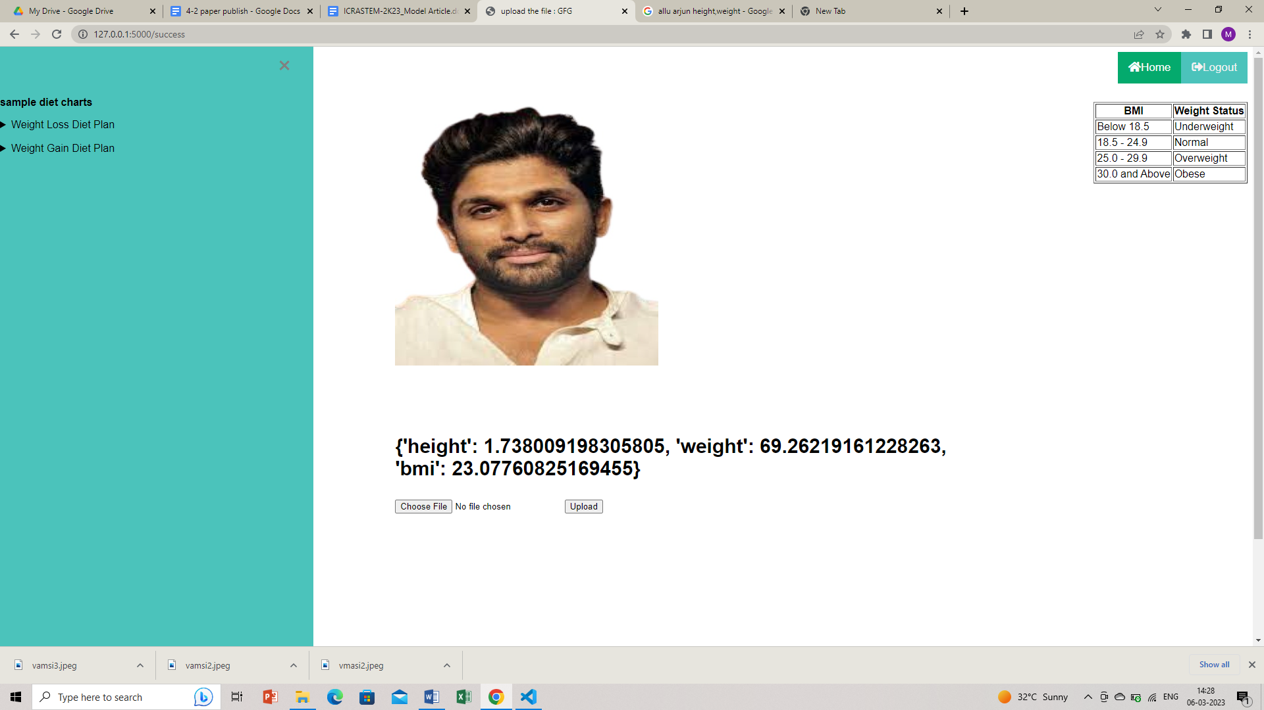

**Figure 5:** Prediction on Test Image

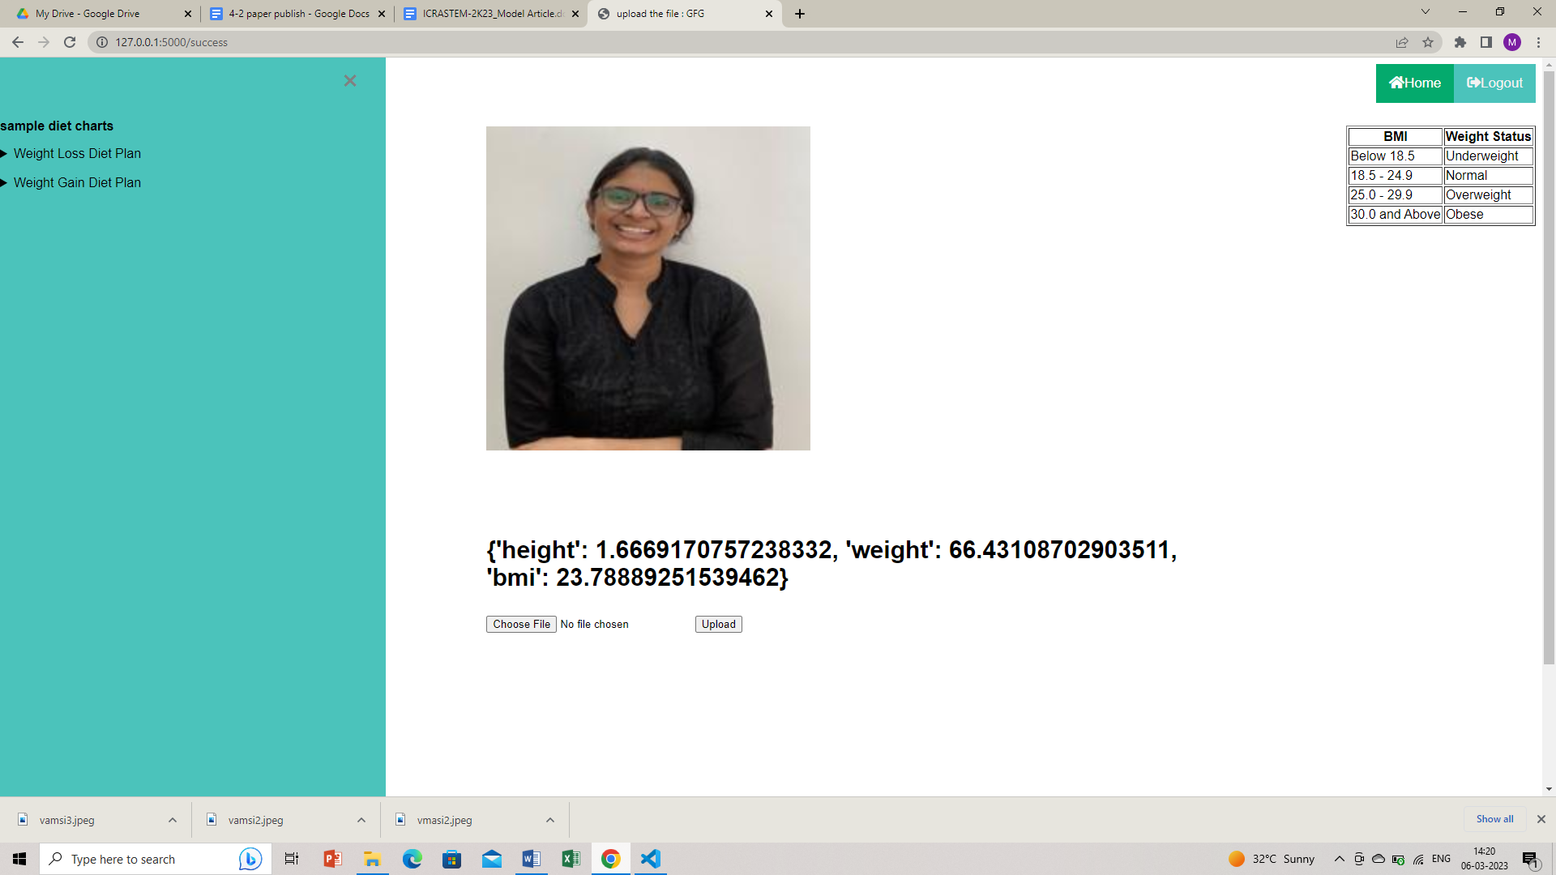

**Figure 6:** Prediction on Test Image



**Figure 7:** Prediction on Image without Face

Through our project, we proved that facial features can be used to estimate the Body Mass Index of a person. In our project, we used a variety of deep learning and machine learning models to calculate the Body Mass Index from an image. We achieved our goal because our project can tell the difference between an overweight person and a normal person by using estimated BMI.

**7. Limitations and Future Scope**

The use of heavy makeup and plastic surgery in our dataset's actor photos makes it challenging to predict BMI accurately. Sometimes the dataset's highly obese class is biased because there aren't as many samples in that category. Since we gathered the dataset manually from various websites on the internet, there might be some mistakes in the annotations.

In the future, we will expand our training dataset and implement some customized healthcare plans using AI tools. In order to improve the use of facial appearance for height, weight, and BMI assessment, additional research on age and ethnicity will be done in the future.

**References**

1. de Wit, L., Have, M. T., Cuijpers, P., & de Graaf, R. (2022). Body Mass Index and risk for onset of mood and anxiety disorders in the general population: Results from the Netherlands Mental Health Survey and Incidence Study-2 (NEMESIS-2). *BMC psychiatry*, *22*(1), 1-11.
2. Wen, L., & Guo, G. (2013). A computational approach to body mass index prediction from face images. *Image and Vision Computing*, *31*(5), 392-400.
3. Nath, Raktim & Kakoty, Kaberi & Bora, Dibya & Welipitiya, Udari. (2021). Face Detection and Recognition Using Machine Learning. 43. 194-197.
4. Sharma, A., & Phonsa, G. (2021, April). Image classification using CNN. In *Proceedings of the International Conference on Innovative Computing & Communication (ICICC)*.
5. Yousaf, N., Hussein, S., & Sultani, W. (2021). Estimation of BMI from facial images using semantic segmentation based region-aware pooling. *Computers in Biology and Medicine*, *133*, 104392.
6. William, I., Rachmawanto, E. H., Santoso, H. A., & Sari, C. A. (2019, October). Face recognition using facenet (survey, performance test, and comparison). In *2019 fourth international conference on informatics and computing (ICIC)* (pp. 1-6). IEEE.
7. Kocabey, E., Camurcu, M., Ofli, F., Aytar, Y., Marin, J., Torralba, A., & Weber, I. (2017, May). Face-to-BMI: Using computer vision to infer body mass index on social media. In *Proceedings of the International AAAI Conference on Web and Social Media* (Vol. 11, No. 1, pp. 572-575).
8. Shrestha, N. (2019). Application of binary logistic regression model to assess the likelihood of overweight. *Am J Theor Appl Stat*, *8*(1), 18-25.
9. Gadekallu, T. R., Iwendi, C., Wei, C., & Xin, Q. (2021). Identification of malnutrition and prediction of BMI from facial images using real-time image processing and machine learning. *IET Image Process*, *16*, 647-658.
10. Siddiqui, H., Rattani, A., Kisku, D. R., & Dean, T. (2020, December). Al-based bmi inference from facial images: An application to weight monitoring. In *2020 19th IEEE International Conference on Machine Learning and Applications (ICMLA)* (pp. 1101-1105). IEEE.
11. Huang, S. (2022). Obesity Prediction Based on Logistic Regression, Random Forest and Support Vector Machine.
12. Gutin, I. (2018). In BMI we trust: reframing the body mass index as a measure of health. *Social Theory & Health*, *16*, 256-271.
13. Misra, A., & Dhurandhar, N. V. (2019). Current formula for calculating body mass index is applicable to Asian populations. *Nutrition & diabetes*, *9*(1), 3.
14. Vimercati, L., De Maria, L., Quarato, M., Caputi, A., Gesualdo, L., Migliore, G., ... & Tafuri, S. (2021). Association between long COVID and overweight/obesity. *Journal of Clinical Medicine*, *10*(18), 4143.
15. Schonlau, M., & Zou, R. Y. (2020). The random forest algorithm for statistical learning. *The Stata Journal*, *20*(1), 3-29.
16. Breiman, L. (2001). Random forests. *Machine learning*, *45*, 5-32.
17. Ramedani, Z., Omid, M., Keyhani, A., Shamshirband, S., & Khoshnevisan, B. (2014). Potential of radial basis function based support vector regression for global solar radiation prediction. *Renewable and Sustainable Energy Reviews*, *39*, 1005-1011.
18. Coetzee, V., Perrett, D. I., & Stephen, I. D. (2009). Facial adiposity: A cue to health?. *Perception*, *38*(11), 1700-1711.
19. Harrison, R. N., Gaughran, F., Murray, R. M., Lee, S. H., Cano, J. P., Dempster, D., ... & Breen, G. (2017). Development of multivariable models to predict change in Body Mass Index within a clinical trial population of psychotic individuals. *Scientific Reports*, *7*(1), 14738.
20. Kissebah, A. H., Freedman, D. S., & Peiris, A. N. (1989). Health risks of obesity. *Medical Clinics of North America*, *73*(1), 111-138.