Week 5 Chart Redesign Activity
Chart D — Revenue by Product Line | Jyothi Sanam
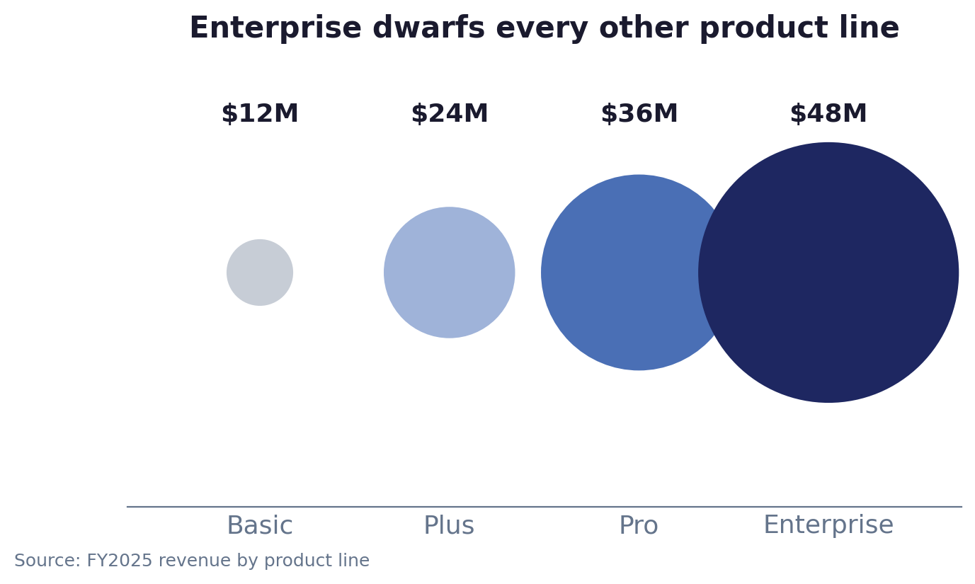
-- The Lie
This chart relies on the 'Radius Fallacy'. It maps revenue values (1D) to the radius of circles (2D bubbles). Because area increases proportional to the square of the radius, the Enterprise bubble ($48M) takes up 16 times more physical pixel space than the Basic bubble ($12M), even though the revenue difference is only 4x. It visually misrepresents the data.
-- The Victim who can be misled
The victims are executive resource allocators. The distorted visual mass creates an exaggerated effect, misleading leadership into believing lower tiers are negligible. This can lead to low investment in the Basic and Plus tiers, which actually account for $72M in revenue, together outperforming Enterprise.
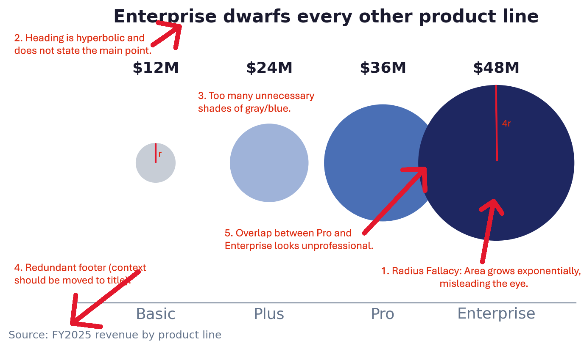
-- How I Rebuilt the chart
I rebuilt this as a vertical bar chart. Bars use linear length, which the human brain processes instinctively and accurately. This delivers the main point within 5 seconds. A $48M bar is exactly 4x the height of a $12M bar. I highlighted the Enterprise bar in solid color to maintain the strategic focus while stripping away the misleading area-scaling, gridlines, and unnecessary footer clutter (moving the FY2025 context directly into the headline).
The other alternative which came to my mind was to build a pie chart, which would visually represent the dominance of a particular product line by its share within the pie. But that would be beneficial if there was a particular sector which would take more or close to 50% of the total space. There, the motive would be to display Enterprise as the clear winner and make more investment in Enterprise plan. But in this scenario, the other product lines also draw significant revenue. So, they should not be ignored. To display the per plan contribution, I have put percentage share in the labels.
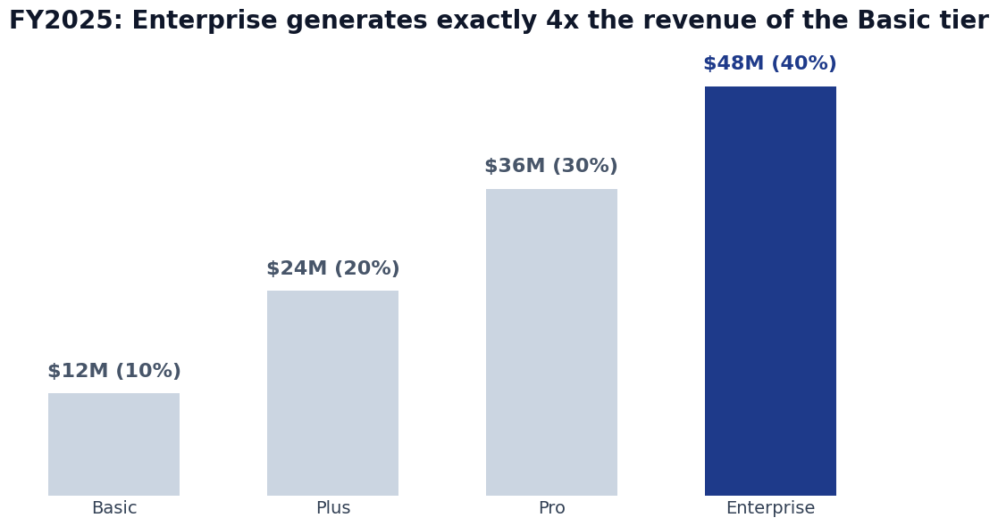
-- What I preserved in the chart
I preserved the core strategic intent: drawing attention to Enterprise growth. The Navy highlight color ensures the eye goes to the right place first. By correcting the geometry, the message becomes honest and defensible: 'FY2025: Enterprise generates exactly 4x the revenue of the Basic tier'.

