Weekly Status Report
One page, every week (Weeks 2–7). Copy this, fill it in, and submit to the dropbox. It's how I see where your project stands — and it's graded on substance, not length.
Name | Jyothi Sanam | Week / Date | 5 / August 2, 2026

Project title

Consumer Complaint Triage – Predicting relief outcome of complaints at scale

Project summary
One or two sentences: the goal and your analysis plan. Flag it if your data is unusual or complex.
The goal is to build an intake triage model that predicts whether an incoming retail banking complaint will result in operational / financial relief or policy explanation to optimize queue routing. The analysis plan involves training text classification and categorical ensemble models on a highly targeted, text-rich subset of the CFPB database representing core retail banking transactions.

Milestones
Your project's steps as bullets; tag DONE as you finish them (e.g., Data collection — DONE, Cleaning — DONE, EDA, Models: KNN/RF/SVM, Tuning, Visualization).
- Project proposal & problem formulation - DONE
- Data vetting & 4-paradigm interrogation - DONE
- Data ingestion & banking sector downsampling - DONE
- Exhaustive Trend EDA & Statistical Validation - DONE
- Data cleaning & tokenization QA (Handling anonymized XXXX mask tokens) - DONE
- Feature extraction pipeline (Text embeddings + Metadata encoding) - DONE
- Baseline model training (TF-IDF + LightGBM / DistilBERT) - DONE
- Model evaluation & error analysis (F1-score optimization) - DONE
- Threshold Calibration & Business Logic Mapping - DONE
- Final Visual Deliverables & Presentation Deck Generation

Last week's “To Do”
Paste your TO DO from last week's report, so we can both see what you said you'd do.

Conduct probability threshold shifting/calibration on the Hybrid Model to find the optimal operational cutoff point for routing the Relief queue.

Explore visual deliverables (Confusion Matrices, Feature Importance Tables, ROC Curves) for the final presentation deck.

Structure the final narrative defending the EDA-Hybrid approach over the DistilBERT approach based on compute ROI, compliance explainability, and queue sorting power.

This week's progress
Specifically what you accomplished or worked through this week. Tie it back to a milestone. Be concrete — “built and compared three models,” not “made progress.”
- Adjusting the Model's Threshold for the Real World: By default, the model uses a 50% cutoff to decide if a complaint needs relief. While 50% gave the highest academic score (F1-score), it doesn't make sense for a real bank. Missing a real relief case causes huge regulatory fines, but accidentally flagging a normal case just wastes a few minutes of an agent's time. By lowering the cutoff to 40%, I found the sweet spot: we catch 85.6% of the real hardship cases. This means sending exactly 13,386 files to human reviewers (out of the ~20,000 cases in our test set). It's more work for the agents, but it protects the bank from major risks.
- Core Presentation Charts: I narrowed down my visuals to the three most important charts to tell the business story
  - Yearly Trends: Showing the massive spike in complaints in 2025 and how relief rates dropped at the exact same time. Note: Complaints in 2026 are only till June 2026, so the volume is 30,909. But even on extrapolation, the volume is still ~30k short of what 2025 saw - 92,865 complaints.
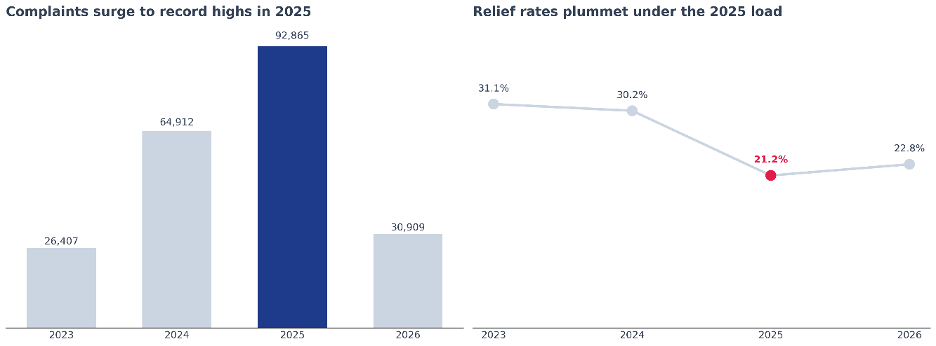

  - 2025 Bank Reactions: A chart comparing how big banks reacted differently to that volume surge (e.g., Navy Federal rejecting almost everyone, crushed by the volume of complaints vs. Bank of America granting much more relief).
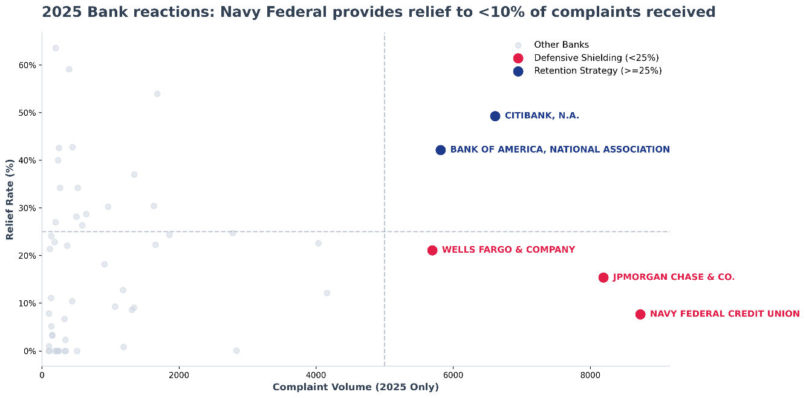

  - Queue-Size Curve: Based on last week’s feedback, I visually compared the number of physical files landing on a manager's desk (the 13,386 flagged files) against the safety benefit (catching 85.6% of the risk). This clearly explains why the 40% threshold is the right choice for flagging a case as requiring relief.
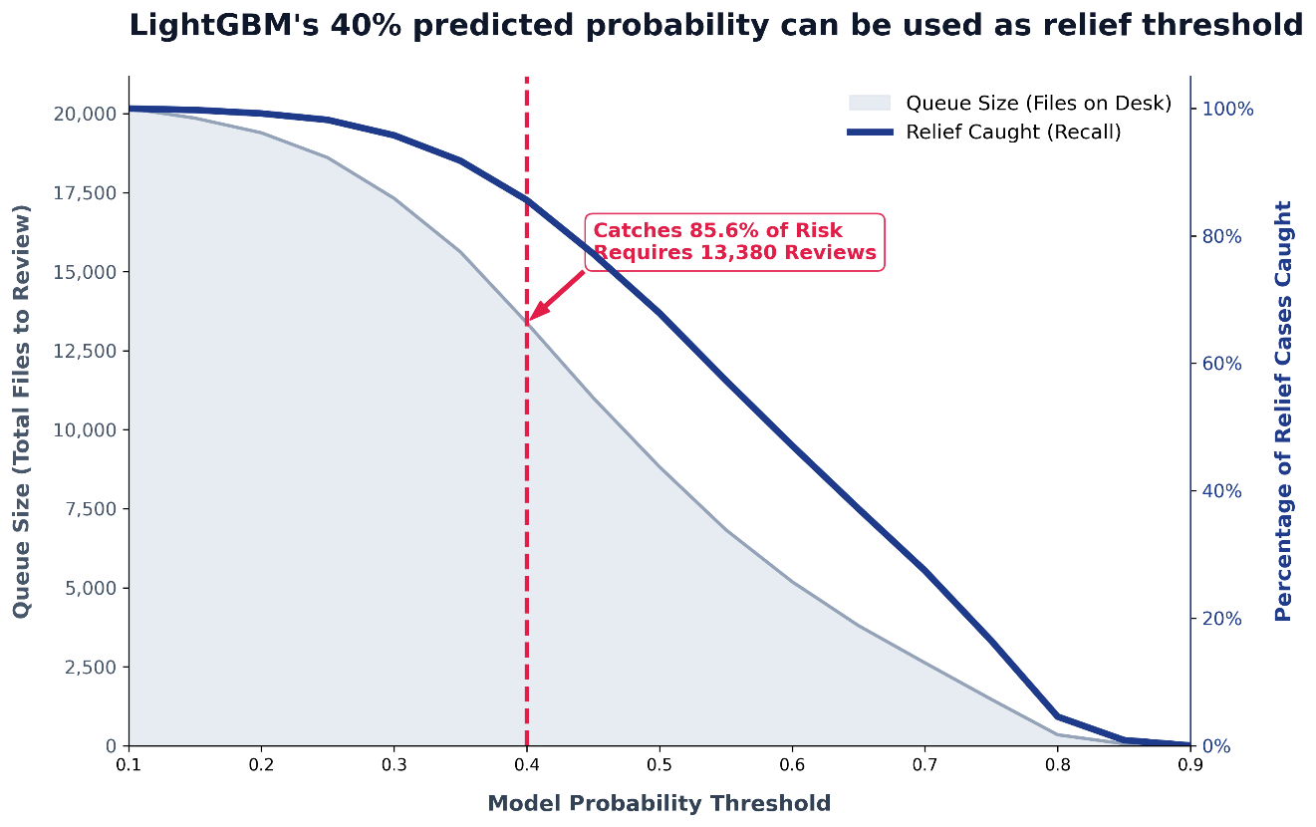

- Chart Redesign Activity: Completed the Week 5 assignment by fixing a misleading revenue bubble chart. The original design used the 'radius fallacy'—making a 4x revenue difference look like a massive 16x difference because it scaled the area of the circles incorrectly. I rebuilt it into a clean, honest bar chart where the visual size perfectly matches the actual dollars. I also removed the redundant footer and updated the title to tell the exact truth.

Issues & discussion
Real blockers and anything you want to talk through. If you want to meet sooner, say so here.
Explaining Costs to the Panel: I have the 40% threshold set, but I need to make sure I explain the business costs clearly to the panel. I need them to understand that wasting 5 minutes of an agent's time is much cheaper than missing a regulatory deadline and getting fined by the CFPB.

Next week's “To Do”
Your concrete plan for the coming week — bullets are fine.
- Outline the exact slide-by-slide flow of the final presentation, ensuring a smooth narrative arc from the initial business problem to the final model recommendation.
- Translate all the remaining technical jargon into plain English. I need to make sure I am speaking the language of executives (focusing on risk, staffing, and ROI).

Resources (optional)
Links or references you want to share with me.

How it's graded: Concrete, verifiable progress against your plan; clear enough that a reader can follow your project's state; and real blockers named with a next-week plan.

