ABSTRACT

Bipolar disorder is a condition that features extreme shifts in mood and fluctuations in energy and activity levels that can make day-to-day living difficult. Previously known as manic depression, it is a serious mental illness that, if left untreated, can destroy relationships, undermine career prospects, and seriously affect academic performance. In some cases, it can lead to suicide.
Technologies like Artificial intelligence, Machine learning, Big data Analysis can help both patients and doctors for better diagnosis of many illness across the world. The goal of this project is to apply different Machine Learning algorithms to symptom-based patient data and find the best possible algorithm based on the accuracy of prediction in order to help create a prediction model. This model would make it easier for psychiatrists to decide whether their patients might be tending towards mania. depression episode or staying in euthymic state.
The first part of the project includes the process of gathering, cleaning and data visualization of data which includes analysis of behavior of features with the help of charts and graphs.
The second part of the project includes the predictive analysis of data. Here we are applying different machine learning algorithms like svm, decision tree, random forest etc., on the patient data in order to compare accuracies and choose the accurate algorithm that suit the problem the most. The main goal of this project is to be able to react in time and avoid the symptoms before the patients starts to suffer from them.
Keywords: Machine Learning, Classification, Supervised learning, Bipolar disorder

- INTRODUCTION
  - Motivation
Medical decision-making especially in emergency situations is not easy. Tools like machine learning can help to evaluate the opportunities. Machine learning approaches for clinical psychology and psychiatry explicitly focus on learning statistical functions from multidimensional data sets to make generalizable predictions about individuals.
In health care, the machine learning approach has performed equally as well as, or better than, clinicians in many tasks.
The use of Machine Learning algorithms allows us to apply different classification and regression models that help with diagnosis of different diseases.
The early success of the new wave of machine learning has fueled considerable popular speculation that deserves to be treated with a degree of skepticism, but it is clear that machine learning techniques will continue to be used because they perform better than classical approaches for many problems.
This is why Machine learning could be useful tool for trying to predict the episode in which a patient might be in or tend towards with the help of different Bipolar Disorder symptoms and patient data.
  - Work Flow
The work flow that has been planned for this project is: data gathering, data cleaning, data analysis, model training and building, model testing and model deployment. (See figure1.1)

Figure 1.1. Project process

The above process is explained step by step below:
- Data Gathering: This part of the project was to gather the data required for this process. After having gathered all the data the next step was to clean it as the data may contain empty values or lack of entries.
- Data Cleaning and Data Analysis: The next part of the project is to clean the data and perform data analysis in order to understand how the variables are distributed and correlated. This also includes identification of outliers that can affect the prediction in aa negative way.
- Model training and deployment: This part of the project is to apply different machine learning algorithms on the different combination of dataset to find the features that the project could fit the most.
- Model testing: The next part is the selection of best combination of dataset and the algorithm that had best testing performance and applied them on randomized patient data in order to observe how they worked.
- Model deployment: The last part of the project is to deploy it in the cloud as a microservice so that the patients can actively participate in their own diagnosis.
  - Data used for the project
The data used for the project is anonymized patient data gathered by psychiatrists. All the data was available in an Excel file with different sheets. The data has been gathered during medical appointments with four different patients that have Bipolar Disorder.
  - Used technologies
The programming language used in this project is Python 3.7, which has a lot of libraries that make data cleaning and visualization less complicated, as well as applying Machine Learning algorithms. The environment used is Jupyter Notebook.
    - Python
Python is a programming language that is widely used in Machine Learning. It is especially useful for data cleaning and plotting as the language is designed for legibility and ease of use.
There are quite a few libraries designed for this task, like Pandas, which includes a lot of methods for data frame handling, or Seaborn and Matplotlib, which are data plotting libraries.
Scikit-learn is the Machine Learning library of choice for this project because it includes pre-processing and cross-validation tools as well as all the known baseline Machine Learning algorithms.

    - Jupyter Notebook
Jupyter Notebook, the logo of which can be seen in Figure 1.2, is a web application consisting of “notebooks” that include live code. It is an interactive environment that contains both code and Markdown language to describe each code snippet.


Figure 1.2. Jupyter Notebook logo

The main reason this environment was chosen is the possibility it has for fast prototyping, because you can visualize the results very fast and in a cleaner way than with a terminal.

- LITERATURE SURVEY
Some different studies and projects are currently carried out in the field of bipolar disorder crisis. It is one of the new areas to apply prediction algorithms. Different existing systems and prediction models are related to, this mood disorder crisis prediction.
[2], Detecting bipolar disorder in the adult population using the Mood Disorder Questionnaire is a Brazilian version that has 983 samples. The model implemented was Decision Tree Classifier using the internal CART algorithm. The accuracy obtained was 88.07% using on the entropy method.
CANTAB along with advanced machine learning algorithms is trained that can objectively identify individual euthymic bipolar disorder patients from health controls, The CANTAB is a standardized tool which is used for assessment of cognitive functioning. The objective of this paper was to distinguish individual patients based on neurocognitive abnormalities using CANTAB [3].
[4] The result obtained by the using LASSO algorithm they could identify individual patients of 71% accuracy. This paper focused on classifying the patient’s state and analyze physical changes in patients with a mood crisis using sensors integrated with smartphones. The approach was to develop a smartphone application that can be able to recognize the patient's state daily.
[5] The objective of this paper was to discriminate, patients from schizophrenia and Bipolar disorder. The dataset used was objective data i.e. RNA from patients who were diagnosed with schizophrenia or bipolar disorder. Validation was done on several biomarker genes by RT-PCR. Linear and Non-Linear combinations of biomarker genes were able to distinguish between schizophrenia, Bipolar Disorder. The accuracy was 95% using receiver operating characteristic (ROC) curve analysis. This project is proposed that the RNA derived from the blood cell has an effective diagnostic function.
The Machine learning algorithm for psychology and psychiatry treatments involves learning statistical functions to get a generalizable prediction about individuals. The objective of this review paper is to provide an understanding of why this approach is needed for augmenting decision-related to diagnosis, prognosis, and treatment of people suffering from mental illness using clinical and biological data [6].
To know which features are correlated and are important which are required for building a prediction model for a successful prediction of the target. The goal of this paper is to obtain which feature as the highest correlation. Machine learning algorithms are applied for ranking features [7].
2.1. Drawbacks of the existing system
- Data gathered in some of the studies are objective data.
- Early based predicting system are not concentrated in certain papers
- Few studies like CANTAB have neuroimaging has the data which can be hard to determine whether structure brain alterations are the result, risk factor or cause of disorder.
- Few existing systems are concentrated only on feature importance.
- Needed for development of calculators that allow translation of prediction model in clinical practice.
  - Proposed System
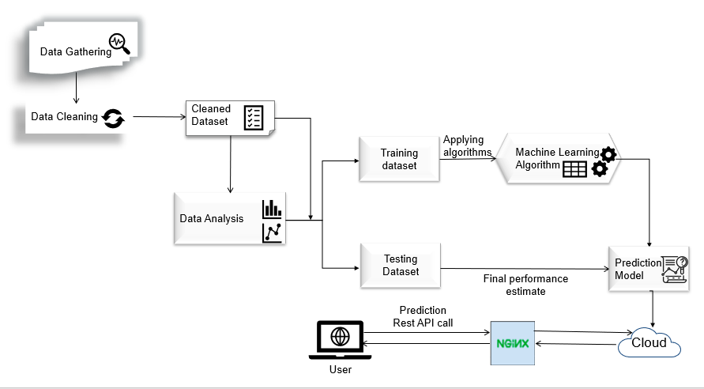
Figure 2.1. Proposed system
We are using only subjective data because every patient might not perceive the different symptoms in the same way. This project not only includes study of feature importance but also includes the application of different algorithms to predict the state with various combinations of these features. To develop an early prediction of symptom-based patient data that would make psychiatrists to decide whether their patients might be tending towards a depression or mania episode, or staying in a euthymic state.

3. DATA GATHERING
3.1. Gathering the data
The first part of the data cleaning consisted in gathering the data that we would be working with. To do so, we exported each worksheet from the Excel file we got to csv format.

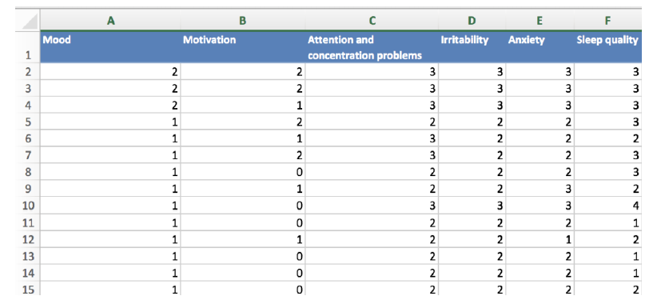
Figure 3.1. Sample of the original Excel file with interview data (Part1)
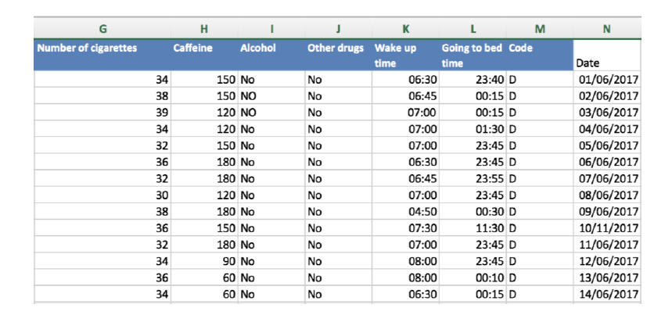
Figure 3.2. Sample of the original Excel file with interview data (Part 2)
The initial Excel file we got was: Episodios (Episodes), Young, HDRS, Diario (Daily interviews) and Intervenciones (Interventions). A sample of the interview data set can be seen in Figure 3.1 and Figure 3.2. To export them to a format readable by Pandas, we saved each sheet as CSV UTF-8 in Microsoft Excel.
To later import the data into our notebook, we read every csv file into a data frame, as shown.

3.1.1. Episode data set
The first data set, which can be seen in Figure 3.4, represented different episode periods of the patients (Depression/Mania). There was a total number of four patients, whose name was anonymized for privacy reasons. The patient with code “O” had constantly mixed episodes so as it is not needed for our work, we omitted it. This left us with three patients.
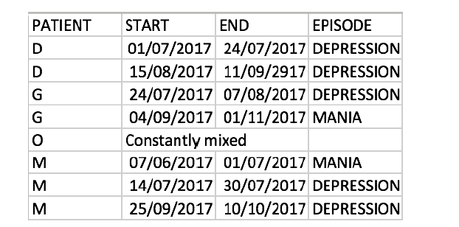
Figure 3.3. Mania and depression episodes in patients.
3.1.2. YMRS data set
The next file included the Young Mania Rating Scale (YMRS) data from different days, with the same patients as the ones in the Episode data set. This scale is one of the most widely used scales to rate manic symptoms. It includes eleven scoring items that are based on the patient’s own report over the previous 48 hours. These scoring items and their values are:
• Elevated Mood:
0: absent
1: mildly increased on questioning
2: optimistic, self-confident, cheerful
3: elevated, humorous
4: euphoric, singing, inappropriate laughter
• Increased Motor Activity-Energy:
0: absent
1: subjectively increased
2: animated, gestures increased
3: excessive energy, temporary hyperactivity
4: motor excitement, continuous hyperactivity

• Sexual Interest:
0: absent
1: mildly increased
2: subjective increase on questioning
3: spontaneous sexual content, elaborates on sexual matters
4: openly sexual towards other patients, staff or interviewer
• Sleep:
0: no decrease in sleep
1: sleeping less than normal amount by up to one hour
2: sleeping less than normal amount by more than one hour
3: decreased need for sleep
4: denies need for sleep
• Irritability:
0: absent
2: subjectively increased
4: irritable during times at interview
6: frequently irritable during interview
8: hostile, interview not possible
•Speech (verbal expressions):
0: no increase
2: talkative
4: increased rate and amount at times
6: consistently increased rate, difficult to interrupt
8: uninterruptible, continuous speech
• Language-Thought Disorder:
0: absent
1: circumstantial
2: distractible
3: flight of ideas, difficult to follow
4: incoherent, impossible to communicate with

• Content (activities):
0: normal
2: questionable plans, new interests
4: special projects
6: grandiose or paranoid ideas
8: delusions, hallucinations
• Disruptive-Aggressive Behaviour:
0: absent
2: subjectively increased
4: animated, gestures increased
6: excessive energy, temporary hyperactivity
8: motor excitement, continuous hyperactivity
• Appearance:
0: appropriate dress and grooming
1: minimally unkempt
2: poorly groomed
3: disheveled, partly clothed
4: completely unkempt, bizarre garb
• Insight (about the illness):
0: present, admits illness
1: possibly ill
2: admits behaviour change but denies illness
3: admits possible behaviour change but denies illness
4: denies any behavioural change

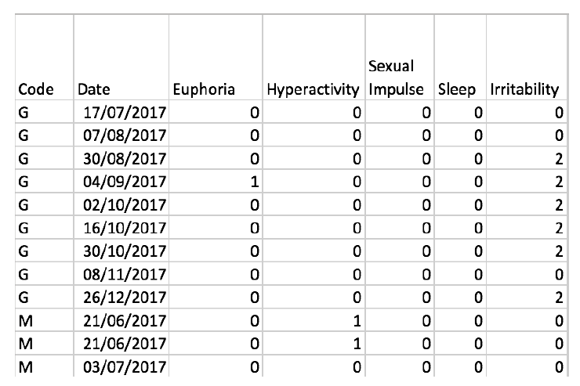

Figure 3.4. Fragment of the YMRS patient data (Part 1)
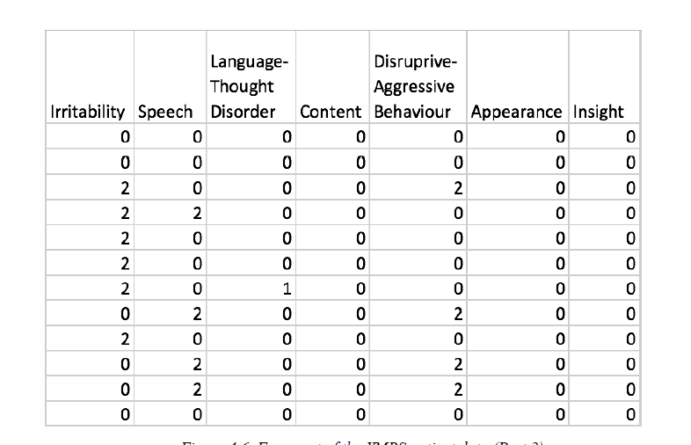
Figure 3.5. Fragment of the YMRS patient data (Part 2)

3.1.3. HDRS data set
Another scale that was used, the Hamilton Depression Rating Scale (HDRS) [19], is the most widely used scale for depression rating. It was designed to be completed after a clinical interview. It has different versions, that include more or less rating items. For this project, we used the HDRS, which has 17 different items regarding depression symptoms experienced by the patients in the previous week. These 17 items and their possible values are the following:

• Depressed Mood:
0: absent
1: feeling state indicated only on questioning
2: feeling state spontaneously reported verbally
3: communicates feeling state non-verbally (i.e. voice)
4: reports feelings only on spontaneous verbal and non-verbal behaviour
• Feelings of guilt:
0: absent
1: feels that he or she has let people down
2: ideas of guilt
3: delusions of guilt
4: hears accusatory voices and experiences threatening hallucinations
• Suicide:
0: absent
1: feels life is not worth living
2: wishes he or she was dead
3: ideas of suicide
4: suicide attempts
• Insomnia (early in the night):
0: no difficulty falling asleep
1: occasional difficulty falling asleep
2: nightly difficulty falling asleep
• Insomnia (middle of the night):
0: no difficulty
1: restless and disturbed during night
2: waking up during night
• Insomnia (early hours of the morning):
0: no difficulty
1: waking in early hours of the morning, goes back to sleep
2: unable to fall asleep again if he/she wakes up
• Work and activities:
0: no difficulty
1: feelings of incapacity
2: loss of interest in activity
3: decrease in time spent (less than 3 hours) or productivity
4: stopped working because of illness
• Retardation:
0: normal speech and thought
1: slight retardation during interview
2: obvious retardation during interview
3: interview difficult
4: complete stupor
• Agitation:
0: none
1: fidgeting
2: playing with hands, hair, etc.
3: can’t sit still
4: nail biting, hair-pulling, etc.
• Psychic anxiety:
0: no difficulty
1: subjective tension
2: worrying about minor matters
3: anxious attitude (apparent in face or speech)
4: fears expressed without questioning
• Somatic anxiety:
0: absent
1: mild
2: moderate
3: severe
4: incapacitating
• Somatic symptoms (gastro-intestinal):
0: none
1: loss of appetite but eating.
2: difficulty eating without staff urging

• General somatic symptoms:
0: none
1: heaviness in limbs, back or head
2: clear-cut symptoms
• Genital symptoms (loss of libido, menstrual disturbances):
0: absent
1: mild
2: severe
• Hypochondriasis:
0: not present
1: self-absorption
2: preoccupation with health
3: frequent complaints
4: hypochondriacal delusions
• Loss of weight:
According to patient:
0: no weight loss
1: probable weight loss associated with illness
2: definite weight loss
3: not estimated
According to weekly measurements:
0: less than 1 lb (450g) loss in one week
1: more than 1 lb (450g) loss in one week
2: more than 2 lb (900g) loss in one week
3: not estimated
• Insight:
0: acknowledges being depressed and ill
1: acknowledges illness but attributes it to other factors
2: denies being ill at all

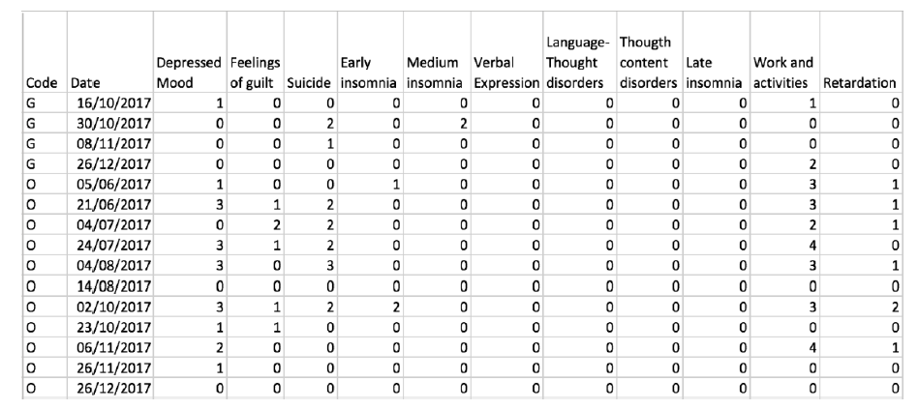
Figure 3.6. Fragment of the HDRS patient data (Part 1)
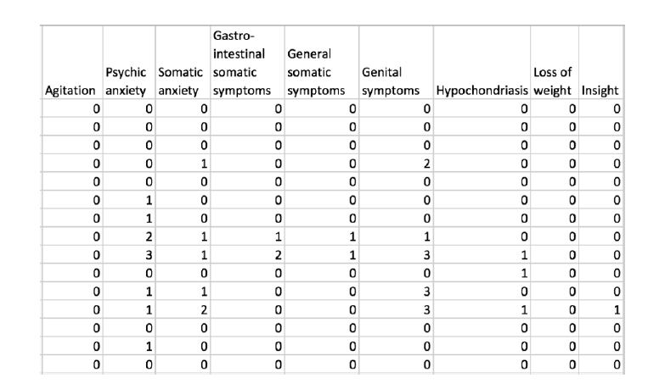
Figure 3.7. Fragment of the HDRS patient data (Part 2)
3.1.4. Interview data set
The next file included data that had been gathered in interviews performed by the psychiatrist on different medical appointments with the patients, as seen in Figure 3.9 and Figure 3.10.
It contained both physical and psychological items. The psychological items represent more subjective data, like anxiety, irritability or concentration problems, whereas the physical items include more objective data, like the number of cigarettes that the patient has smoked in a day or the time in which the patient woke up or went to bed. The features used in the interviews were the following:

• Mood: mood level of the patient, ranging from -3 to 3.
• Motivation: motivation level of the patient, ranging from -3 to 3.
• Attention and concentration problems: level of attention and concentration problems of the patient, ranging from 0 to 4.
• Irritability: irritability level of the patient, ranging from 0 to 4.
• Anxiety: anxiety level of the patient, ranging from 0 to 4.
• Sleep quality: quality level of the patient’s sleep, ranging from 0 to 4.
• Menstrual cycle: whether a female patient is in her menstrual cycle.
• Number of cigarettes: number of cigarettes smoked by the patient since he or she woke up.
• Caffeine: amount of caffeine ingested by the patient since he or she woke up.
• Alcohol: whether the patient has consumed any alcohol.
• Other drugs: whether the patient has consumed any other drugs.
• Wake up time: when the patient woke up.
• Going to bed time: when the patient went to bed.
• Code: patient code (first letter of the patient’s name).
• Date: when the questionnaire was completed.
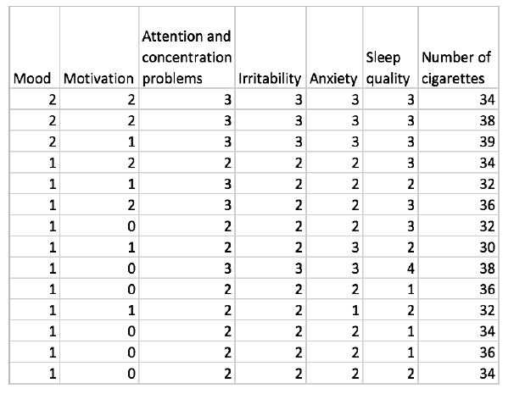
Figure 3.8. Interview data (Part 1)
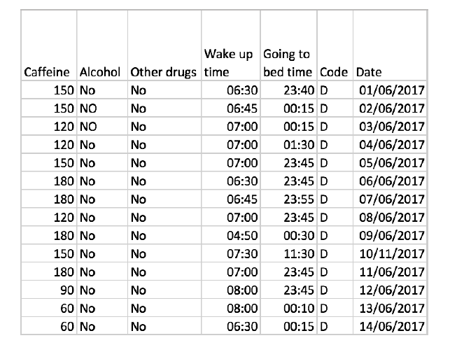
Figure 3.9. Interview data (Part 2)
3.1.5. Intervention data set
The last file included a summary of all the medical interventions that different doctors had with the patients, as shown in Figure 3.11. These interventions include medical appointments, videos, phone calls and interventions from hospitals. It also contains a value for the GAF (Global Assessment of Functioning) which evaluates symptoms, normal activities and interpersonal relationships of the patient.
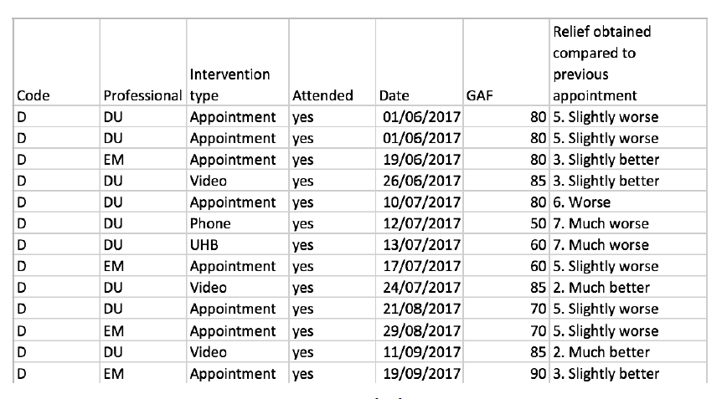
Figure 3.10. intervention

- DATA CLEANING
4.1. Cleaning the data
This part included the whole process of preparing the data to get clean data sets that could be used later for visualization and for algorithm training. Each data set was cleaned separately because they all had a different structure and size.
4.1.1. Episode data set
We started by giving the columns proper names so that all the data sets had a similar format (see Figure 4.1).

Figure 4.1. Column name translation of the Episode data set

The episodes that the patients had gone through were recorded as DEPRESIÓN and MANIA, which means depression and mania respectively. In order to make the data set cleaner, we changed the codes to D for depression and M for mania.
The dates presented in the data set were recorded in string format so, in order to have all the dates in the same format, we changed them to datetime, which is a Python module for manipulating dates. We iterated over every entry in the data set and changed the date, as seen in Figure 4.2.

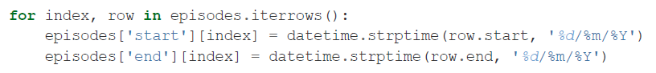
Figure 4.2. Formatting the dates in the Episode data set
4.1.2. YMRS data set
The YMRS data set had a column named Observaciones that was filled with NaN (Not a Number) values. It didn’t add any value to the data set, so we dropped it (see Figure 4.3).

Figure 4.3. Dropping Observaciones column from the YMRS data set
The next step was to rename the columns the same way as we did with the Episode data set (see Figure 4.4), so that we had all the names in the same format.
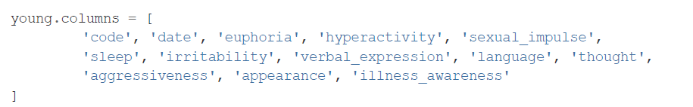
Figure 4.4. Column name translation of the YMRS data set
4.1.3. HDRS data set
With this data set, we started by dropping the column Tipo de intervención the same way as we did with the YMRS data set, because it only had NaN values. We also renamed all the columns (see Figure 4.5) like we did with the previous data sets.

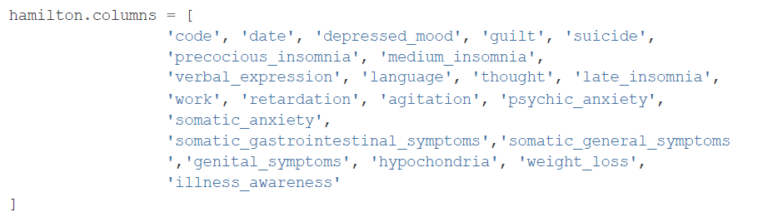
Figure 4.5. Column name translation of the HDRS data set
With the isnull() function we obtained that there were empty values in the data set. We proceeded to print the values that were null. By printing the values of the rows before and after these empty values, we could get an idea of which values we could fill them with, which in this case was the same for all. So, we proceeded to fill the empty values with the ones obtained from these rows, as seen in Figure 4.6.

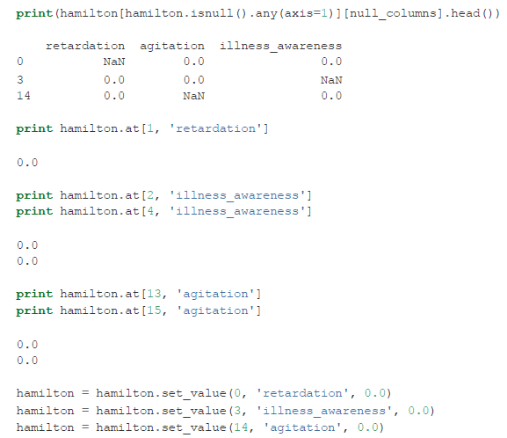.
Figure 4.6. Filling empty values in the HDRS data set
The next step was to format all the values in the data set so that they had the same type, because some values had Floating Point type and others had Integer type. We changed all to Integer. After that, just as we did with the Episode and YMRS data sets, we changed the format of the dates to datetime.
4.1.4. Interview data set
The data set that contained the interview data from different medical appointments was the one that had the biggest amount of data and therefore presented a bigger challenge when cleaning it. The first step was to rename the columns, as we did with the other data sets (see Figure 4.7).
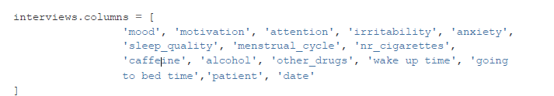
Figure 4.7. Column name translation of the Interview data set
The next step was to see if there were any empty values in the data set, which in this case was true. We could observe that the menstrual cycle feature was empty in all rows, probably because all the patients in the study were males. The whole column was dropped because it didn’t add any value to the data set.
We needed to print the rest of the empty values in order to see if we could fill them with other data. We compared the irritability value that was empty with the previous value and the one after it to see if they were similar. We could see that both were 1, so we filled the empty space with that value. The other value that was missing was a date, which would most surely be between two other days, so we set the value to the missing day between them. This whole process can be seen in Figure 4.8
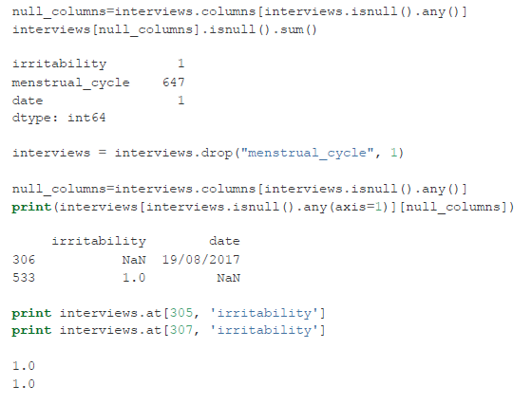.
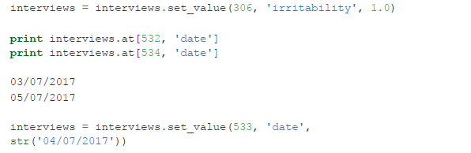
Figure 4.8. Completing missing values in the Interview data set

After filling the empty values, we changed all the Floating-Point values to Integer and changed the dates to datetime, like we did with the rest of the data sets, in order to have the same format for all the numeric features and the dates.
4.1.5. Intervention data set
The first step in cleaning the intervention data set was to rename the columns, which we did with the other data sets (see Figure 4.9).

Figure 4.9. Column name translation of the Intervention data set

We could also drop the rows that contained GAF values that were NaN, because we did not want to risk making up such concrete values. The doctor and the intervention type were also dropped because they did not add any value to the data set and we wanted generic data.
The interventions that the patients did not attend to were not valuable either, so we dropped them from the data set (see Figure 4.10). This meant that we could get rid of the column that indicated if the patient attended or not, because at that moment we only had data from interventions that the patients had attended to.
Figure 4.10. Dropping entries from interventions that patients did not attend to

We only needed the numerical value of the column that indicated the relief felt by the patients on each intervention, so we split the strings and took only the number (see Figure 4.11), which ranged from 1 to 7 (1 being much better and 7 being much worse).
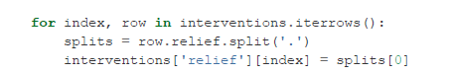
Figure 4.11. Taking the numerical value from the relief column

- EXPLORATORY DATA ANALYSIS
Exploratory data analysis (EDA) is an essential step in any research analysis. The primary aim with exploratory analysis is to examine the data for distribution, outliers and anomalies to direct specific testing of your hypothesis. It also provides tools for hypothesis generation by visualizing and understanding the data usually through graphical representation. EDA aims to assist the natural patterns recognition of the analyst. Finally, feature selection techniques often fall into EDA.
For each dataset, we used four types of visualization techniques:
- Histograms: This kind of plot gives a good overview on how the data are distributed in a data set, although it depends on the bins that are chosen, which are the intervals in which the data are classified into. This might not always be the best way to represent the data, as the whole of the data set is not plotted.
- Heatmaps: These are graphs that show the correlation between all the features in a data set, with a colour scale that represents a higher or lower correlation between the features.
- Scatterplots: This technique is very useful for studying the relationship between different features in a data set, showing a distribution of all the values of each feature. In this part, we included also the kernel density plots, which are quite useful to avoid over plotting, as they show where the values are more concentrated with different colour scales, and the marginal plots, which show both the distribution and the relationship between the features.
- Boxplots: A boxplot is a graph that gives you a good indication of how the values in the data are spread out.
  - YMRS dataset
    - Summary Statistics
We used describe method to view some basic statistical details like percentile, mean, std etc. of the data frame. To find out if there are any outliers in the dataset, we used this method. (see Figure.5.1).
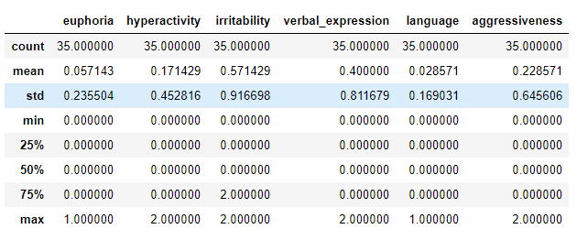
Figure 5.1. Describing the ymrs data frame
We didn’t find any outliers in the data frame; hence we proceed to plot histogram.
    - Histogram
We plotted histogram for separate features (see figure 5.2).We can observe that most of the features have row values of 0 and there were only two values present in most of the features, from this we can say that data available is less and when tested with algorithm we can expect some results.

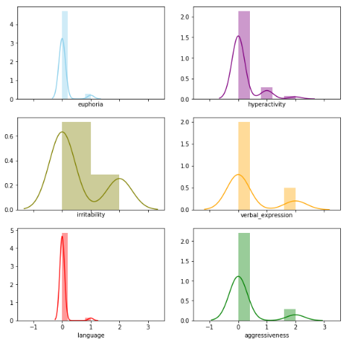
Figure 5.2. Histogram distribution of ymrs data.

    - Heatmap
Next, we plotted heatmaps to check if there was any correlation found between features (see figure 5.3). Heatmap is a graphical representation of degree of correlation between two features by using colors. The lowest correlation is represented using lighter color and the highest correlation is represented using darker color or vice versa.
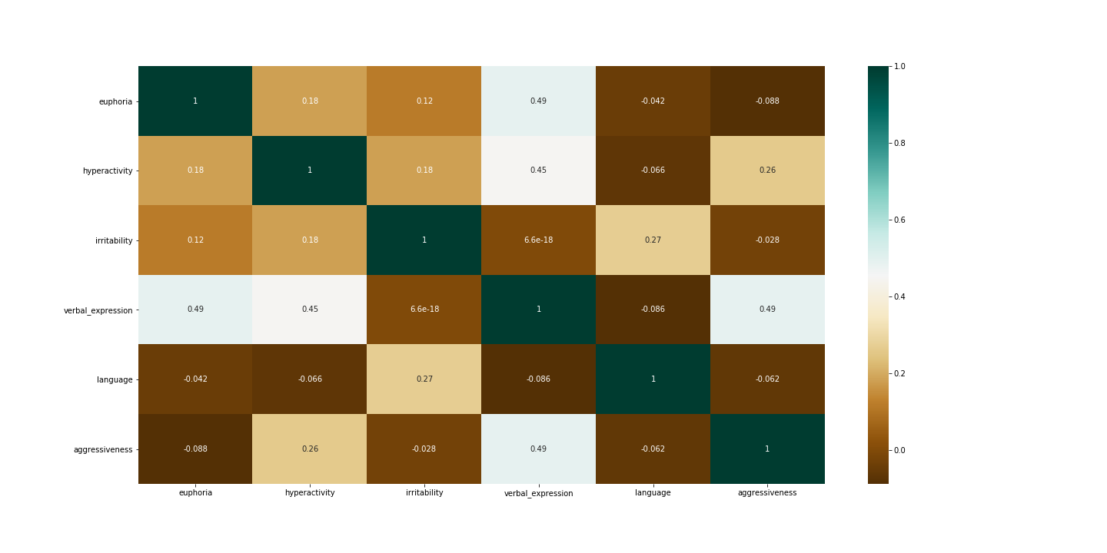
Figure 5.3. Heatmap correlation for YMRS dataset.
Here we can observe that the highest corelated feature is verbal expression with aggressiveness, euphoria, hyperactivity. Since, verbal expression is correlated with hyperactivity and aggressiveness we can say that if the patient is speech rate is more then he/she may be hyperactive.
    - Scatterplot
Scatterplot is the plotting representation that is used to plot data point horizontally and vertically that helps us to understand how one variable affects another variable.
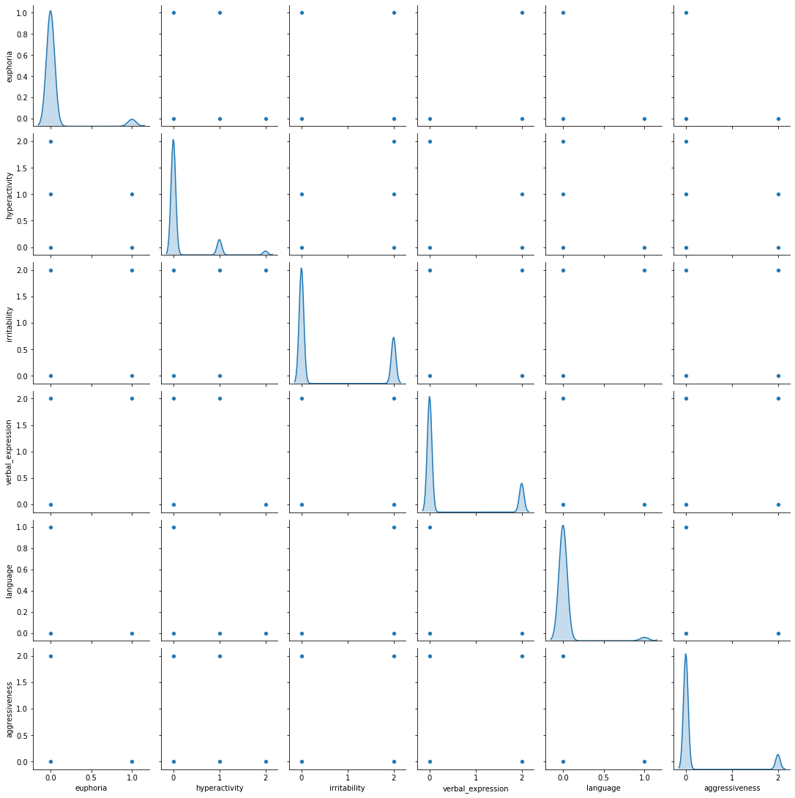
Figure 5.4. Scatter plot distribution for ymrs dataset.
In the figure 5.4 we can observe that verbal expression and aggressiveness had similar distribution even with less data. Hyperactivity and irritability also should distribution.
    - Marginal plot and 2D density plot
Marginal plot can help in finding overlapping data point which can make it difficult to interpret the data.
Here we plotted verbal expression and aggressiveness which was correlated in scatter plot. If we observe most of the row values were concentrated on (0,0) (see figure 5.5).
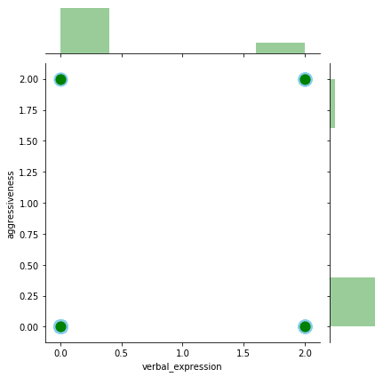
Figure 5.5. Marginal plot for aggressiveness and verbal expression in ymrs dataset

Let’s plot 2d density for better understanding (see Figure 5.6)
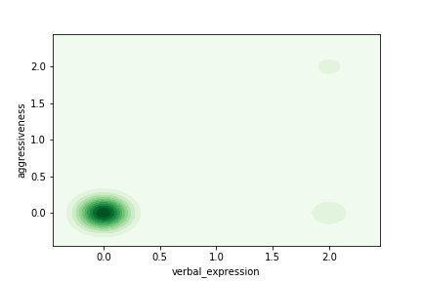
Figure 5.6. 2D density plot for aggressiveness and verbal expression in ymrs dataset
Here also there are most of values concentrated on 0, but we can find some independent values around (2,0) and (2,2). Thereby we can say that there can but some relationship between their two variables.

Let’s plot for verbal expression and euphoria (see Figure 5.7 and Figure 5.8)

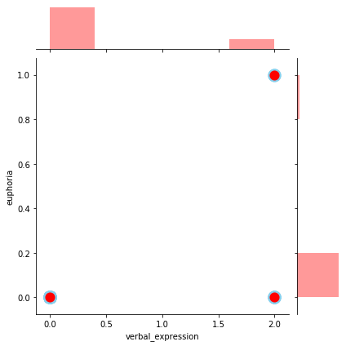
Figure 5.7. Marginal plot verbal expression and euphoria for ymrs dataset
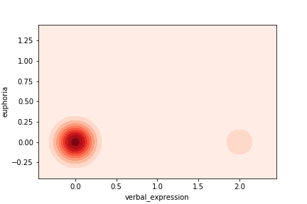
Figure 5.8. 2D density plot verbal expression and euphoria for ymrs dataset

  - HDRS dataset
    - Summary Statistics
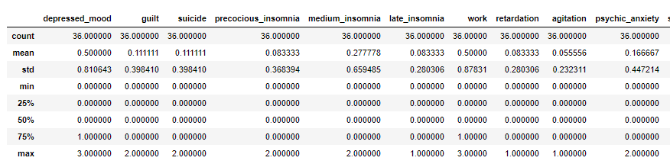
Figure 5.9. Describing the HDRS data frame.
We didn’t find any outliers, hence we proceeded to plot histogram.
    - Histogram
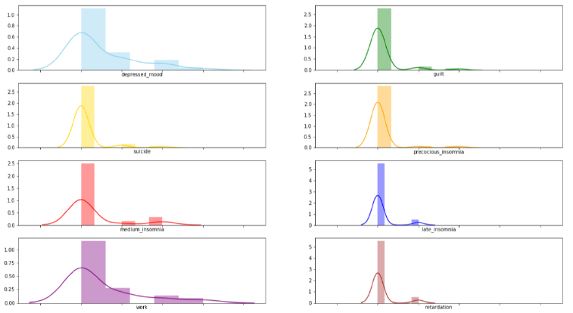
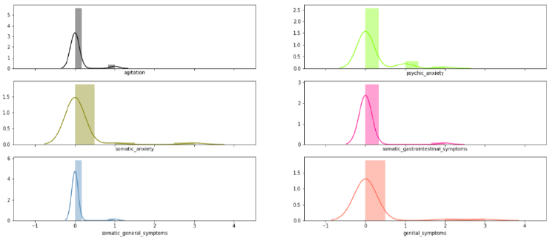
Figure 5.10. Histogram for HDRS dataset

We plotted histogram for HDRS dataset (see Figure 5.10). Here we observe that the distribution curve is almost similar in all the features. Depressed mood and work, suicide and precious insomnia showed similar distribution.
    - Heatmap
We plotted heatmap for HDRS dataset for better understanding (see Figure 5.11) 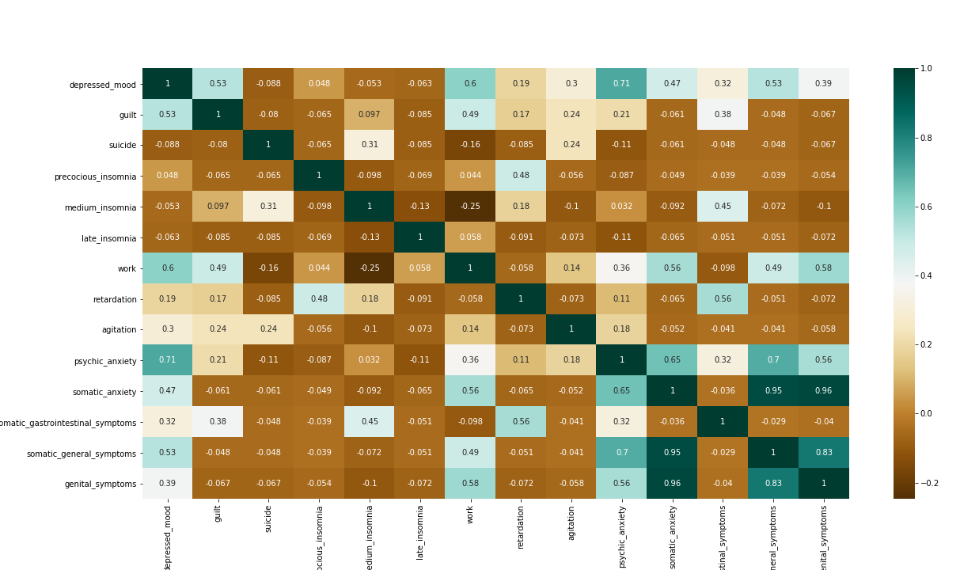
Figure 5.11. Heatmap for HDRS dataset
There are a lot of variables that seem to be correlated in this heatmap. We can see correlations between:
- 'depressed_mood' and 'work': This tells us that the less a patient is willing to go to work or do other activities that he or she usually does, the more depressed he or she will probably feel.
- 'depressed_mood' and 'psychic_anxiety': This correlation is quite interesting because it shows a relationship between the level of anxiety of a patient and a depressed mood. If a patient feels anxious, he or she will probably feel more depressed than usual.
- 'psychic_anxiety' and 'somatic_anxiety': These two variables could be merged into one, 'anxiety', as they are quite similar and show a clear correlation. We will plot them with a density plot later to confirm the correlation.
- 'psychic_anxiety' and 'somatic_general_symptoms': This tells us that if the patient is anxious, he or she will most surely have some kind of somatic symptom
    - Scatterplot
We plotter scatter plot to find if there were any other features shown distribution.
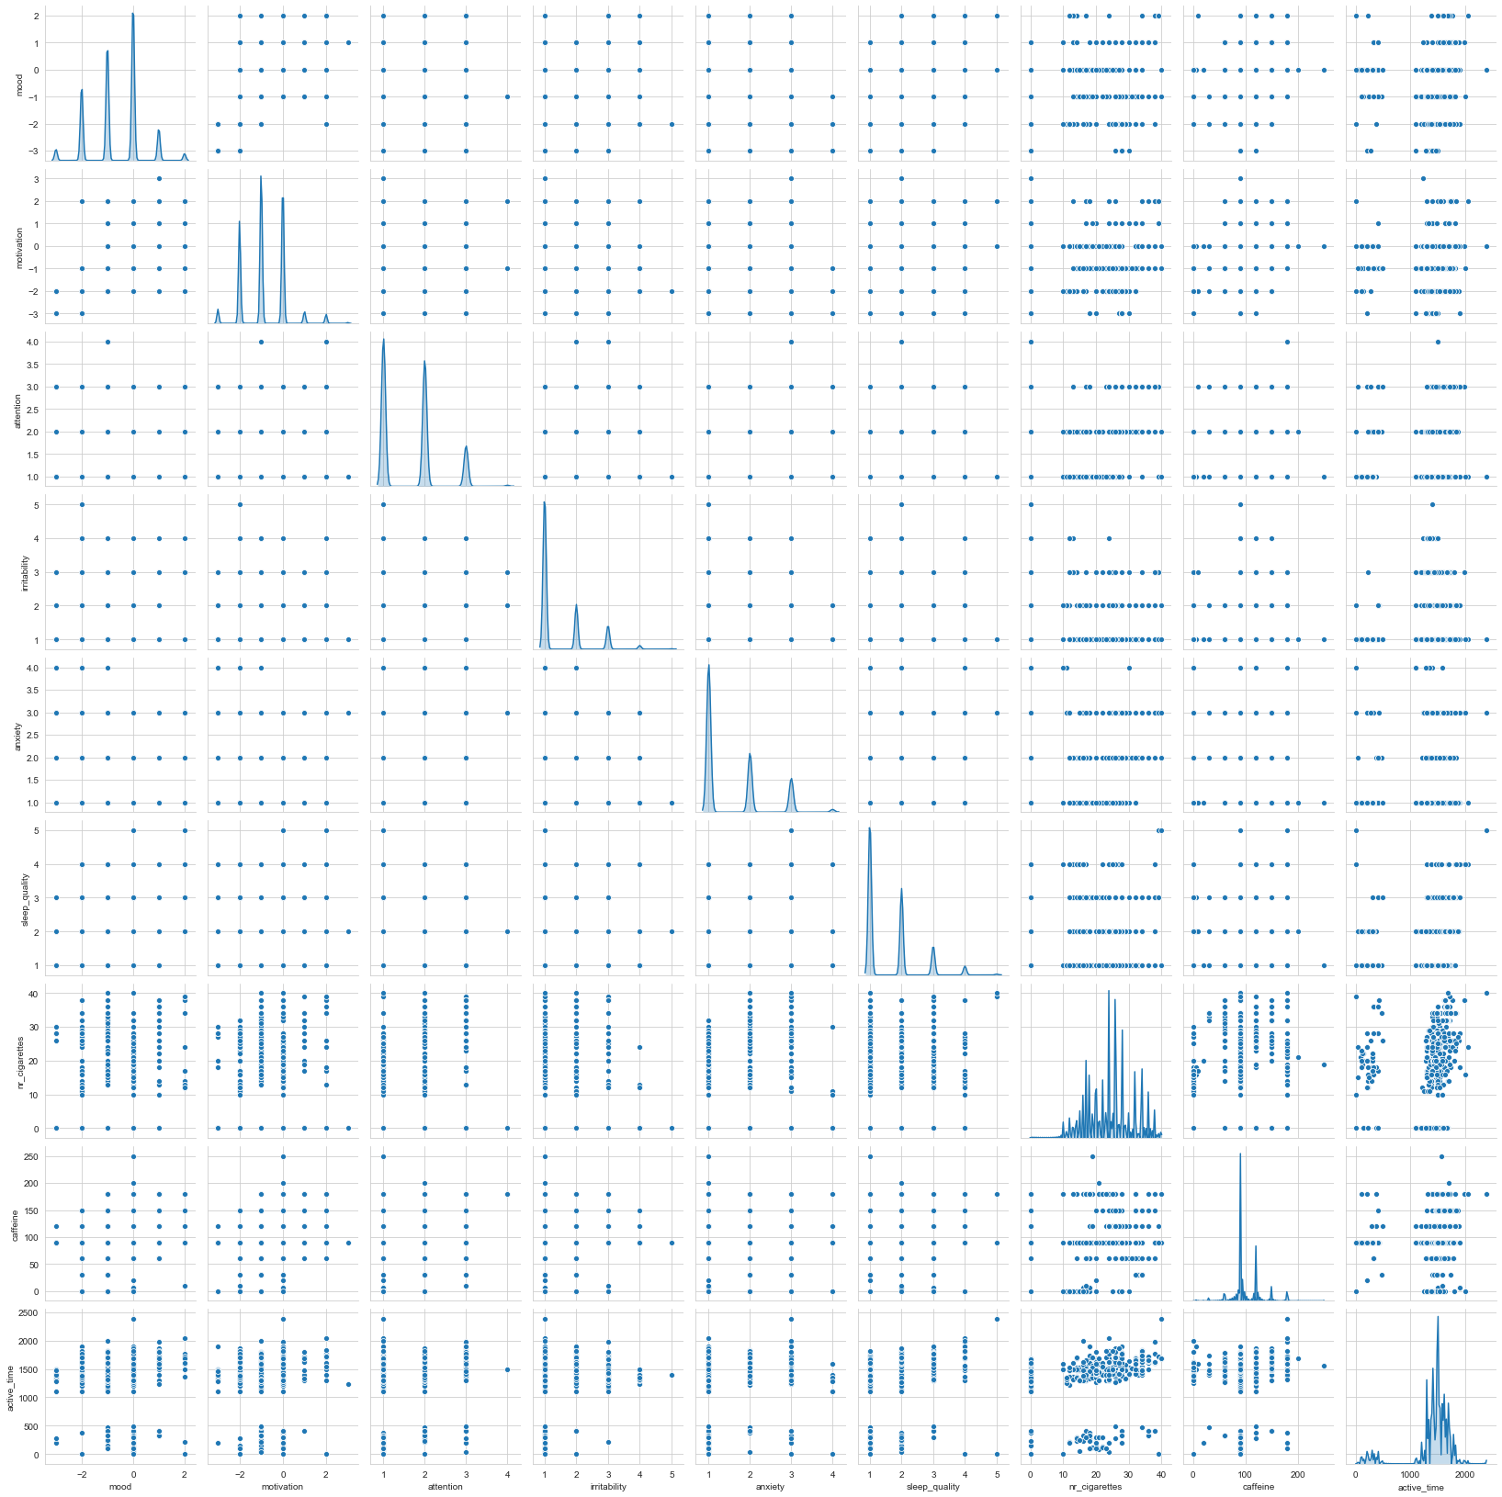
Figure 5.12. Scatter plot for HDRS dataset
In the plot above we observe an equal distribution between 'depressed_mood' and both 'work' and 'psychic_anxiety'. Let's make both a marginal an a 2D density plot to further visualize the relationship between these variables.

    - Marginal plot and 2D density plot
We plotted Marginal and 2D density for understanding the distribution between the features we got from scatter plot.
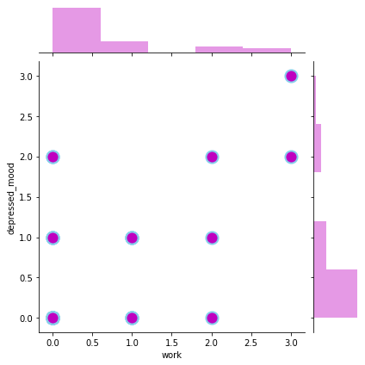
Figure 5.13 Marginal plot for depressed mood and work in HDRS dataset
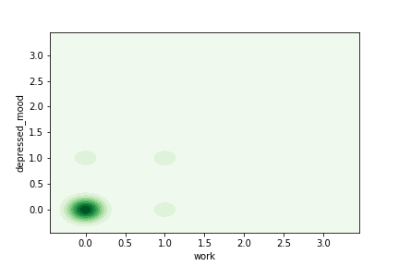
Figure 5.14 2D density plot for depressed mood and work in HDRS dataset
From the figure 5.13 and 5.14 we can observe that these features showed a linear relationship, which means that if the patient is depressed then he/she might show less interest in activities or work or vice versa.

Now let’s plot for psychic anxiety and depressed mood.

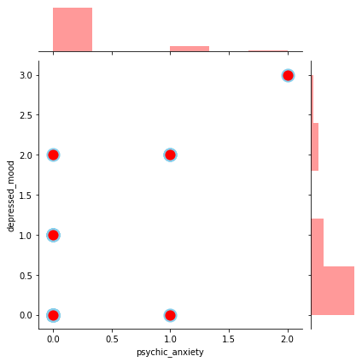
Figure 5.15 Marginal plot for depressed mood and psychic_anxiety in HDRS dataset
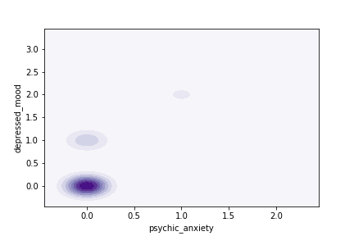
Figure 5.16 2D density plot for depressed mood and anxiety in HDRS dataset
From the above figures we can infer that when the patient is worrying about minor things or is in subjective tension then he/she might be in depressed mood.

Let’s plot for Somatic anxiety and psychic anxiety
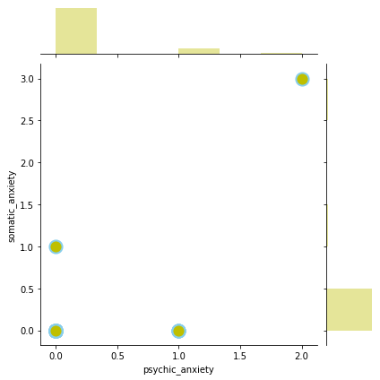
Figure 5.17 Marginal plot for Somatic anxiety and psychic anxiety in HDRS dataset

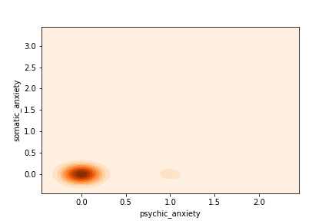
Figure 5.18 2D density plot for Somatic anxiety and psychic anxiety in HDRS dataset
We can observe that from figure 5.17 and 5.18 there is some sort of relationship between hence these features can be studied while applying algorithms. Sometimes highly correlated features can lower the prediction score.

Let’s plot for Somatic General Symptoms and Genital Symptoms
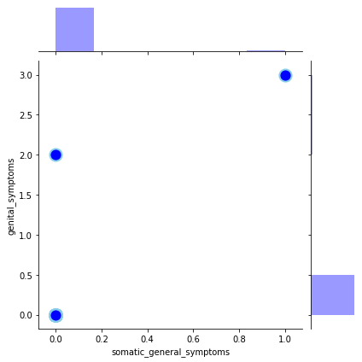
Figure 5.19 Marginal plot for Somatic General symptoms and genital symptoms in HDRS dataset
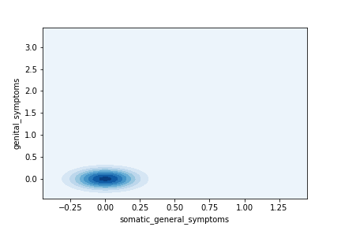
Figure 5.20 2D density for Somatic General symptoms and genital symptoms in HDRS dataset

There was no relation found between these features.

  - Interview dataset
    - Summary Statistics
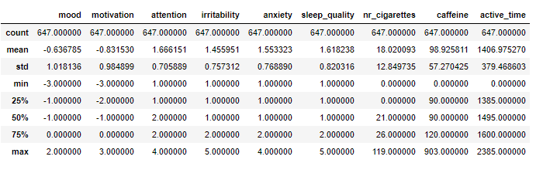
Figure 5.21 Describing the Interview Data frame
- Mean value is less than median value of each column represented by 50% (50th percentile) in index column.
- Notably large difference in 75th %tile and max values of predictors ‘nr_cigarettes’, ’caffeine’
- Thus observations 1 and 2 suggests that there are extreme values-Outliers in our dataset.
    - Histogram
We plotted histogram for other feature which didn’t had any outliers.
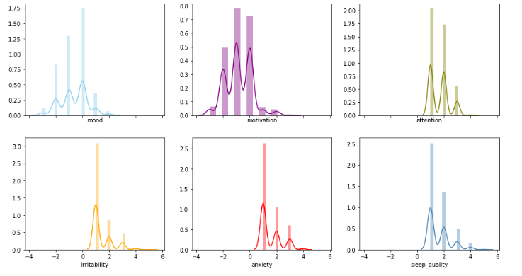
Figure 5.22 Histogram for Interview dataset
We could see the distribution of the data properly. Mood and motivation had more negative values, ranging from -4 to 2. The rest of the features had more positive values, which ranged from 0 to 4.

    - Boxplot
We are using box plot here to find out the outliers.
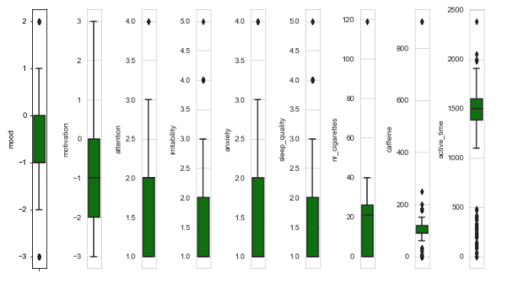
Figure 5.23 Finding the outliers using box plot for interview dataset.
We could observe in caffeine feature there are values in between values 800 and 1000, which meant that there could be an outlier there. A value higher than 800 had to be a writing error by the interviewer, because almost all the values of this feature ranged between 0 and 200. We checked if there were any values above 300 (see Figure 5.24).

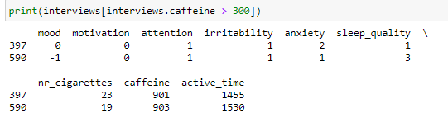
Figure 5.24. Checking if there are outliers in the Interview data set

There were two values above 300 in the data set, specifically 397 and 590 which, as we mentioned above didn’t make any sense if we compared them to the rest of the caffeine values in the data set. We proceeded to change the values to the same values as the rows before and after (see Figure 5.25), because outliers could affect the prediction with such a small amount of data as we had.

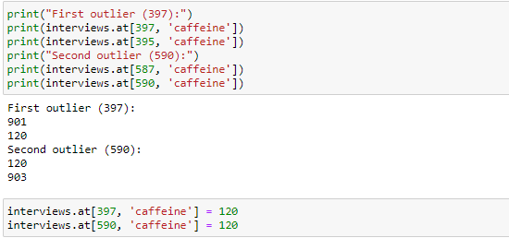
Figure 5.25. Changing the value of the outliers in the Interview data set
We can also see that cigarettes also have outliers. It showed that the number of cigarettes smoked by the patients were distributed between 0 and 40. We could also observe there were value between 100 and 120, which meant that a patient smoked between 100 and 120 cigarettes in a day, which had to be an error in this case too. We removed those values like we did with the caffeine values that were above 300, because they could affect the accuracy of some algorithms.
    - Heatmap
Let’s proceed to plot heatmap for interview dataset
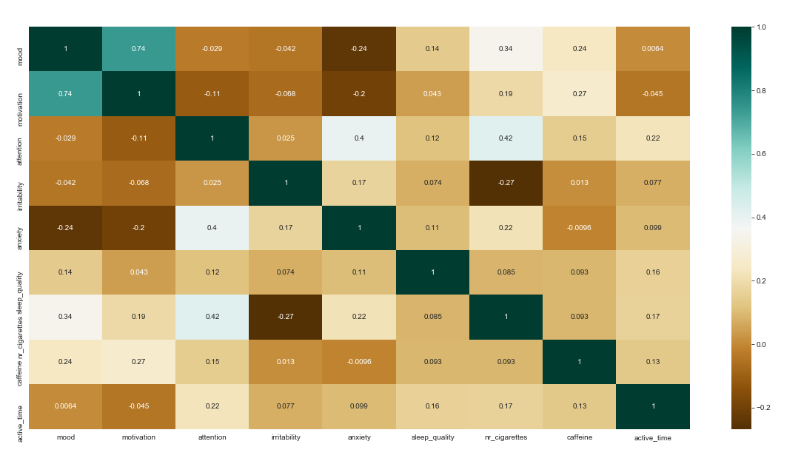
Figure 5.26 Heatmap for Interview dataset
The variables that seem to be highly correlated are 'mood' and 'motivation'. we will use scatter plot to know the clear relationship.

    - Scatterplot
Figure 5.27 Scatter plot for Interview dataset.
There is a linear relationship between 'mood' and 'motivation', just as we saw with the heatmap above. Another interesting relationship is the one between 'anxiety' and 'sleep quality'. We proceed to plot a marginal plot of Mood and Motivation.

    - Marginal plot and 2D density plot
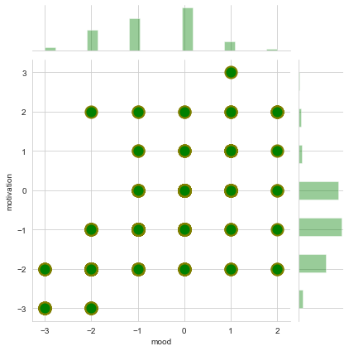
Figure 5.28 Marginal plot for mood and motivation in Interview dataset.
Let’s plot 2D density for better understanding.

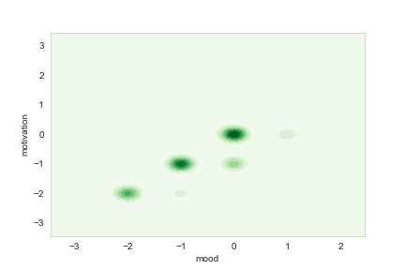
Figure 5.29 2D density plot for mood and motivation in Interview dataset.
In the above figures we can observe that mood and motivation show a linear relationship.

  - Intervention dataset
    - Summary Statistics
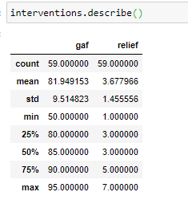
Figure 5.30 Describing Intervention Data frame
We didn’t find any outliers. Since there were only two columns, we did marginal and 2d density plots.
    - Marginal plot and 2D density plot
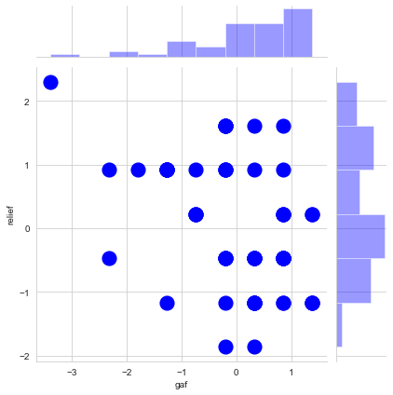
Figure 5.31 Marginal plot for interview dataset
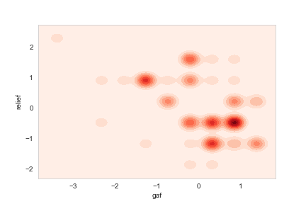
Figure 5.32 Marginal plot for interview dataset
There wasn’t any sort of clear distribution from both the figures.
- Combination of Dataset
In the chapter, we will combine the dataset with the episode dataset in order to understand how the features selected in the Exploratory data analysis are distributed with the target variable. This is done in order to select which combination of dataset had enough data for the algorithm to process and also to check which dataset give better accuracy.
The entire or row which had no records in Episode dataset were considered as euthymic state. We had three possible states the patient could be Mania-> M, Depression->D and N-> Euthymic state.
This part also helped us to understand how the data were distributed depending on which state the patient was in.
  - YMRS and Episode dataset
We merged ymrs and episode dataset by declaring a function with the help of date of each row that returned the episode of patient and added into a separate column in the YMRS dataset and we named it as episode (see Figure 6.1)
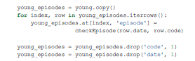
Figure 6.1 Merging the YMRS and Episode dataset
We plotted the features that were correlated in the YMRS dataset to see if there is any distribution depending on which state the patients were in (see Figure 6.2)
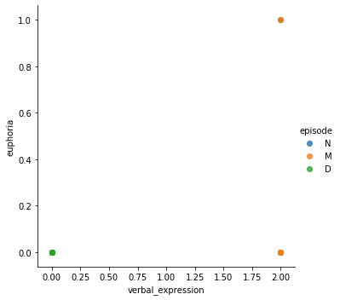
Figure 6.2. Distribution of euphoria and verbal expression patient states in YMRS dataset
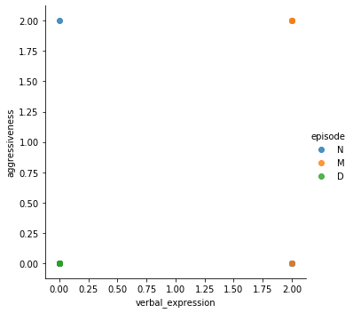
Figure 6.3. Distribution of aggressiveness and verbal expression patient states in YMRS
In the figure 6.2 and 6.3 we can observe that there was a partial distribution was found which indicates that the data points are overlapping because of less dataset. Hence, it was difficult to see if these features were distributed differently depending on the state of the patients.
  - HDRS and Episode dataset
We followed the same steps as done for YMRS dataset and dropped ‘code’ and ‘date’ column. We plotted the features that were correlated in the HDRS dataset to see if there is any distribution depending on which state the patients were in (see Figure 6.4)
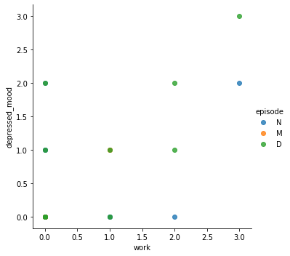
Figure 6.4. Distribution of depressed mood and work patient states in HDRS dataset
We can observe that the distribution of patient state in depressed_mood feature happened at much higher values from 2 to 3. We can say that if the patient was depressed then he/she may show less interest in work or vice versa.
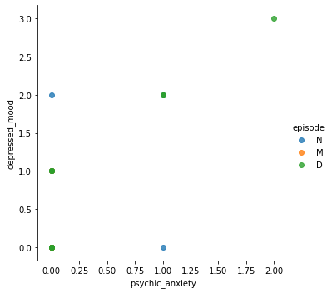
Figure 6.5. Distribution of depressed mood and psychic anxiety patient states in HDRS
In figure 6.5 the distribution of 'psychic anxiety' and 'depressed_mood' is quite clear with the above plot. This could indicate that, for example, if the patient has subjective tension (1) or starts worrying about minor things (2), it is probably because he or she is starting to feel more depressed.
The two other features that we found out were correlated in the Exploratory Data Analysis were somatic anxiety and psychic anxiety. We plotted them too in order to see how the different episodes were distributed (see Figure 6.6).
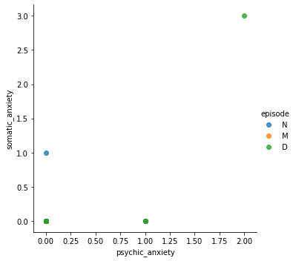
Figure 6.6. Distribution of somatic anxiety and psychic anxiety patient states in HDRS
There was no clear pattern in the distribution of these two features depending on the states of the patient, so we couldn’t make any valid conclusions with this plot.
  - Interview dataset
As we previously did with the YMRS and HDRS data sets, we merged the Interview data set with the Episode data set by iterating over each element and saving the episode the patient was in. We dropped the patient and date columns as we no longer needed them. The features that were correlated in the Interview data set were mood and motivation. We plotted a scatter plot like we did with the previous features (see Figure 6.7), in order to see the distribution on different episodes.
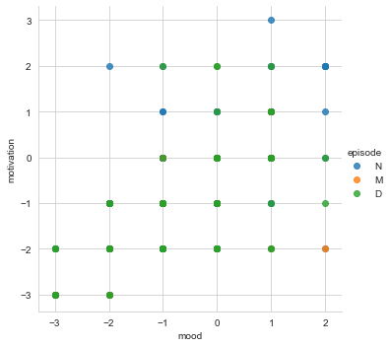
Figure 6.7. Distribution of mood and motivation on different patient states in the Interview
We can observe that there are more points where the patient had a depression episode in the negative part of the axis (-3,0),but here we couldn’t find some distribution for other states of the patients therefore we plotted a bar graph to find distribution of states (see figure 6.8).
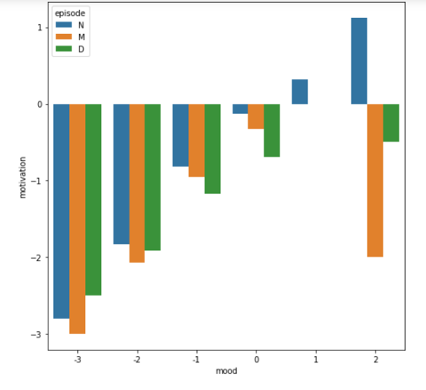
Figure 6.8. Bar graph Distribution of mood and motivation on different patient states in the Interview
Here we observed that if mood value is greater than 0 then the patient is in normal state.
The two other features that we found out were correlated in the Exploratory Data Analysis were sleep and quality. We plotted bar graph for them too in order to see how the different episodes were distributed (see Figure 6.9).
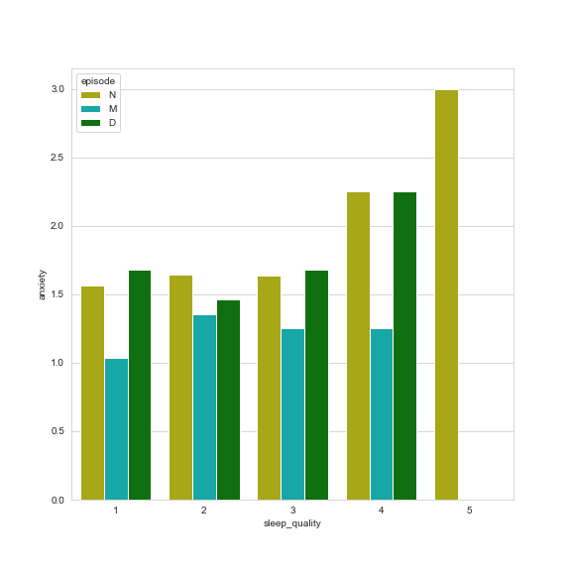
Figure 6.9. Anxiety and sleep quality bar plot with patient states in the Interview
These two features were clearly not representative for the state of a patient, because the distribution was very similar in all the possible combinations of values. There were no values for anxiety when the sleep quality was 5 for the states of mania and depression, which could either mean that there were not enough data or that the patients going through a mania or depression episode never had the highest level of quality when they slept.
Since we didn’t have clear understanding we plotted for features.
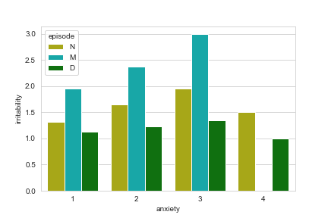
Figure 6.10. Anxiety and irritability bar plot with patient states in the Interview
Here we could conclude that if the patient is more anxious then they are more irritated, this indicated that the patient may be tending towards mania episode. There were no data points for mania when anxiety was 4, this could possibly indicate that may be loss of data or if anxiety level is 4 then the patient may be tending towards depression with less mood or motivation.
  - Intervention dataset
With the Intervention data set we did the exact same process of adding the episode to each entry of the Intervention data set and we dropped the code and date columns. We saw that GAF and relief did not have any relationship at all during the Exploratory Data Analysis, but we decided to make a plot in order to check if the distribution of the data was different on each episode of the patients (see Figure 6.11).
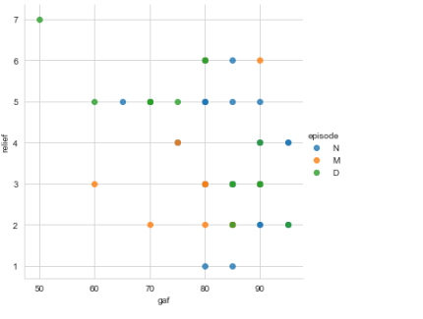
Figure 6.11. GAF and relief bar plot with patient states in the Intervention
No distribution was found in figure 6.10 hence we plotted bar graph for understanding.

Figure 6.12. GAF and relief bar plot with patient states in Intervention data set
It was useful to see that the only values recorded for level 7 of relief (feeling much worse) were from patients in a depression state, which meant that the doctor should worry when the patient reports feeling much worse, as it could indicate the start of a depression episode.

- Model Training and Building
The two most common types of Machine Learning that are used nowadays are supervised learning and unsupervised learning.
The supervised learning technique consists in creating a model, with the help of an algorithm, which will predict an output for a certain input. It often counts with a set of data for which the input and output are known. This set of data is called the training set.
Supervised learning problems can be of two types, regression and classification. Regression is a problem in which the output is quantitative, like predicting stock prizes based on previously obtained results. Classification is a problem in which the output is qualitative. The problem that is presented in this project is a classification problem, as it aims to predict whether the patient is having a mania or depression episode, or is staying in a euthymic state.
Unsupervised learning is used when the output is not known for the input values. The main type of problem in unsupervised learning is clustering, which consists in grouping the input data in clusters. Clusters are huge collections of data that have similar features.
In this part, we tested different classification algorithms on the data sets that we had previously obtained. The target or value that we tried to predict was the state a patient is in (Depression, Mania or Euthymic), so all the data sets had to have a column with the episode associated to the rest of the features, which we ensured in the data set combination section. The data sets on which we tested the algorithms were:
• YMRS: Young Mania Rating Scale data (young_episodes).
• HDRS: Hamilton Depression Rating Scale data (hamilton_episodes).
• Interviews: interview data (interviews_episodes).
• Interventions: intervention data (intervention_episodes).
With such a small amount of data as was available for the project, it was almost impossible to avoid underfitting of the models. This occurs when the model has a very high training and testing error, because it fails to learn the possible relationships that can exist between the data.
Even if the risk of underfitting existed, we still tried testing which algorithms performed well, so that we could discard the ones that performed poorly for when they were to be applied to larger amounts of data.
The algorithms that we used for this part are: Decision Tree, Random Forest, Support Vector Machines and Logistic Regression. The reason why these algorithms have been chosen for this project is explained down below in the section that corresponds to each algorithm.
The fact that these algorithms have been applied on this project doesn’t mean that they are the best option for the classification of Bipolar Disorder states, but rather that they are the most suitable ones given the amount of data and number of features used in the project. In future studies that make use of this project, if the data sets are larger, it could be interesting to apply other algorithms too, like the Naïve Bayes algorithm or any kind
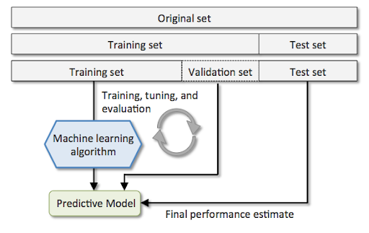
Figure 7.1. Diagram of the Machine Learning algorithm application process
of Boosting algorithm, as to see how they perform on this particular classification problem.
Before applying each algorithm, as is necessary for every classification problem, the original data needed to be split into a training and testing set (see Figure 7.1). Later, the training data would be used to train the prediction models and the testing data would be used to compare the output of the model with the real targets by cross-validation.
The testing set is used for obtaining the accuracy of the model, as mentioned above, which is done by comparing the output obtained from the testing input and the real output of the testing set. In order to divide the original data sets into training and testing sets, we used the train_test_split() function from the scikit-learn library, an example of which can be seen in Figure 7.2, where the test size represents the percentage of the data that is used for the testing set (in this case 30%).
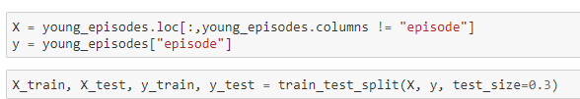
Figure 7.2. Splitting the YMRS data set into training and testing data sets

  - Decision Tree
A decision tree is a tree where each node represents a feature(attribute), each link(branch) represents a decision(rule) and each leaf represents an outcome(categorical or continues value).The whole idea is to create a tree like this for the entire data and process a single outcome at every leaf(or minimize the error in every leaf).
There are couple of algorithms there to build a decision tree, we only talk about a few which are
- CART (Classification and Regression Trees) → uses Gini Index (Classification) as metric.
- ID3 (Iterative Dichotomiser 3) → uses Entropy function and Information gain as metrics.
We are using CART algorithm to build the model
In the case of the DecisionTreeClassifier, if we don’t change the default hyper-parameters, the result will be a fully-grown tree with no pruning at all. This can make the tree very complex and memory consuming, so we have taken the liberty of tuning these hyper-parameters depending on the size and number of features of the data sets. The hyper-parameters that have been used for the DecisionTreeClassifier in this project are:
• max_depth: the maximum number of nodes in a branch.
• min_samples_leaf: the minimum number of samples required at a leaf node.
The reason why we are using this algorithm is, Decision tress often mimic the human level thinking so it’s so simple to understand the data and make some good interpretations. Decision trees actually make you see the logic for the data to interpret (not like black box algorithms like SVM, NN, etc.) and also the way it discriminates different features that make wrong predictions and the ease in being able to see this discrimination with some plotting libraries, such as the Graphviz library for Python, which let us plot the Decision Tree classifier.
    - YMRS Dataset
The first step was to divide the data set into a training and a testing test, like we mentioned above, after which we proceeded to train the model, as seen in Figure 7.3.

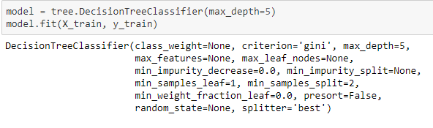
Figure 7.3. Model training with Decision Tree classifier
The max_depth in this case was set to 5 and the min_samples_leaf was set to 1 (the default value for the DecisionTreeClassifier), because the data were very scarce. With this model, we obtained an accuracy of 36%, which was really low and would make a very bad prediction on real data. With the help of the Graphviz [30] library, we plotted the Decision Tree classifier in order to see how each decision was made (see Figure 7.4).
Figure 7.4. Decision Tree graph of YMRS data
We could see that the most important split for this tree was aggressiveness lower or equal than 1 and that the tree continued by dividing the left branch with irritability values lower than or equal to 1 and the right branch with hyperactivity values lower than or equal to 0’5. This showed that if a patient had a value of aggressiveness greater than 1, he or she would automatically be classified as having a Mania episode, because the splits were not equally distributed, which didn’t make much sense, as an aggressiveness level of 1 is quite low (it ranges from 0 to 8).
    - HDRS Dataset
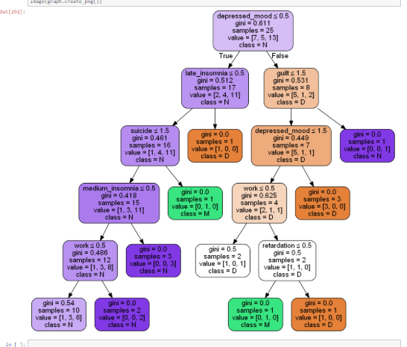
Figure 7.5. Decision Tree for HDRS dataset
In figure 7.5 we can observe that the split is happening in depressed mood lesser than or equal to 0.5 when the values on the right-hand side are classified has Depression.
Another important spilt is suicide, if suicide value is greater than 0.5 than it is classified as Mania. We can say that more that patient has suicide thoughts than he or she may be tending towards Mania.

    - Interview Dataset
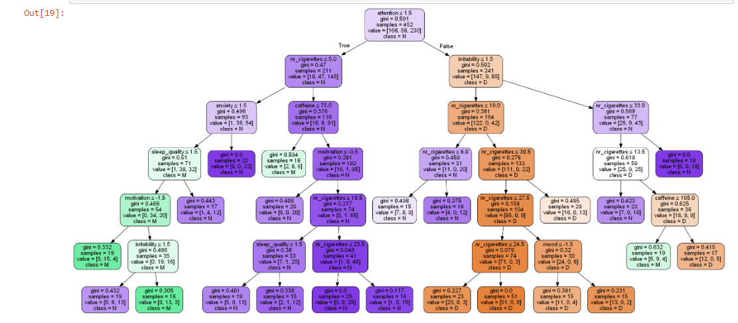
Figure 7.6. Decision Tree for HDRS dataset
In this tree, the most important split was an attention value lower or greater than 1.5. All the Mania episodes were classified on the left side of this split and all the Depression episodes on the right side, which could mean that attention is an important variable in this kind of classification. The nr_cigarettes variable was present in eight different splits in the tree, which could indicate that this variable is important for this type of diagnosis.
It was interesting to follow the splits as a whole, as they presented very concrete conclusions on the decision making of the algorithm. For example, as seen in the first branch, a patient with a low attention level that doesn’t smoke a lot and is quite anxious and not that irritable but feels very unmotivated will be labelled as having a Mania episode

    - Intervention Dataset
In the tree graph (see Figure 7.7) we can observe that the splits were very random and that there was no clear pattern on how the algorithm made the decisions.
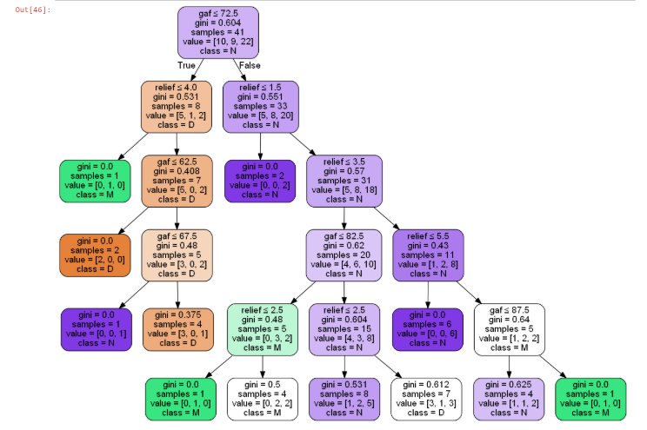
Figure 7.7 Decision Tree graph of Intervention data
    - Overall Prediction accuracy

Dataset | Accuracy
YMRS | 36%
HDRS | 63%
Interview | 74%
Intervention | 55%
Figure 7.8 Prediction accuracies of the Decision Tree algorithm
As shown in Figure 7.8, the Decision Tree classifier had the best accuracy with the Interview data set. We can say that the best scoring data set, in relation with the amount of data, was the Interview data set.

  - Random forest
The Random Forest algorithm consists in an array of tree predictors in which every tree is depending on values of a random vector that is sampled with the exact same distribution for all the trees. Like the Decision Tree algorithm, the decision criteria consist in looking at each feature in the training set individually and choosing the ones that help the most in giving the model an optimal fit. The Random Forest algorithm is implemented with the RandomForestClassifier from the scikit-learn library, and the process of implementation was very similar to the DecisionTreeClassifier.
This algorithm has been chosen as one of the options for this project because of the speed and scalability it presents on huge data sets and because it can be combined with programming paradigms like Map Reduce, which is made for processing huge amounts of data. This is quite useful for future implementations and the continuity of the project, which will hopefully include much larger data sets.
    - Overall Prediction Accuracy

Dataset | Accuracy
YMRS | 54%
HDRS | 54%
Interview | 76%
Intervention | 61%
Figure 7.9. Prediction accuracies of the Random Forest algorithm

  - Support vector Machine
Support Vector Machines (SVM) aim to maximize the distance between the targets in a hyperplane, in order to find a hyperplane that is optimal for classification. The support vectors are the vectors that define this hyperplane.
SVM maps the input vectors into a high-dimensional feature space. In this space, the optimal separating hyperplane is constructed [32]. Given the distance (confidence) from each point in the training set to the decision hyperplane
𝑑(𝑥, 𝐿) = 𝑤 ⋅ 𝑥 + 𝑏
where 𝑤 is the vector that defines the optimal hyperplane and 𝑥 are the coordinates of the point, SVM finds this optimal hyperplane with the optimization problem
𝑚𝑎𝑥 𝑤,𝛾 𝛾 𝑠. 𝑡. ∀𝑖, 𝑦𝑖 (𝑤 ⋅ 𝑥𝑖 + 𝑏) ≥ 𝛾
which finds 𝛾, the largest possible margin, such that, for every point in the training set, the margin is at least 𝛾, which implicates finding the 𝑤 that achieves this margin (see Figure 7.10). This is achieved by multiplying the distance of each point in the training set by the class of the prediction.
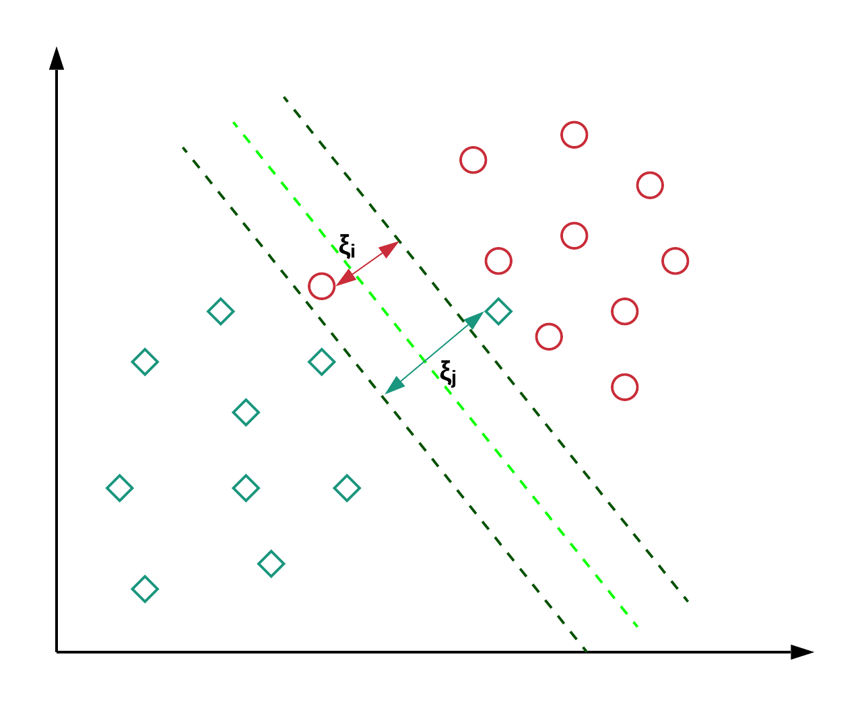
Figure 7.10. Finding the largest possible margin to the hyperplane

The reason why this algorithm has been chosen for this project is the good generalization that it generally provides even if there are biased values in the data, which is something very useful as we don’t really know if there could be any bias in our data.

    - Overall Prediction Accuracy

Dataset | Accuracy
YMRS | 45%
HDRS | 45%
Interview | 70%
Intervention | 66%
Figure 7.11. Prediction accuracies of the SVM

The accuracy matrix for the SVM algorithm, as seen in Figure 7.11, showed that the accuracy obtained with the YMRS data set was 45%, which was the same as the accuracy obtained with the Random Forest algorithm and, again, was very low. The consequence would probably be a very poor model performance. Moreover, the accuracy obtained with the HDRS data set was 45%, which was same as YMRS dataset.
The Interview data set returned a score of 70% with the SVM algorithm, which was lower than the accuracy obtained with the two previously studied algorithms (Decision Tree and Random Forest), but we considered that it could still be interesting to use this algorithm for prediction so that we could check the performance it offered on real data.
The Intervention data set returned an accuracy of 66%, which is a quite good performance and should be considered for future implementations of this algorithm on the same kind of problem.

  - Logistic Regression
The mathematical concept behind a Logistic Regression model is the natural logarithm of an odds ratio between two variables, also called logit. The Logistic Regression is explained with the Logistic Function, which takes an input and outputs a number between 0 and 1, and is defined as:
𝜎(𝑡) = 𝑒𝑡 𝑒𝑡 + 1
In this function, 𝑡 is a linear function that can be represented as 𝑡 = 𝛽0 + 𝛽1𝑥 and, therefore, the Logistic Function can be expressed as:
𝜋(𝑥) = 𝑒𝛽0+𝛽1𝑥 𝑒𝛽0+𝛽1𝑥 + 1
The logit, which is the equivalent to the Linear Regression expression and, as mentioned above, represents the concept behind the whole model, is the inverse of the Logistic Function, i.e.:
𝑔(𝑥) = 𝑙𝑛 [ 𝜋(𝑥) 1 − 𝜋(𝑥)] = 𝛽0 + 𝛽1𝑥
Traditionally, what characterizes the Logistic Regression algorithm is that the outcome variable is binary, which is not the case in this problem, as the possible outcomes are three (D, M or N). Nevertheless, the scikit-learn Python library allows the application of a Multi-class Logistic Regression by default, fitting a binary problem for each label (one vs. all classification) by calculating the probability of each possible outcome separately. A basic diagram of how this algorithm works can be seen in Figure 7.12.
Figure 7.12. Basic diagram of one vs. all Multi-class Logistic Regression classification
    - Overall Prediction Accuracy
Dataset | Accuracy
YMRS | 45%
HDRS | 45%
Interview | 69%
Intervention | 40%
Figure 7.13. Prediction accuracies of the Decision Tree algorithm
Taking a look at the prediction accuracy matrix (see Figure 7.13), the accuracy obtained with the YMRS data set was 45% which as same as previous dataset and it was very low.
The Interview data set returned a score of 69% which is an acceptable performance if we consider that it has much more data than the rest of the data sets.
The accuracy of the Logistic Regression classifier with the Intervention data set was 40%, which is lower than the score obtained with the rest of the algorithms used. This data set clearly didn’t perform quite well with any of the algorithms used, but it shouldn’t be discarded for future implementations with more data.

- Model testing with Random data
In order to check if the predictions made by the different models obtained with the algorithms made any sense, we proceeded to randomize some patient data to test the models on. This was done by randomizing the values of the different items in the Interview data set (see Figure 8.1).
Every item has a different range so, for example, the mood values that we generated had to be between -3 and 3, the range in which those values were in the interviews performed by the psychiatrist. We did this with a loop that generated interview data for fifty random patients in order to be able to see which algorithms made the most reasonable prediction.
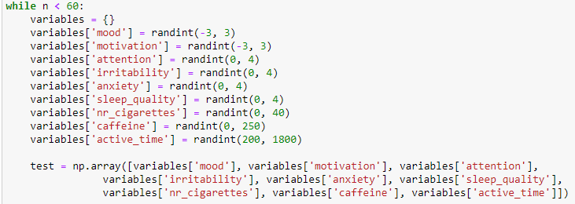
Figure 8.1. Random patient interview data generation
The Random Forest classifier seemed to make quite reasonable predictions. In the case of a patient that feels down and sleeps a lot, this algorithm predicted that he or she could be tending towards a Depression episode, as seen in Figure 8.2.
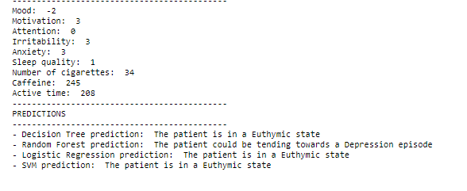
Figure 8.2. Prediction of a Depression episode on a patient with the lowest mood value
Another example of a precise prediction was the one made by both Logistic Regression and Random Forest on a patient feeling unmotivated and down and with a high level of anxiety, as can be seen in Figure 8.3.
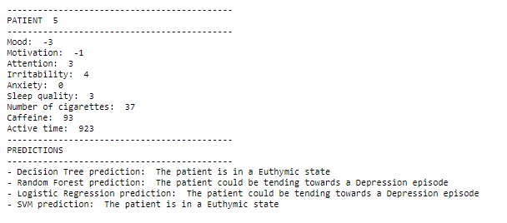
Figure 8.3. Prediction of a Depression episode on a patient with the lowest mood and motivation value
In other cases, if the patient was feeling down but was quite active and was both irritable and anxious, the Random Forest algorithm predicted that this patient could be tending towards a Mania episode (see Figure 8.4) when the rest of the algorithms predicted that he or she was in a Euthymic state.
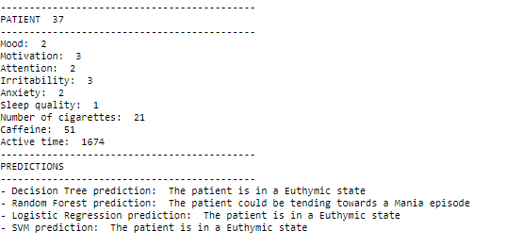
Figure 8.4. Prediction of a Mania episode on an active patient with high anxiety and irritability levels
If the patient had a normal behaviour, i.e. good mood and motivated, with normal anxiety and irritability levels, all the algorithms predicted that he or she was in a euthymic state, as seen in Figure 8.5.

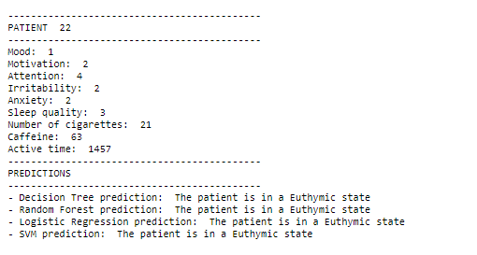
Figure 8.5. Prediction of Euthymic episode on an active patient.
Some of the predictions were not reasonable at all. For example, the state of a patient with a depressed mood and a quite low motivation level with a lot of sleeping hours was predicted as Euthymic, as seen in Figure 8.6, when the doctor would probably label it as tending towards a Depression.
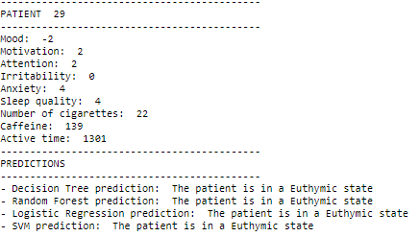
Figure 8.6. Prediction of a Euthymic state on a patient with clear depression symptoms

  - Accuracy Table
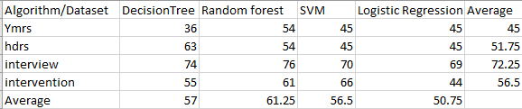
Figure 8.7. Accuracy Matrix of overall algorithms

This matrix showed that, in average, the data set that returned the best prediction accuracy (72%) was the Interview data set, as seen on the right column. The algorithm that performed the best, also in average (61%), was the Random forest algorithm, as seen on the row farthest down.
The Random Forest algorithm made the most accurate predictions, in the sense that they were very reasonable given the behaviour of the patients, which we tested with randomized data. These predictions made possible the implementation of a small program with the Random Forest classifier that we obtained, which can be used by the doctors with real patients.

- Model Deployment
Machine learning is a process which is widely used for prediction. N number of algorithms are available in various libraries which can be used for prediction. When we develop a machine learning model using Scikit-Learn, TensorFlow, Keras, PyTorch etc., the ultimate goal is to make it available in production. Often times when working on a machine learning project, we focus a lot on Exploratory Data Analysis (EDA), Feature Engineering, tweaking with hyper-parameters etc. But we tend to forget our main goal, which is to extract real value from the model predictions. We use the prediction model within different application in deploying machine learning in the real world. However, there is complexity in the deployment of machine learning models. This article aims to make you get started with putting our trained machine learning models into production using Flask API (See figure 9.1).
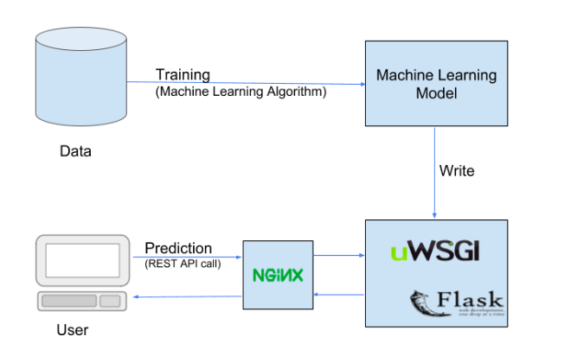
Figure 9.1 Model deployment
Why flask is used:
- Easy to use.
- Built in development server and debugger.
- Integrated unit testing support.
- RESTful request dispatching.
- Extensively documented.

  - Final test with real data

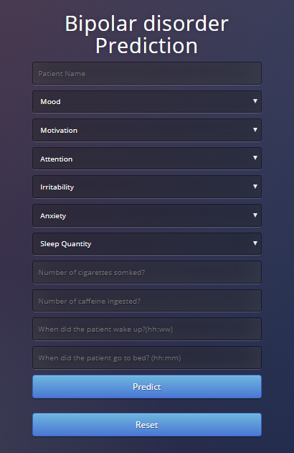
Figure 9.2 Parameters for prediction
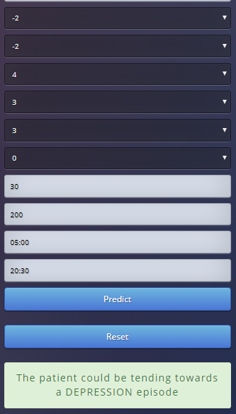
Figure 9.3. Prediction for a Depression episode
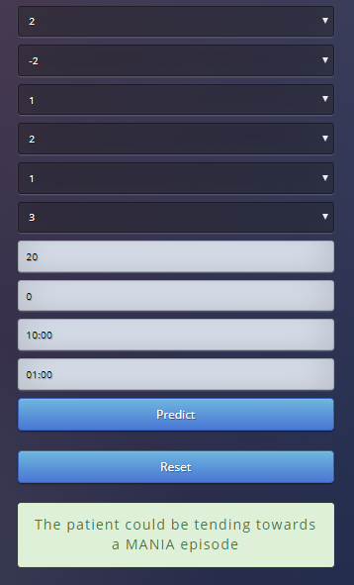
Figure 9.4. Mania Prediction

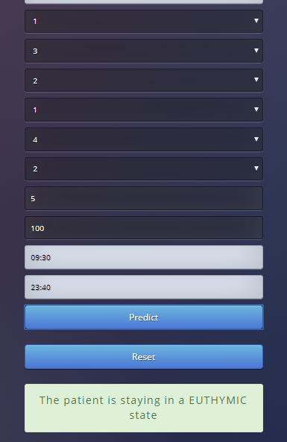
Figure 9.5 Euthymic prediction
10.Results and Conclusion
10.1. Results
This project is early symptom-based prediction application were algorithms are implemented and the results are depicted. In data gathering and cleaning, with such small datasets it was very challenging as all other process depended on that data available. There were few incomplete values and empty datasets present, hence that didn’t affect whole process because most had similar distribution. During data analysis, certain features showed interesting relationships. Figure 5.11 HDRS dataset Heatmap showed correlations between depressed mood and work which we confirmed by using marginal plot Figure 5.13 and 2D kernel density plot Figure 5.14, which indicated that when patient is depressed then he or she may lose interest in work. During interview dataset analysis, outliers were removed by using box plot Figure 5.23 which could have actually affected out prediction model. In Interview dataset features like mood and motivation Figure 5.26 showed the highest correlation, when 2D density plot was plotted a linear relationship was seen which may indicate that the patient gives same answers when interviewed. After selecting features combination of episode dataset with other datasets is plotted using marginal plot. Figure 6.6 shows the Depression state is distributed more on the negative points which indicated that the patient might be tending towards depression when the values of mood and motivation are low. To understand Mania state other features of interview dataset is plotted. Figure 6.9 showed that more irritable and anxious the patient is then he or she may be tending towards Mania episode. By applying different algorithms and its implementations, taking the average of the accuracy of each dataset and algorithms, the dataset which showed best accuracy was Interview Dataset and the algorithm which showed best accuracy was Random forest. For Interview Dataset, random forest showed 76% accuracy which is the highest compared to other algorithms applied on it. Hence, it is concluded that random forest showed more average accuracy compared to other algorithms which were applied on the dataset Figure 7.14.
After finding the accuracy random test data is used to test the prediction model. With this, further a web application is created and deployed in Heroku cloud platform. Figure 9.2 shows the parameters we considered for the prediction. The final prediction is shown in Figure 9.3, 9.4 and 9.5.

10.2. Conclusion
The focus of this project is to build an early symptom-based prediction application that can be used by the doctors to predict the patients state even before they suffer from states of bipolar disorder. In future when large data is available for any of the dataset then there is no need of analysis from the beginning. The steps that should performed is also shown in this paper. Further with such limited data understanding how the features behave and also deep understanding of each algorithm was much needed to make the models perform in the best possible way. The entire application showed the prediction of bipolar disorder of a patient in his or her early stages of the disorder.
10.3. Future Work
This model is done using limited dataset but in future if larger amount of data is available then the same algorithms can used to train the datasets. The application uploaded in cloud could further be update with features like once the patient done using the application then the report will directly be sent to the doctors. In future, predicting drugs for the patients depending on the state he or she might be in particular period of time and all these data can be stored in cloud.

11.Bibilography
[1] Sagar, R., Dandona, R., Gururaj, G., Dhaliwal, R. S., Singh, A., Ferrari, A., ... & Kumar, G. A. (2020). The burden of mental disorders across the states of India: the Global Burden of Disease Study 1990–2017. The Lancet Psychiatry, 7(2), 148-161.
[2] Jadhav, Ranjana, et al. "Mental Disorder Detection: Bipolar Disorder Scrutinization Using Machine Learning." 2019 9th International Conference on Cloud Computing, Data Science & Engineering (Confluence). IEEE, 2019.
[3] Wu, Mon-Ju, et al. "Individualized identification of euthymic bipolar disorder using the Cambridge Neuropsychological Test Automated Battery (CANTAB) and machine learning." Journal of affective disorders 192 (2016): 219-225.
[4] Grünerbl, Agnes, et al. "Smartphone-based recognition of states and state changes in bipolar disorder patients." IEEE Journal of Biomedical and Health Informatics 19.1 (2014): 140-148.
[5] Tsuang, Ming T., et al. "Assessing the validity of blood‐based gene expression profiles for the classification of schizophrenia and bipolar disorder: A preliminary report." American Journal of Medical Genetics Part B: Neuropsychiatric Genetics 133.1 (2005): 1-5.
[6] Dwyer, Dominic B., Peter Falkai, and Nikolaos Koutsouleris. "Machine learning approaches for clinical psychology and psychiatry." Annual review of clinical psychology 14 (2018): 91-118.
[7] Doryab, Afsaneh, et al. "Impact factor analysis: combining prediction with parameter ranking to reveal the impact of behavior on health outcome." Personal and Ubiquitous Computing 19.2 (2015): 355-365.
[8] Salvador, Raymond, et al. "Evaluation of machine learning algorithms and structural features for optimal MRI-based diagnostic prediction in psychosis." PLoS One 12.4 (2017).
[9] Arribas, Imanol Perez, et al. "A signature-based machine learning model for distinguishing bipolar disorder and borderline personality disorder." Translational psychiatry 8.1 (2018): 1-7.
[10] J. W. Tukey, Exploratory Data Analysis, vol. 23, London: Addison‐Wesley Publishing Company Reading, 1977, pp. 413-414.

[11] M. Faurholt-Jepsen et al., Smartphone data as objective measures of bipolar disorder symptoms, vol. 217, Psychiatry Research, 2014, pp. 124-127.

[12] Librenza-Garcia, Diego, et al. "The impact of machine learning techniques in the study of bipolar disorder: a systematic review." Neuroscience & Biobehavioral Reviews 80 (2017): 538-554.

[13] R. C. Young et al., A rating scale for mania: reliability, validity and sensitivity, British Journal of Psychiatry, 1978, pp. 429-435.
[14] M. Hamilton, A rating scale for depression, Journal of Neurology, Neurosurgery, and Psychiatry, 1960, pp. 56-62.
[15] J. W. Tukey, Exploratory Data Analysis, vol. 23, London: Addison‐Wesley Publishing Company Reading, 1977, pp. 413-414.
[16] J. R. Quinlan, Induction of Decision Trees, vol. 1, Hingham, Massachusetts: Kluwer Academic Publishers, 1986, pp. 81-106.
[17] L. Breiman, Random Forests, vol. 45, Berkeley, California: Machine Learning, 2001, pp. 5-32.
[18] C. Hsu, C. Chang and C. Lin, A Practical Guide to Support Vector Classification, Taipei: National Taiwan University, 2003.
[19] C. Peng, K. Lee and G. Ingersoll, An Introduction to Logistic Regression Analysis and Reporting, vol. 96, Bloomington, Indiana: The Journal of Educational Research, 2002, pp. 3-14.
[20] T. Patil and S. Sherekar, Performance Analysis of Naive Bayes and J48 Classification Algorithm for Data Classification, vol. 6, International Journal Of Computer Science And Applications, 2013, pp. 256-261.

