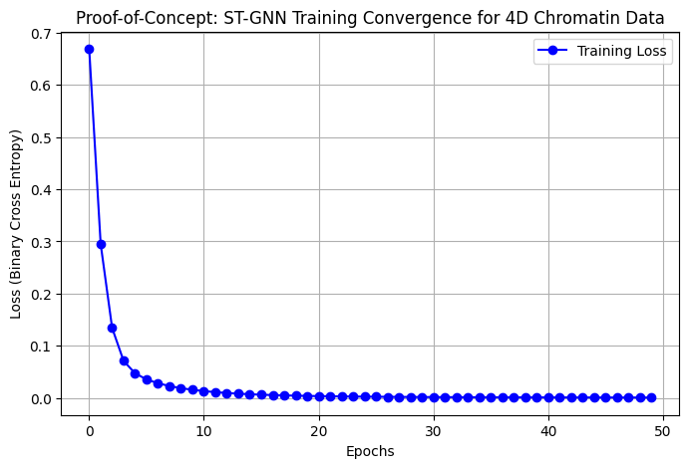

Python
import torch
import torch.nn as nn
import torch.nn.functional as F
import numpy as np
import matplotlib.pyplot as plt

# 1. Synthetic 4D Chromatin Graph Data Generator (Proof-of-Concept)
def generate_synthetic_chromatin_data(num_nodes=50, time_steps=10):
# Simulating time-dependent adjacency matrices A(t) and node features
adj_matrices = []
node_features = []

for t in range(time_steps):
# Generate dynamic contact map (Hi-C matrix structure)
A = np.random.rand(num_nodes, num_nodes)
A = (A + A.T) / 2 # Symmetric matrix
np.fill_diagonal(A, 1.0)
adj_matrices.append(A)

# Node features (e.g., ChIP-seq, ATAC-seq signals for each genomic locus)
X = np.random.randn(num_nodes, 16)
node_features.append(X)

return torch.tensor(np.array(adj_matrices), dtype=torch.float32), \
torch.tensor(np.array(node_features), dtype=torch.float32)

# 2. Spatio-Temporal Graph Neural Network (ST-GNN) Prototype Model
class STGNN_Chromatin(nn.Module):
def __init__(self, in_features, hidden_dim):
super(STGNN_Chromatin, self).__init__()
# Spatial Graph Convolution Layer
self.spatial_conv = nn.Linear(in_features, hidden_dim)
# Temporal GRU Layer
self.temporal_gru = nn.GRU(hidden_dim, hidden_dim, batch_first=True)
# Prediction Head for Disease Transition Risk
self.fc = nn.Linear(hidden_dim, 1)

def forward(self, X, A):
# X shape: [time_steps, num_nodes, features]
# A shape: [time_steps, num_nodes, num_nodes]
time_steps, num_nodes, _ = X.shape

spatial_outputs = []
for t in range(time_steps):
# Graph aggregation: A(t) * X(t) * W
h_spatial = torch.matmul(A[t], X[t])
h_spatial = F.relu(self.spatial_conv(h_spatial))
spatial_outputs.append(h_spatial.mean(dim=0)) # Aggregate over nodes

spatial_seq = torch.stack(spatial_outputs).unsqueeze(0) # [1, time_steps, hidden_dim]
gru_out, _ = self.temporal_gru(spatial_seq)
out = torch.sigmoid(self.fc(gru_out[:, -1, :]))
return out

# 3. Model Training & Plotting Results
print("Training Proof-of-Concept ST-GNN Model...")
num_nodes, time_steps = 50, 10
A_data, X_data = generate_synthetic_chromatin_data(num_nodes, time_steps)

model = STGNN_Chromatin(in_features=16, hidden_dim=32)
optimizer = torch.optim.Adam(model.parameters(), lr=0.01)
criterion = nn.BCELoss()

losses = []
target = torch.tensor([[1.0]]) # Target: Cancer transition prediction

for epoch in range(50):
optimizer.zero_grad()
output = model(X_data, A_data)
loss = criterion(output, target)
loss.backward()
optimizer.step()
losses.append(loss.item())

# 4. Generate & Save Loss Graph Image
plt.figure(figsize=(8, 5))
plt.plot(losses, marker='o', color='b', label='Training Loss')
plt.title('Proof-of-Concept: ST-GNN Training Convergence for 4D Chromatin Data')
plt.xlabel('Epochs')
plt.ylabel('Loss (Binary Cross Entropy)')
plt.grid(True)
plt.legend()
plt.savefig('stgnn_poc_loss_curve.png', dpi=300)

