Zomato Restaurant Analysis Project Report
Project Title: Zomato Restaurant Analysis
Submitted by: Jyoti Nayak
Technologies: SQL | Excel | Power BI | Tableau
ExcelR Institute
Submission Date :08-07-2026

1. Executive Summary
A short summary explaining that the project focuses on analyzing restaurant data from Zomato using SQL, Excel, Power BI, and Tableau. The objective is to transform raw data into meaningful business insights through data cleaning, modeling, visualization, and KPI analysis.

2. Project Objective
Analyses restaurant performance across countries and cities.
- Identify top-performing restaurants and locations.
- Study ratings and pricing trends.
- Analyze online delivery and table booking availability.
- Build interactive dashboards.
- Generate business insights for decision-making.

3. Dataset Description
Include:
- Number of Restaurants: 9,551
- Countries: 15
- Cities: 141 and ETC

4. Tools Used
Tool | Purpose
Microsoft Excel | Data Cleaning, Pivot Tables, Dashboard
SQL | Data Analysis and KPI Queries
Power BI | Interactive Dashboard
Tableau | Business Visualization

5. Excel Data Cleaning
This section should describe your work professionally.
Data Preparation
The raw dataset contained inconsistencies and required preprocessing before analysis.
The following data cleaning activities were performed:
- Converted date columns from Text format to Date format.
- Handled missing values using appropriate replacement techniques.
- Standardized data formats.
- Removed duplicate records.
- Replaced incorrect values.
- Split combined columns into meaningful fields.
- Merged First Name and Last Name where required.
- Verified column headers and data consistency.

6. Excel Dashboard Development
After cleaning the data,
- Created Pivot Tables
- Created Pivot Charts
- Added Slicers
- Designed KPI Cards
Dashboard 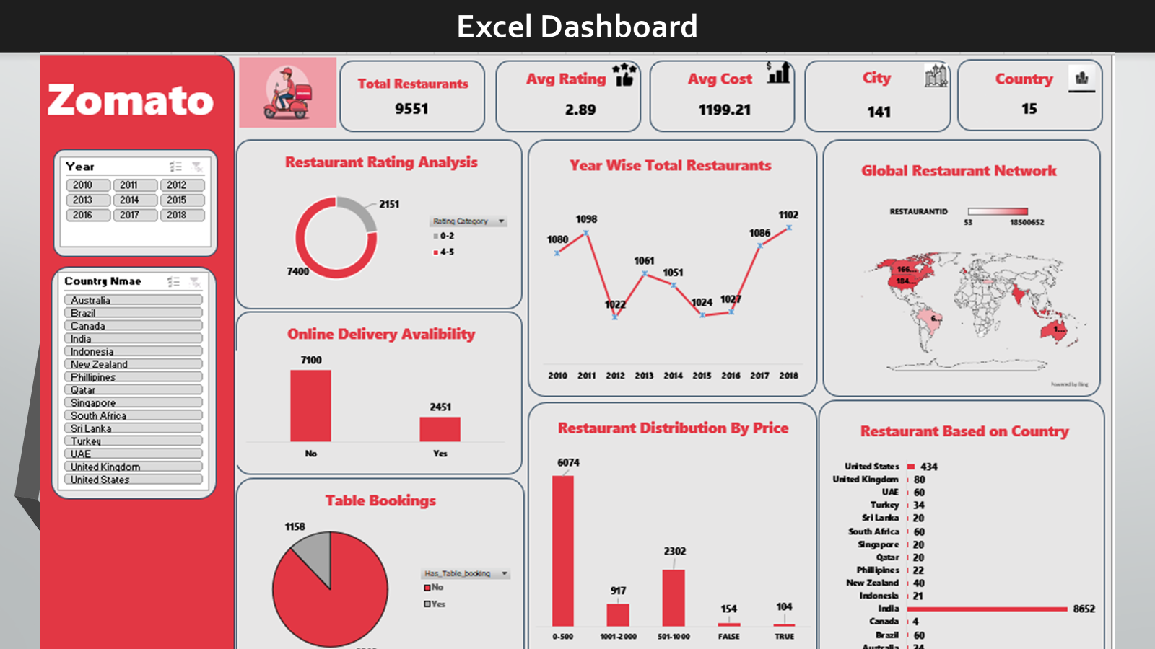

7. SQL Data Analysis
This will be one of the strongest sections.
Include:
Database Creation
- Created Zomato database
- Imported Restaurant table
- Imported Country table
Data Loading
- Loaded data using SQL Import Wizard.
- Validated imported records.
Calendar Table Creation
Created a Calendar table containing:
- Year
- Month
- Quarter
- Fiscal Month
- Fiscal Quarter
Joins
Merged
- Restaurant Table
- Country Table
- Calendar Table
using SQL JOIN operations.
SQL Concepts Used
- SELECT
- WHERE
- GROUP BY
- ORDER BY
- Aggregate Functions
- INNER JOIN
- Common Table Expressions (CTE)
- Window Functions
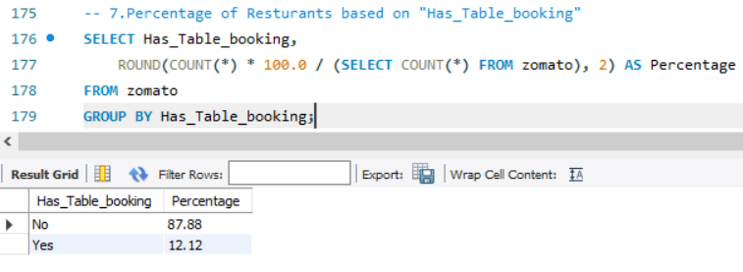

8. Power BI Development.
Data Transformation
Performed data preparation using Power Query.
Activities included:
- Data type conversion
- Data validation
- Missing value handling
- Data transformation
Data Modeling
- Calendar Table using DAX
- Country Dimension Table
Established One-to-Many Relationships.
DAX Measures
Created KPI measures including:
- Total Restaurants
- Total Cities
- Total Countries
- Average Rating
- Average Cost for Two
Dashboard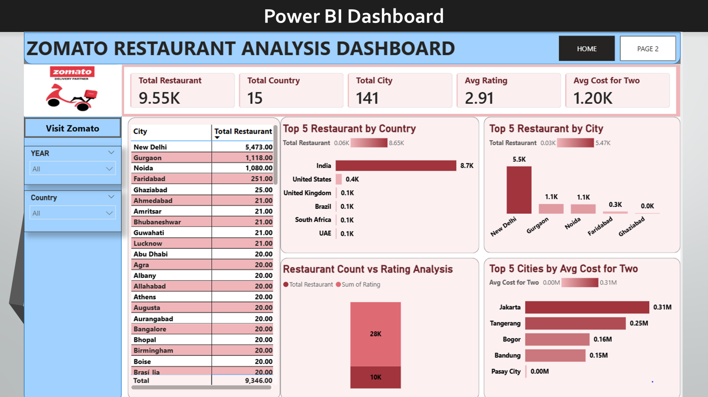

9. Tableau Dashboard
Imported cleaned Excel dataset.
Performed
- Data Relationship
- Table Join
- Calculated Fields
- Filters
- Parameters
- Interactive Dashboard Design
Dashboard
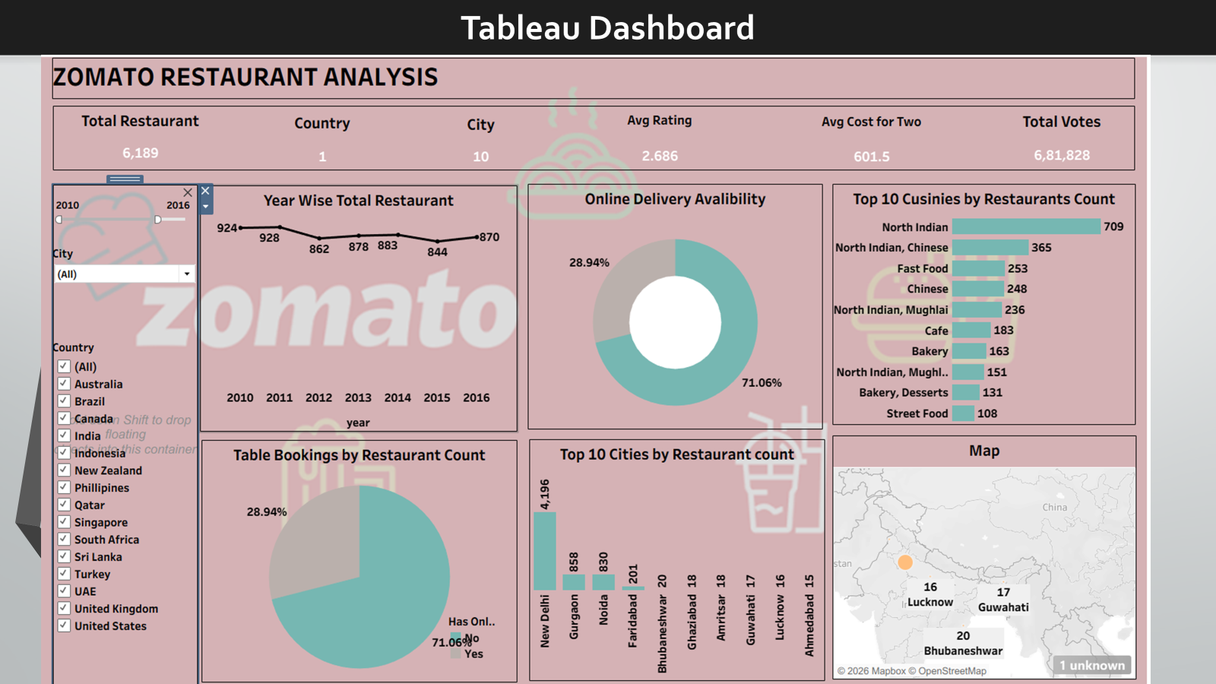

10. Business Insights
Examples:
- India has the highest number of restaurants.
- New Delhi has the largest restaurant concentration.
- Average ratings vary across cities.
- Online delivery is more common than table booking.
- Pricing differs significantly between countries.

11. Challenges Faced
Write honestly:
- Faced issues while importing data into SQL.
- Resolved data loading problems using Import Wizard.
- Managed missing values during preprocessing.
- Built relationships across multiple tables.
- Learned DAX and SQL analytical functions while developing KPIs.

12. Skills Gained
- Data Cleaning
- Power Query
- SQL
- DAX
- Data Modeling
- Dashboard Design
- Business Intelligence
- Data Visualization
- Analytical Thinking

13. Conclusion
This project demonstrates a complete end-to-end data analytics workflow, starting from raw data preparation through Excel and SQL, followed by data modeling in Power BI and visualization in Power BI, Tableau, and Excel. The resulting dashboards provide actionable insights into restaurant distribution, ratings, pricing, online delivery, and customer trends, enabling data-driven business decisions.

