CRYPTO CURRENCY ANALYSIS DASHBOARD A PROJECT REPORT

Submitted by JYOTHI SHRI S (21ADR019)

HEMANTHH V V (21ADR018) HARIARASU R (21ADR014) PRADEEP R R (21ADR033)

for

20ADC33 DATA ANALYSIS DEPARTMENT OF ARTIFICIAL INTELLIGENCE



KONGU ENGINEERING COLLEGE

(Autonomous) PERUNDURAI ERODE – 638060

DECEMBER 2022

**DEPARTMENT OF ARTIFICIAL INTELLIGENCE KONGU ENGINEERING COLLEGE**

**(Autonomous) PERUNDURAI ERODE – 638 060**

**DECEMBER 2022**

Department of Artificial Intelligence

**20ADC33 – Data Analysis Project Report**

Signature of course in-charge Signature of the HOD

Submitted for the continuous Assessment viva voice examination held on

EXAMINER I EXAMINER II

# ABSTRACT

Cryptocurrency payments only exist as digital entries and cannot be carried around or exchanged as physical currency. Cryptocurrency is a category of digital assets that may be bought, sold, or traded safely and was developed using cryptographic methods. The fact that all of its transactions are securely encrypted and the exchanges are extremely secure is implied by the name. It is a form of digital payment that doesn't rely on banks to confirm transactions. Future of cryptocurrency. Along with the financial industries, it is also causing disruption in other industries including information technology, healthcare, retail, travel and tourism, and many more. Understanding bitcoin trading can be aided by taking into account basic stock market trading techniques. Trading involves buying and selling goods, and trading in cryptocurrencies is doing both while utilising a cryptocurrency trading platform. Blockchain is a popular technology for managing and storing transactions in cryptocurrency.

For cash outing a crypto, need to sell the cryptocurrency for cash and then can either transfer the cash to bank or buy more cryptocurrency. The IRS classifies cryptocurrency as a type of property. If received Bitcoin as payment then need to pay income taxes on its current value. If sold the cryptocurrency for profit then taxes on the difference between purchase price and sales price have to payed. According to the stats, there were 13,669 cryptocurrencies as of late 2021. Out of this, Bitcoin has the largest share in terms of market capitalisation, amounting to about $650 billion. The top 4 cryptocurrencies after Bitcoin, based on their market capitalization, or the total value of all of the coins currently in circulation are Ethereum, Tether, Binance Coin, XRP. Analysis is made on those 4 coins to know about its market capitalisation and other factors.

# TABLE OF CONTENTS

|  |  |  |
| --- | --- | --- |
| **CHAPTER**  **No.** | **TITLE** | **PAGE NO.** |
|  | **ABSTRACT** | 3 |
| **1.** | **INTRODUCTION** |  |
|  | 1.1 INTRODUCTION | 5 |
|  | 1.2 DATA COLLECTION | 5 |
|  | 1.3 PROBLEM STATEMENT | 6 |
|  | 1.4 BUSINESS OBJECTIVE | 7 |
| **2.** | **DATA PREPARATION AND MODELING** |  |
|  | 2.1 DATA PREPARATION | 8 |
|  | 2.2 DATA MODELLING | 17 |
| **3.** | **DATA ANALYSIS AND INTERPRETATION** |  |
|  | 3.1 DATA ANALYSIS | 20 |
|  | 3.2 PUBLISHING DASBOARDS | 22 |
|  | 3.3 INFERENCE | 23 |
| **4.** | **CONCLUSION** | 45 |
| **5.** | **REFERENCES** | 45 |

# CHAPTER 1

# INTRODUCTION

# 1.1 INTRODUCTION

The cryptocurrency is the foundation for the dashboard that has been created and the whole analysis. The majority of cryptocurrencies are decentralised, blockchain-based networks, a public database run by a distributed computing network. One distinctive feature of cryptocurrencies is that, in most cases, no central authority distributes them. The phrase "crypto-currency" comes from the network security techniques that involve encryption. People are drawn to cryptocurrencies for a variety of reasons, such as their usage in illegal activities, fluctuating exchange rates, and the network flows that support them. Additionally, their portability, accountability, and divisibility were complimented. Almost always, cryptocurrencies are designed to be unaffected by and unregulated by the government. Although trading in cryptocurrencies differs from trading on the stock market, some stock market trading techniques can be used to understand cryptocurrency trading. Trading involves buying and selling goods, and trading in cryptocurrencies is doing both while utilising a cryptocurrency trading platform.

# 1.2 DATA COLLECTION

First have to collect and aggregate the data in the particular industry where established an objective. Data collection is the process of compiling and analysing precise data from different sources to identify solutions to issues, patterns, and probabilities, among other things, to assess potential outcomes. Choosing the type of data needed—quantitative (numeric) or qualitative (descriptive), such as customer reviews—is a crucial first step. Data can be collected from internal and external sources. Internal sources like databases and systems, marketing automation, etc, whereas external sources like census bureaus, google trends, amazon API, global finance data, etc. Data collected here is an external data collected from Kaggle.

* DATASET:

In the world, there are many different cryptocurrencies. According to market capitalization, which measures the combined worth of all coins currently in circulation, Ethereum, Tether, Binance Coin, and XRP are the top 4 cryptocurrencies after Bitcoin. Each currency has its own csv file in the dataset. Daily price history is accessible as of April 28, 2013. The historical price data for the top cryptocurrencies by market capitalization can be found in this dataset.

<https://www.kaggle.com/datasets/sudalairajkumar/cryptocurrencypricehistoy>

* + - * Source: www.kaggle.com

In the world, there are many different cryptocurrencies. According to market capitalization, which measures the combined worth of all coins currently in circulation, Ethereum, Tether, Binance Coin, and XRP are the top 4 cryptocurrencies after Bitcoin. Each currency has its own csv file in the dataset. Daily price history is accessible as of April 28, 2013. The historical price data for the top cryptocurrencies by market capitalization can be found in this dataset.

The variables in the data set are “S No” serial number, “Name” name of the cryptocurrency, “Symbol” symbol of the cryptocurrency, “Date” date of observation, “Open” Opening price on the given day, “High” Highest price on the given day, “Low” Lowest price on the given day, “Close” Closing price on the given day, “Volume” Volume of transactions on the given day, “Market Cap” Market capitalization in USD.

# 1.3 PROBLEM STATEMENT

Cryptocurrency is a category of digital assets that may be bought, sold, or traded safely and was developed using cryptographic methods. Needed a cryptocurrency wallet in order to use cryptocurrencies. It is a form of digital payment that doesn't rely on banks to confirm transactions. As of the end of 2021, there were 13,669 cryptocurrencies, according to Coin market cap. People struggle to pick the best cryptocurrency to invest their money in because there are thousands of different cryptocurrencies in existence. According to market capitalization, which measures the combined value of all coins in circulation, the top 5 cryptocurrencies are: Bitcoin (BTC), Ethereum (ETH), Tether (USDT), Binance Coin (BNB), and XRP (XRP). Even after listing the top 5 among 14,000 cryptocurrencies, it is hard to choose the right one, the coin which can be trusted. Many people have lost their investments by choosing the cryptocurrencies to invest in a wrong way.

Many people lose their investment by choosing untrusted cryptocurrencies. Normally people store their cryptocurrencies on their crypto wallet files on their computers. Therefore, they can be stolen if there is no proper security. Since cryptocurrency investment includes real time money, profit, loss, at first a better analysed overview of all those cryptocurrencies are required for every customer for choosing among those coins. Cryptocurrency which is highly trusted by the people over the past years and with high security should be choosen by all the customers. For this analysis past data’s about the cryptocurrencies will be useful.

# 1.4 BUSINESS OBJECTIVE

## To compare and analyze which coin has better performance among the 4 cryptocurrency coins.

## To find the best coin to invest for according to the past data’s.

## To analyze the role played by month of the year in profit and loss in the cryptocurrency investment.

## To analyze the deviation between opening value and closing value of a day.

# CHAPTER 2

# DATA PREPARATION AND MODELLING

# 2.1 DATA PREPARATION

Data collection, combination, structure, and organisation are all steps in the process of preparing data for use in business intelligence (BI), analytics, and data visualisation applications. Pre-processing, profiling, cleaning, validating, and transforming data are all parts of data preparation. Additionally, combining data from several internal systems and outside sources is frequently required. Additionally, self-service data preparation technologies are being used by business users, data scientists, data engineers, and other data analysts more and more.

* DATA COLLECTION

Data scientists, BI team members, other data experts, and end users who acquire data should check that it fits well with the goals of the anticipated analytics applications during this step. Open Power BI and click “Get data” from the home tab and select the data downloaded and a pop up is shown. Click “Load” to load the Tether table data into Power BI. Similarly, repeat this process for other tables Binance coin table, Ethereum table, XRP table, After loading all the tables in Power BI can see the tables in the “Field” tab as shown in FIG 2.1.

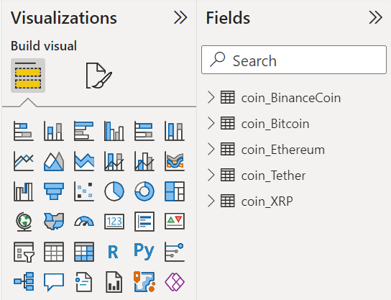

Figure 2.1 Loading data

* DATA DISCOVERY AND PROFILING

Data exploration and profiling are used to better comprehend the obtained data for the aim, what it contains, and what preparations are required. Data profiling can assist with this by locating patterns, correlations, and other qualities in the data, as well as discrepancies, abnormalities, missing numbers, and other problems, so they can be fixed. After loading the data, Click on each table in the field tab on the right side to see the attributes of each table. Click on the table to see the attribute on “Field” tab and it will open a section as shown in the FIG 2.2. similarly can see the attributes of all other table which is included in the dataset. The dataset have all the tables which has same 10 attributes.

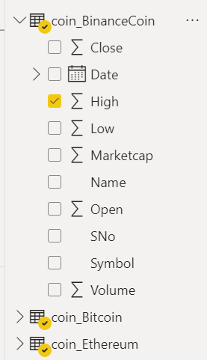

Figure 2.2 Data discovery

* DATA STRUCTURING

Data structuring combines data management, organisation, retrieval, and storage into a single format that enables quick access and alteration. The data must now be categorised and transformed into a model to satisfy the criteria of analytics. For instance, to make data available to BI and analytics tools, information must be transformed from comma-separated values (CSV) files or other file formats into tables. The table view of table is displayed by clicking "Data" on the left side below the "Report" view, as shown in FIG. 2.3, as have already loaded data into Power BI, which implicitly turned ".csv" into a table.

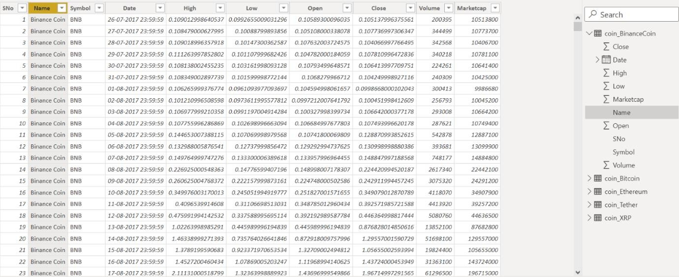

Figure 2.3 Data view

* DATA CLEANSING

One of the most crucial steps for an organisation to develop a culture around sound data decision-making is data cleaning, also known as data cleansing and data scrubbing. The practise of correcting or deleting inaccurate, damaged, improperly formatted, duplicate, or incomplete data from a dataset is known as data cleaning. There are numerous ways to clean up data; in this case, cleaning the data is accomplished by selecting the transform the data option as illustrated in FIG. 2.4.

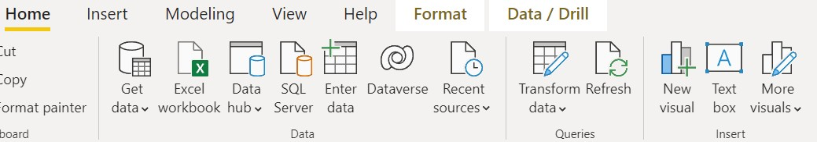

Figure 2.4 Transform data

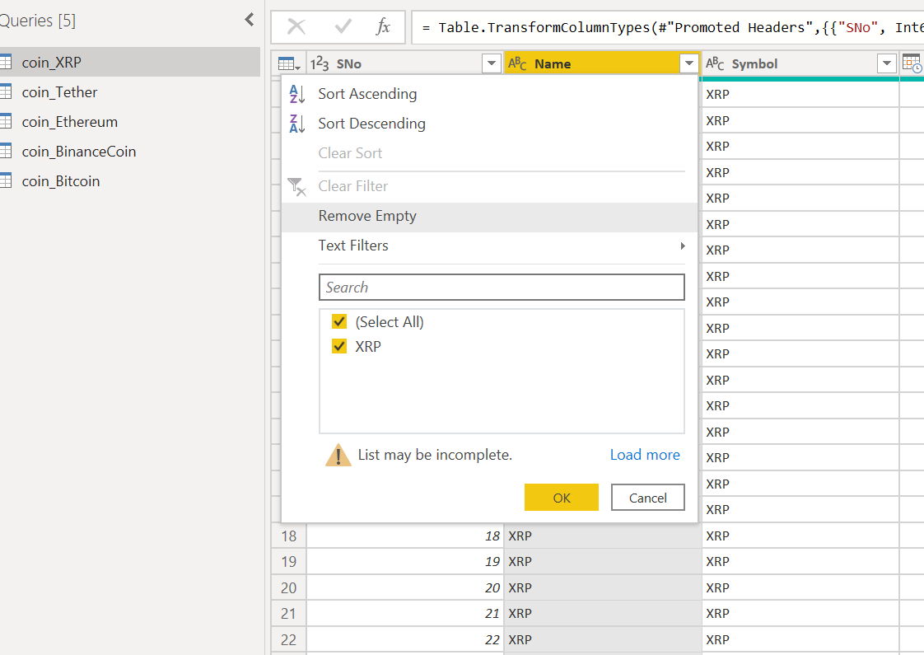 Removing the empty rows on all the columns is an important step as the empty rows can lead to wrong analysis of the data hence for removing the empty rows click on the column in which have to remove the empty row and then right click on the column and can see the “Remove Empty” option which will remove those empty rows in the subsequent rows as shown in the FIG 2.5. After removing the empty rows and completing all other transformations required for the dataset for all the tables, now can click the top right most option “Close and Apply” as shown in the FIG 2.6 which will apply all those transformation done on the dataset.

Figure 2.5 Removing empty columns

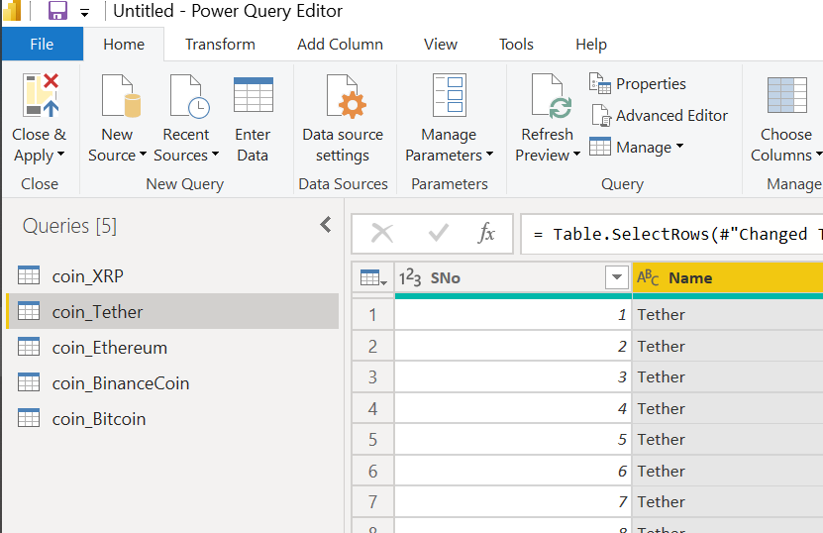

Figure 2.6 Applying the transformations

* DATA TRANSFORMATION AND ENRICHMENT

The information needs to be organised before being transformed into an efficient format. Data enrichment considerably enhances and optimises data sets as necessary by doing actions like completing and incorporating data. Creating measures is an important step in analysing a dataset as that will lead us to analyse a data in more effective way and can get a better inference. Measure creating is important when dataset has more complex field. Can further enhance the dataset by modifying the data type of each attribute in table to get the most related result later as shown in the FIG 2.7.

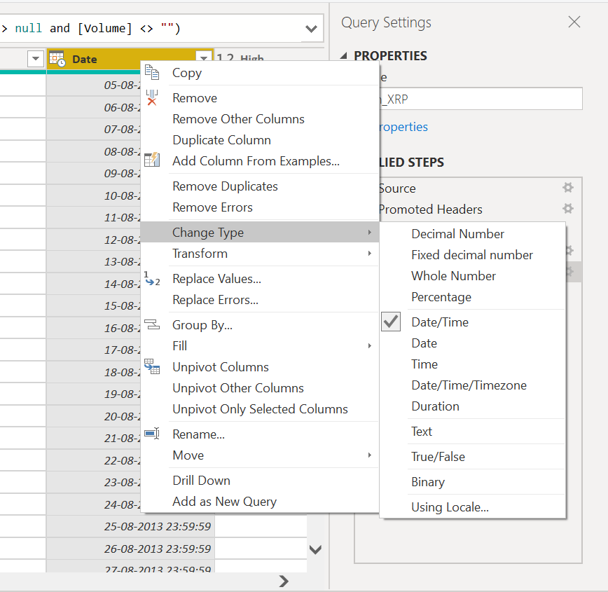

Figure 2.7 Changing datatype

Coin Tether is not in correct order hence it is sorted in ascending order. All the “date” column in each table is changed from general date format i.e. “14-03-2001 13:30:55” format to short date format i.e. “14-03-2001” as the time is same for all rows in each table i.e. “23:59:59”. Changing the date type will help to reduce the complexity of the column. As every table contained the same attributes, have to differentiation the attributes name. Renaming all the attributes according to their table will help us to differentiate.

For Binance coin table

* “Date” into “Date_BINAN”
* “Open” into “Open_BINAN”
* “High” into “High_BINAN”
* “Low” into “Low_BINAN”
* “Close” into “Close_BINAN”
* “Volume” into “Volume_BINAN”
* “Market Cap” into “Marketcap_BINAN”

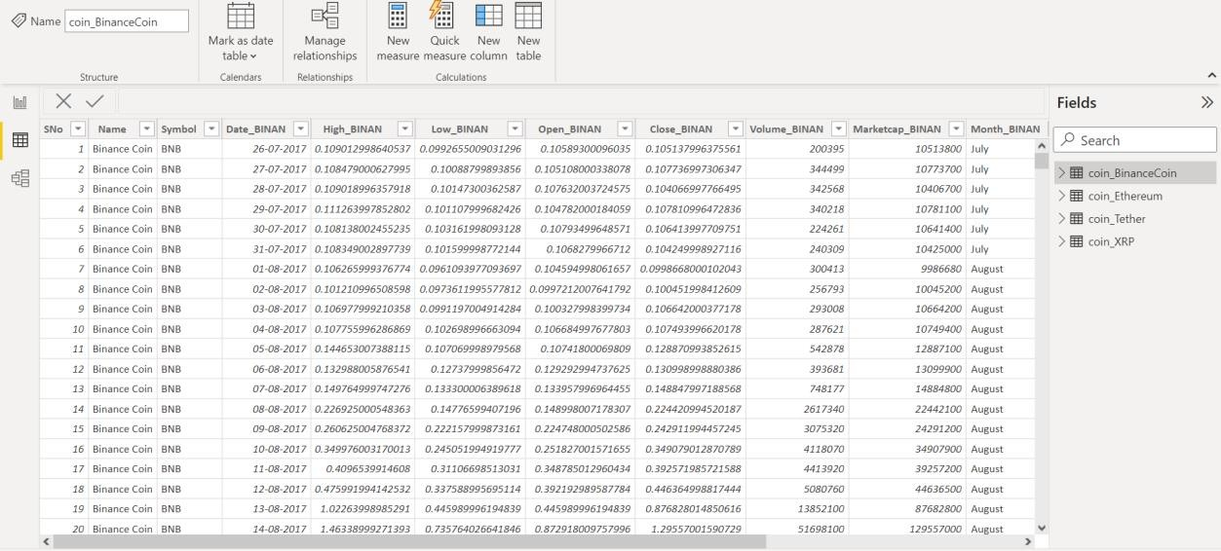

Figure 2.8 Changing name of binance coin

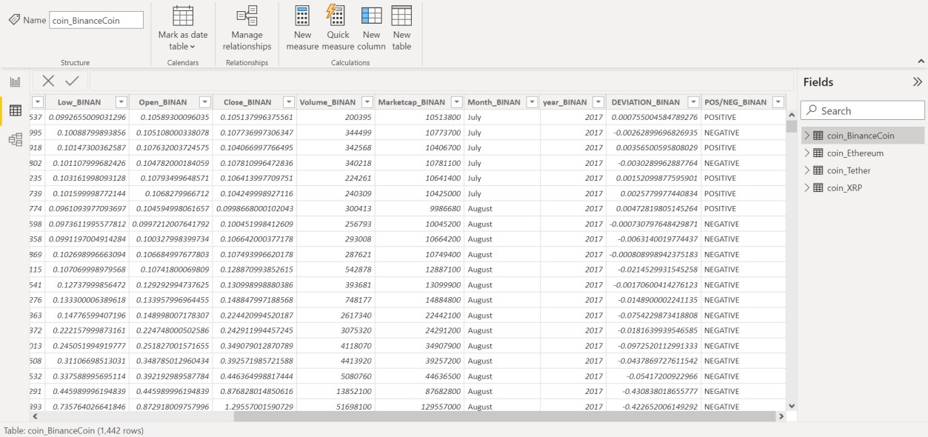

Figure 2.9 Changing name of binance coin

For Ethereum coin table

* “Date” into “Date_ETH”
* “Open” into “Open_ETH”
* “High” into “High_ETH”
* “Low” into “Low_ETH”
* “Close” into “Close_ETH”
* “Volume” into “Volume_ETH”
* “Market Cap” into “Marketcap_ETH”

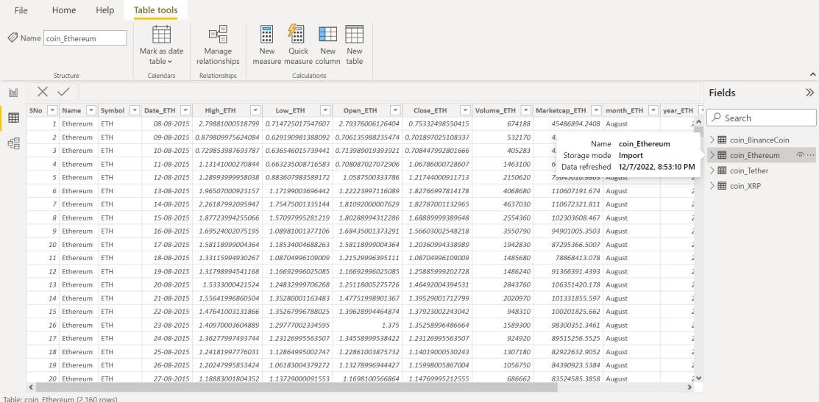

Figure 2.10 changing name of Ethereum coin

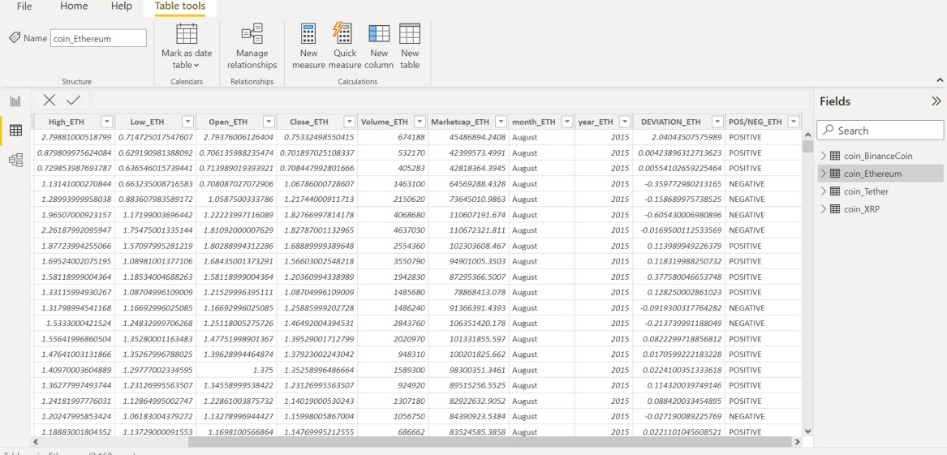

Figure 2.11 Changing name of Ethereum coin

For Tether coin table

* “Date” into “Date_TETH”
* “Open” into “Open_TETH”
* “High” into “High_TETH”
* “Low” into “Low_TETH”
* “Close” into “Close_TETH”
* “Volume” into “Volume_TETH”
* “Market Cap” into “Marketcap_TETH”

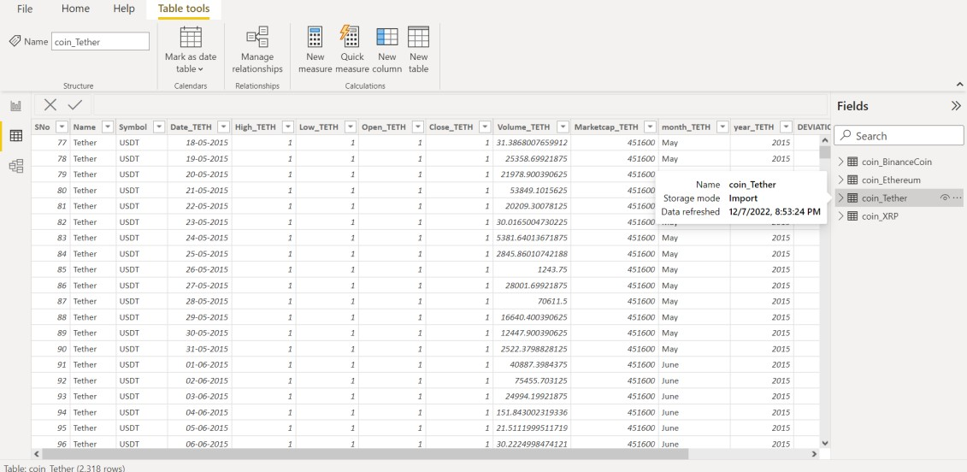

Figure 2.12 Changing the name of tether coin

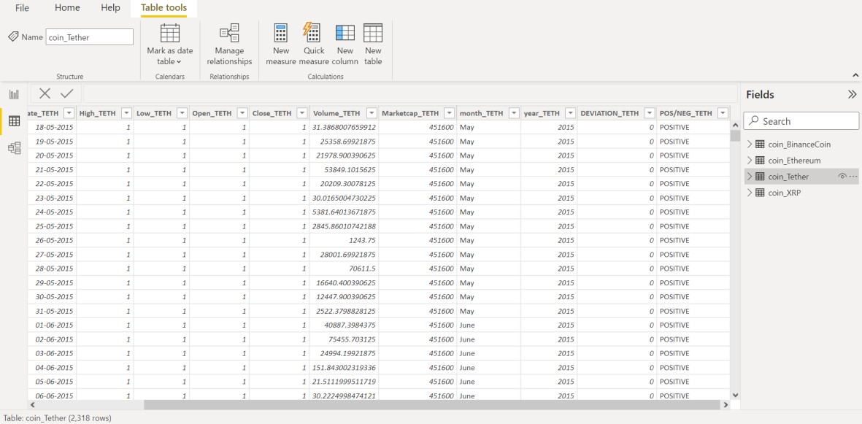

Figure 2.13 Changing the name of tether coin

For XRP coin table

* “Date” into “Date_XRP”
* “Open” into “Open_XRP”
* “High” into “High_XRP”
* “Low” into “Low_XRP”
* “Close” into “Close_XRP”
* “Volume” into “Volume_XRP”
* “Market Cap” into “Marketcap_XRP”

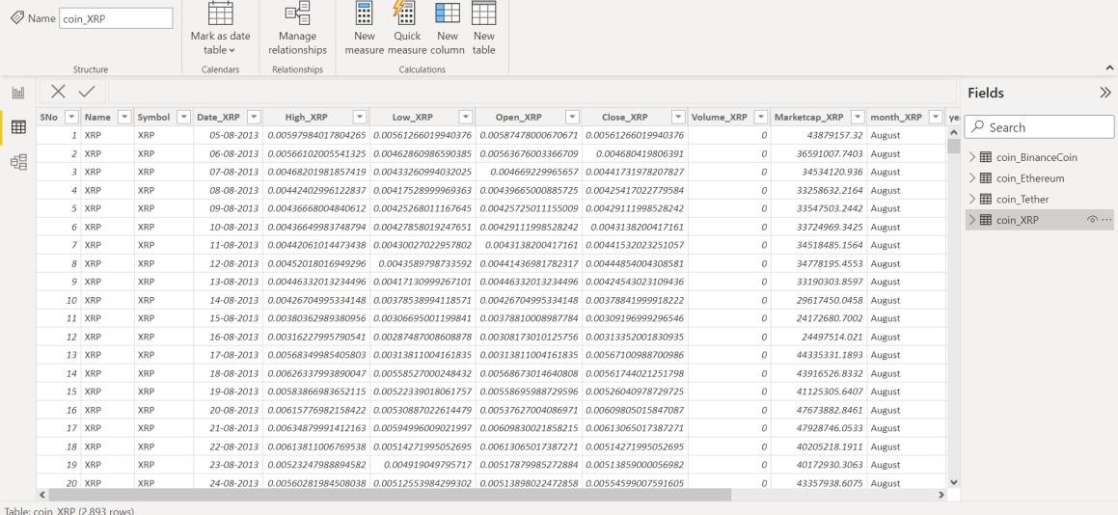

Figure 2.14 Changing the name of XRP coin

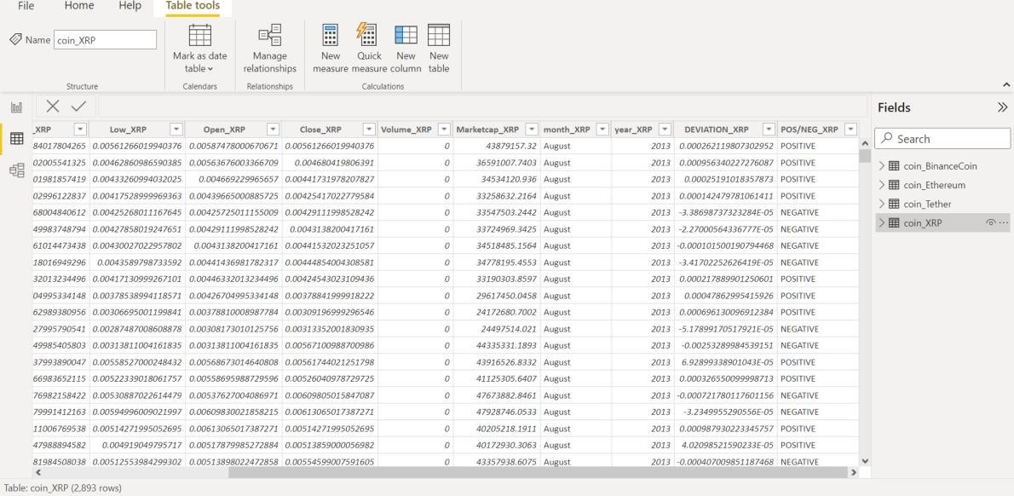

Figure 2.15 Changing the name of XRP coin

* Month and year from date is created as a separate column for each table for easy analysis using month and year.
* A new column is created with difference between opening value and closing value.
* DEVIATION_BINAN = coin_BinanceCoin[Open_BINAN]- coin_BinanceCoin[Close_BINAN]
* An another new column is created with data’s of positive/negative deviation.
* POS/NEG_BIT=IF(coin_Bitcoin[DEVIATION_BIT]>=0,"POSITIVE","NEGATIVE")
* CHALLENGES ON DATA PREPARATION

The data preparation is not an easy method to perform as can face some challenges on the data preparation like Inadequate or nonexistent of the data profiling, some data’s may be missing or incomplete in every column, can have invalid data values, the name of the column may not be related one, maintaining and expanding the preparation is process is complicated one.

# 2.2 DATA MODELLING

Data modelling is the act of analysing and defining all the various data of the company produces and collects, as well as the connections between those data points. It can also be the process of using formal techniques to simplify the diagram or data model of a software system. Data modelling is a practise in comprehending and outlining the data requirements, and it produces visual representations of the data as it is used at the company. The objective is to provide examples of the different types of data that are used and stored inside the system, their relationships, possible groupings and organisational structures, formats, and properties. Data models are created for commercial purposes. Data modelling can be done at several levels of abstraction. Gathering data on business requirements from end users and stakeholders is the first stage. The development of a specific database architecture begins with the translation of these business principles into data structures. Standardized schemas and formal methodologies are used in data modelling. These data models should ideally be viewed as live documents that change as the business environment does needs. Planning IT architecture and strategy and supporting business activities both heavily rely on data models. It can be distributed to associates, competitors, and suppliers.

* TYPES OF DATA MODELS

Conceptual, logical, and physical data models are the three different categories of data models. Conceptual data models, also known as domain models, provide a broad overview of the system's functionality, organisational structure, and business rules. Entity classes, their traits and limitations, their connections, and pertinent security and data integrity requirements are frequently included. Any notation is usually straightforward. Less abstract and offering more information about the ideas and connections in the topic at hand are logical data models.

* IMPACTS OF DATA MODELS

Need a good data model to acquire the most useful analytics for business intelligence that guides decision-making, data modelling and data analytics go hand in hand. Each business unit is forced to consider how they contribute to the overall business goals through the process of developing data models. Additionally, no matter how big and complicated the data estate is or gets, a strong data model ensures improved analytics performance. When all of the data is well-defined, it is considerably simpler to analyse just the data. The linkages between the data attributes have already been established, making it easy to analyse and observe effects as altered the procedures, costs, or staffing.

* DATA MODELING PROCESS

The data modelling process includes identifying the entities of the table, identifying the key properties of each entity, identifying the relationships among entities as the each table contains some relationship among the entities, Mapping the attributes to entities completely, Assigning the keys as needed and deciding on a degree of normalization that balance the need to reduce redundancy with performance requirements and then finalizing and validating the data model

* BENEFITS OF DATA MODELING

Errors in the creation of databases and software are decreased via data modelling. They substantially improve enterprise-wide consistency in documentation and system architecture. Database and application performance are improved through data modelling. They facilitate data mapping across the enterprise and enhance coordination between the business intelligence and development teams. Additionally, they facilitate and expedite the conceptual, logical, and physical phases of database design. The data model relationship of data is defined by default and hence the data model relationship of data set is defined as one-to-one relation for all table as shown in FIG 2.8

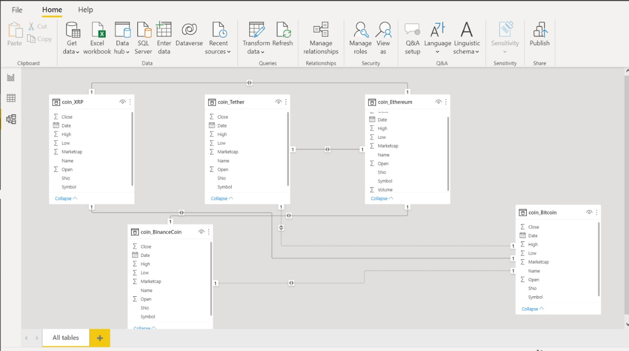

## Figure 2.8 Data model

# CHAPTER 3

# DATA ANALYSIS AND INTERPRETATION

# 3.1 DATA ANALYSIS

The Data Analysis is a process to conclude what is happening and what has happened in that particular industry or domain. Data analysts looks back at previous performance to determine what went wrong in the performance of the company or the institution. It is also a method of predicting future performance based on historical data which would be very helpful for future investments of the business companies etc. Analytic dashboards are frequently the outcome of the analysis. Finding relevant information, drawing conclusions from data, and supporting decision-making are the objectives of data analysis. Concluding Data Analysis is the process of scrutinising, purifying, changing, and modelling data with the objective of unearthing pertinent information, guiding deductions, and assisting decision-making.

# QUESTIONS PREPARED FOR THE DATASET

1. How did all the cryptocurrencies values have been increased/decreased with time?
2. Which coin has the largest value among binance coin, tether, XRP for the summation of high value of each day?
3. Which are the most and least profitable coin in the month of August in the range of years.
4. Which coin has the highest and lowest average deviation of opening and closing value?
5. Find which month has the highest and lowest volume of transaction in the year 2017 for the coin tether?
6. Analyse the number of days in which the Ethereum had a market cap greater than 60000000 for year by year and also by month by month?
7. Which among the 4 coins have recorded the least value in all the years?
8. Which coin is most transacted coin for every month?
9. How has ethereum volume of transaction varied over time?
10. The number of days in which the volume of transaction of the coin XRP is equal to 0?
11. In Which month XRP was most profitable?
12. Find the top 2 coins out of 4 based on market cap?
13. The number of positively deviated values in Ethereum (opening value is higher than closing value)
14. Compare the opening value of coin XRP over the time period?
15. Which among the coin Ethereum and XRP have recorded the high value in all the years?
16. Which coin is the least profitable coin among the 4?
17. Compare the closing value of Ethereum for each month and give the highest and lowest value recorded month.
18. Count the number of negatively deviated days in the table Tether for each year.
19. In which year the market cap of coin Tether was the highest?
20. Which coin has the best average deviation among 4 coins?

# 3.2 PUBLISHING DASHBOARDS

gjk

Figure 3.1 Dashboard

# 3.3 INFERENCE

1. How did all the cryptocurrencies values have been increased/decreased with time?

STEPS:

Visualizations → Stacked area chart X axis → year_BINAN

Y axis → Marketcap_BINAN, Marketcap_TETH, Marketcap_XRP, Marketcap_ETH

OUTPUT:

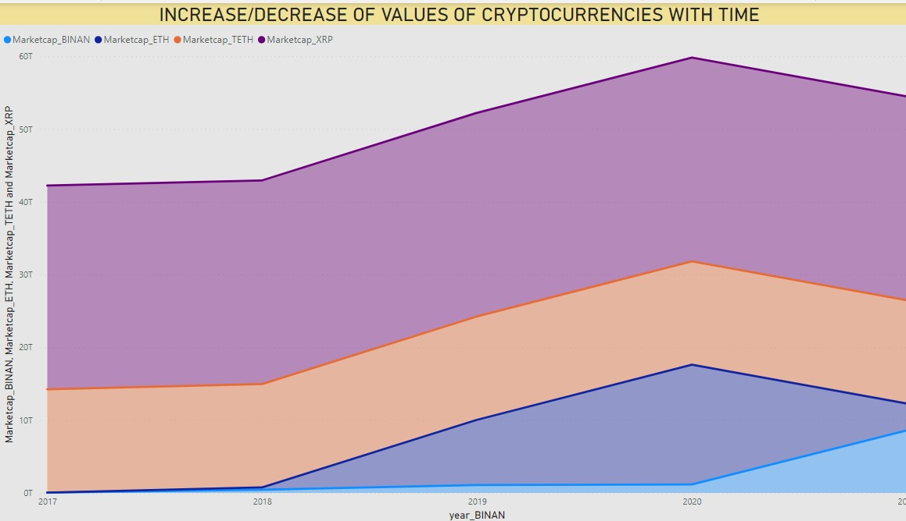

## Figure 3.1 increase/decrease with time

INFERENCE:

* The Marketcap of BINANCE COIN has been constantly growing in the years 2017, 2018, 2019, 2020 and suddenly increased with a high value after 2020.
* The Marketcap of XRP coin, Marketcap ETHEREUM coin, Marketcap TETHER COIN has been increased from the year 2017 to 2018 and increased highly from 2018 to 2020 and suddenly decreased after 2020

1. Which coin has the largest value among binance coin, tether, XRP for the summation of high value of each day?

STEPS:

Measure created for sum of high values of each day.

SUM_HIGH_BINAN = SUM(coin_BinanceCoin[High_BINAN]) SUM_HIGH_XRP = SUM(coin_XRP[High_XRP]) SUM_HIGH_TETH = SUM(coin_Tether[High_TETH])

Visualisations → funnel chart Values → measures

OUTPUT:

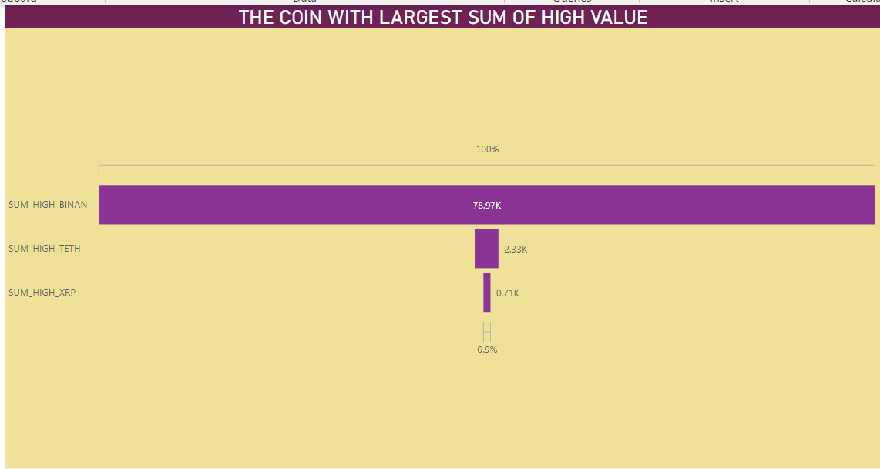

## Figure 3.2 coin with largest sum of high value

INFERENCE:

Binance coin has the largest value among binance coin, tether, XRP for the summation of high value of each day with a value of 78.97k

1. Which are the most profitable coins and least profitable coin in the month of August in the range of years.

STEPS:

Measures created for average of marketcap of all coins

AVG_MRKTCAP_BINANCE = AVERAGE(coin_BinanceCoin[Marketcap_BINAN]) AVG_MRKTCAP_ETHERE = AVERAGE(coin_Ethereum[Marketcap_ETH]) AVG_MRKTCAP_TETHER = AVERAGE(coin_Tether[Marketcap_TETH]) AVG_MRKTCAP_XRP = AVERAGE(coin_XRP[Marketcap_XRP])

Visualisations → clustured columnchart X axis→Month_BINAN

Y axis→average measures of all coins Filter→month→august

Slicer→ year_BINAN

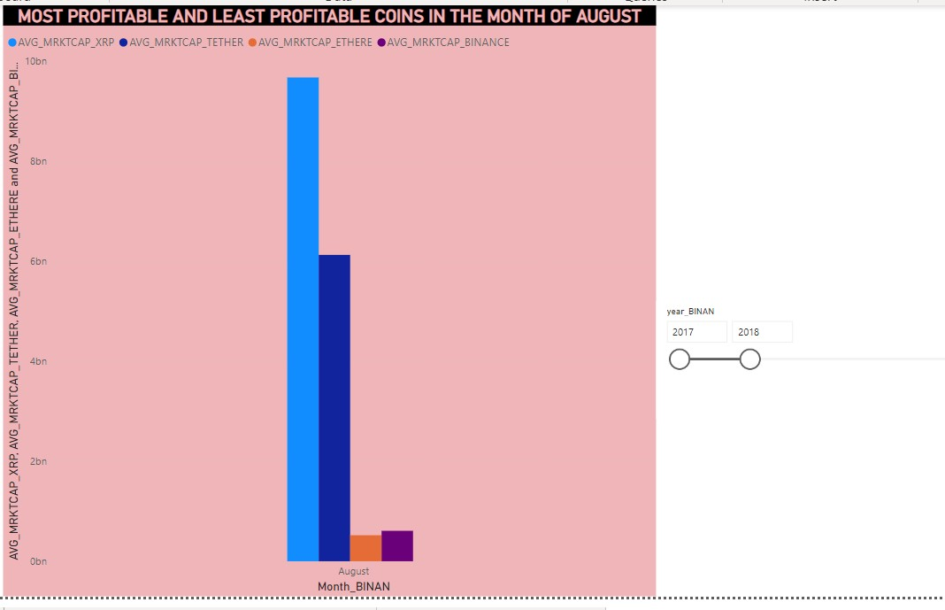OUTPUT:

## Figure 3.3 most and least profitable coin on august

INFERENCE:

The most profitable coins and least profitable coin in the month of August in

* 2017 – 2018 are XRP AND ETHEREUM
* 2017 – 2019 are ETHEREUM AND BINANCE
* 2017 – 2020 are ETHEREUM AND BINANCE
* 2017 – 2021 are ETHEREUM AND BINANCE

1. Which coin has the highest and lowest average deviation of opening and closing value?

STEPS:

Visualisations→clustured column chart

Y axis→Deviation of opening and closing values columns of all coins Filter → average of deviation column

OUTPUT:

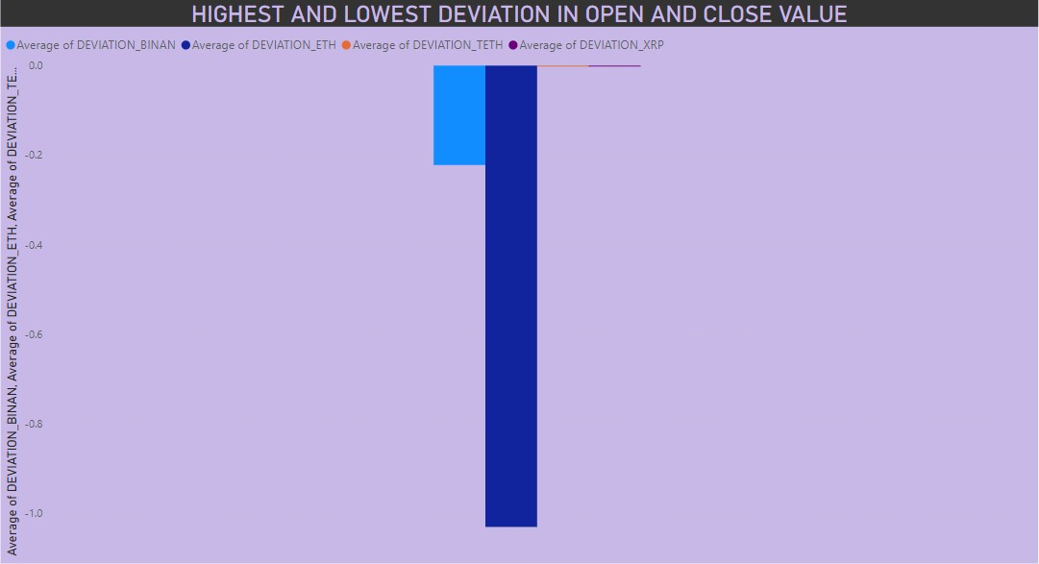

## Figure 3.4 highest and lowest deviation

INFERENCE:

Ethereum has the highest average deviation of opening and closing value of -1.03

and XRP, TETHER has the lowest average deviation of opening and closing value of 0.00

1. Find which month has the highest and lowest volume of transaction in the year 2017 for the coin tether?

STEPS:

Measure for average volume of transaction of coin tether. AVG_VOT_TETHER = AVERAGE(coin_Tether[Volume_TETH])

New column YEAR, MONTH is created. month_TETH = coin_Tether[Date_TETH].[Month]

visualisations 🡪 LINE CHART x axis🡪 month_TETH

y axis🡪 measure legend🡪year

filter🡪basic fliter 🡪 year – 2017

OUTPUT:

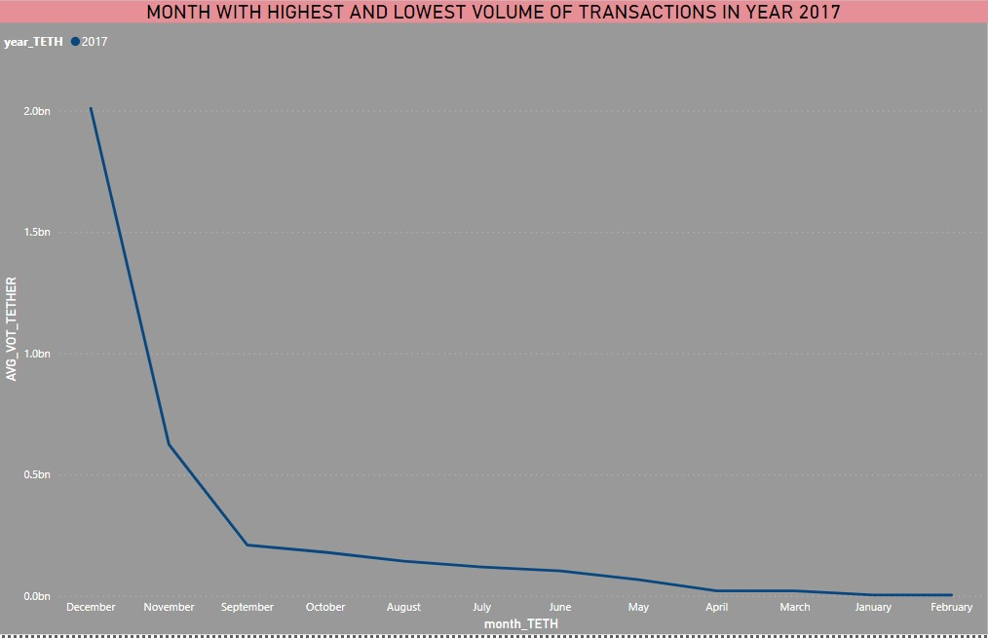

## Figure 3.5 month with highest and lowest volume of transactions

INFERENCE:

DECEMBER month has the highest volume of transaction and FEBRUARY month has the lowest volume of transaction in the year 2017 for the coin tether

1. Analyse the number of days in which the Ethereum had a market cap greater than 60000000 for year by year and also by month by month?

STEPS:

Measure:

count_eth = CALCULATE(COUNT('coin_Ethereum'[Marketcap_ETH]),'coin_Ethereum'[Marketcap_ET H]>60000000)

Visualisations→card Value→count_eth Slicer 1 → year_eth Slicer 2 → month_ETH

OUTPUT:

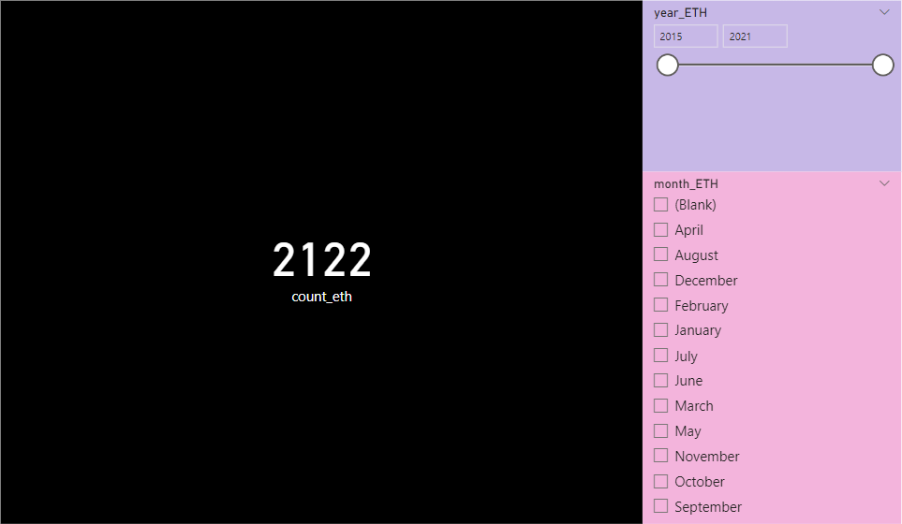

## Figure 3.6

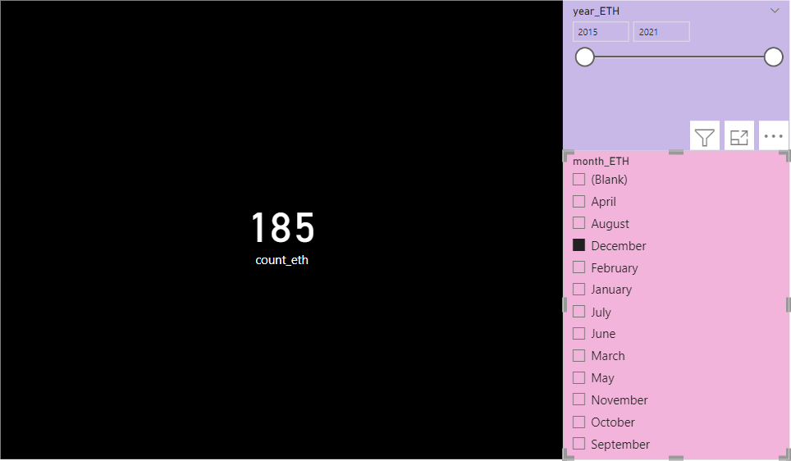

Figure 3.7

INFERENCE:

* The number of days in which the Ethereum had a market cap greater than 60000000 for the range of year 2015 to 2021 is 2122
* The number of days in which the Ethereum had a market cap greater than 60000000 for the range of year 2015 to 2021 only in the December month is 185
* We can find for all required period of year and month, in which it have to be analyzed

1. which among the 4 coin have recorded the least value in all the years?

STEPS:

Measure for min is created

LOW_BINANCE = MIN(coin_BinanceCoin[Low_BINAN]) LOWEST_ETH = MIN(coin_Ethereum[Low_ETH]) LOW_TETHER = MIN(coin_Tether[Low_TETH]) LOWEST_XRP = MIN(coin_XRP[Low_XRP])

Visualisations 🡪 funnel chart Values🡪measures

OUTPUT:

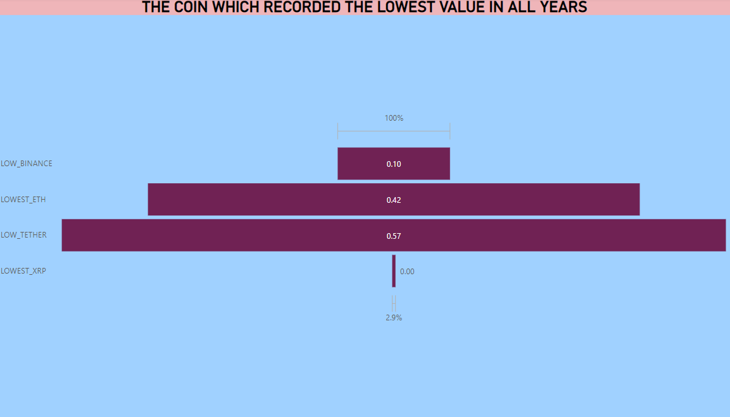

## Figure 3.8 coin which recorded lowest value

INFERENCE:

The lowest value recorded among the All coins in all years is ‘XRP COIN’ with a lowest value of 0.00

1. which coin is most transacted coin for every month?

STEPS:

Measure is created for average of volume of transaction of all coins.

AVG_VOT_TETHER = AVERAGE(coin_Tether[Volume_TETH]) AVG_VOL_BINAN = AVERAGE(coin_BinanceCoin[Volume_BINAN]) AVG_VOL_ETH = AVERAGE(coin_Ethereum[Volume_ETH]) AVG_VOL_XRP = AVERAGE(coin_XRP[Volume_XRP])

Visualisations🡪clustured column chart Y axis 🡪 average measures

Slicer 🡪 month_TETH

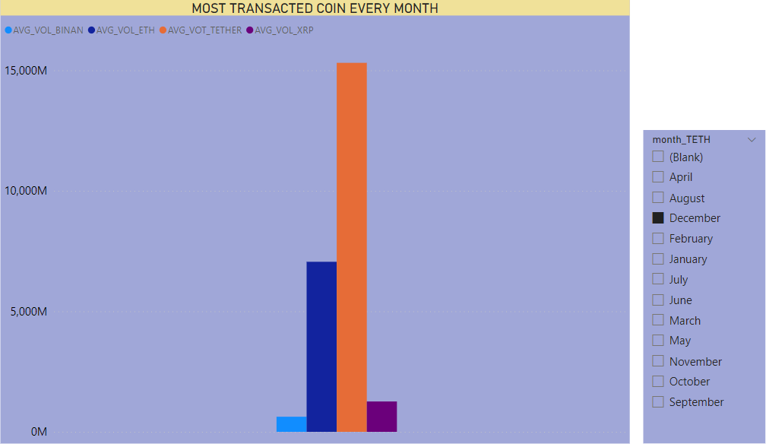OUTPUT:

## Figure 3.9 most transacted coin every month

INFERENCE:

The coin which is most transacted coin for every month

* January - TETHER
* February - TETHER
* March - TETHER
* April - TETHER
* May - TETHER
* June – TETHER
* July - TETHER
* August - TETHER
* September - TETHER
* October - TETHER
* November - TETHER
* December – TETHER

1. How has ethereum volume of transaction varied over time?

STEPS:

Measure is created for the average volume of transaction of Ethereum AVG_VOL_ETH = AVERAGE(coin_Ethereum[Volume_ETH])

Visualizations 🡪 area chart X axis 🡪 year_ETH

Y axis 🡪 measure

OUTPUT:

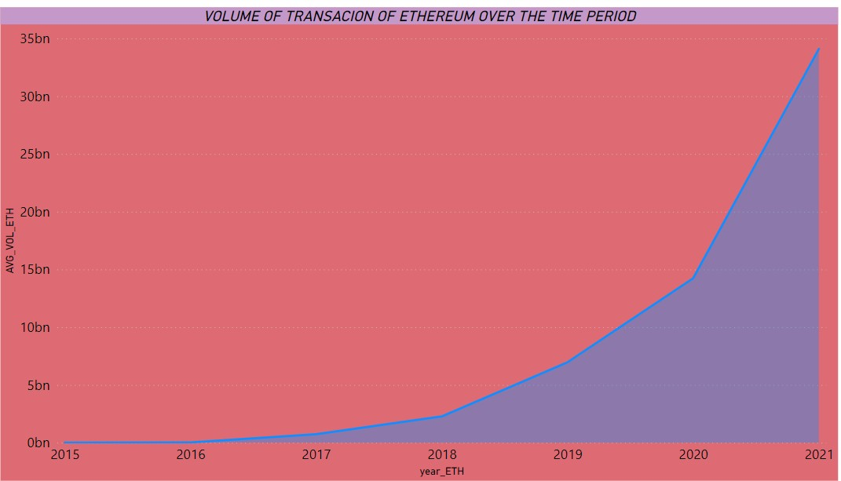

## Figure 3.10 volume of transaction of ethereum

INFERENCE:

Ethereum volume of transaction has been increased over time.

1. The number of days in which the volume of transaction of the coin XRP is equal to 0?

STEPS:

Measure:

DAYS_VOL_XRP_0 =

CALCULATE(COUNT(coin_XRP[Volume_XRP]),coin_XRP[Volume_XRP]=0)

Visualisations 🡪 card

Value🡪DAYS_VOL_XRP_0

OUTPUT:



## Figure 3.11

INFERENCE:

The number of days in which the volume of transaction of the coin XRP is equal to 0 is 144 days.

1. In Which month XRP was most profitable?

STEPS:

Measure:

SUM_MRKTCAP_XRP = SUM(coin_XRP[Marketcap_XRP])

Visualisations🡪Donut chart Values 🡪 SUM_MRKTCAP_XRP Legend 🡪 month_XRP

OUTPUT:

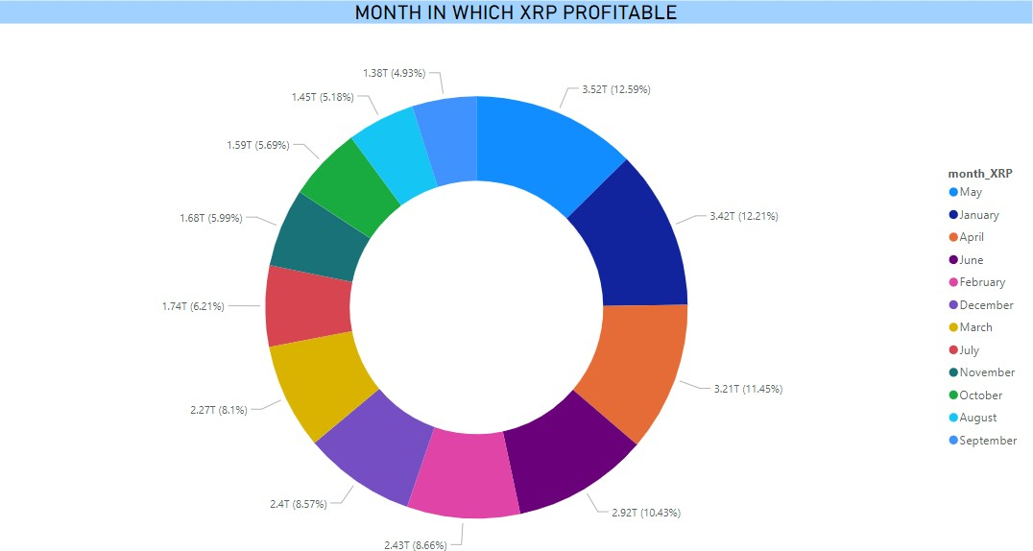

## Figure 3.12 month in which XRP more profitable

INFERENCE:

The month in which XRP was most profitable is MAY

1. Find the top 2 coins out of 4 based on market cap?

STEPS:

Measures created for each coin for avg market cap

AVG_MRKTCAP_BINANCE = AVERAGE(coin_BinanceCoin[Marketcap_BINAN]) AVG_MRKTCAP_ETHERE = AVERAGE(coin_Ethereum[Marketcap_ETH]) AVG_MRKTCAP_TETHER = AVERAGE(coin_Tether[Marketcap_TETH]) AVG_MRKTCAP_XRP = AVERAGE(coin_XRP[Marketcap_XRP])

Visualisations🡪pie chart

Values🡪measures of average marketcap

OUTPUT:

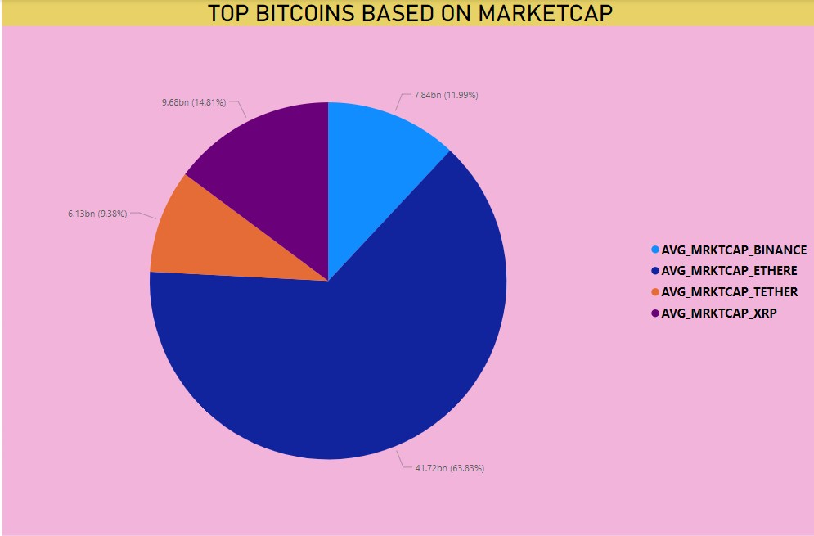

## Fig 3.13 top bitcoins based on marketcap

INFERENCE:

Ethereum and XRP are the top 2 coins out of 4 based on market cap.

1. The number of positively deviated values in Ethereum (opening value is higher than closing value)?

STEPS:

Measure:

Count_pos_eth = CALCULATE(COUNT(coin_Ethereum[POS/NEG_ETH]),coin_Ethereum[POS/NEG_ETH]

="POSITIVE")

Visualisations🡪card Value🡪count_pos_eth

OUTPUT:

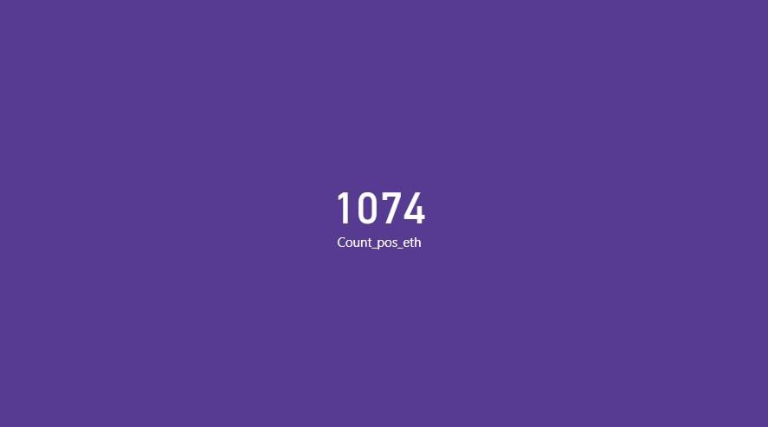

## Figure 3.14

INFERENCE:

1074 values has positive deviated values in Ethereum i.e. opening value is higher than closing value.

1. Compare the opening value of coin XRP over the time period?

STEPS:

Visualizations → area chart X axis → year_XRP

Y axis → Average of OPEN_XRP

OUTPUT:

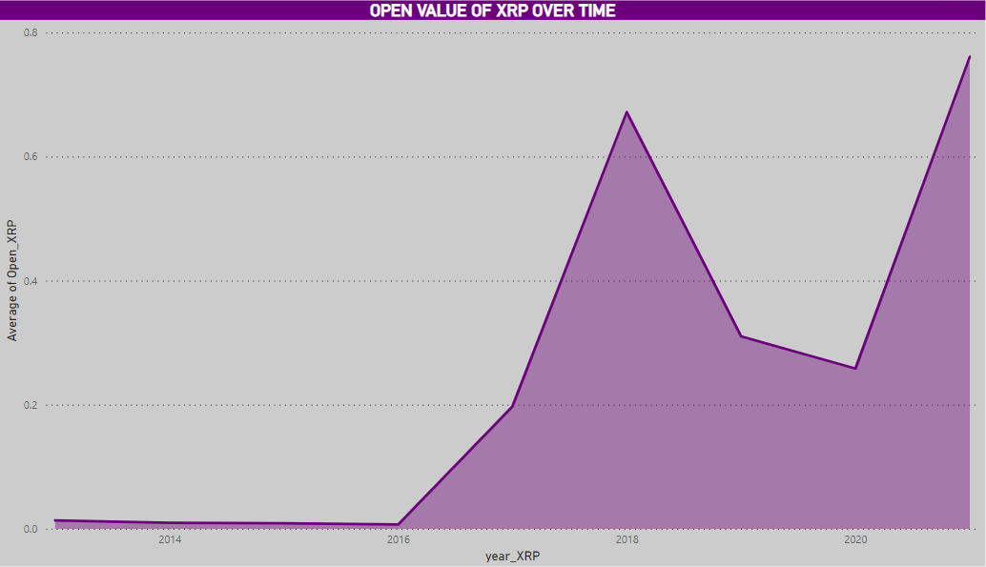

## Figure 3.15 open value of XRP

INFERENCE:

* The opening value of the XRP a low value in the years 2014 and 2016
* It increased during the year 2016 to 2018
* Decreased slightly till 2020
* Then started increasing after 2020

1. Which among the coin Ethereum and XRP have recorded the high value in all the years?

STEPS:

Measure for min is created

HI_XRP = MAX(coin_XRP[High_XRP]) HI_ETH = MAX(coin_Ethereum[High_ETH])

Visualisations 🡪 donut chart Values 🡪 measures

OUTPUT:

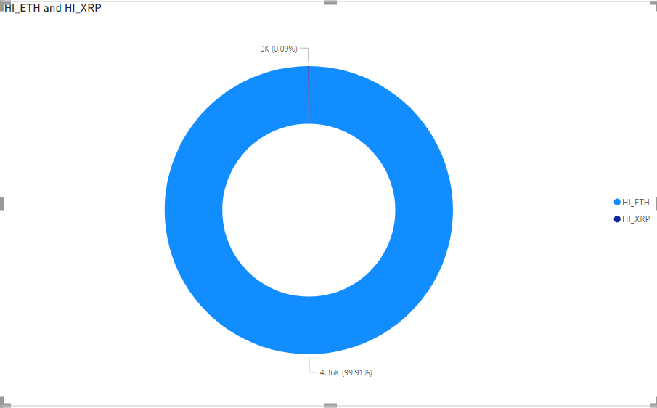F

Figure 3.16 highest value in all years

INFERENCE:

Ethereum have recorded the high value in all the years among the coin Ethereum and XRP.

1. Which coin is the least profitable coin among the 4?

STEPS:

Measures created for average of marketcap of all coins

AVG_MRKTCAP_BINANCE = AVERAGE(coin_BinanceCoin[Marketcap_BINAN]) AVG_MRKTCAP_ETHERE = AVERAGE(coin_Ethereum[Marketcap_ETH]) AVG_MRKTCAP_TETHER = AVERAGE(coin_Tether[Marketcap_TETH]) AVG_MRKTCAP_XRP = AVERAGE(coin_XRP[Marketcap_XRP])

Visualisations🡪pie chart Values🡪measure of average of marketcap

OUTPUT:

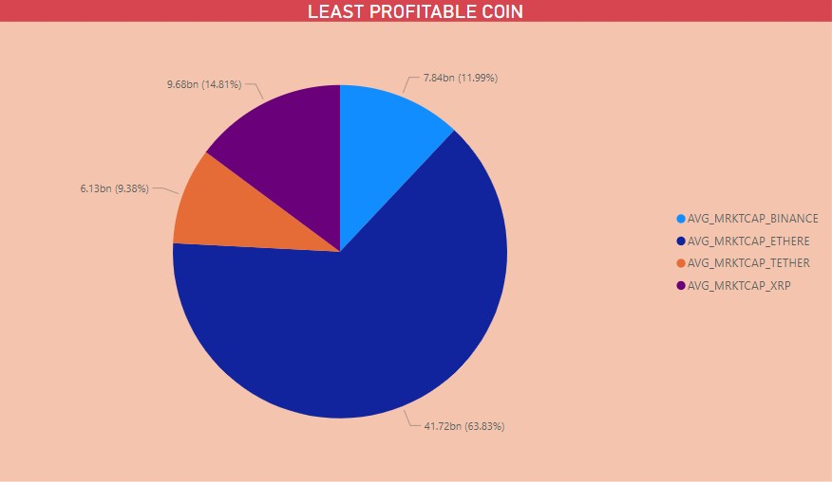

## Fig 3.17 least profitable coin

INFERENCE:

Tether is the least profitable coin among the 4

1. Compare the closing value of Ethereum for each month and give the highest and lowest value recorded month.

STEPS:

Visualisations → tree map

Values→ average of closing value of Ethereum.

OUTPUT:

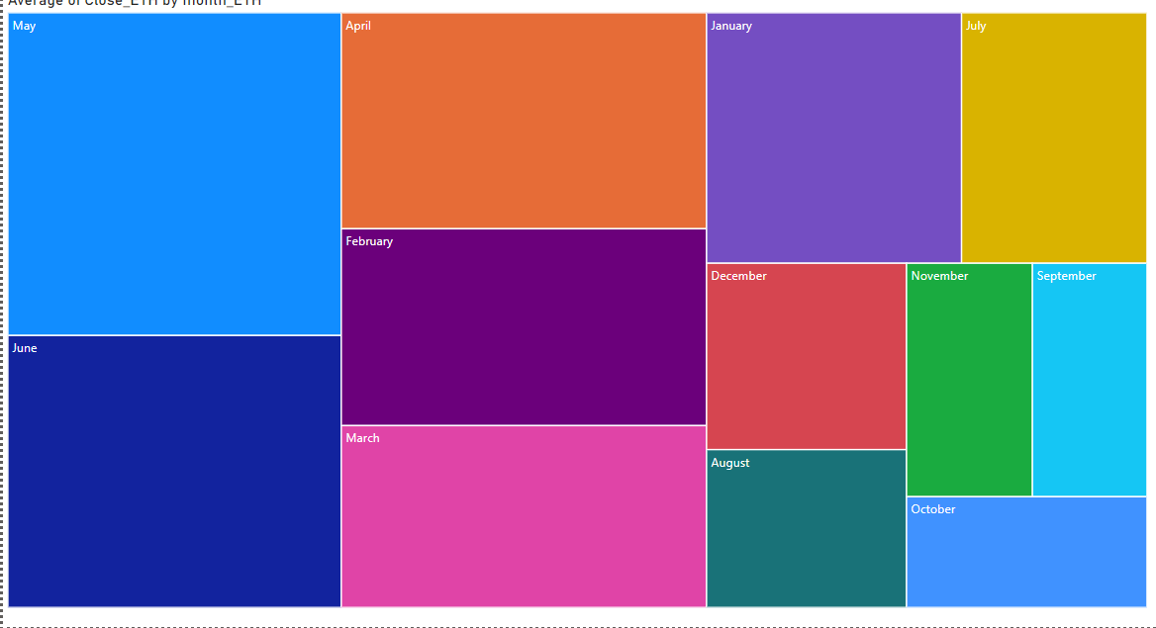

## Fig 3.18 closing value of Ethereum

INFERENCE:

Highest value → may of a value of 730.83 Lowest value → October of a value of 180.74

1. Count the number of negatively deviated days in the table Tether for each year.

STEPS:

Measure:

Count_neg_teth = CALCULATE(COUNT(coin_Tether[POS/NEG_TETH]),coin_Tether[POS/NEG_TETH]=" NEGATIVE")

Slicer→year_eth Visualisation 🡪 card Field 🡪 count_neg_eth

OUTPUT:

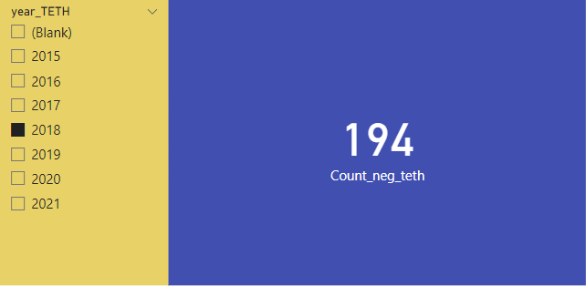

## Figure 3.19

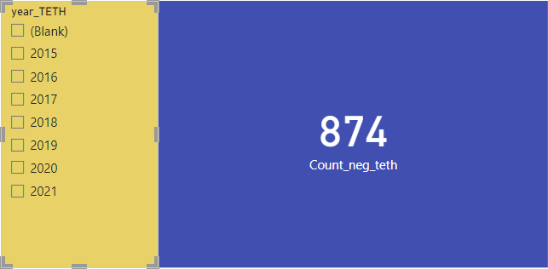

Figure 3.20

INFERENCE:

The number of negatively deviated days in the table Tether for each year are

* 2015 – 5 days
* 2016 – 51 days
* 2017 – 171 days
* 2018 – 194 days
* 2019 – 178 days
* 2020 – 189 days
* 2021 – 86 days
* Totally 874 days for all years

1. In which year the market cap of coin Tether was the highest?

STEPS:

Measure:

AVG_MRKTCAP_TETHER = AVERAGE(coin_Tether[Marketcap_TETH])

Visualisations 🡪 tree map Category 🡪 year_TETH

Values 🡪 AVG_Marketcap_TETH

OUTPUT:

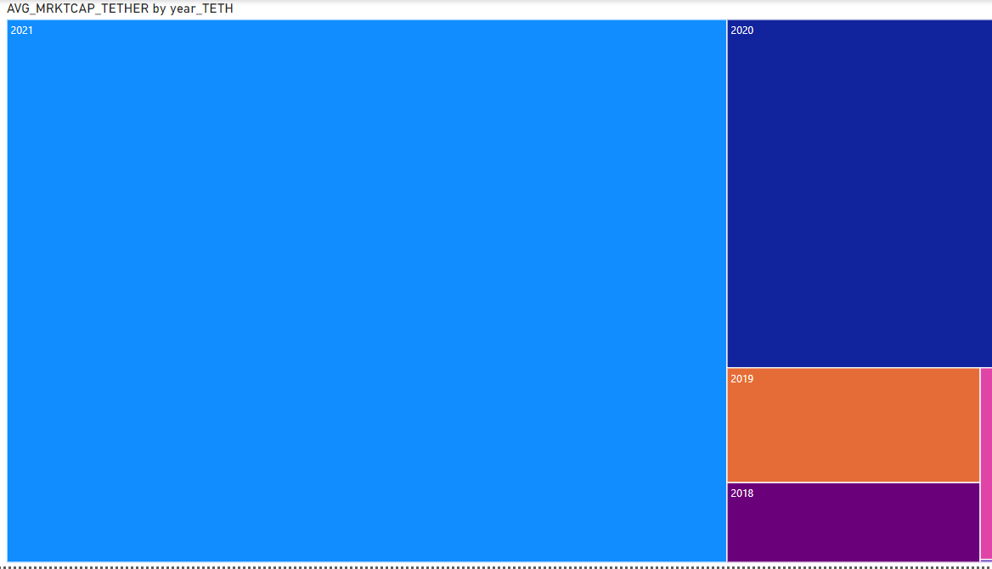

## Figure 3.21 year in which marketcap of tether the highest

INFERENCE:

The year in which the market cap of coin Tether was the highest is 2021

1. Which coin has the best average deviation among 4 coins?

STEPS:

Visualisations 🡪 pie chart

Values 🡪 Average of deviation of binance , Ethereum and bitcoin

OUTPUT:

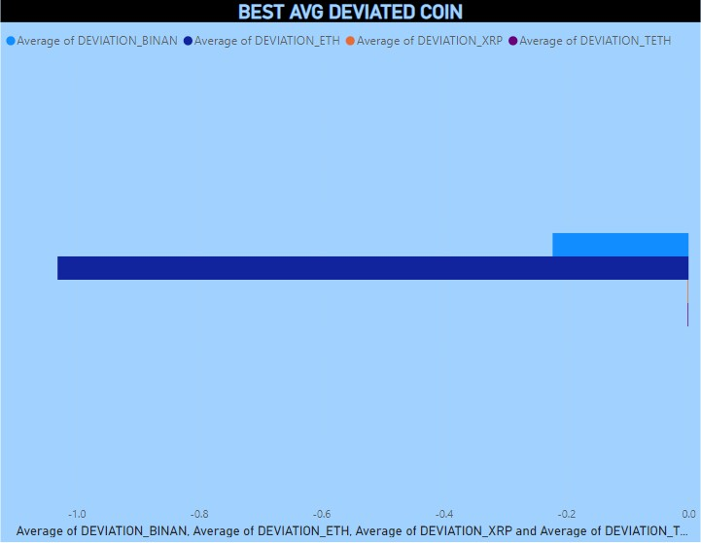

## Figure 3.22 best deviated coin

INFERENCE:

The coin which has the best average deviation among 4 coins is Ethereum

## CONCLUSION

Many analysis have been done on the top 4 cryptocurrencies in the world and the analysis gave us many pros and cons, which will help us to choose the best cryptocurrency to invest for. Since there are thousands of different cryptocurrencies in the world, people found difficulties to choose the better one among all cryptocurrencies to invest their money. According to market capitalization, which measures the combined value of all coins in circulation, the top 5 cryptocurrencies are: Bitcoin (BTC), Ethereum (ETH), Tether (USDT), Binance Coin (BNB), and XRP (XRP). Even after listing the top 5 among 14,000 cryptocurrencies, it is hard to choose the right one, the coin which can be trusted. Many people have lost their investments by choosing the cryptocurrencies to invest in a wrong way. Many people lose their investment by choosing untrusted cryptocurrencies. Normally people store their cryptocurrencies on their crypto wallet files on their computers. Therefore, they can be stolen if there is no proper security. Since cryptocurrency investment includes real time money, profit, loss, at first a better analysed overview of all those cryptocurrencies is required for every customer for choosing among those coins. For choosing those cryptocurrencies to invest for, this analysis will be very useful.

## REFERENCES

1. [https://www.oswego.edu/cts/basics-about-](https://www.oswego.edu/cts/basics-about-cryptocurrency#%3A~%3Atext%3DA%20cryptocurrency%20is%20a%20digital%2Cyou%20need%20a%20cryptocurrency%20wallet) [cryptocurrency#:~:text=A%20cryptocurrency%20is%20a%20digital,you%20need%20](https://www.oswego.edu/cts/basics-about-cryptocurrency#%3A~%3Atext%3DA%20cryptocurrency%20is%20a%20digital%2Cyou%20need%20a%20cryptocurrency%20wallet) [a%20cryptocurrency%20wallet.](https://www.oswego.edu/cts/basics-about-cryptocurrency#%3A~%3Atext%3DA%20cryptocurrency%20is%20a%20digital%2Cyou%20need%20a%20cryptocurrency%20wallet)
2. <https://www.kaspersky.com/resource-center/definitions/what-is-cryptocurrency>
3. <https://www.investopedia.com/terms/c/cryptocurrency.asp>
4. [https://www.investopedia.com/analyze-crypto-](https://www.investopedia.com/analyze-crypto-6456223#%3A~%3Atext%3DA%20cryptocurrency%20analysis%20involves%20examining%2Cto%20determine%20its%20trends%20better) [6456223#:~:text=A%20cryptocurrency%20analysis%20involves%20examining,to%2](https://www.investopedia.com/analyze-crypto-6456223#%3A~%3Atext%3DA%20cryptocurrency%20analysis%20involves%20examining%2Cto%20determine%20its%20trends%20better) [0determine%20its%20trends%20better.](https://www.investopedia.com/analyze-crypto-6456223#%3A~%3Atext%3DA%20cryptocurrency%20analysis%20involves%20examining%2Cto%20determine%20its%20trends%20better)