Day 1
What is Programming?
Programming is the process of giving instructions to a computer to make it perform tasks.
What is an Algorithm?
An algorithm is a description of how to systematically perform a task.
“Arrange the chairs”
Vs
“Make 8 rows with 10 columns in each row”
What is Python?
Python is a high-level programming language, through gave instructions to our computer.
Variables:
A variable is a name that locates a memory allocation of values.
Variable doesn’t store the values, it just point out the memory location of the value in memory.
Data type:
Identity of data or behavior of data.
- Numeric data type:
- "int” (integer): 2, 0, -2, 3
- “float” (floating point): 2.3 4.6 6.98
- String data type: Text data “str” write in ‘ ’ or “ ”
- Boolean data type: check conditions
- True: If the condition is correct.
- False: It the condition is wrong.
- None: No value is stored.

Type Conversion & Casting:
Type Conversion: Implicit, done automatically by Python.
Type Casting: Explicitly, done by the programmer.

Operators:
Operations performed on Operands is known as Operators.
Types of Operators:

- Arithmetic Operator:
- Addition: ‘+’
- Subtraction: ‘-’
- Multiplication: ‘*’
- Division: ‘/’
- Floor division: ‘//’
- Modulus: ‘%’
- Exponentiation: ‘**’

- Comparison Operator:
- Equal to: ‘==’
- Not Equal to: ‘!=’
- Greater than: ‘>’
- Greater than or Equal to: ‘>=’
- Less than: ‘<’
- Less than or equal to: ‘<=’

- Logical Operator:
- ‘Not’: opposite value
- ‘and’: both conditions should True
- ‘or’: any one condition should be True

- Assignment Operator:
- Assign: ‘=’
- Addition Assign: ‘+=’
- Subtraction Assign: ‘-=’
- Multiplication Assign: ‘*’
- Division Assign: ‘/=’
- Floor Division Assign: ‘//=’
- Modulus Assign: ‘*=’
- Exponential Assign: ‘**=’

- Membership Operator:
- ‘in’: if the value is present in any sequence data type.
- ‘not in’: if the value not present in any sequence data type.

- Identity Operator:
- ‘is’: checks two variables locate same memory location (True)
- ‘is not’: checks if the variables locate same memory location (False)

Operator Precedence:
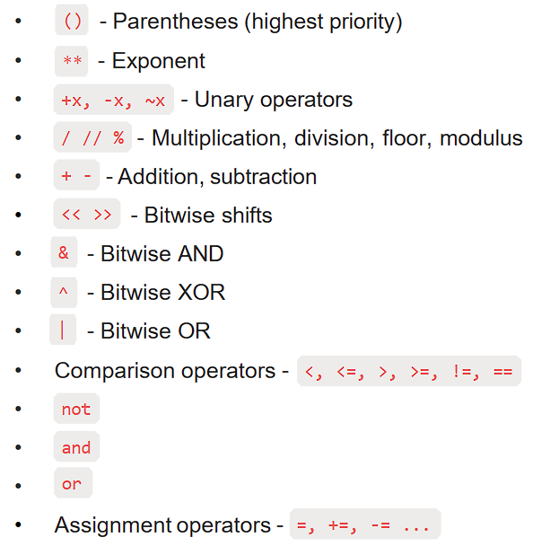

Input:
We use the function to take input from user while the program is running.
- (int(input()): stores integer value
- (float(input()): stores floating point number
- input(): stores string value

