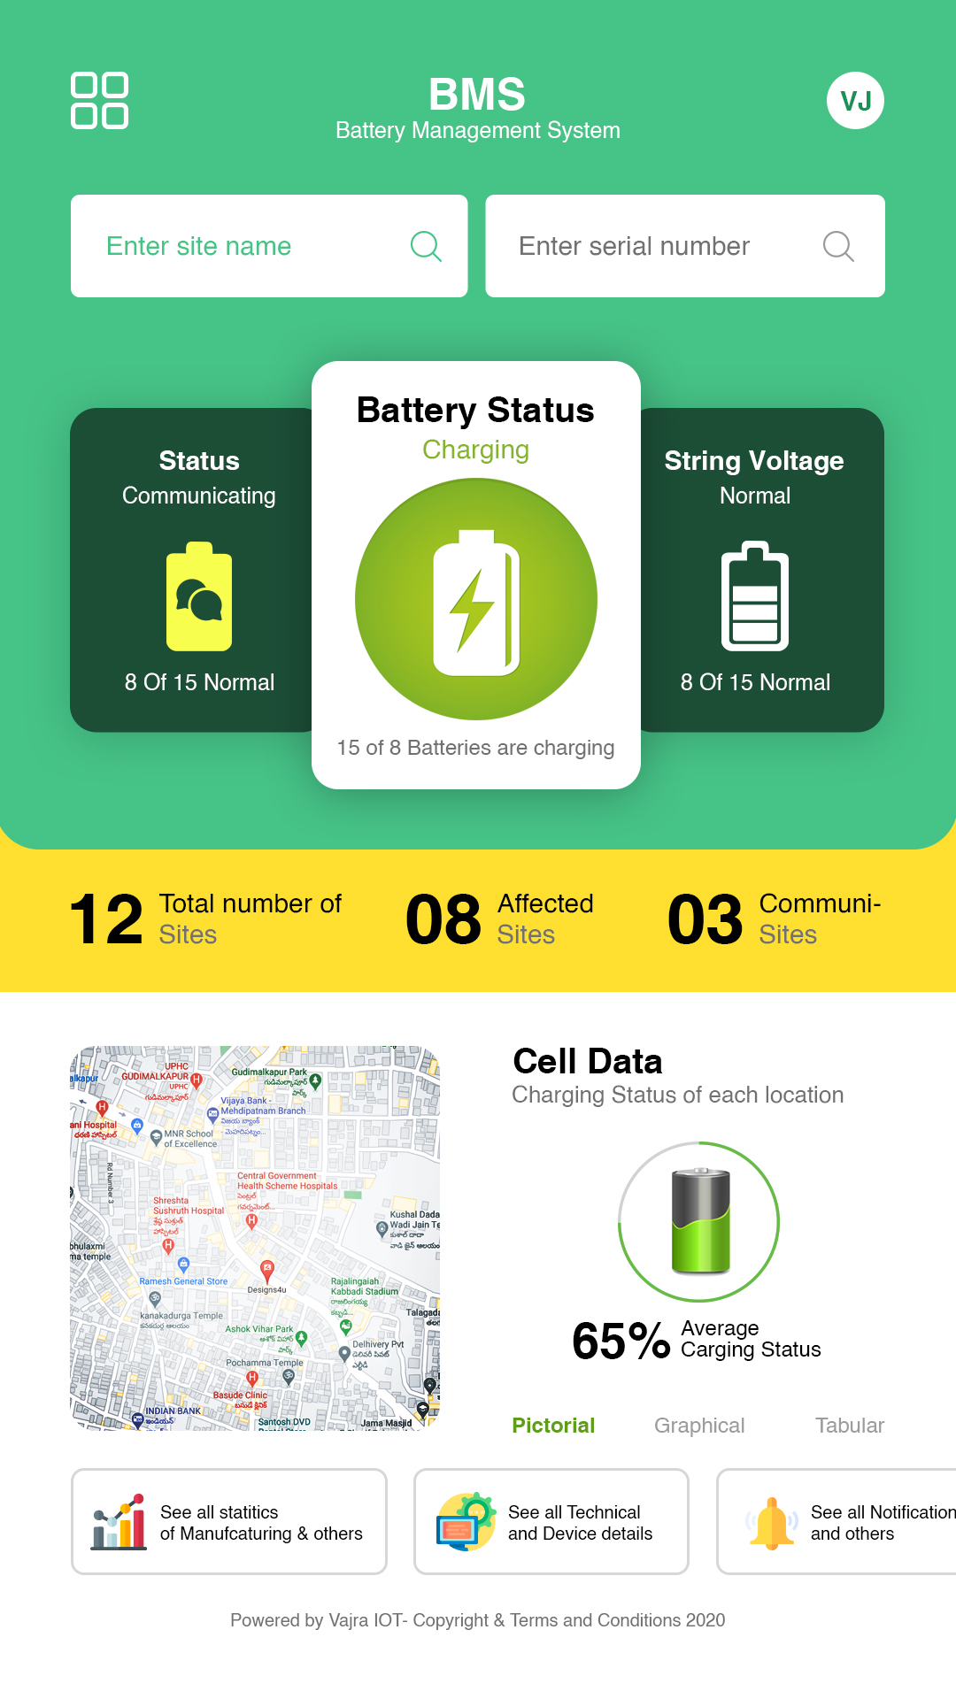

Helvitica  
 # 000000

Helvitica  
 # 717171

Helvitica  
# 7d7d7d

Helvitica  
 # 919191

Helvitica  
 # 5f9d1a

Color Value1  
#ffdf30  
Helvitica Bold  
#000000

Radios box bg color: # 1b4c35

Helvitica  
#46c387

Color Value1  
#46c387