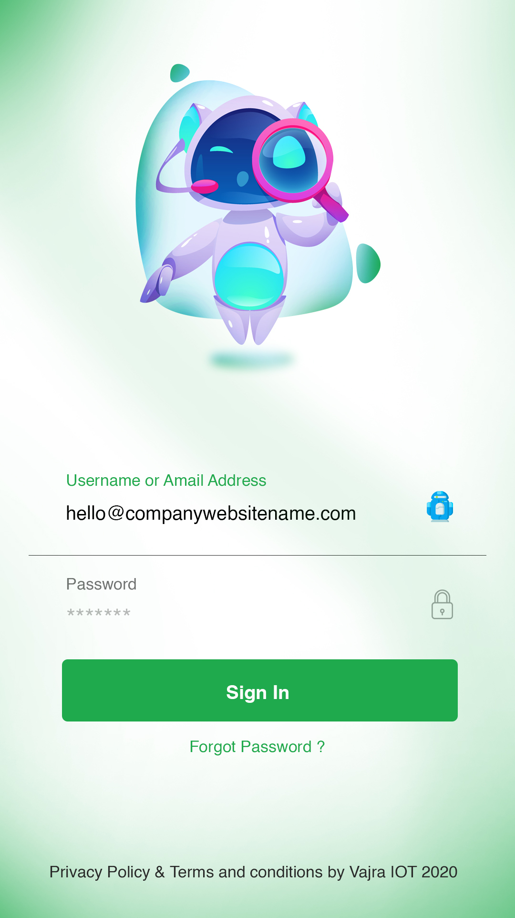

Helvetica  
#000000

Helvetica  
#1faa4d

Button BG Color  
#1faa4d

Helvetica  
#6e7370

Helvetica  
#000000

Helvetica  
#1faa4d