**PROJECT REPORT ON**

**Comparative Analysis of TCP Variants for Audio Transmission and File Transmission Over Multi-Hop Mobile Ad Hoc Networks**

Submitted in partial fulfillment of the requirements for the award of the degree of

**BACHELOR OF TECHNOLOGY**

**Submitted by**

123003243- SUGGULA JYOTHSNA- CSE



**Under the Guidance of**

**Prof. Sasikala Devi. N**

**School of Computing**

**SASTRA DEEMED TO BE UNIVERSITY**

(A University established under section 3 of the UGC Act, 1956)

Tirumalaisamudram

Thanjavur - 613401

February (2022)

**SHANMUGHA**

**ARTS, SCIENCE, TECHNOLOGY & RESEARCH ACADEMY (SASTRA DEEMED TO BE UNIVERSITY)**

**(A University Established under section 3 of the UGC Act, 1956)**

**TIRUMALAISAMUDRAM, THANJAVUR – 613401**



**BONAFIDE CERTIFICATE**

Certified that this project work entitled **“Comparative Analysis of TCP Variants for Audio Transmission and File Transmission Over Multi-Hop Mobile Ad Hoc Networks”** submitted to the Shanmugha Arts, Science, Technology & Research Academy (SASTRA Deemed to be University), Tirumalaisamudram - 613401 by Suggula Jyothsna (123003243), CSE in partial fulfillment of the requirements for the award of the degree of **BACHELOR OF TECHNOLOGY** in their respective programme. This work is an original and independent work carried out under my guidance, during the period August 2021 - February 2022.

# Prof. Sasikala Devi. N ASSOCIATE DEAN

**SCHOOL OF COMPUTING**

Submitted for Project Viva Voce held on___________________

# Examiner – I Examiner – II

# TABLE OF CONTENTS

| S. NO | TOPIC | Page No. |
| --- | --- | --- |
| 1 | ACKNOWLEDGEMENTS | 4 |
| 2 | ABSTRACT | 5 |
| 3 | CHAPTER 1 INTRODUCTION | 8 |
| 4 | CHAPTER 2 RELATED WORKS | 10 |
| 5 | CHAPTER 3 PROPOSED WORK | 12 |
| 6 | CHAPTER 4 SOURCE CODE | 20 |
| 7 | CHAPTER 5 RESULTS | 26 |
| 8 | CHAPTER 6 PERFORMANCE EVALUATION | 37 |
| 9 | CHAPTER 7 CONCLUSION | 55 |
| 10 | CHAPTER 8 REFERENCES | 56 |

# List of Tables

| **Table No.** | **Table Name** | **Page No.** |
| --- | --- | --- |
| Table 1.1 | Simulation Parameters for Routing protocols with CBR traffic | 36 |
| Table 1.2 | Simulation Parameters for TCP Variants with CBR traffic | 41 |
| Table 2.1 | Simulation Parameters for Routing protocols with FTP Application | 46 |
| Table 2.2 | Simulation Parameters for TCP Variants with FTP Application | 51 |

# ACKNOWLEDGEMENTS

First of all, I would like to thank God Almighty for his endless blessings.

I would like to express my sincere gratitude to **Dr. S. Vaidyasubramaniam, Vice-Chancellor** for his encouragement during the span of my academic life at SASTRA Deemed University.

I'll be eternally grateful, and I'd like to express my gratitude to you **Dr. A.Umamakeswri, Dean, School of Computing, and R. Chandramouli, Registrar** I received great support while teaching at SASTRA Deemed University.

I am highly grateful to **Dr. Shankar Sriram, Associate Dean, School of Computing** for his constant support, motivation and academic help extended for the past three years of my life in the School of Computing.

I would specially thank and express my gratitude to **N.Sasikala Devi , Associate Professor, School of Computing** for providing me with an opportunity to do this project and for her guidance and support to successfully complete the project.

I also thank all the Teaching and Non-teaching faculty, and all other people who have directly or indirectly help me through their support, encouragement,and all other help expanded for completion of my venture and for fruitful completion of all courses amid my scholastic life at SASTRA Regarded College..

Finally, I thank my parents and all others who help me acquire this interest in the project and aided me in completing it within the deadline without much struggle.

# ABSTRACT

MANET (Mobile Ad Hoc Network) is an infrastructure-free network that belongs to the wireless ad hoc network category. Ad hoc wireless networks with many hops are called multi-hop ad hoc networks, and the topology is unpredictable and changes rapidly with dynamic topologies. The location of the mobile node may change and the state of the radio channel may fluctuate.This necessitates a highly resilient and adaptable communication protocol capable of easily handling the challenges of wireless multi-hop networks. There are various routing protocols that are useful for communication.AODV, AOMDV, DSR, DSDV, etc.TCP is a widely used protocol in wireless networks that simplifies the transmission of packets. It creates a connection between the sender and the recipient, this protocol is known as a connection-oriented protocol. TCP is in charge of end-to-end connections and ensures that data is transmitted reliably. It handles error detection and recovery and also confirms package delivery. One of the important features of the Transmission control protocol is that it can handle congestion, when the packet sending rate is more than the receiving rate congestion arises. TCP Tahoe, TCP Reno, TCP New Reno, TCP Vegas, TCP SACK, TCP FACK, TCP Asym, TCP RBP, Full TCP, CUBIC, and other versions are available to address congestion.

A comparative analysis has been made with simulation to choose a routing protocol with an appropriate TCP variant for audio transmission and file transmission over MANET. Simulations are made to select appropriate routing protocols out of AODV, AOMDV, DSR, DSDV that match an Ad-hoc scenario. AOMDV protocol appears to perform more effectively than other routing protocols. Now by using the appropriate routing protocol, performance analysis of TCP variants such as TCP Tahoe, TCP Reno, TCP New Reno, TCP Vegas, TCP SACK is done to find the effective combination. Simulation results are TCP Vegas with AOMDV routing protocol gives best among all variants for both Audio Transmission and File Transmission with Average throughput *410.97 Kbps*, Average End-to-End Delay *69.81 msec* for Audio Transmission with the respective scenario, Average throughput *388.53 Kbps*, Average End-to-End Delay *93.63 msec* for File Transmission with the respective scenario.

**Keywords**:

**Ad hoc wireless networks; MANET; Audio transmission; Routing protocols; File Transmission; TCP Variants.**

# NOTATIONS

| **NOTATION** | **DESCRIPTION** |
| --- | --- |
| t0 | Time at which first packet is received from the neighbor |
| t | Current time |
| w | Time window |
| cwnd | Congestion window |
| ssthresh | Threshold value |
| rwnd | Receiver’s window |

# ABBREVIATION

| MANET | Mobile Ad-Hoc Network |
| --- | --- |
| AODV | Ad-hoc On-Demand Distance Vector |
| AOMDV | Ad-hoc On-Demand Multi path Distance Vector |
| DSR | Dynamic Source Routing |
| DSDV | Destination-Sequence Distance-Vector |
| TCP | Transmission Control Protocol |
| AIMD | Additive increase/multiplicative decrease |
| CWND | Congestion Window |
| MSS | Maximum Segment Size |
| ACK | Acknowledgement |
| RTT | Round trip time |
| PDR | Packet Delivery ratio |

**CHAPTER 1**

# INTRODUCTION

Wireless communication has been rapidly emerging in the last few decades. Wired connections are being replaced with wireless slowly and provide people with facilities to use various mobile devices from anywhere at any point of time and gave rise to various applications. This has also given a new direction to the internet; many ideas and applications are designed which decreases the cost and allows us to use infrastructure wireless networks. Most wireless technologies use radio waves as the medium and transfer the information between two or more points.

Fixed infrastructure and Ad Hoc Networks are the two types of wireless networks. based on how nodes interconnect among themselves. In fixed architecture, there is an access point which acts as a router or a bridge. This access points will have all the information about the network and will be identifying the route for transmitting data from source node to destination node. Whereas in Ad Hoc Networks which is having no fixed infrastructure or an administration system for identifying the route. They have Dynamic Topologies. The nodes will be self-configuring and do not rely on pre-existing infrastructure for establishing communication between nodes. Connection of two or more devices do not always need a centrally managed network. So, they can set-up an Ad hoc network between the devices anyway this connection will be temporary. These types of networks are used for establishing communication in environments where it would be difficult for creating a specific infrastructure for communication.

A mobile node network (MANET) is a collection of mobile nodes that may be dynamically configured at any time and in any location, without the need for existing infrastructure. MANET is a set of free mobile users who can communicate wirelessly.

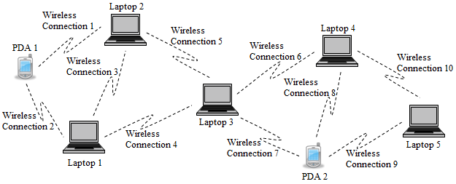

Fig-1. Mobile Ad Hoc Network Architecture

A node in MANET can act as Host or Router, and the Connectivity is achieved in form of multi-hop graph between nodes.The topology is dynamic due to mobile nodes that move arbitrarily with respect to remaining nodes in the network.Mobile nodes are energy constrained they probably rely on batteries.

* Radio networks are risky to physical security when compared with fixed networks. So, MANET has limited security.
* The establishment of network is fast, no need for an access point since it is not centralized.
* Nodes are mobile using radio waves that have low capacity than wired link.
* Medium routing is tough due to the dynamic nature of the topology and changing behavior. In an Ad-hoc network nodes routing paths which are already established may be broken during data transfer and can leave or join anytime. So, due to this we need to maintain and reconstruct the routing path with minimal delay and overhead. Mostly MANETs are used in military battlefield, during the battle issues raises are control of topology, energy efficiency, quality of service (QOS), security which are existing in wired networks those are refused in MANET.

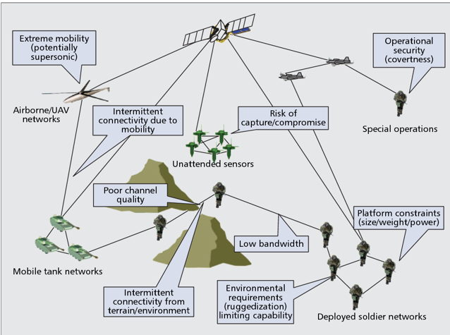

Fig-2. The constraints of the tactical military environment

Transmission Control Protocol (TCP) is a protocol of transport layer in TCP/IP protocol suit. It is used for reliable transmission of data packets. It includes many mechanisms to solve the problems that raises when transmission, it can handle packet loss, out-of-order packet, corrupted packets, duplicate packets. TCP flow control and Congestion control mechanisms for reliable data transfer.Because it is a connection-oriented protocol, it utilises a three-way handshake to establish a secure connection. The connection should be full-duplex, with the SYN, SYN-ACK, and ACK flags being exchanged. For the SYN packet, the client first chooses a starting sequence number. The server now chooses a sequence number and sends a SYN/ACK packet, both the server and the client acknowledge by incremental sequence number. Once the connection is established ACK is forwarded. This way the connection is established, and packets are transmitted.

**CHAPTER 2**

# RELATED WORKS

Adel et al. (2010) proposed a The performance of the AODV, DSDV, OLSR, and DSR routing protocols is compared in a mobile ad hoc network. Packet Delivery Fraction (PDF), Average End to End Delay, and Number of Packets Dropped were examined, and it was determined that AODV is preferable for real-time traffic. The performance of DSDV is superior for a lesser number of nodes.

Ahuja et al. (2000) proposed a In Manet, we analysed the performance of TCP over several routing protocols and used cmu extensions to do so, the performance of TCP tahoe over routing protocols and determine the behavior of TCP over them

Banerjee et al. (2020) presented a Performance Survey of MANET Routing Protocols with TCP Congestion Control Algorithms and concluded Due to the very low powered nodes in MANET, it is extremely essential to avoid a huge number of retransmissions caused due to link failures or congestion. Optimal application of congestion control algorithms is therefore necessary to make the network reliable along with the routing protocols.

Leenas et al. (2021) presented a A Comparison of Proactive, Reactive, and Hybrid Routing Protocols in Mobile Ad Hoc Networks, which included an experimental setup utilising the simulator NS version 2.35. For low and high mobile nodes between 10 and 60 nodes, we examined performance differentials on simulated regions such as 600 x 600 m2, 800 x 800 m2, and 1000 x 1000 m2.

Molia et al. (2018) proposed TCP Variations for Versatile Adhoc Systems: Challenges and Arrangements proposed Concurring to misfortune separation, misfortune forecast, and misfortune evasion approaches, a consider of a collection of Transmission control convention variations based on misfortune taking care of approach is advertised. The essential objective of this survey is to distinguish current troubles and future headings for TCP in MANETs..

Senthamilselvi et al. (2015) proposed In mobile ad-hoc networks, TCP variations are used to test the performance of routing protocols. In a MANET environment, the study analyses four IETF defined routing protocols in order to provide a full performance evaluation.. DSR, AODV, OLSR, and TORA are among the routing protocols explored, and they cover a wide range of design options, including source routing, hop-by-hop routing, periodic advertisement, and on-demand route discovery.

Shenoy et al. (2019) proposed TCP Variants for Video Transmission Over Multi-hop Mobile Ad Hoc Networks: A Comparative Analysis and The researchers determined that combining AODV and TCP Vegas improves throughput, resulting in fewer packets being lost and a higher Packet Delivery Ratio (PDR). When compared to other TCP variations that have been investigated, the congestion window grows rapidly. In the case of Tahoe, Vegas, and SACK, the congestion window is steady. In comparison to other variations, TCP New Reno sends out more packets.

Singh et al. (2021) proposed TCP Variants Performance Analysis on MANETs Using AODV and DSDV Routing Protocols.With both the DSDV and AODV protocols, TCP Vegas achieved minimal delay and packet loss. With both the AODV and DSDV routing protocols, TCP bag, on the other hand, was able to achieve minimum acknowledgment.

Singh et al. (2020) proposedPerformance Evaluation of DSDV and AODV Routing Protocols in the Internet, with a Special Focus on Node Density and Routing Overhead In terms of routing overhead and the number of received packets, the simulation results show that DSDV outperforms AODV.The AODV, on the other hand, outperforms the DSDV in terms of node density and hop count..

Thangam et al. (2009) proposed A study on cross-layer based approach for moving forward TCP execution in multi bounce portable ad hoc systems the essential focal points of remote systems in comparison with their wired partners incorporate adaptable portability administration, speedier and cheaper sending, and eventually simpler support and overhaul procedures

**CHAPTER 3**

# PROPOSED FRAMEWORK

As we know Mobile Ad hoc Networks (MANET) are the collection of mobile nodes that can be dynamically setup anywhere, anytime without the use of preexisting infrastructure. Mobile Ad hoc Networks is an autonomous group of mobile users that can communicate over wireless network. There are three types different of MANET routing protocols: Proactive, Reactive, Hybrid.

* **Proactive Routing**:

This type of routing is also called as Table-Driven routing. Every node should maintain a routing table which is up-to-date. This can be done by often querying its immediate nodes for information of routing. Due to continue exchange information this affects the bandwidth utilization so there by decrease in the battery’s lifetime. One of the major advantages is the routes are available quickly so, low latency in finding path. Quality of service (QOS) is guaranteed and we can know the state information.Major disadvantage is more overhead and periodic update is needed so, extra packets are needed for checking the node’s presence

*Examples*:Optimized Link State Routing (OLSR), Destination-Sequence Distance-Vector (DSDV), and so on.

* **Reactive Routing:**

This is based on request-response model. Route is determined only when needed so, there is less overhead due to no periodic update. Reactive Routing is also called demand driven due to on-the-fly route establishment. Here routes are established only on demand, when data must be transferred from one location to another To find the best path, it uses the route discovery technique. Although scalability is good, route latency is significant.

*Examples*: Dynamic Source Routing (DSR), Ad-hoc On-Demand Distance Vector (AODV) routing.

* **Hybrid routing:**

This is the combination of Proactive and Reactive, for nearby nodes proactive routing is used and for long-distance nodes reactive routing is used. Hierarchical routing is other class, divides the network to zones or clusters.

*Example*: Zone Routing Protocol (ZRP)

**Ad-hoc On-Demand Distance Vector (AODV):**

For mobile ad hoc networks and wireless networks, the AODV routing protocol was created. This only creates routes between the nodes when they are required, such as when a request is received from the source node. As a result, AODV is known as an On-Demand algorithm because it does not generate additional communication traffic. Only when the sources require it are they kept up to date. Until the nodes' connections are formed, they are deafeningly quiet. If any node requires the connection, they send a broadcast request and the remaining nodes forward the message, make a record of the requested node. So, AODV creates a series of routes which are temporary to traceback to the requested node. The node which sends the request uses the route containing the least number of hops to the source. If the entries are not used, then the routing tables are recycled after some time. In case, if a link fails or gets down the routing error is passed to the node which is transmitted and this process is repeated.

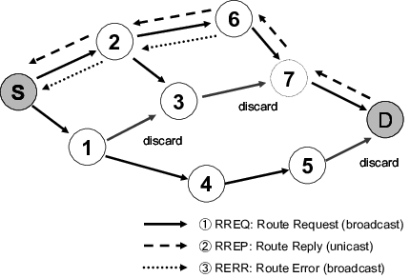

Fig-3: AODV routing protocol

**Ad-hoc On-demand Multipath Distance Vector (AOMDV):**

The AOMDV protocol is a multipath modification of the AODV protocol that searches for multiple paths between the source and destination. In the event of a route failure, it will take a different route.When all routes get fail, new route should be discovered. Multipath routing is a step up from single-path routing. Its benefit is that it manages network traffic and prevents congestion so, increase in reliability. It creates a loop free node if required and maintains connectivity throughout the network. Disadvantage of using AOMDV is having more overheads during discovery of route which is due to increase in flooding.

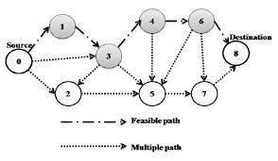

Fig-4: AOMDV routing protocol

**Dynamic Source Routing (DSR):**

DSR is a well-structured routing technique for multi-hop Mobile Ad-hoc networks. This allows the Ad-hoc networks to be self-configuring without the fixed infrastructure. As it is a reactive protocol, operate only On-demand basis requirement. If a sender's packet determines the complete sequence of nodes and its back trace, that is through which node the packet is forwarded then this type of routing is called Source routing. The advantage is that the intermediate node does not need to keep up-to-date routing information in order to forward packets.Less network overhead as the number of message exchange between the nodes is very low. DSR have two main phases "Route Maintenance" and "Route Discovery". Every node in DSR must have a route cache containing all well-known self-to-destination pairs. If a node wants to send packet it uses the cache to deliver it. In case, the destination does not exist in the cache, Route Discovery phase is starts to discover a route to destination by sending a request which includes destination address, source address, unique identification number.The Route Maintenance phase is started if a route is present in the cache but is not valid. If a node executes a route request packet only if its address isn't in the cache, it isn't processed. When the destination or any of the nodes in between knows the path to the destination, a route reply is generated.

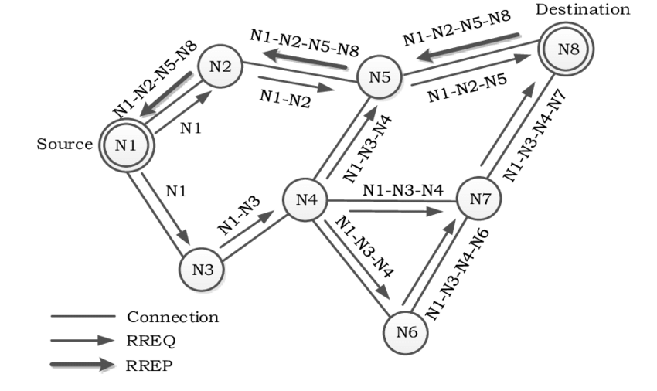

Fig-5: DSR routing protocol

**Destination-Sequence Distance-Vector (DSDV):**

DSDV is uses Bellman-Ford algorithm. Each routing tables contain all destinations with the respective next node. For every exchange between the nodes the routing tables are updated. Every node will broadcast to its neighboring nodes entries, exchange can be done by sending the whole routing table, or doing an incremental update which means updating the recently changed one. Nodes which receive the data and update the tables and if they get a better route, they will use that route. Updates of the routing table are frequently performed and if there is a new event detected in the topology the routing table gets changed. If there are many changes in the topology the total table is exchanged whereas in the stable topology there will be incremental updates by this there will be less traffic. The selection of route it is done by the metric sequence number this indicates the time sent by the destination node. If there are two identical routes the one which has dust sequence number is used and the other one is destroyed. DSDV requires regular update in the routing tables due to frequent change which also uses the battery power and the bandwidth even if the network is idle.

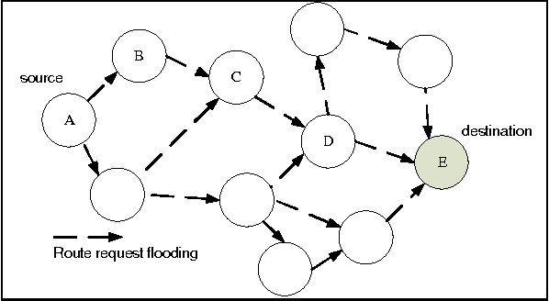

Fig-6: DSDV routing protocol

**Transmission control protocol** (TCP) employs an AIMD-based congestion avoidance algorithm.TCP uses congestion policy to avoid congestion there are many phases

1. **Slow start:**

This phase begins with the initial value of the congestion window, which grows by 1 MSS (maximum segment size) for each acknowledgement received, essentially doubling the window size for each RTT (round trip time). The size of the congestion window grows rapidly during this period.

At first, cwnd = 1

For 1st RTT, cwnd = 2^ (1) =2

2nd RTT, cwnd = 2^ (2) = 4

3rd RTT, cwnd = 2^ (3) = 8 and so on until loss event occurs

The threshold is calculated ssthresh=cwnd/2

1. **Congestion Avoidance:**

This phase starts after the threshold value now the size of the cwnd is increases in an additive manner for each RTT.

At first cwnd = I

After 1 RTT, cwnd = i+1

2 RTT, cwnd = i+2

3 RTT, cwnd = i+3

1. **Congestion Detection:**

When a congestion develops, the congestion window size is reduced, and the sender can recognise that the condition has happened when there is a timeout or three duplicate acknowledgements, requiring retransmission. It is necessary to retransmit any packets that have been lost owing to congestion.

* *Retransmission due to timeout*:

congestion possibility is high

1. Setting cwnd=1
2. Start again with slow start phase

* *Retransmission due to three duplicate acknowledgements*:

Congestion possibly is low

1. Setting cwnd= ssthresh
2. Start with the congestion avoidance phase
3. **Fast Recovery:**

This is a last improvement in TCP. However, in this fast recovery, slow start is avoided and used only in the beginning of the connection. The three duplicate acknowledgements tell us that more than a packet is lost, now the receiving side sends a dup ACK if it receives an out of order packet.

After receiving 3 duplicate acknowledgements:

1. retransmit the missing segment

2. Set cwnd=ssthresh +3

3. Each time other duplicate acknowledgement arrives goes to congestion avoidance. If it receives a new acknowledgement, it exits fast recovery.

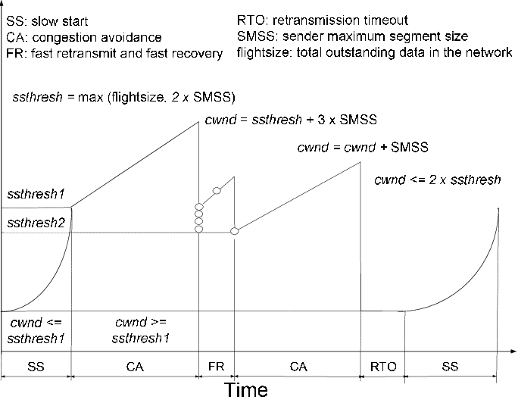

Fig-7: Congestion window vs Time

In Figure-7, x-axis indicates time and y-axis indicates Congestion window. It illustrates the variation in average throughput of the network with variation in Number of mobile nodes in the network

TCP provides different variants:

1. **TCP Tahoe**

This is TCP's default variation, which is based on the idea of "packet conservation," which states that if the connection's bandwidth capacity is full, no packets will be injected unless one is removed. Slow Start, congestion avoidance, and fast retransmission are all examples of this.

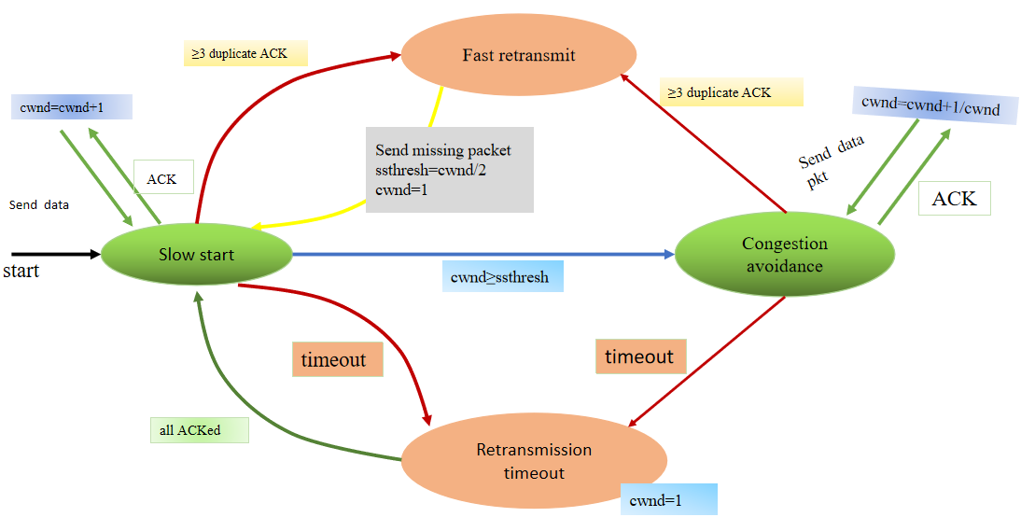

Fig-8: Slow Start, Congestion Avoidance, and Fast Retransmit are options for TCP Tahoe.

1. **TCP Reno:**

In TCP Reno the window size is changed cyclically in some situations. The size of the window increases until the packet loss. When three duplicate packets are received it is a sign of congestion. TCP Reno will enter the new mechanism that is fast recovery when the congestion occurs. This includes Slow Start, congestion avoidance, Fast retransmit, Fast Recovery.

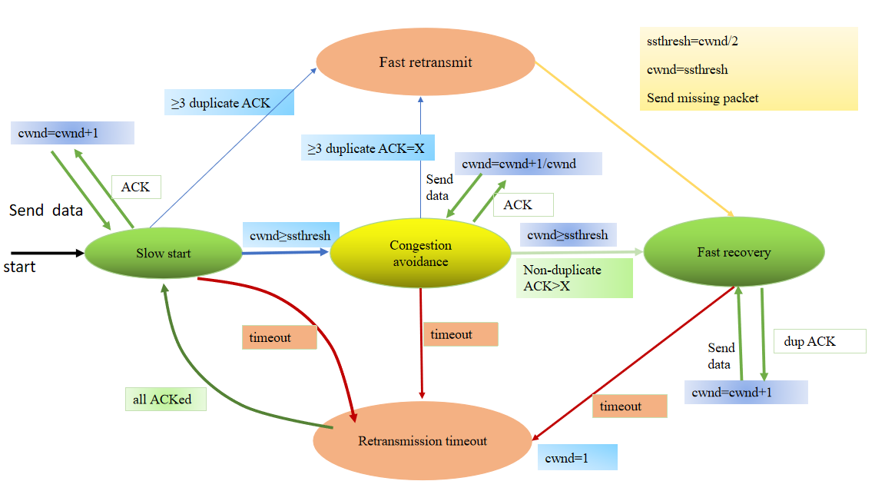

Fig-9: TCP Reno changing between Slow Start, congestion avoidance,

Fast retransmit, Fast recovery.

Multiple Packet Loss

* + Partial ACK received when first packet retransmitted
  + ACK causes moving out of Fast Recovery state
  + Cwnd halved – wait for timeout!
  + Affects Reno performance

1. **TCP New Reno:**

TCP Reno's extension is TCP Newreno which has some advantages it can detect multiple packet loss and here the congestion avoidance mechanism is efficient it and utilizes the resources much more efficient so it has few retransmits. Extend the Fast recovery phase, don't exit Fast Recovery if you get Partial Acknowledgement. As TCP new Reno can detect multiple packet loss the fast recovery phase continues and when further acknowledgement arrives

If it acknowledges all the packets then it exits fast recovery

1. Set cwnd= ssthresh
2. Continue congestion avoidance

If the ACK is not a complete ACK,The following packet in line is therefore determined to be lost, and the packet is retransmitted with the number of dup ACK received set to 0.

1. **TCP Sack:**

Selective Acknowledgment is used by TCP to get out of the congestion which arises due to dropped packets. We can know which packets are received by the receiver, by which we can transmit only missing packets.

1. **TCP Vegas:**

TCP Vegas identify the congestion on basis of increasing RTT (Round trip time). It is not like other variants of TCP which identifies the congestion due to packet loss

| **Metrics\variants** | **TCP Reno** | **TCP NewReno** | **TCP Sack** | **TCP Vegas** |
| --- | --- | --- | --- | --- |
| **Slow Start** | Yes | Yes | Yes | Modified version |
| **Congestion Avoidance** | Yes | Yes | Yes | Modified version |
| **Fast Retransmit** | Yes | Yes | Yes | Yes |
| **Fast Recovery** | Yes | Modified Version | Modified version | Yes |
| **Selective Acknowledgement** | No | No | Yes | No |
| **Difficulty** | Can’t handle multiple packet loss | Takes one RTT for detecting packet loss | Implementation of selective acknowledgement is a challenging task. | Do not have any mechanism for rerouting |

**CHAPTER 4**

# SOURCE CODE

**Aodv2.tcl: CBR TRAFFIC (AUDIO TRANSMISSION)**

#Code by S Jyothsna

#Reg No :123003243

#### Simulations and parameters setup

set val(chan) Channel/WirelessChannel ;# channel type

set val(prop) Propagation/TwoRayGround ;# radio-propagation model

set val(netif) Phy/WirelessPhy ;# network interface type

set val(mac) Mac/802_11 ;# MAC type

set val(ifq) Queue/DropTail/PriQueue ;# interface queue type

set val(ll) LL ;# link layer type

set val(ant) Antenna/OmniAntenna ;# antenna model

set val(ifqlen) 50 ;# max packet in ifq

set val(nn) 12 ;# number of mobilenodes

set val(rp) AODV ;# routing protocol

set val(x) 1000 ;# X dimension of topography

set val(y) 1000 ;# Y dimension of topography

set val(stop) 15.0 ;# time of simulation till end

set networks1 [new Simulator]

set topograph [new Topography]

$topograph load_flatgrid $val(x) $val(y)

create-god $val(nn)

###Open the NS trace file with the commands

set trfille [open Aodv2.tr w]

$networks1 trace-all $trfille

$networks1 use-newtrace

####Open the NAM trace file

set namming [open Aodv2.nam w]

$networks1 namtrace-all $namming

$networks1 namtrace-all-wireless $namming $val(x) $val(y)

set chan [new $val(chan)];

$networks1 node-config -adhocRouting $val(rp) \

-llType $val(ll) \

-macType $val(mac) \

-ifqType $val(ifq) \

-ifqLen $val(ifqlen) \

-antType $val(ant) \

-propType $val(prop) \

-phyType $val(netif) \

-channel $chan \

-topoInstance $topograph \

-energyModel "EnergyModel" \

-initialEnergy 50.0 \

-txPower 0.9 \

-rxPower 0.7 \

-idlePower 0.6 \

-sleepPower 0.1 \

-agentTrace ON \

-routerTrace ON \

-macTrace ON \

-movementTrace ON

# #### Nodes Definition

#Create 11 nodes

set nide0 [$networks1 node]

$nide0 set X_ 995

$nide0 set Y_ 556

$nide0 set Z_ 0.0

$networks1 initial_node_pos $nide0 30

set nide1 [$networks1 node]

$nide1 set X_ 482

$nide1 set Y_ 637

$nide1 set Z_ 0.0

$networks1 initial_node_pos $nide1 30

set nide2 [$networks1 node]

$nide2 set X_ 549

$nide2 set Y_ 950

$nide2 set Z_ 0.0

$networks1 initial_node_pos $nide2 30

set nide3 [$networks1 node]

$nide3 set X_ 708

$nide3 set Y_ 473

$nide3 set Z_ 0.0

$networks1 initial_node_pos $nide3 30

set nide4 [$networks1 node]

$nide4 set X_ 233

$nide4 set Y_ 949

$nide4 set Z_ 0.0

$networks1 initial_node_pos $nide4 30

set nide5 [$networks1 node]

$nide5 set X_ 354

$nide5 set Y_ 555

$nide5 set Z_ 0.0

$networks1 initial_node_pos $nide5 30

set nide6 [$networks1 node]

$nide6 set X_ 432

$nide6 set Y_ 362

$nide6 set Z_ 0.0

$networks1 initial_node_pos $nide6 30

set nide7 [$networks1 node]

$nide7 set X_ 587

$nide7 set Y_ 512

$nide7 set Z_ 0.0

$networks1 initial_node_pos $nide7 30

set nide8 [$networks1 node]

$nide8 set X_ 456

$nide8 set Y_ 471

$nide8 set Z_ 0.0

$networks1 initial_node_pos $nide8 30

set nide9 [$networks1 node]

$nide9 set X_ 248

$nide9 set Y_ 174

$nide9 set Z_ 0.0

$networks1 initial_node_pos $nide9 30

set nide10 [$networks1 node]

$nide10 set X_ 388

$nide10 set Y_ 272

$nide10 set Z_ 0.0

$networks1 initial_node_pos $nide10 30

set nide11 [$networks1 node]

$nide11 set X_ 475

$nide11 set Y_ 985

$nide11 set Z_ 0.0

$networks1 initial_node_pos $nide11 30

#time,distance,dest cord,velocity,

#last parameter is velocity 25

$networks1 at 0.5 "$nide0 setdest 400.0 300.0 25.0"

$networks1 at 0.0 "$nide1 setdest 500.0 30.0 25.0"

$networks1 at 0.7 "$nide2 setdest 500.0 100.0 20.0"

$networks1 at 0.5 "$nide3 setdest 480.0 400.0 26.0"

$networks1 at 0.0 "$nide4 setdest 300.0 500.0 5.0"

$networks1 at 0.0 "$nide5 setdest 102.0 200.0 30.0"

$networks1 at 0.5 "$nide6 setdest 100.0 600.0 17.0"

$networks1 at 0.5 "$nide7 setdest 700.0 300.0 25.0"

$networks1 at 0.0 "$nide8 setdest 134.0 30.0 25.0"

$networks1 at 0.7 "$nide9 setdest 656.0 600.0 20.0"

$networks1 at 0.5 "$nide10 setdest 675.0 400.0 26.0"

$networks1 at 0.0 "$nide11 setdest 500.0 30.0 5.0"

#Setup a TCP connection from Agent class and attach it with node

set transcp0 [new Agent/TCP]

$networks1 attach-agent $nide0 $transcp0

set sinking0 [new Agent/TCPSink]

$networks1 attach-agent $nide1 $sinking0

$networks1 connect $transcp0 $sinking0

$transcp0 set packetSize_ 1500

#Setup a TCP connection from agent class and attach it with node

set transcp2 [new Agent/TCP]

$networks1 attach-agent $nide10 $transcp2

set sinking2 [new Agent/TCPSink]

$networks1 attach-agent $nide9 $sinking2

$networks1 connect $transcp2 $sinking2

$transcp2 set packetSize_ 1500

###Setup a cbr Application over TCP connection

set constbr [new Application/Traffic/CBR]

$constbr attach-agent $transcp0

$constbr set packetSize_ 1000

$constbr set rate_ 2.0Mb

$constbr set random_ 2

$networks1 at 1.0 "$constbr start"

$networks1 at 15.0 "$constbr stop"

###Setup a cbr Application over TCP connection

set constbr1 [new Application/Traffic/CBR]

$constbr1 attach-agent $transcp2

$constbr1 set packetSize_ 1000

$constbr1 set rate_ 2.0Mb

$constbr1 set random_ 2

$networks1 at 1.0 "$constbr1 start"

$networks1 at 15.0 "$constbr1 stop"

proc fininshing {} {

global networks1 trfille namming

$networks1 flush-trace

close $trfille

close $namming

exec nam Aodv2.nam &

exit 0

}

for {set i 0} {$i < $val(nn) } { incr i } {

$networks1 at $val(stop) "\$nide$i reset"

}

$networks1 at 0.5 "$networks1 trace-annotate \"Starting CBR0 node0 to node1\""

$networks1 at 0.5 "$networks1 trace-annotate \"Starting CBR1 node10 to node9\""

$networks1 at $val(stop) "$networks1 nam-end-wireless $val(stop)"

$networks1 at $val(stop) "fininshing"

$networks1 at $val(stop) "puts \"done\" ; $networks1 halt"

$networks1 run

[**Full Source Code**](https://drive.google.com/drive/u/1/folders/1qBb9Jc9BXyEJKvbfJtD8PehOcpikGPJv)

**CHAPTER 5**

# RESULTS

**Wireless Dynamic Topology for CBR Traffic**

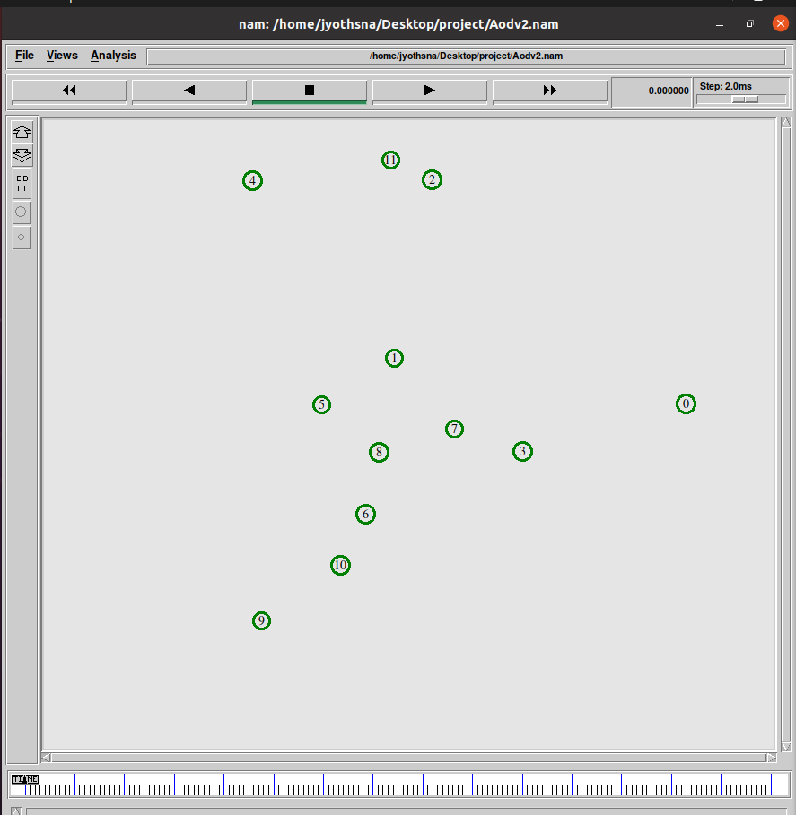

Fig-10: Simulation screen at time of 0 seconds

**Nam window for AODV protocol with CBR traffic:**

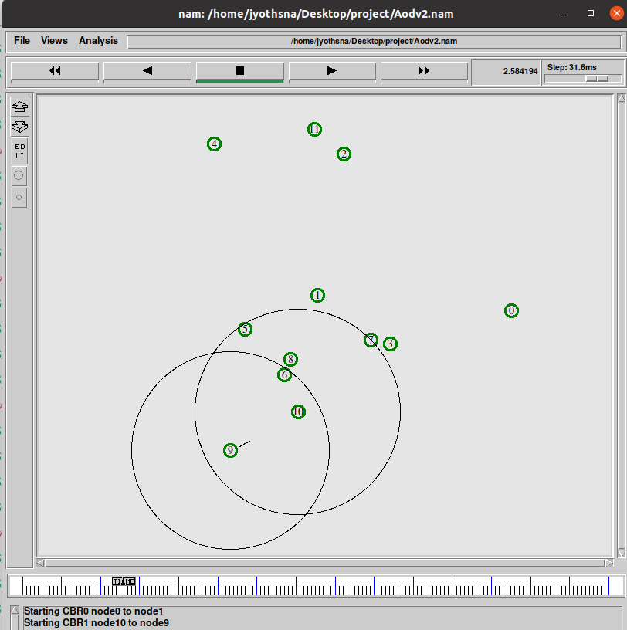

Fig. Simulation screen at intermediate time

The above figure depicts the Simulation screen at intermediate time. We can see that source node 0 and destination node 1 are not in communication range of each other. But source node 10 and the destination node 9 are in communication range and transmitting packets.

**Nam window for AOMDV protocol with CBR traffic:**

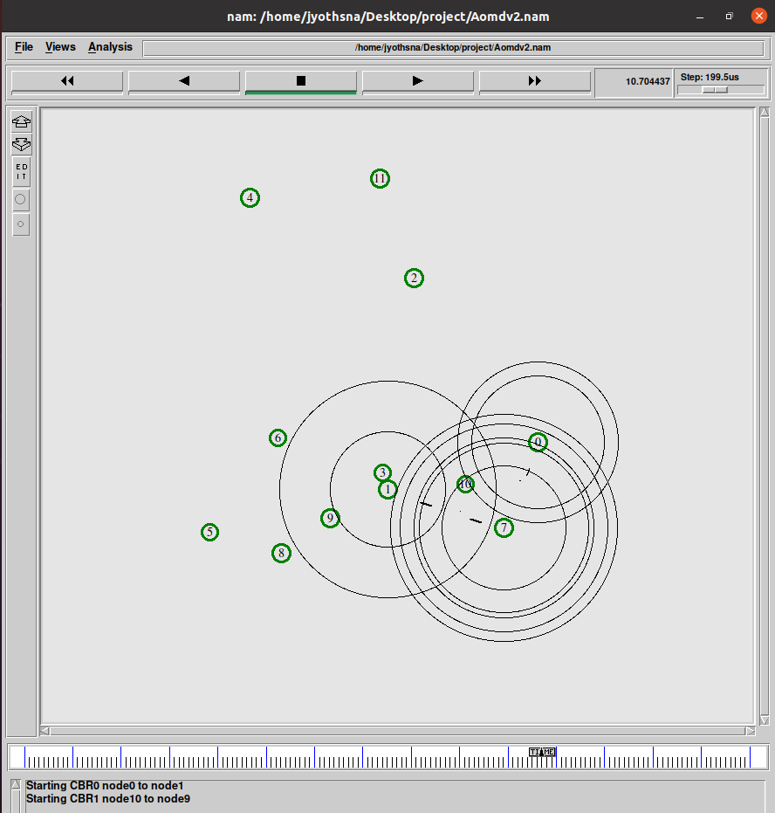

Fig. Simulation Screen depicting the transmission of data packets

The above figure depicts the Simulation screen at intermediate time. We can see that source node 0 and destination node 1 are not in communication range of each other. So they are using intermediate node 7 to reach the destination node.

**Nam window for DSR protocol with CBR traffic:**

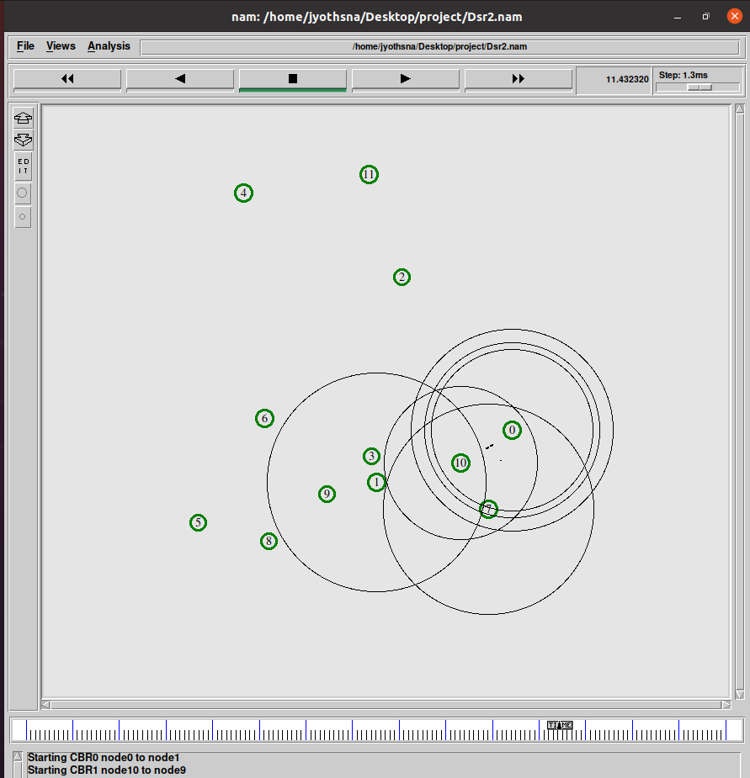

Fig. Simulation screen at intermediate time transmission of packets between node 0 to node 1 via node 10

**Nam window for DSDV protocol with CBR traffic:**

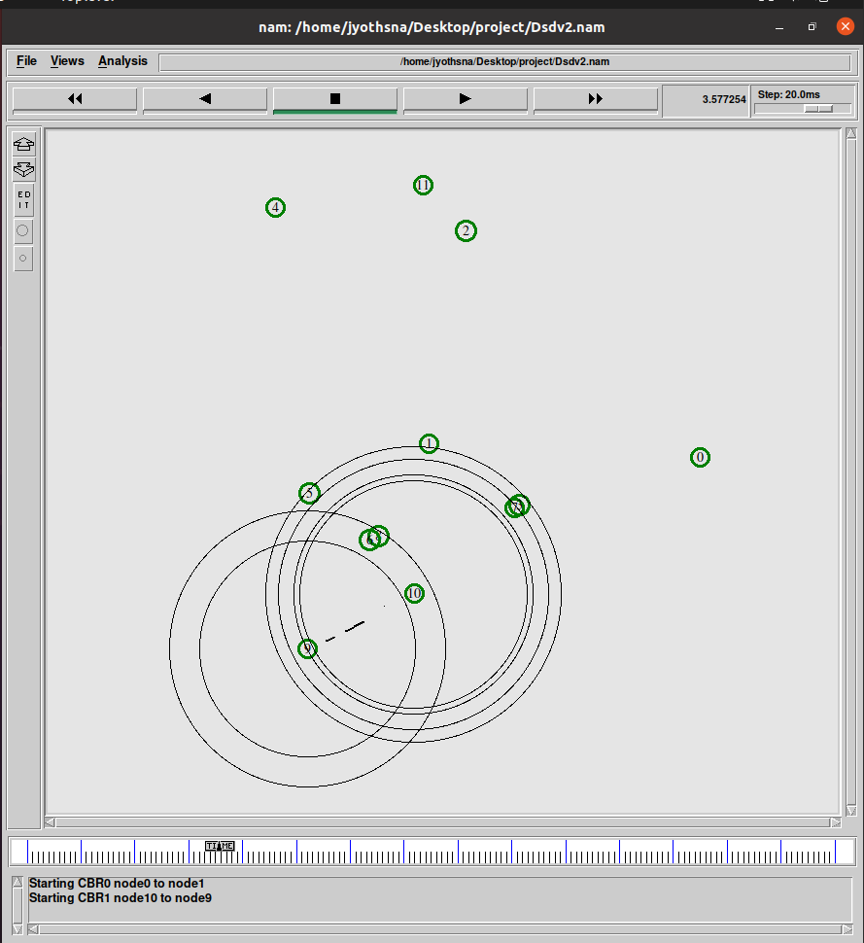

Fig. Simulation screen at intermediate time transmission of packets between node 10 to node 9

**Wireless Dynamic Topology for TCP Variants with CBR traffic:**

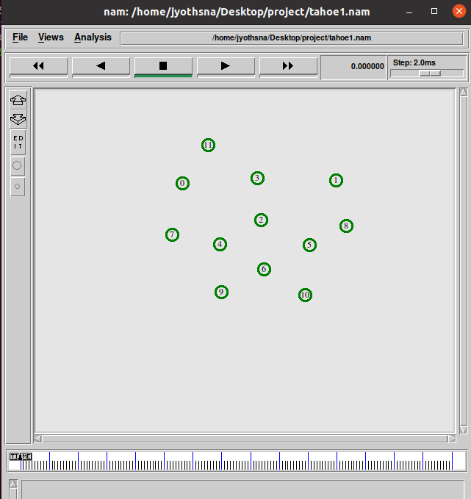

**Nam window for Tahoe variant with CBR traffic:**

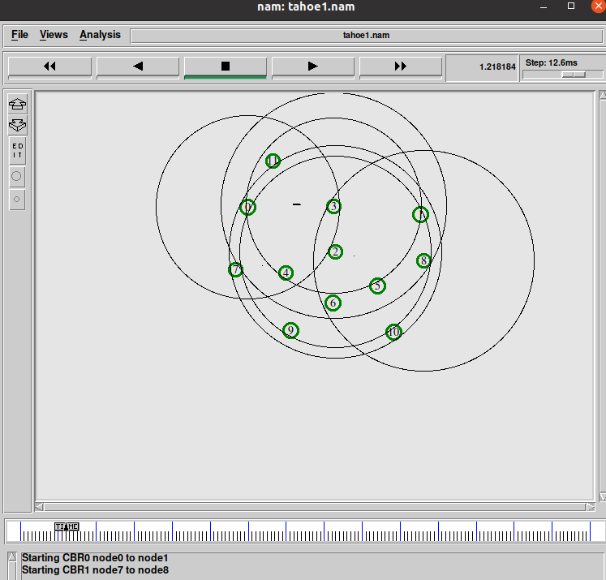

Fig. Simulation at intermediate time transmission of packets between node0 to node 1 via node 3

**Nam window for Reno variant with CBR traffic:**

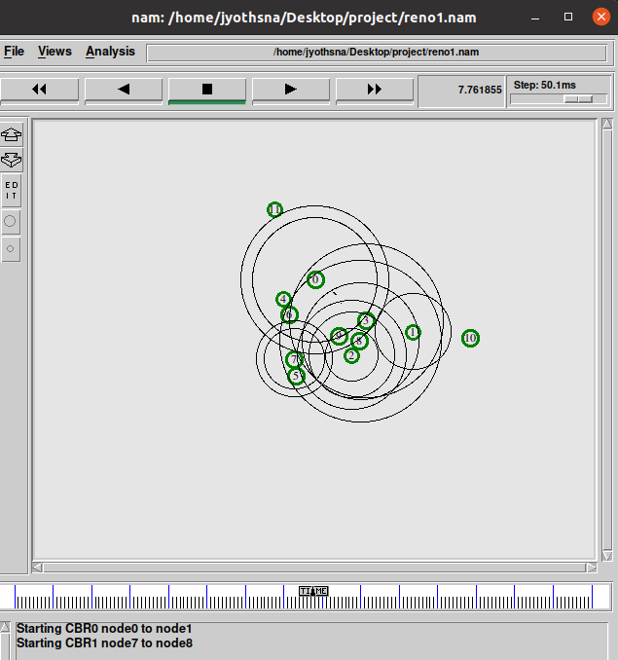

Fig. Simulation at intermediate time transmission of packets between node0 to node 1 via node 3

**Nam window for New Reno variant with CBR traffic:**

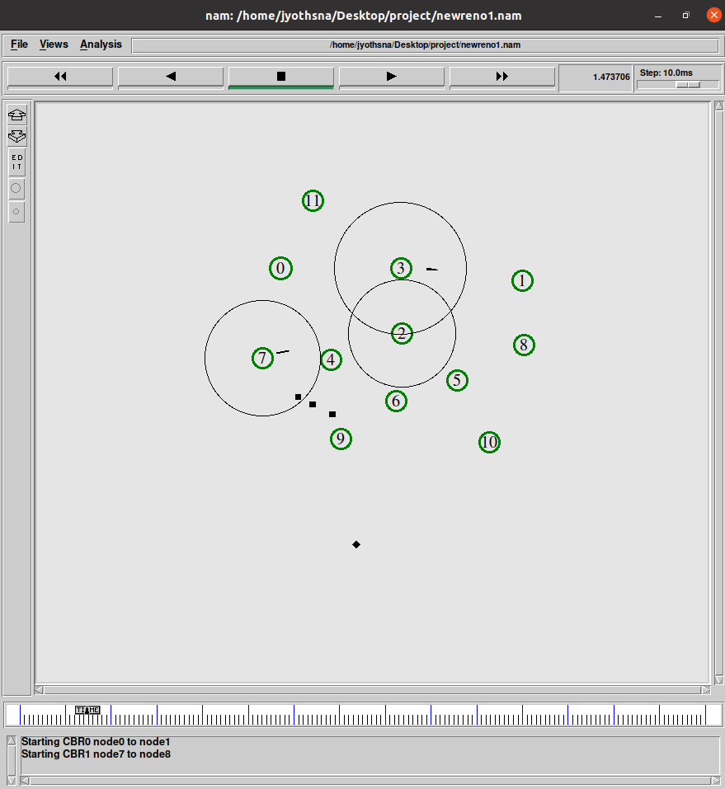

Fig. Simulation at intermediate time transmission of packets between node 7 to node8 via node 2

**Nam window for Sack variant with CBR traffic:**

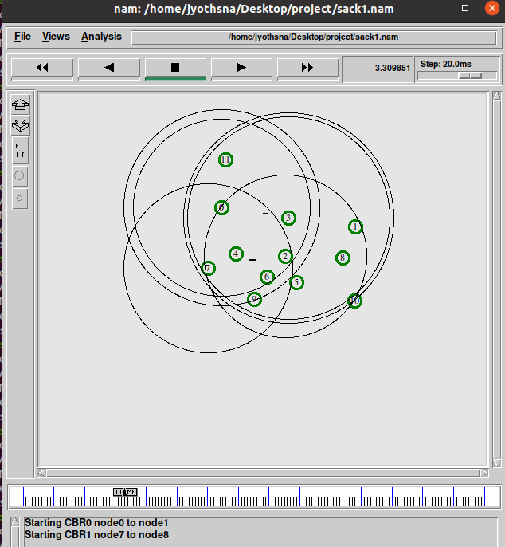

Fig. Simulation at intermediate time transmission of packets between node 0 to node1 via node 3

**Nam window for Vegas variant with CBR traffic:**

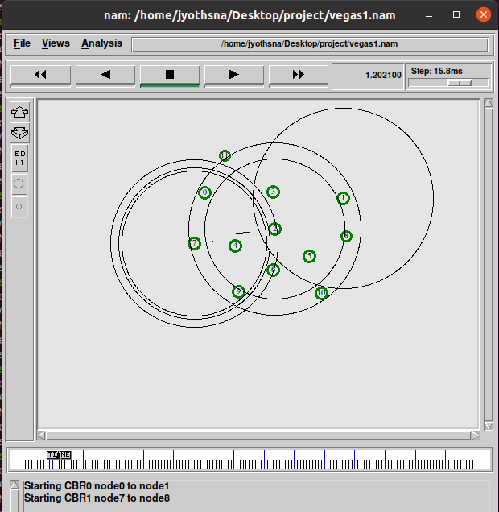

Fig. Simulation at intermediate time transmission of packets between node7 to node 8 via node 2

**Wireless Dynamic Topology for FTP Application:**

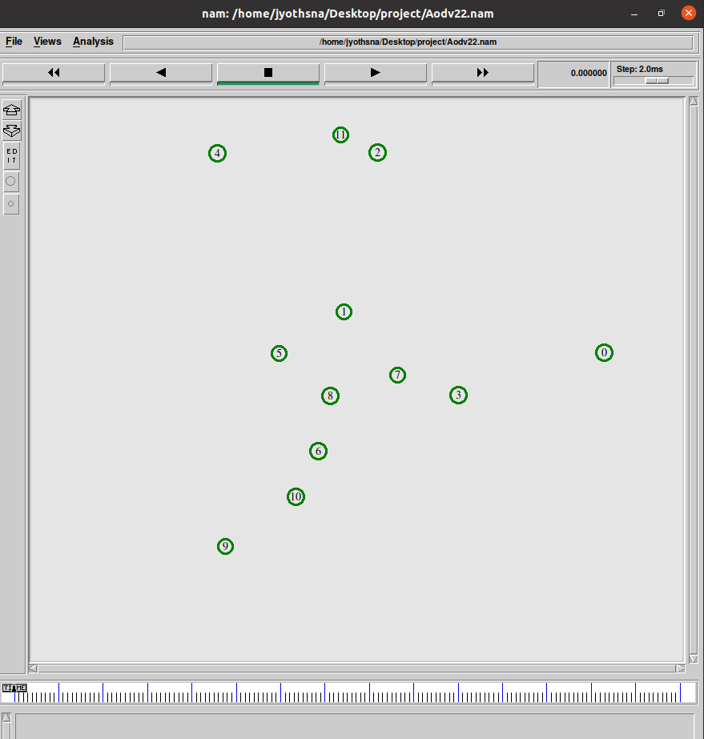

**Nam window for AODV protocol with FTP Application:**

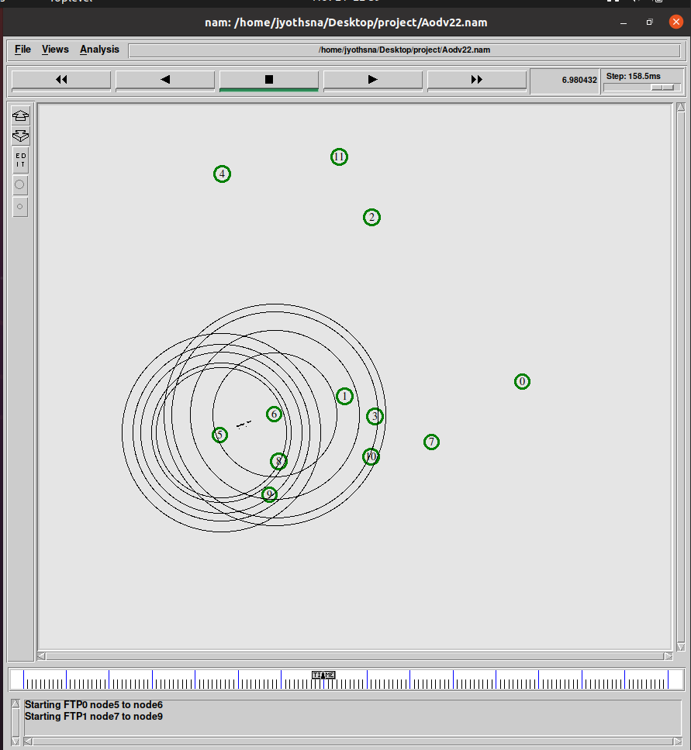

Fig. Simulation screen at intermediate time transmission of packets between node 5 to node 6

**Nam window for AOMDV protocol with FTP Application:**

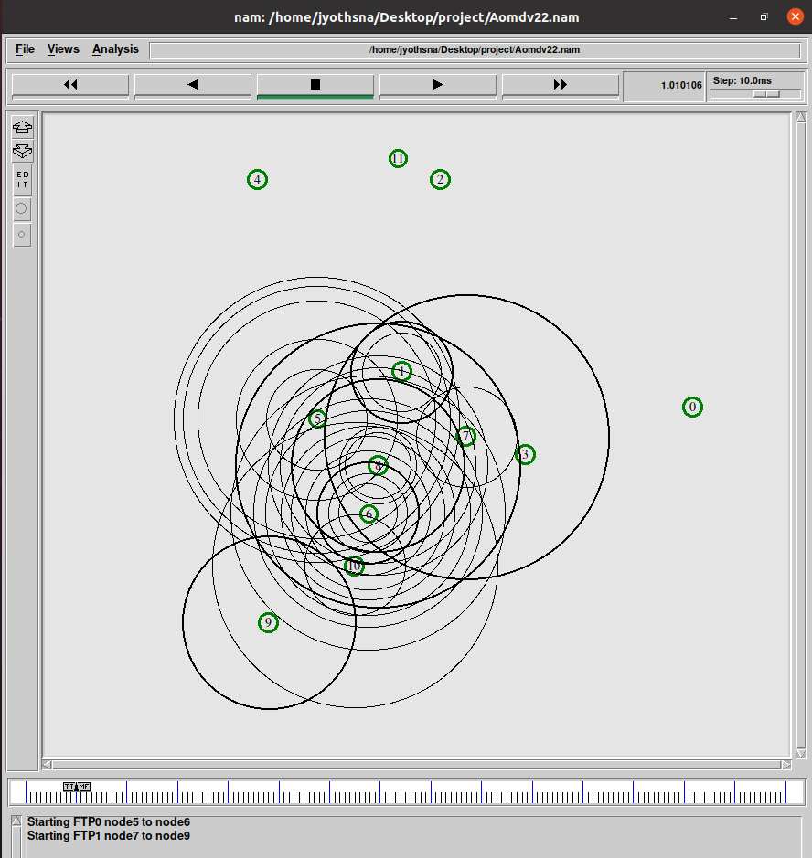

Fig. Simulation screen at intermediate time

**Nam window for DSR protocol with FTP Application:**

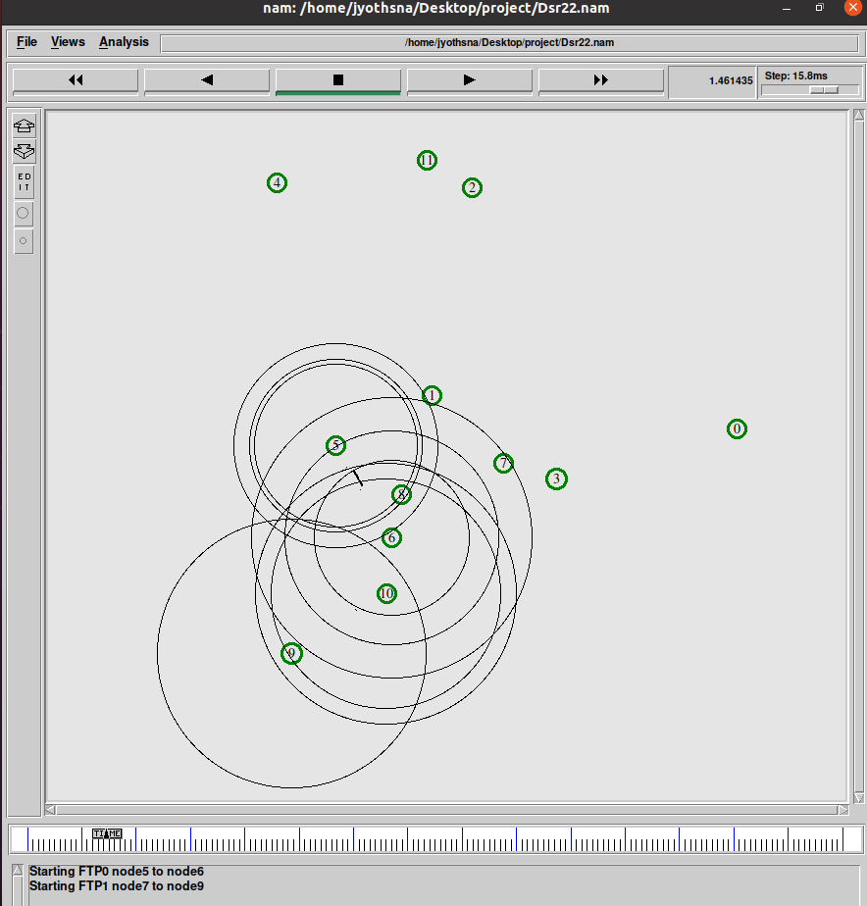

Fig. Simulation screen at intermediate time

**Nam window for DSDV protocol with FTP Application:**

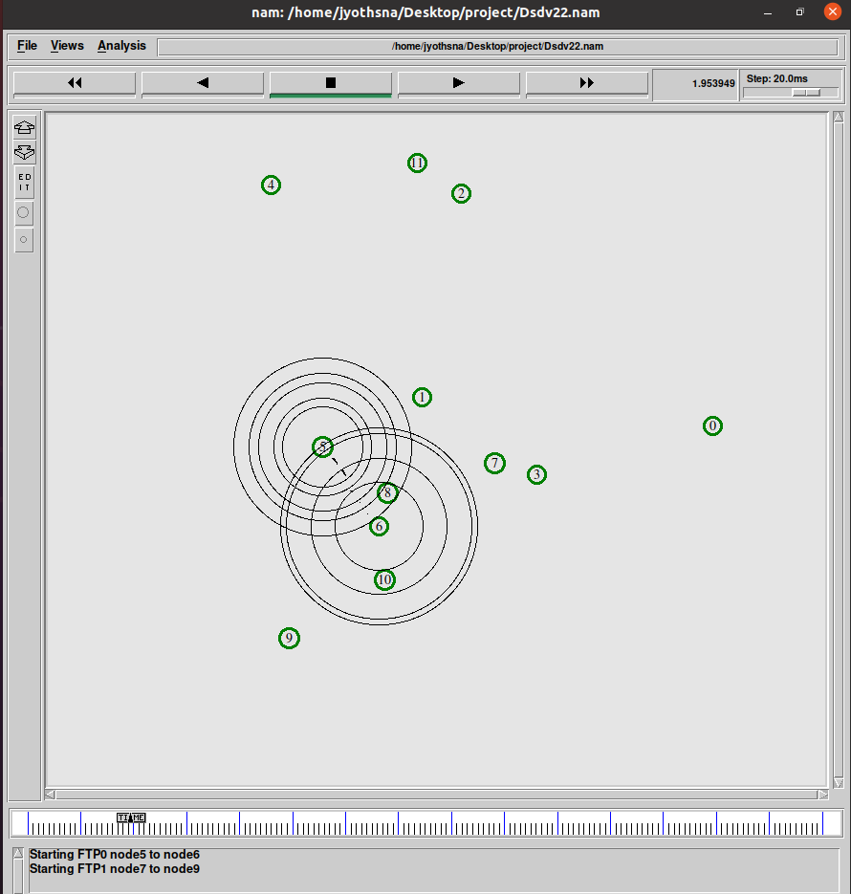

Fig. Simulation screen at intermediate time

**Wireless Dynamic Topology for TCP Variants with FTP Application:**

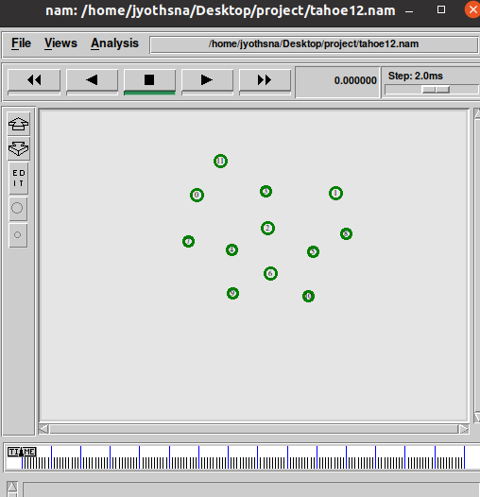

**Nam window for Tahoe variant with FTP Application:**

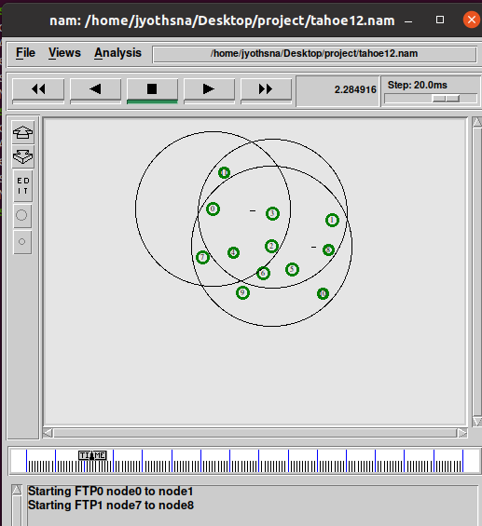

Fig. Simulation screen at intermediate time transmission of packets between node 0 to node 1 via 3

**Nam window for Reno variant with FTP Application:**

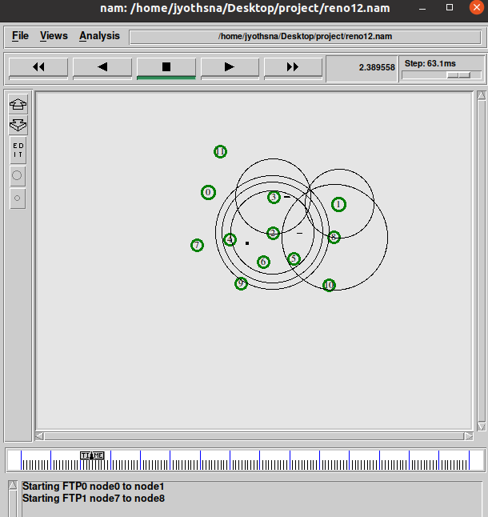

Fig. Simulation screen at intermediate time transmission of packets between node 0 to node 1

**Nam window for New Reno variant with FTP Application:**

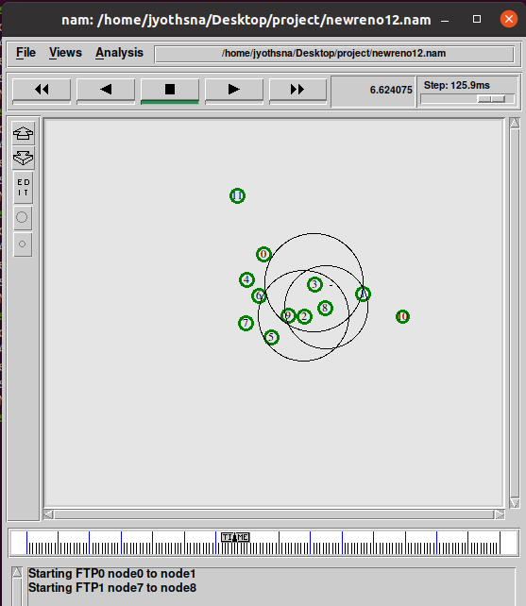

Fig. Simulation screen at intermediate time transmission of packets between node 0 to node 1

**Nam window for Sack variant with FTP Application:**

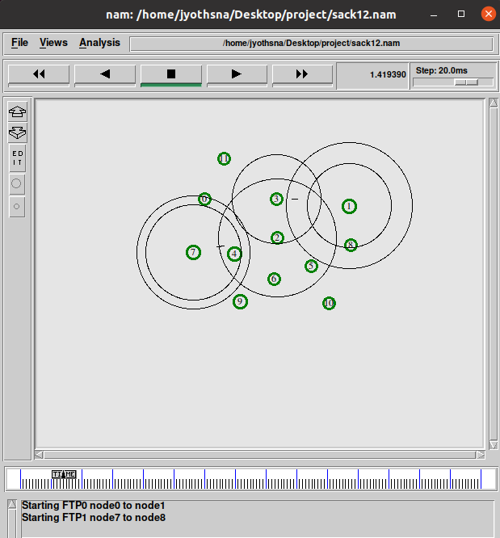

Fig. Simulation screen at intermediate time transmission of packets between node 0 to node 1

**Nam window for Vegas variant with FTP Application:**

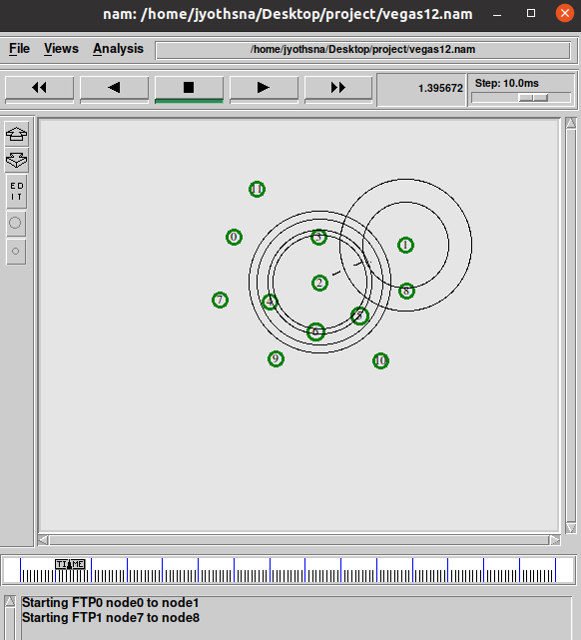

Fig. Simulation screen at intermediate time transmission of packets between node 0 to node 1

**CHAPTER 6**

# PERFORMANCE EVALUATION

The proposed Comparative Analysis of TCP Variants for Audio Transmission and File Transmission Over Multi-Hop Mobile Ad Hoc Networks is simulated is NS2 simulator.

In this we have analyzed two scenarios, in one scenario we have studied three parameters Average throughput, Instant Throughput, Average end to end delay, Residual Energy and Packet Delivery Ratio (PDR) and in the second scenario we have analyzed the same parameters by TCP Variants.

# SCENARIO 1.1: Routing protocols with CBR Traffic:

The following are the simulation parameters for the first scenario:

Table-1.1. Simulation Parameters for Routing Protocols for CBR Traffic

| PARAMETER | VALUE |
| --- | --- |
| Simulation Environment | 1000 x 1000 sq.mt |
| Channel Type | Wireless |
| Radio-propagation model | TwoRayGround |
| Simulation time | 15 sec |
| MAC Protocol | IEEE 802.11 |
| Network Interface type | Wireless physical |
| Interface Queue Type | PriQueue |
| Antenna Model | OmniAntenna |
| Initial Energy | 50 J |
| Maximum speed | 30m/sec |

Average Throughput for AODV, AOMDV, DSR, DSDV for CBR Traffic

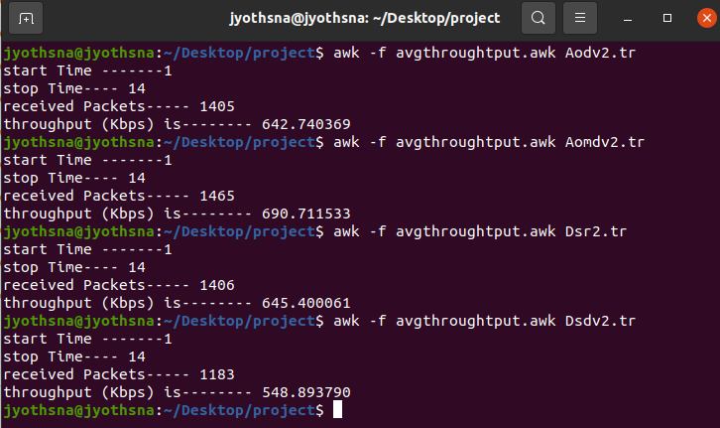

Average End-to-End delay for AODV, AOMDV, DSR, DSDV for CBR Traffic

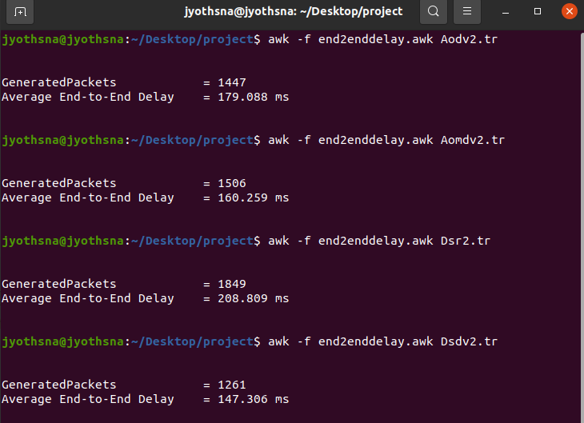

Packet delivery ratio for AODV, AOMDV, DSR, DSDV for CBR Traffic

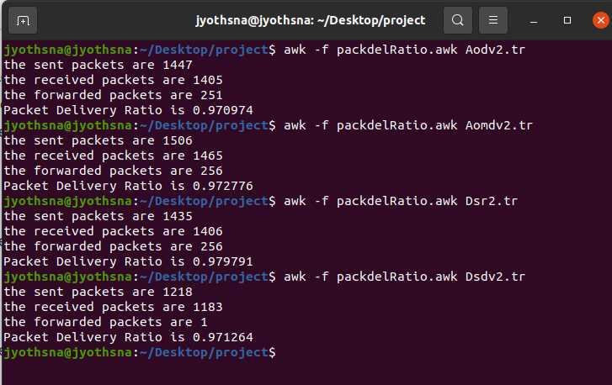

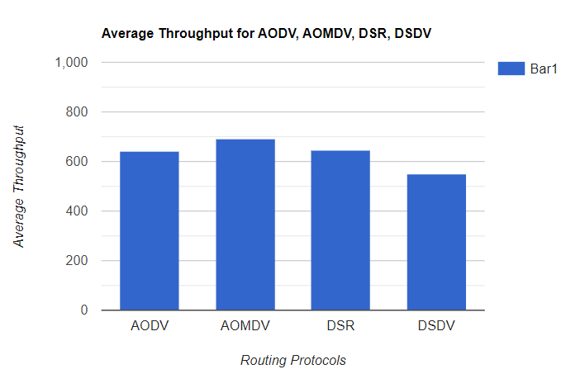

Fig-10. Average throughput Vs Routing Protocols

In Figure-10, The MANET Routing Protocols are shown on the x-axis, while the average throughput is shown on the y-axis (kbps). It illustrates the variation in average throughput of the network with variation in Routing protocols. According to the analysis, it is observed that Average throughput of AOMDV is more than the other routing protocols and DSDV has most negligible average throughput.

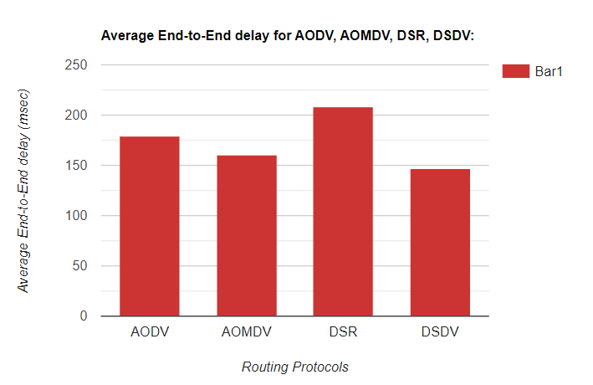

Fig-11. Average end-to-end delay vs Routing Protocols

In Figure-11, x-axis indicates the Routing Protocols in MANET and y-axis shows average delay in milliseconds(msec). It depicts the variation in average delay of the network with variation in routing protocols. According to the analysis, it is observed that Average delay is more for DSR when compared to all and AOMDV, DSDV have more minor average delay

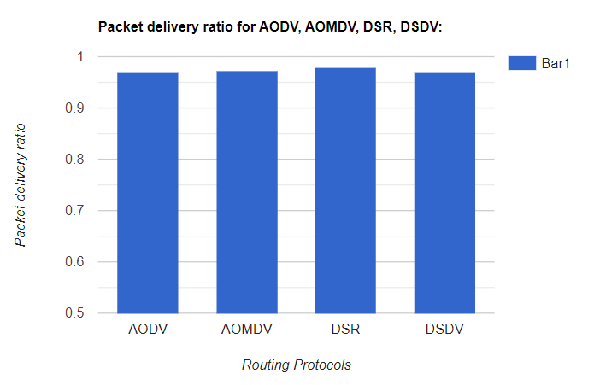

Fig-12: Packet delivery ratio Vs Routing Protocols

In Figure-12, x-axis indicates the Routing Protocols in MANET and y-axis indicates PDR. It illustrates the variation in PDR of the network with variation in Routing Protocols in MANET. According to the analysis, it is observed that PDR is almost equal for all protocols but more for DSR when compared with others

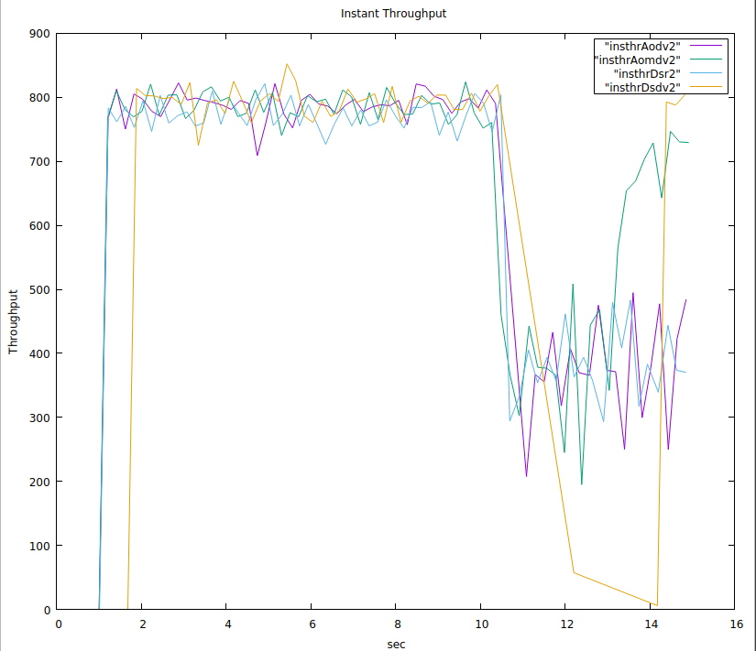

Fig-13: Throughput Vs Time

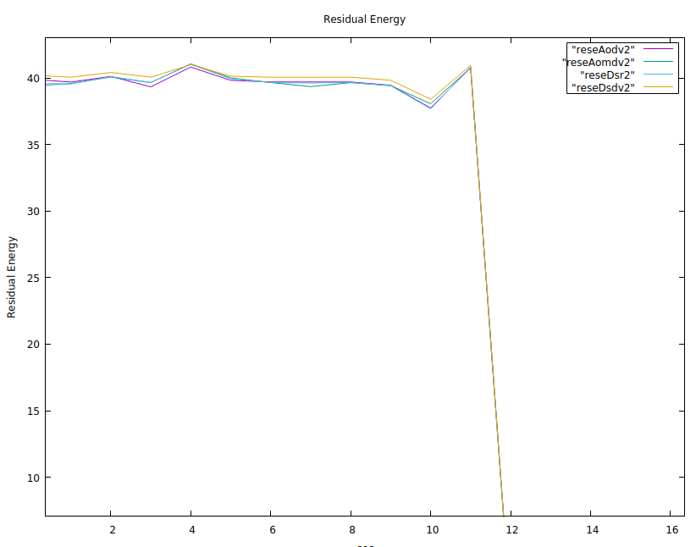

Fig-14: Residual Energy Vs nodes

So, in Scenario 1.1 AOMDV routing protocol seems to be perform well in all scenarios with more average throughput, Packet delivery Ratio and more minor end-to-end delay when compared with others. Now, AOMDV routing protocol is suitable for Scenario 1.2 that is comparing AOMDV with all TCP Variants.

# SCENARIO 1.2: Comparing TCP variants with CBR Traffic:

The simulation parameters for the first scenario are as follows:

From Scenario 1.1 we got to know that AOMDV performs well than other routing protocols for the given topology. So, Taking the AOMDV Routing protocol and comparing the TCP variants with CBR traffic is done here

Table-1.2. Simulation Parameters for TCP variants with CBR Traffic

| PARAMETER | VALUE |
| --- | --- |
| Simulation Environment | 723 x 794 sq.mt |
| Channel Type | Wireless |
| Radio-propagation model | TwoRayGround |
| Simulation time | 15 sec |
| MAC Protocol | IEEE 802.11 |
| Network Interface type | Wireless physical |
| Interface Queue Type | PriQueue |
| Antenna Model | OmniAntenna |
| Initial Energy | 50 J |
| Maximum speed | 30m/sec |

Average Throughput for Tahoe, Reno, New Reno, Sack, Vegas for CBR Traffic

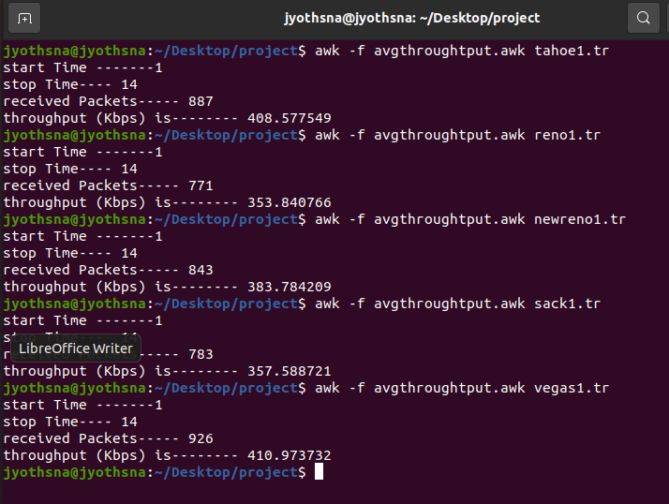

Average End-to-End delay for Tahoe, Reno, New Reno, Sack, Vegas for CBR Traffic

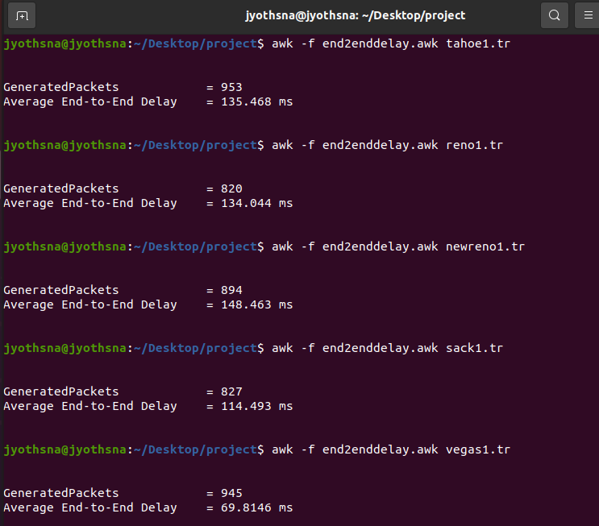

Packet delivery ratio for Tahoe, Reno, New Reno, Sack, Vegas for CBR Traffic

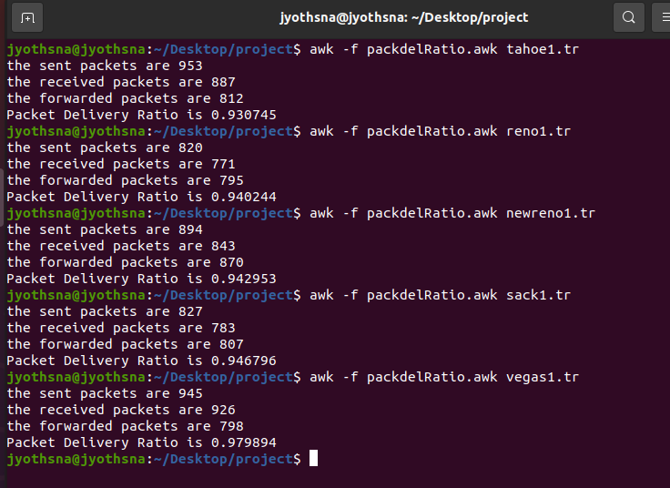

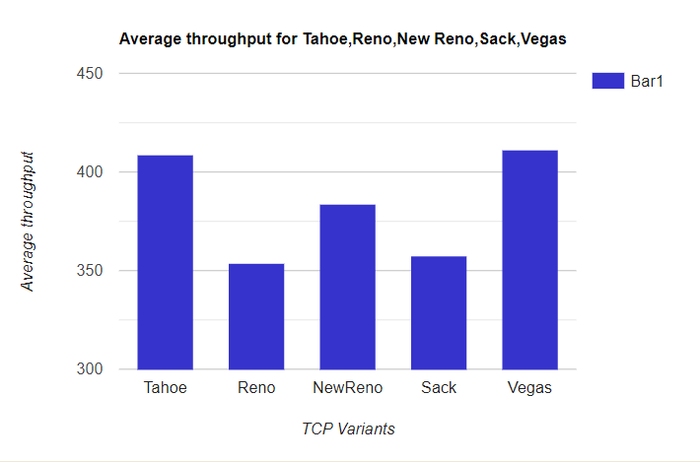

Fig-15. Average throughput Vs TCP Variants

In Figure-15, x-axis indicates the TCP Variants and y-axis shows average throughput in (kbps). It illustrates the variation in average throughput of the network with variation in TCP Variants. According to the analysis, it is observed that Average throughput of Vegas is more than the other Variants and Reno has most negligible average throughput.

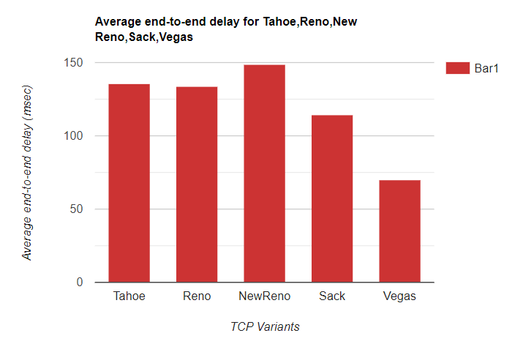

Fig-16. Average end-to-end delay vs TCP Variants

In Figure-16, x-axis indicates the TCP Variants and y-axis shows average delay in milliseconds(msec). It depicts the variation in average delay of the network with variation in TCP Variants. According to the analysis, it is observed that Average delay is more for New reno when compared to all and Vegas have more minor average delay.

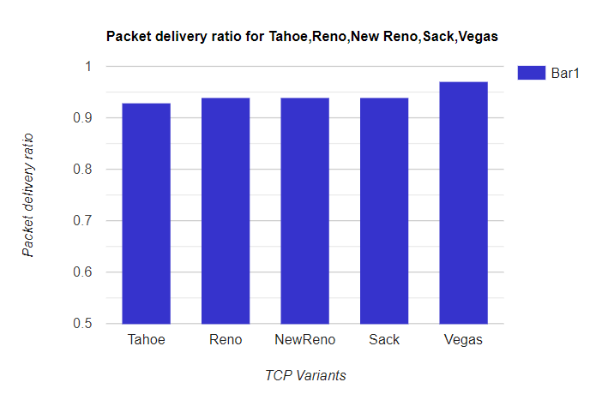

Fig-17: Packet delivery ratio Vs TCP Variants

In Figure-17, x-axis indicates the TCP Variants and y-axis shows PDR. It illustrates the variation in PDR of the network with variation in TCP Variants. According to the analysis, it is observed that PDR is almost equal for all protocols but more for Vegas when compared with others

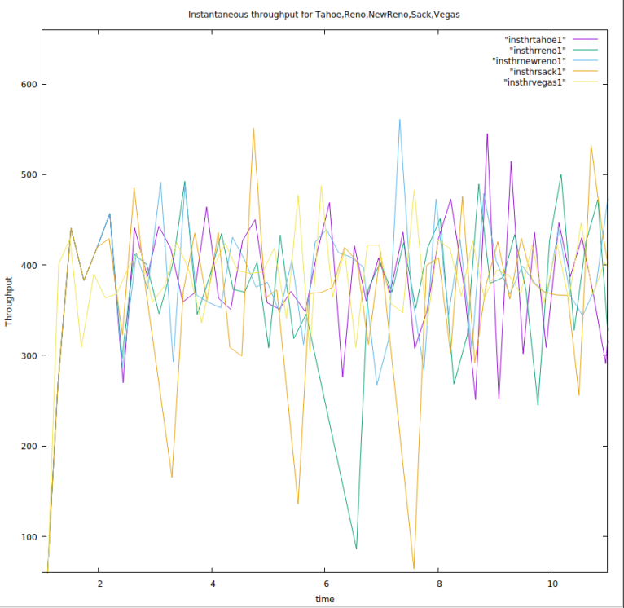

Fig-18 Instantaneous Throughput vs time

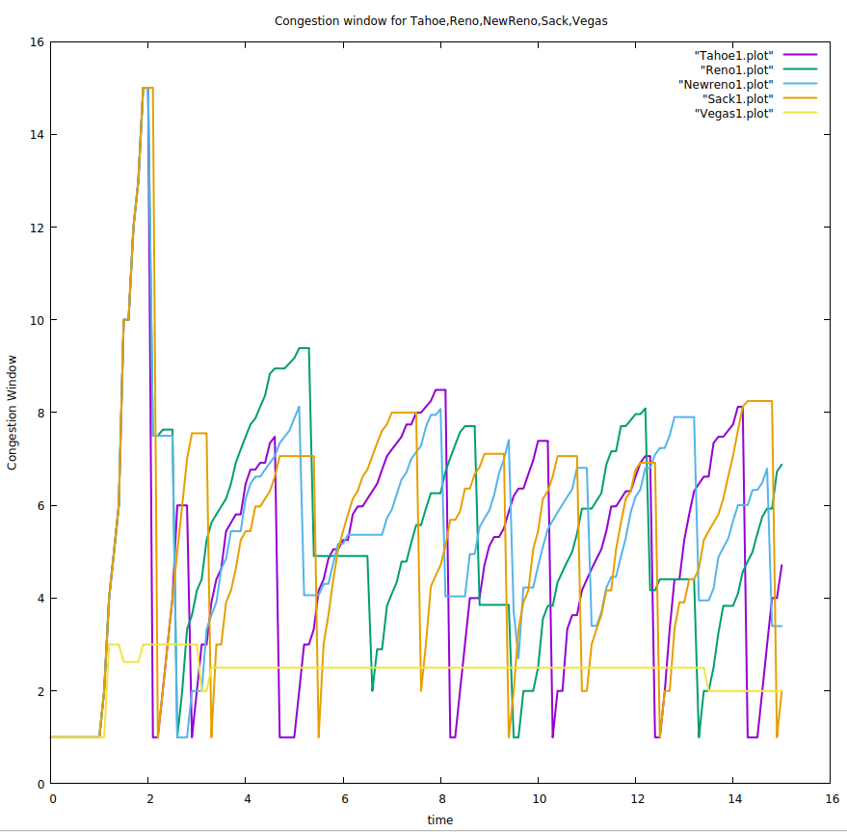

Fig-18: Congestion window for Tahoe, Reno, New Reno, Sack, Vega

# SCENARIO-2.1: Routing protocols with FTP Application:

The simulation parameters for the second scenario are as follows:

Simulation has been carried out using NS2 simulator with the following parameters

Table-2.1. Simulation Parameters for Routing Protocols for FTP Application

| PARAMETER | VALUE |
| --- | --- |
| Simulation Environment | 1000 x 1000 sq.mt |
| Channel Type | Wireless |
| Radio-propagation model | TwoRayGround |
| Simulation time | 15 sec |
| MAC Protocol | IEEE 802.11 |
| Network Interface type | Wireless physical |
| Interface Queue Type | PriQueue |
| Antenna Model | OmniAntenna |
| Initial Energy | 50 J |
| Maximum speed | 30m/sec |
| Packet size |  |

Average Throughput for AODV, AOMDV, DSR, DSDV for FTP Application

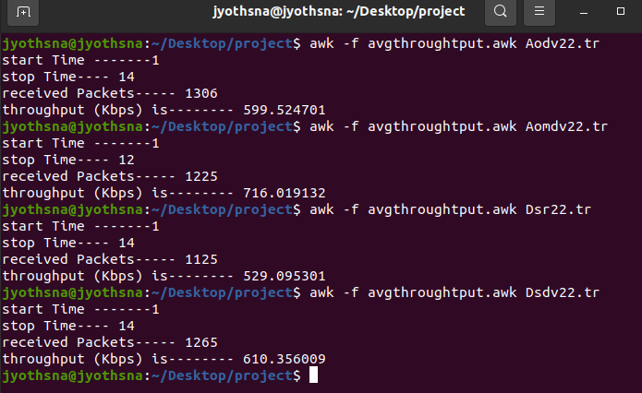

Average End-to-End delay for AODV, AOMDV, DSR, DSDV for FTP Application

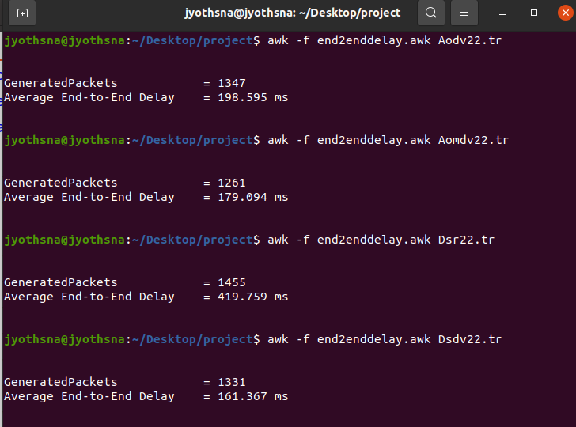

Packet delivery ratio for AODV, AOMDV, DSR, DSDV for FTP Application

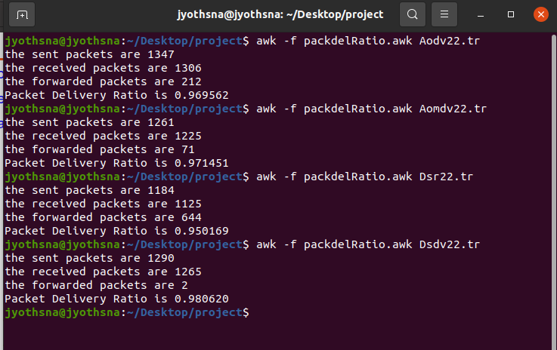

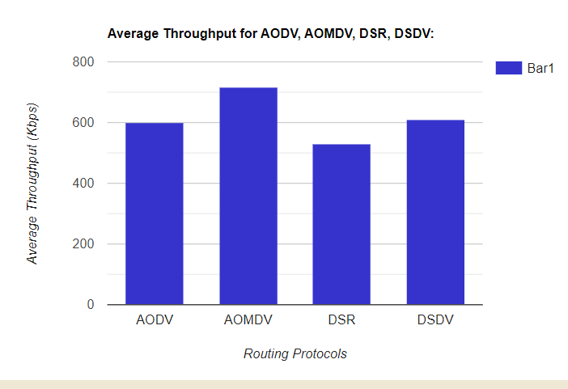

Fig-19. Average throughput Vs Routing Protocols

In Figure-19, x-axis indicates the Routing Protocols in MANET and y-axis shows average throughput in (kbps). It illustrates the variation in average throughput of the network with variation in Routing protocols. According to the analysis, it is observed that Average throughput of AOMDV is more than the other routing protocols and DSR has most negligible average throughput.

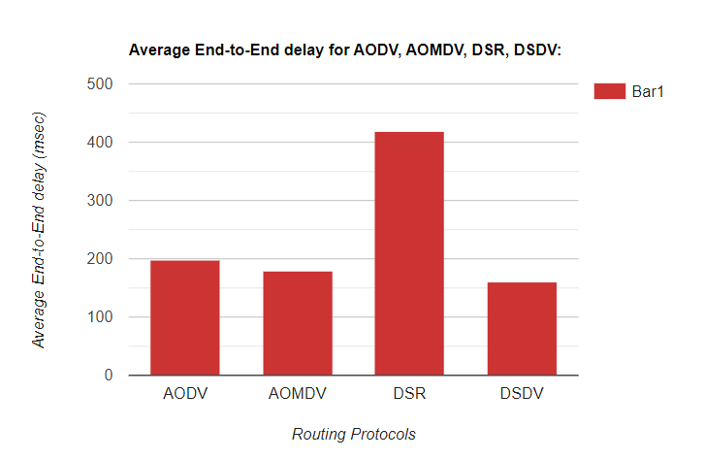

Fig-20. Average end-to-end delay vs Routing Protocols

In Figure-20, x-axis indicates the Routing Protocols in MANET and y-axis shows average delay in milliseconds(msec). It depicts the variation in average delay of the network with variation routing protocols. According to the analysis, it is observed that Average delay for DSR is more when compared with others and AOMDV, DSDV have less end to end delay.

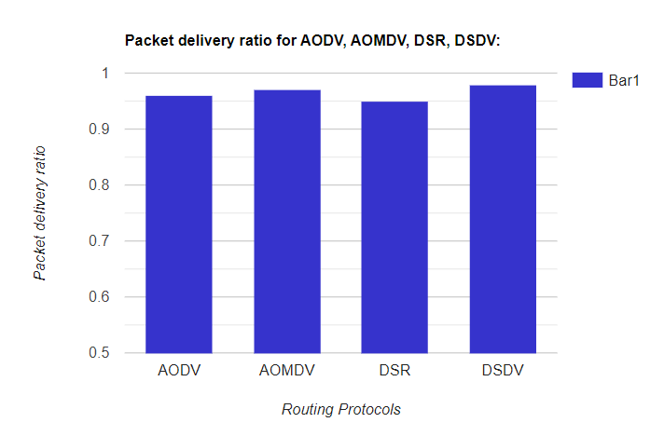

Fig-21: Packet delivery ratio Vs Routing Protocols

The x-axis in Figure-21 represents MANET Routing Protocols, whereas the y-axis represents PDR. It shows how the network's PDR varies depending on the routing protocols used in MANET. According to the findings, PDR is nearly comparable for all methods, but is higher for DSDV when compared to others.

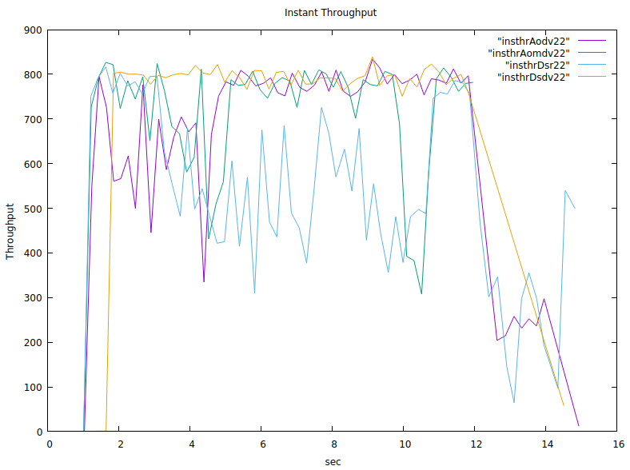

Fig-22: Throughput Vs Time

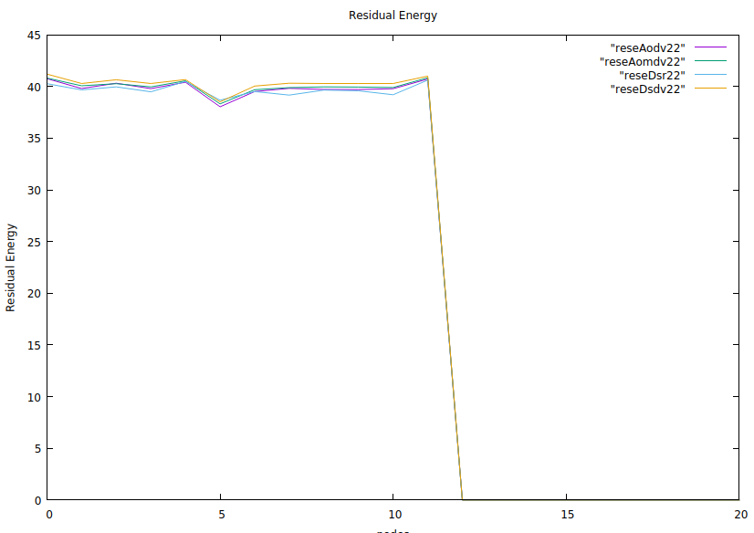

Fig-23: Residual Energy Vs nodes

So, in Scenario 2.1 AOMDV routing protocol seems to be perform well in all scenarios with more average throughput, Packet delivery Ratio and more minor end-to-end delay when compared with others. Now, AOMDV routing protocol is suitable for Scenario 2.2 that is comparing AOMDV with all TCP Variants.

# SCENARIO 2.2: Comparing TCP variants with FTP Application:

The simulation parameters for the second scenario are as follows:

Table-1.2. Simulation Parameters for TCP variants with FTP Application

| PARAMETER | VALUE |
| --- | --- |
| Simulation Environment | 723 x 794 sq.mt |
| Channel Type | Wireless |
| Radio-propagation model | TwoRayGround |
| Simulation time | 15 sec |
| MAC Protocol | IEEE 802.11 |
| Network Interface type | Wireless physical |
| Interface Queue Type | PriQueue |
| Antenna Model | OmniAntenna |
| Initial Energy | 50 J |
| Maximum speed | 30m/sec |

Average Throughput for Tahoe, Reno, New Reno, Sack, Vegas for FTP application

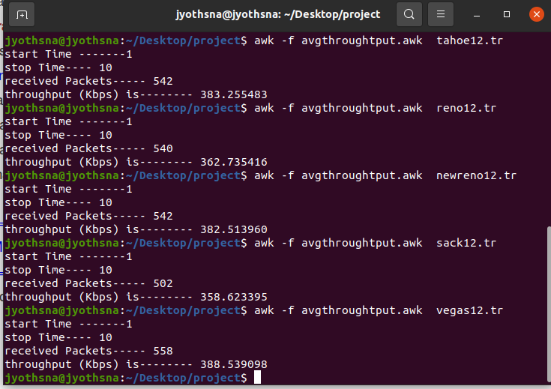

Average End-to-End delay for Tahoe, Reno, New Reno, Sack, Vegas for FTP application

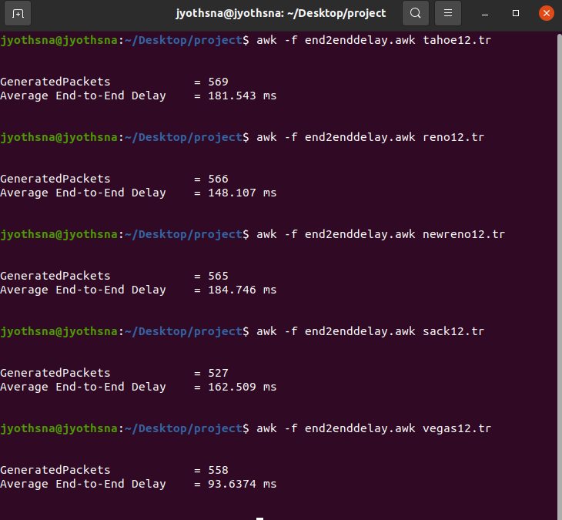

Packet delivery ratio for Tahoe, Reno, New Reno, Sack, Vegas for FTP application

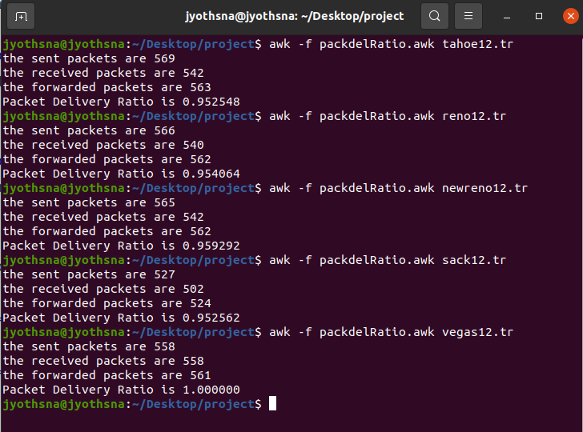

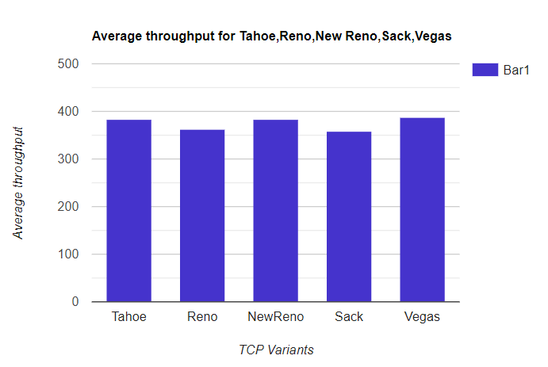

Fig-24. Average throughput Vs TCP Variants

In Figure-24, x-axis indicates the TCP Variants and y-axis shows average throughput in (kbps). It illustrates the variation in average throughput of the network with variation in TCP Variants. According to the analysis, it is observed that Average throughput of Vegas is more than the other TCP Variants.

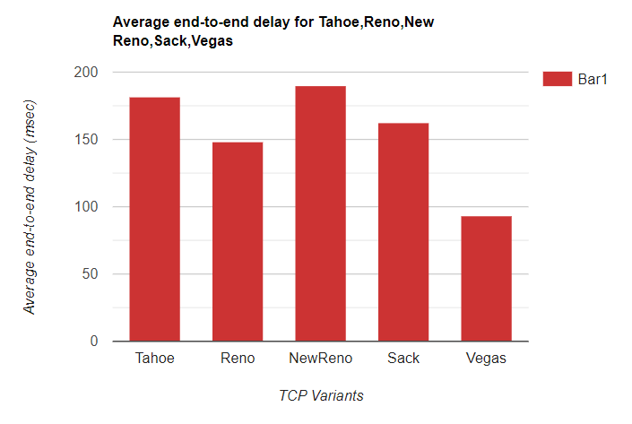

Fig-25. Average end-to-end delay vs TCP Variants

In Figure-25, x-axis indicates the TCP Variants and y-axis shows average delay in milliseconds(msec). It depicts the variation in average delay of the network with variation in TCP Variants. According to the analysis, it is observed that Average delay is more for New Reno when compared to all and Vegas have more minor average delay.

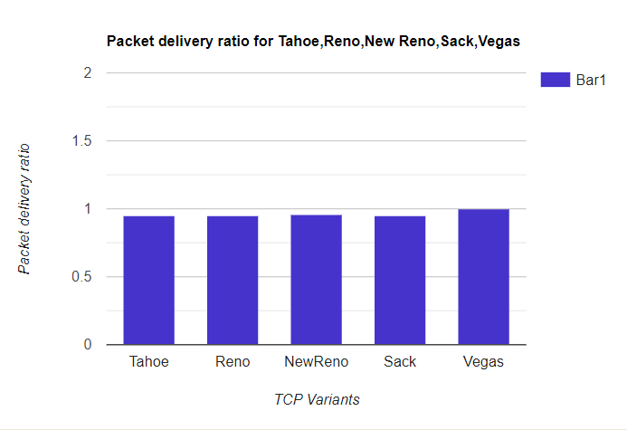

Fig-26: Packet delivery ratio Vs TCP Variants

In Figure-26, x-axis indicates the TCP Variants and y-axis shows PDR. It illustrates the variation in PDR of the network with variation in TCP Variants. According to the analysis, it is observed that PDR is almost equal for all protocols but more for Vegas when compared with others.

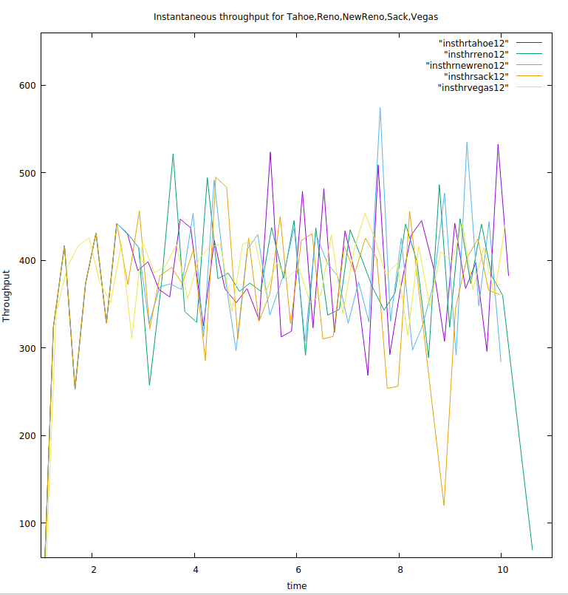

Fig-27 Instantaneous Throughput vs time

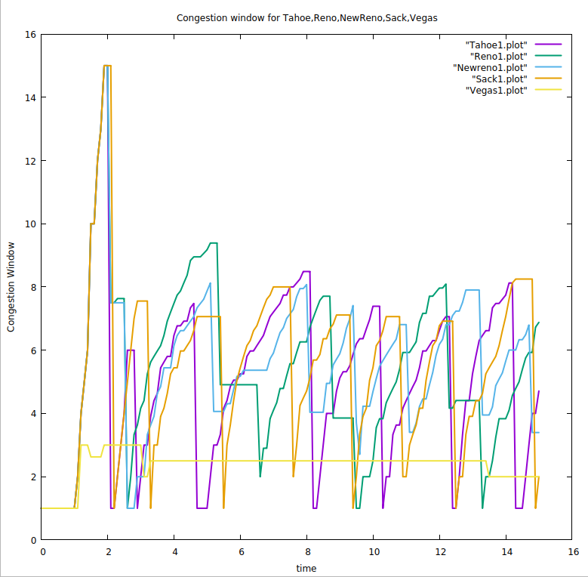

Fig-28 Congestion window for Tahoe, Reno, Newreno, Sack, Vegas

**CHAPTER 7**

# CONCLUSION

A comparative analysis is performed for choosing a suitable routing protocol which is also used in the TCP protocol's performance analysis. As we choose AODV, AOMDV, DSR, DSDV and are well-known ad-hoc routing protocols AOMDV gives maximum throughput of 690 Kbps for Audio transmission and 716 Kbps for File transmission. Average end-to-end delay for AOMDV is more minor when compared with all protocols, by analyzing all metrics AOMDV is chosen to be the proper protocol. The AOMDV routing protocol was used to compare five TCP variants: TCP Reno, TCP New Reno, TCP SACK, TCP Vegas, and TCP Tahoe. When compared to other variations, TCP Vegas has a good packet delivery ratio and less minor delay, implying that Vegas has good throughput, less uncertainty, and more PDR with good congestion management. As a result, TCP Vegas works better with the AOMDV protocol.

**CHAPTER 8**

# REFERENCES

(Adel ,2010) Adel, S. A., & Tijare, P. A. (2010). Performance Comparison of AODV DSDV OLSR and DSR Routing Protocols in MANET. *International Journal of Information Technology and Knowledge Management*, *2*(2), 545-548.

(Ahuja ,2000) Ahuja, A., Agarwal, S., Singh, J. P., & Shorey, R. (2000, May). Performance of TCP over different routing protocols in mobile ad-hoc networks. In *VTC2000-Spring. 2000 IEEE 51st Vehicular Technology Conference Proceedings (Cat. No. 00CH37026)* (Vol. 3, pp. 2315-2319). IEEE.

(Banerjee ,2020) Banerjee, S., Ghosh, A., Mahapatra, S., & Karmakar, R. (2020, September). Performance Survey of MANET Routing Protocols with TCP Congestion Control Algorithms. In *2020 IEEE 1st International Conference for Convergence in Engineering (ICCE)* (pp. 433-438). IEEE.

(Leenas ,2021) Leenas, T., & Shriparen, S. (2021, August). Comparative analysis of Proactive, Reactive, and Hybrid Routing Protocols in Mobile Ad Hoc Networks. In *2021 10th International Conference on Information and Automation for Sustainability (ICIAfS)* (pp. 36-41). IEEE.

(Molia ,2018) Molia, H. K., & Kothari, A. D. (2018). TCP variants for mobile adhoc networks: Challenges and solutions. *Wireless Personal Communications*, *100*(4), 1791-1836.

(Nigar, 2018) Nigar, N., & Azim, M. A. (2018). Fairness comparison of TCP variants over proactive and reactive routing protocol in MANET. *International Journal of Electrical and Computer Engineering*, *8*(4), 2199.

(Senthamilselvi,2015) Senthamilselvi, M., & Muruganandam, A. (2015). Performance evaluation of routing protocols by Transmission control protocol variants in mobile ad-hoc networks. *International Journal of Computer Science and Mobile Computing*, *4*(2), 346-358.

(Shenoy, 2019) Shenoy, S. U., Kumari, S., & Shenoy, U. K. K. (2019).Comparative Analysis of TCP Variants for Video Transmission Over Multi-hop Mobile Ad Hoc Networks. In International Conference on Computer Networks and Communication Technologies (pp. 371-381). Springer, Singapore.

(Singh, 2021) Singh, R., Singh, N., & Dinker, A. G. (2021). Performance Analysis of TCP Variants using AODV and DSDV Routing Protocols in MANETs. Recent Advances in CS and Communications (Formerly: Recent Patents on Computer Science), 14(2), 448-455.

(Singh,2020) Singh, R., & Singh, N. (2020, March). Performance Assessment of DSDV and AODV Routing Protocols in Mobile Adhoc Networks with Focus on Node Density and Routing Overhead. In 2020 International Conference on Emerging Smart Computing and Informatics (ESCI) (pp. 298-303). IEEE.

(Thangam ,2009) Thangam, S., & Kirubakaran, E. (2009, April). A survey on cross-layer based approach for improving TCP performance in multi hop mobile adhoc networks. In 2009 International Conference on Education Technology and Computer (pp. 294-298). IEEE.