1. **Landing Screen**

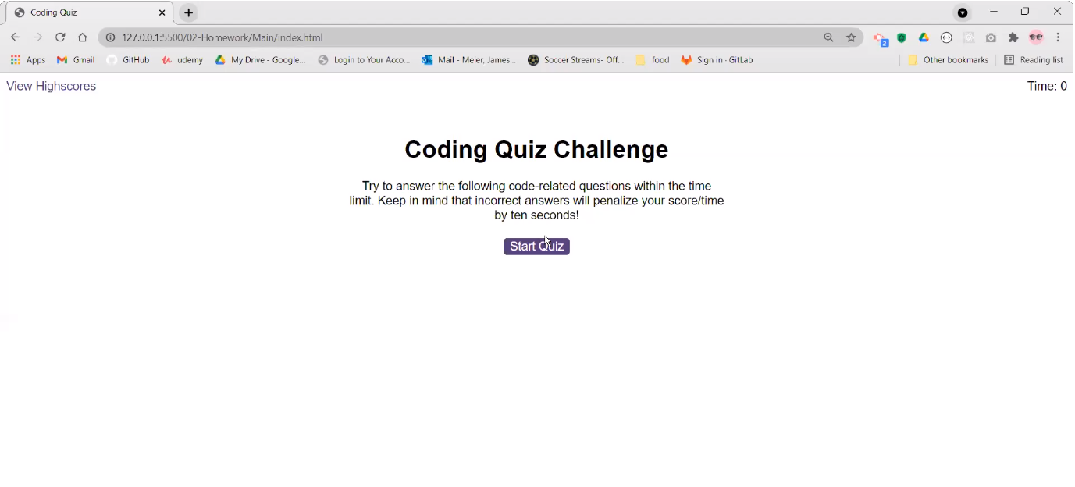

1. **Questions Screen (On click of Start Quiz)**

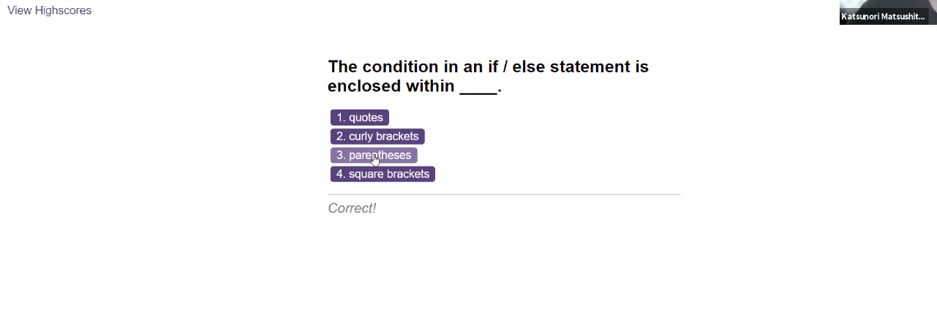

1. **Final Screen**
   1. **On timeout**
   2. **On all questions attempted**



1. **Score Sheet Screen**
   1. On click of Submit from above screen.
   2. On click of View Scores.



1. Go back – will go to Landing Screen
2. Clear Highscores – will clear the local storage scores