Report: Optimising NYC Taxi Operations
Include your visualisations, analysis, results, insights, and outcomes. Explain your methodology and approach to the tasks. Add your conclusions to the sections.

Data Preparation
  - Loading the dataset
    - Sample the data and combine the files
Number of rows in the combined DataFrame: 1911120
DataFrame has been downsampled to 300,000 rows.
Number of rows in the downsampled DataFrame: 300000
DataFrame saved to 'sampled_nyc_taxi_data.csv'

Data Cleaning

Fixing Columns
    - Fix the index
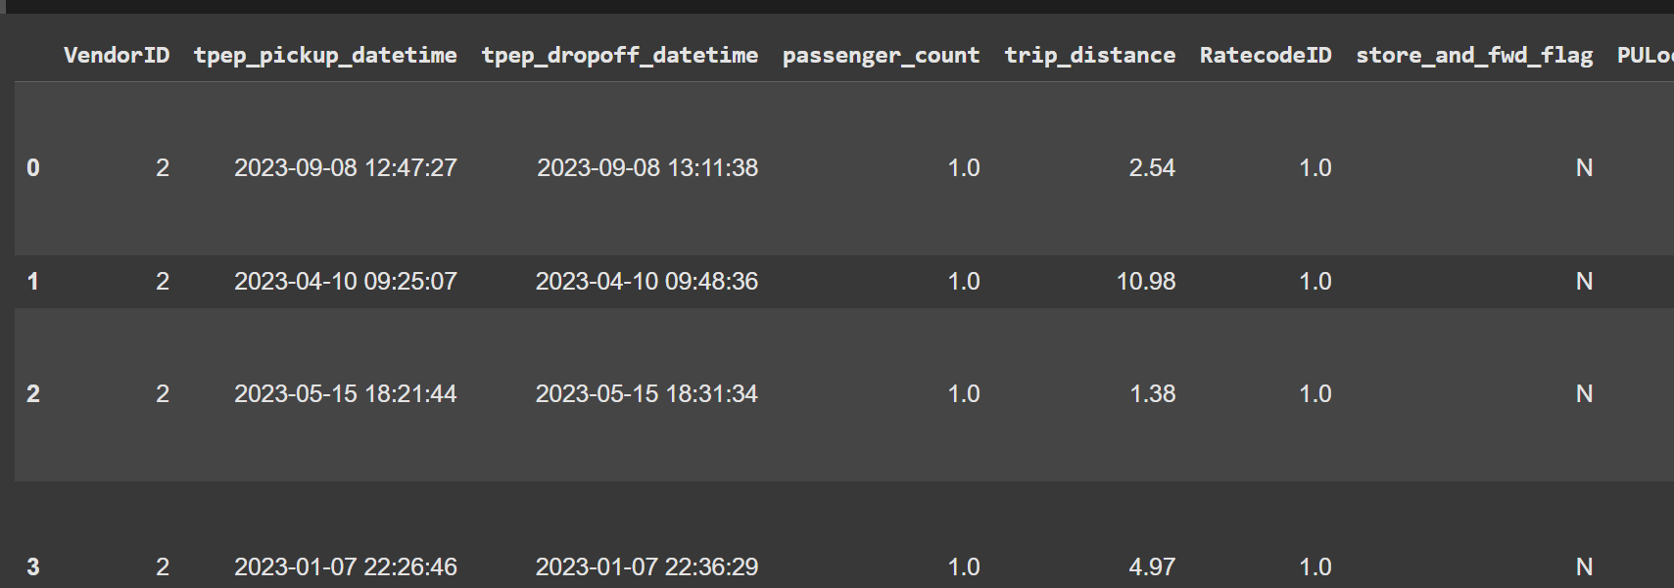
    - Combine the two airport_fee columns
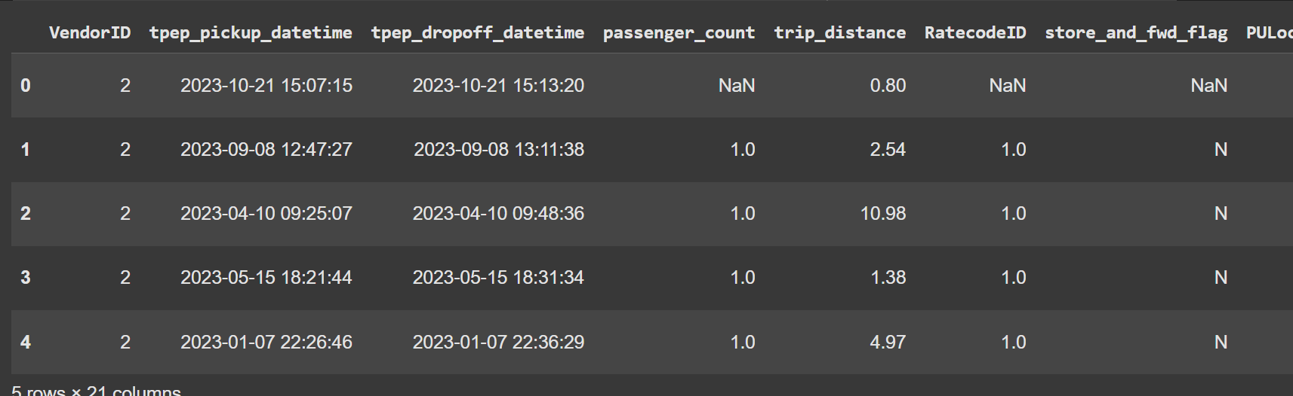

Handling Missing Values
    - Find the proportion of missing values in each column
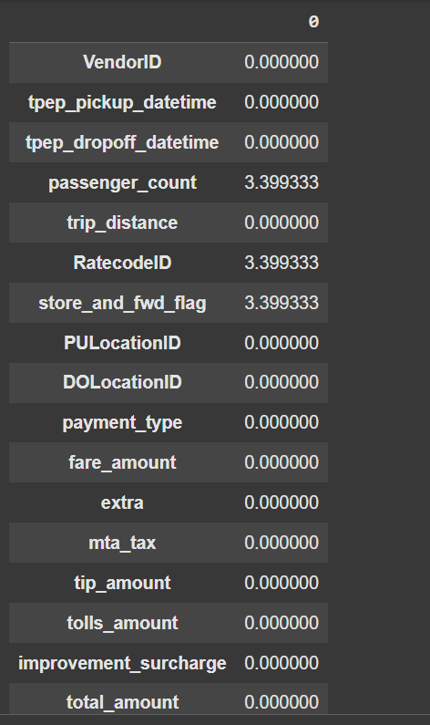
    - Handling missing values in passenger_count
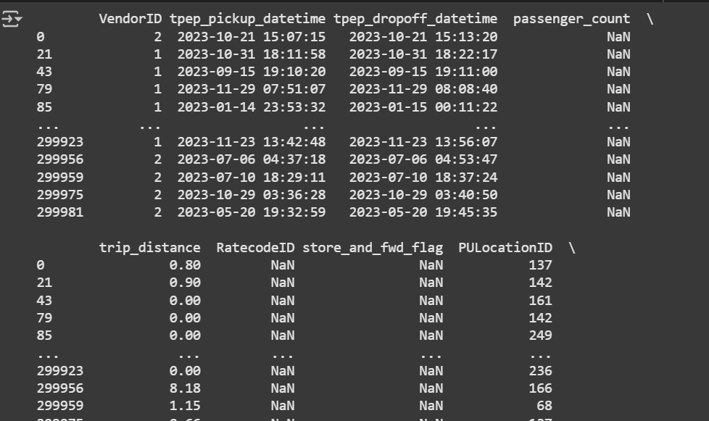
    - Handle missing values in RatecodeID
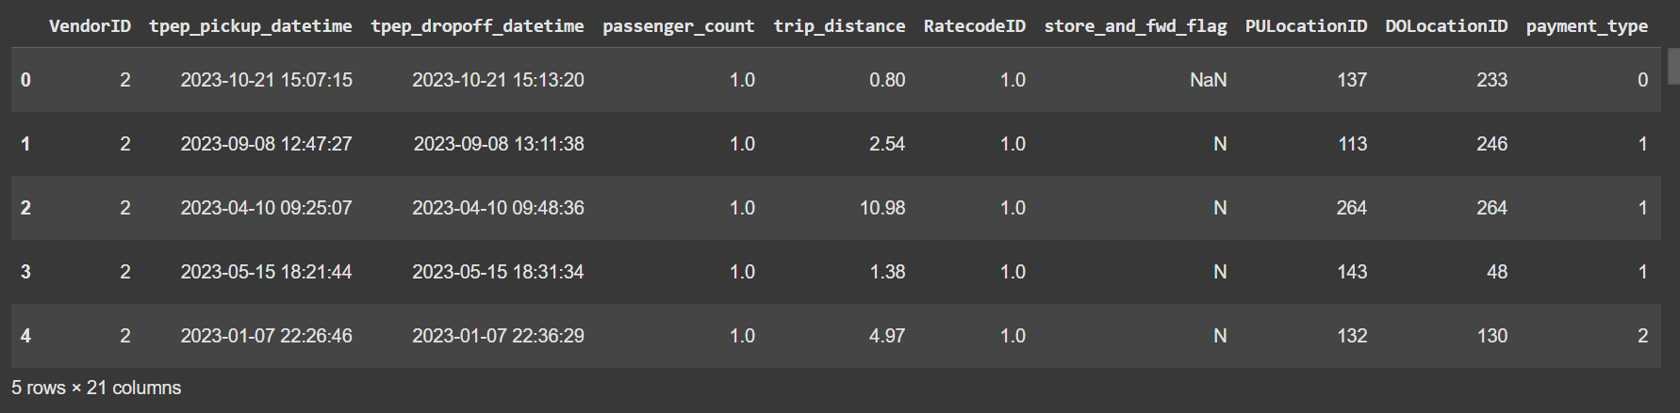
    - Impute NaN in congestion_surcharge
Column 'store_and_fwd_flag' has missing values.
Column 'airport_fee' has missing values.

Handling Outliers and Standardising Values
    - Check outliers in payment type, trip distance and tip amount columns
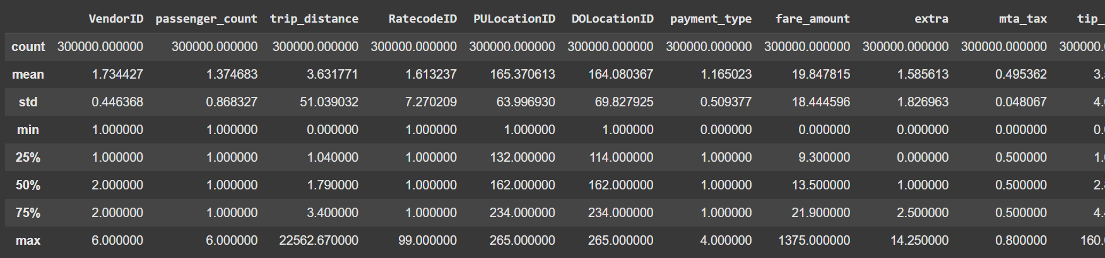

Exploratory Data Analysis

General EDA: Finding Patterns and Trends
    - Classify variables into categorical and numerical
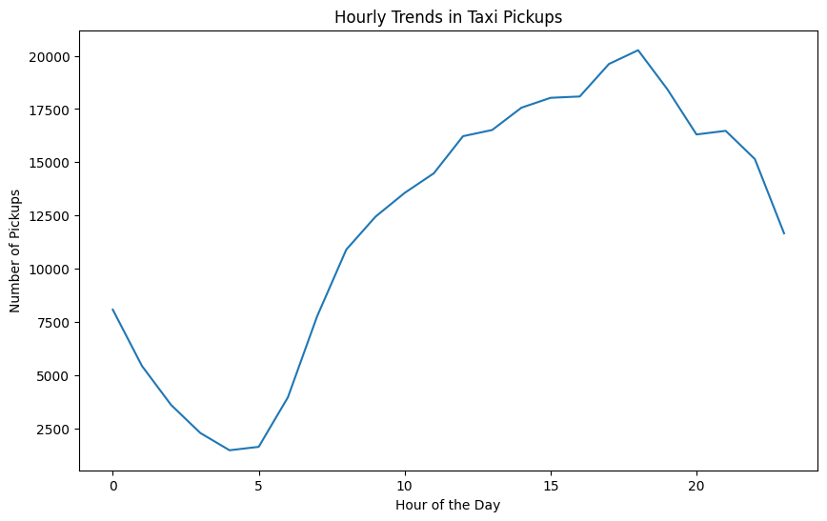
    - Analyse the distribution of taxi pickups by hours, days of the week, and months
    - Filter out the zero/negative values in fares, distance and tips
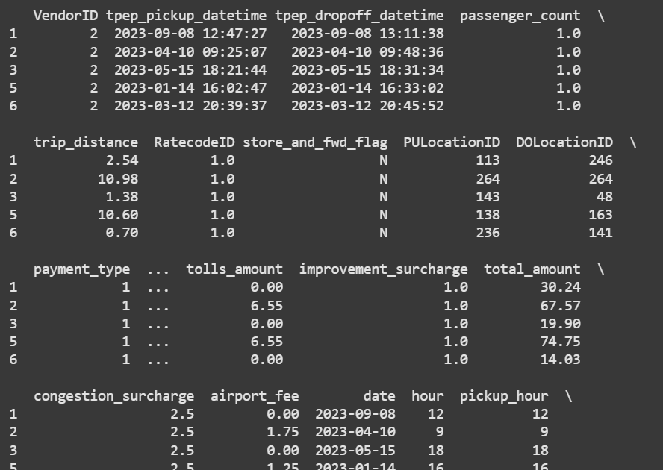
    - Analyse the monthly revenue trends
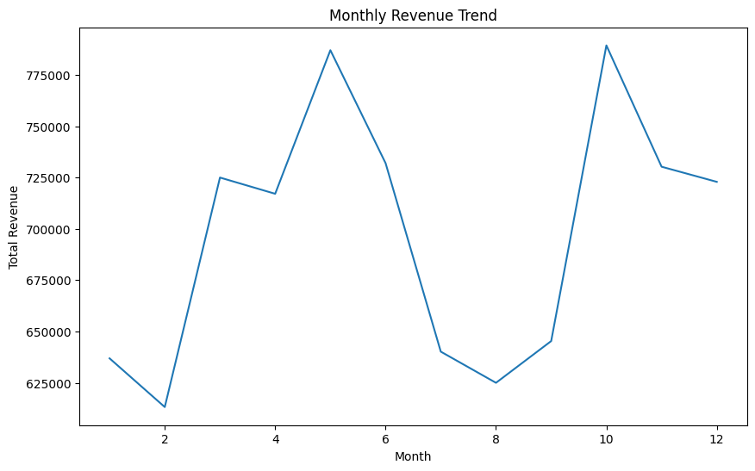
    - Find the proportion of each quarter’s revenue in the yearly revenue
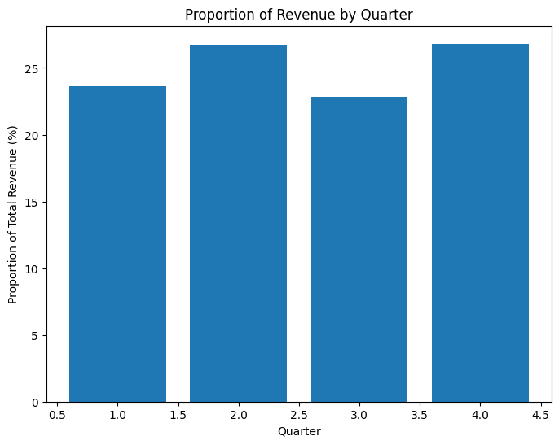
    - Analyse and visualise the relationship between distance and fare amount
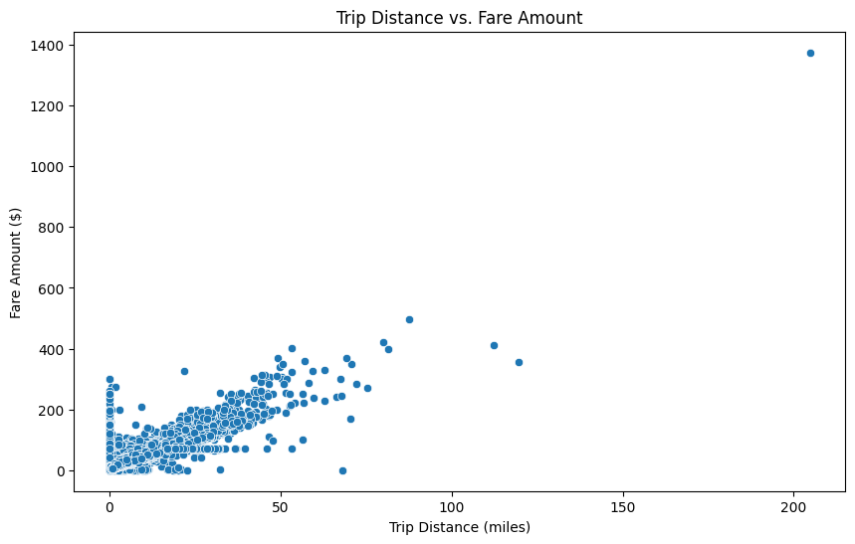
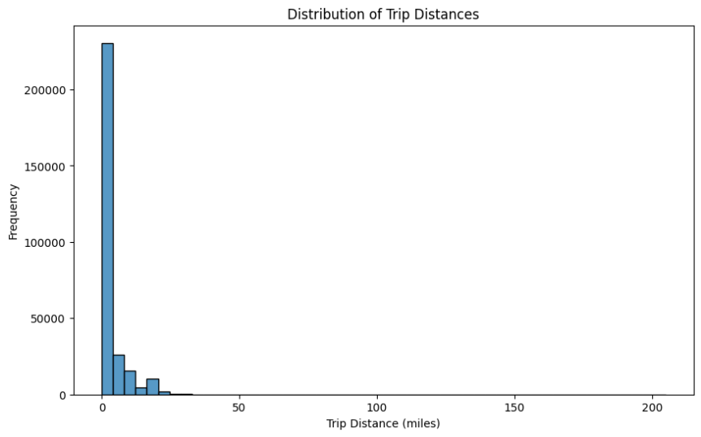
    - Analyse the relationship between fare/tips and trips/passengers
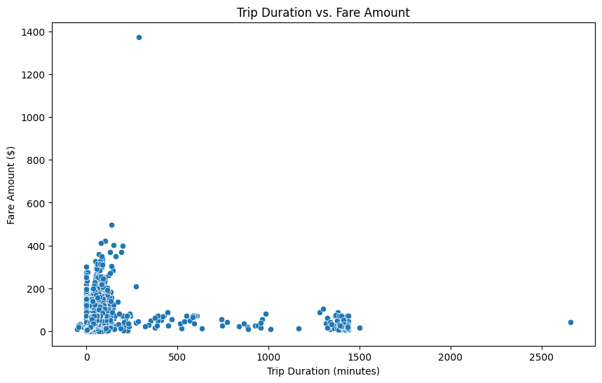
    - Analyse the distribution of different payment types
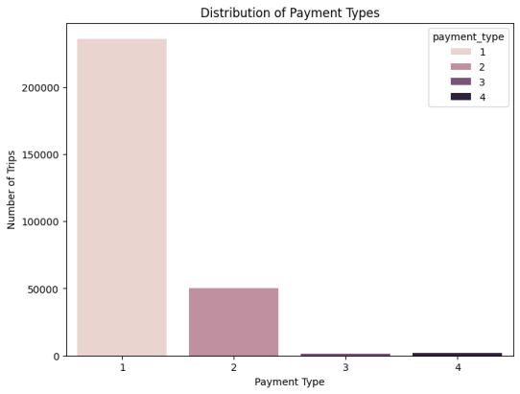
    - Load the taxi zones shapefile and display it
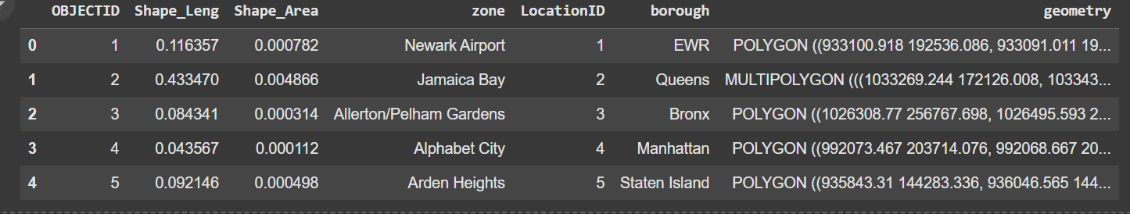
    - Merge the zone data with trips data
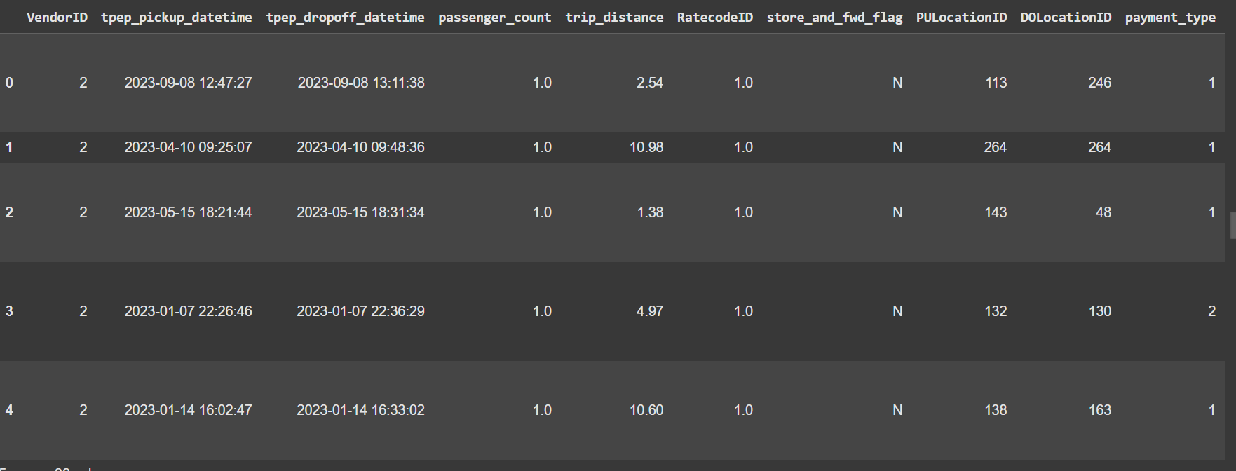
    - Find the number of trips for each zone/location ID
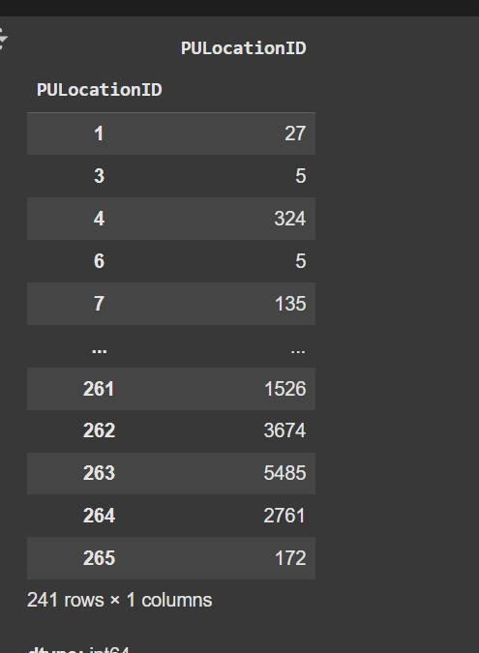
    - Add the number of trips for each zone to the zones dataframe
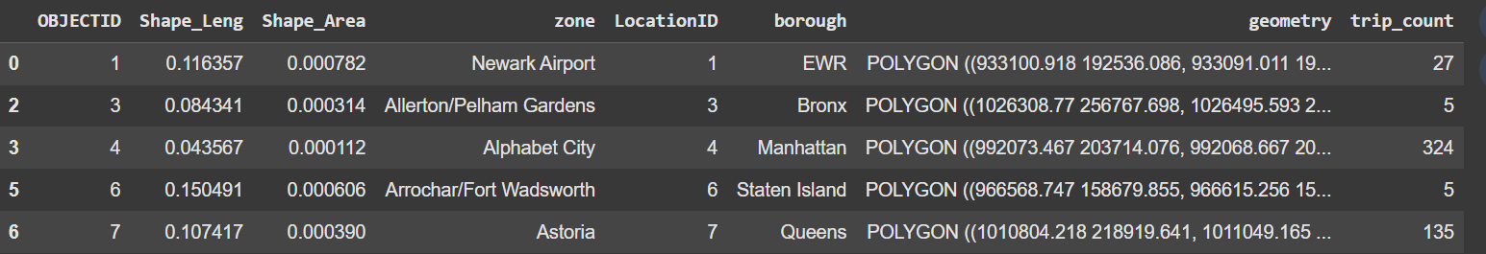
    - Plot a map of the zones showing number of trips
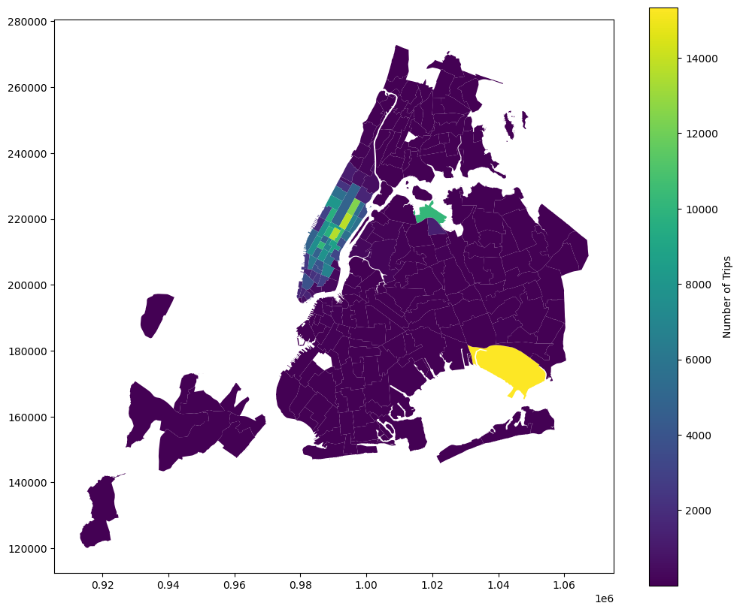
    - Conclude with results

Detailed EDA: Insights and Strategies
    - Identify slow routes by comparing average speeds on different routes
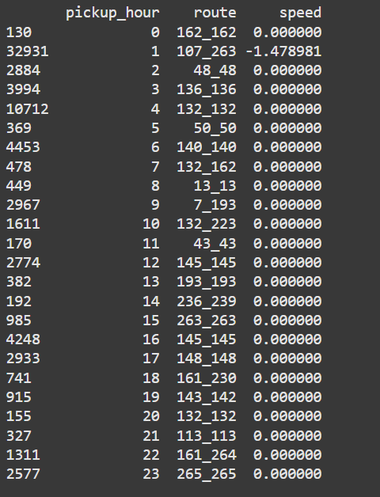
    - Calculate the hourly number of trips and identify the busy hours
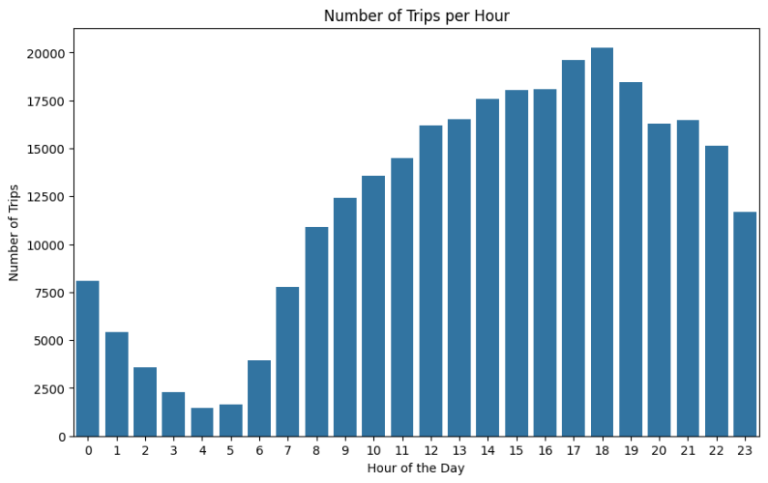
    - Scale up the number of trips from above to find the actual number of trips
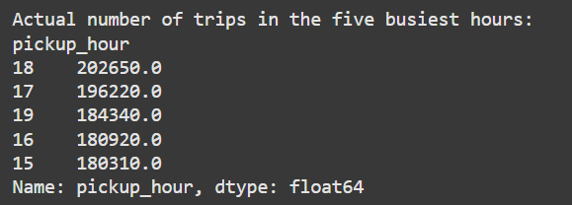
    - Compare hourly traffic on weekdays and weekends
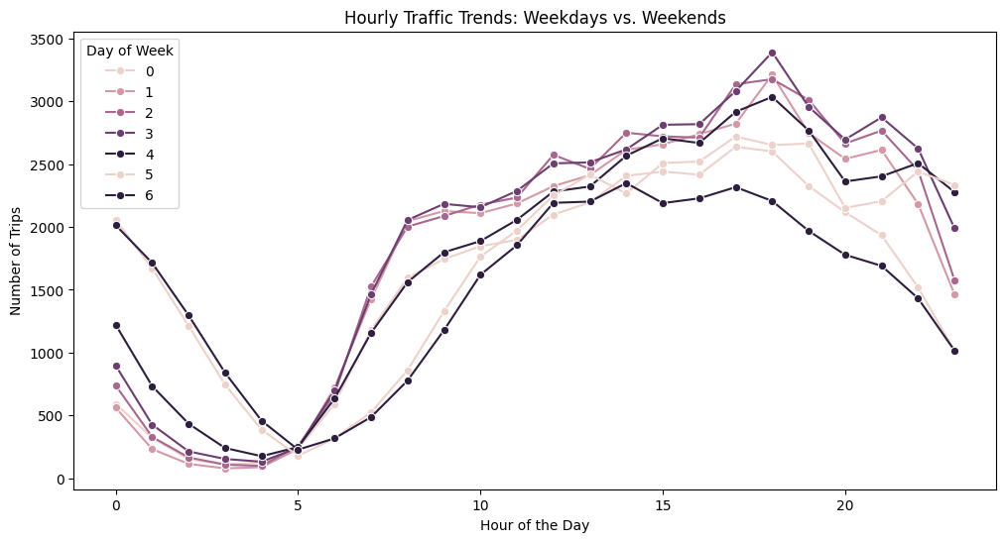
    - Identify the top 10 zones with high hourly pickups and drops
Top 10 Pickup Zones:
Index([132, 237, 161, 236, 162, 138, 186, 142, 230, 170], dtype='int64', name='PULocationID')

Top 10 Dropoff Zones:
Index([236, 237, 161, 230, 170, 162, 239, 142, 141, 68], dtype='int64', name='DOLocationID')
    - Find the ratio of pickups and dropoffs in each zone
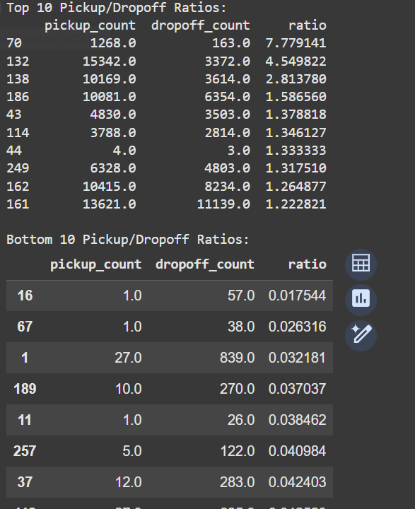
    - Identify the top zones with high traffic during night hours
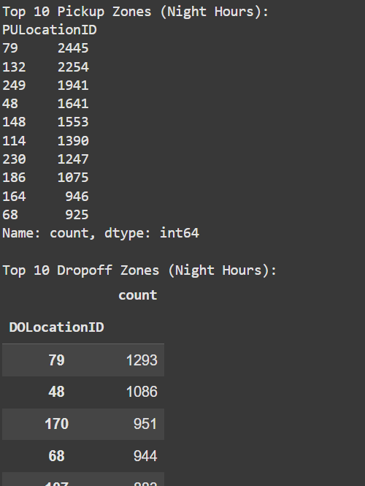
    - Find the revenue share for nighttime and daytime hours
Nighttime Revenue Share: 11.99%
Daytime Revenue Share: 88.01%
    - For the different passenger counts, find the average fare per mile per passenger
passenger_count
1.0 10.718841
2.0 6.076498
3.0 3.114451
4.0 3.552935
5.0 1.808098
6.0 1.304975
dtype: float64
    - Find the average fare per mile by hours of the day and by days of the week
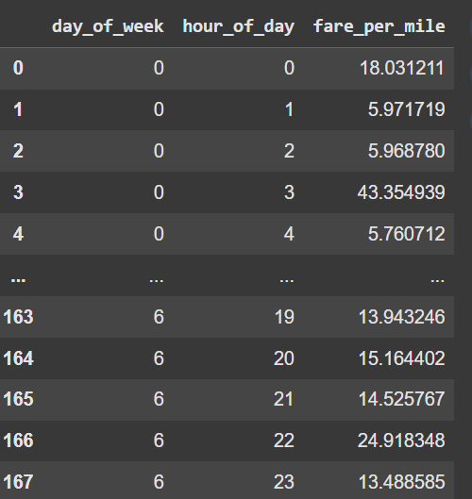
    - Analyse the average fare per mile for the different vendors
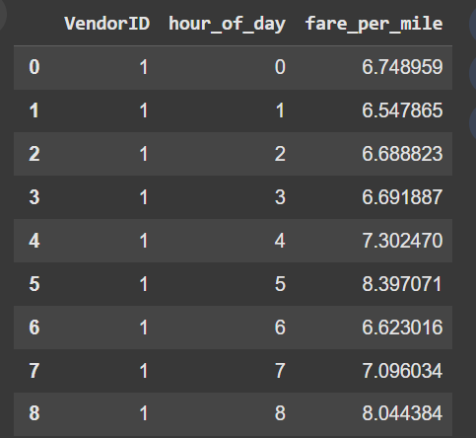
    - Compare the fare rates of different vendors in a distance-tiered fashion
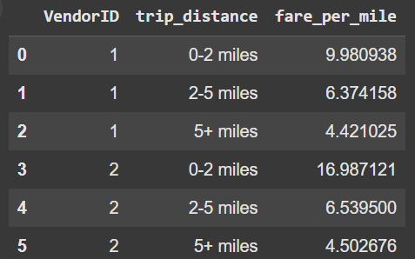
    - Analyse the tip percentages
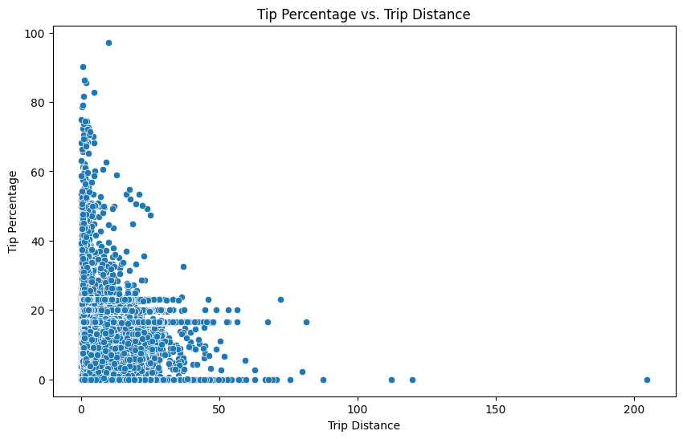
    - Analyse the trends in passenger count
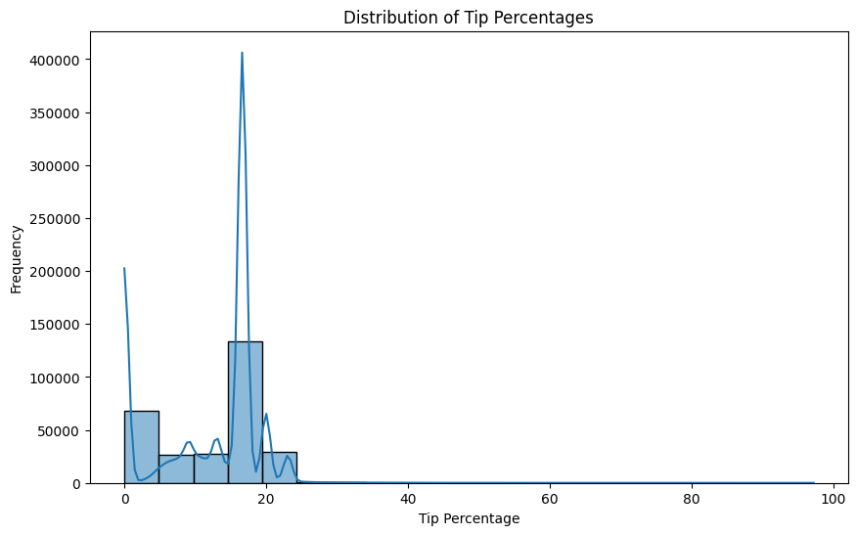
    - Analyse the variation of passenger counts across zones
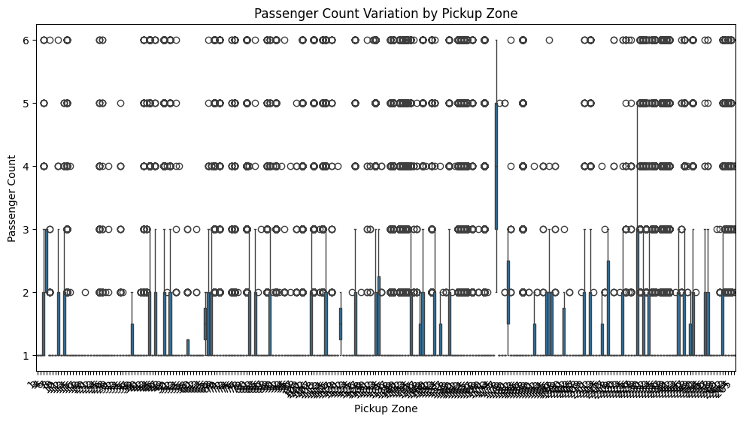
    - Analyse the pickup/dropoff zones or times when extra charges are applied more frequently.
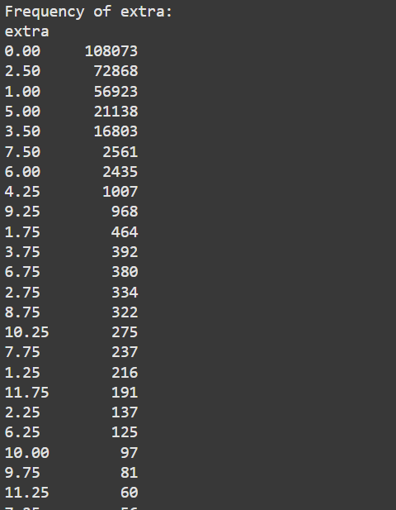

Conclusions

Final Insights and Recommendations
    - Recommendations to optimize routing and dispatching based on demand patterns and operational inefficiencies.

# Recommendations to optimize routing and dispatching

# 1. Dynamic Pricing: Implement surge pricing during peak hours and in high-demand zones.
# - Identify peak hours and high-demand zones using the hourly pickup/dropoff trends and top zones analysis.
# - Adjust prices based on the ratio of pickups/dropoffs to optimize supply and demand.
# - Consider time-of-day and day-of-week variations in demand when adjusting prices.

# 2. Optimized Vehicle Dispatching:
# - Allocate more vehicles to high-demand zones during peak hours.
# - Use real-time data to predict demand and proactively adjust vehicle distribution.
# - Prioritize dispatching to areas with high pickup/dropoff ratios.
# - Consider using predictive models to forecast demand and optimize vehicle allocation in advance.

# 3. Route Optimization:
# - Use algorithms to determine the most efficient routes for drivers based on current traffic, demand, and pickup/dropoff locations.
# - Consider incorporating real-time traffic information into routing algorithms.
# - Factor in the average trip distance and fare rates for different vendors and distance tiers when calculating optimal routes.

# 4. Nighttime Operations:
# - Increase the number of vehicles operating during night hours (11PM-5AM) in zones with high night time demand.
# - Consider offering different pricing strategies for night trips based on revenue shares.

# 5. Consider passenger counts:
# - Adjust pricing based on the average fare per mile per passenger for different passenger counts.

# 6. Improve Customer Experience:
# - Analyze customer tipping behaviors and identify factors that influence tip percentages.
# - Investigate low tip areas (distance, passenger count, time of day) to understand and improve these aspects.
# - Consider rewarding drivers with high tip percentages or good customer service ratings.

# 7. Address Surcharges:
# - Analyze the frequency and locations of extra charges to understand their prevalence.
# - Investigate zones and times with high surcharge applications to understand root causes and explore potential solutions.

# Example:
# During weekdays (Monday-Friday) between 5 pm and 8 pm, increase the number of available vehicles in zones 7, 231, 4, and 263.
# Apply a 20% surcharge during peak hours in these zones.
# During the early morning and late-night hours, reduce the vehicle supply in areas of low demand and reposition to high demand zones

    - Suggestions on strategically positioning cabs across different zones to make best use of insights uncovered by analysing trip trends across time, days and months.

# Position more cabs in high-demand zones during peak hours, as identified by analyzing pickup/dropoff ratios across different times, days, and months. This ensures sufficient supply to meet increased demand.

    - Propose data-driven adjustments to the pricing strategy to maximize revenue while maintaining competitive rates with other vendors.

# Data-Driven Pricing Adjustments

# 1. Time-Based Adjustments:
# - Implement dynamic pricing based on hourly and daily demand fluctuations.
# - Offer lower fares during off-peak hours and days to attract price-sensitive customers and fill empty vehicles.
# - Consider a tiered pricing strategy for different time blocks (e.g., rush hour, daytime, nighttime). Refer to 3.2.8 for revenue shares.

# 2. Location-Based Adjustments:
# - Consider the average fare per mile in different zones (identified in 3.2.15) to establish competitive pricing.
# - Implement zone-specific surge pricing during peak hours or special events.

# 3. Distance-Based Adjustments:
# - Consider a minimum fare for short trips and gradually increase the price per mile for longer journeys.

# 4. Passenger Count Adjustments:
# - Adjust pricing based on the average fare per mile per passenger for different passenger counts (3.2.9).
# - This will ensure fair pricing for shared rides and incentivize riders to opt for shared trips where possible.

# 5. Vendor Competitiveness:
# - Adjust prices to undercut competitors in specific zones or times when possible while still maintaining profitability.

# 6. Surcharge Optimization:
# - Evaluate the impact of existing surcharges on revenue and customer satisfaction.
# - Re-evaluate or refine surcharge strategies based on this analysis.

# 7. Customer Behavior (Tipping):
# - While not directly impacting pricing, understanding the factors influencing tips (trip distance, passenger count, time of pickup) can indirectly impact pricing.
# - For example, offering slightly lower fares to incentivize higher tips could be considered, or offering higher base fares for long trips.

# Implementation:
# - A/B testing: Implement changes gradually and test their impact on revenue, customer behavior, and market share.
# - Data Monitoring: Continuously monitor key metrics (revenue, ride volume, customer satisfaction) to measure the success of pricing adjustments.
# - Machine Learning: Utilize machine learning techniques to predict demand and dynamically adjust pricing in real-time.

