1. While entering details for Register. Left ‘Last Name’ field empty.

Actual Result: Help message displayed ‘First Name is required’

Expected Result: Help message should have displayed ‘Last Name is required’

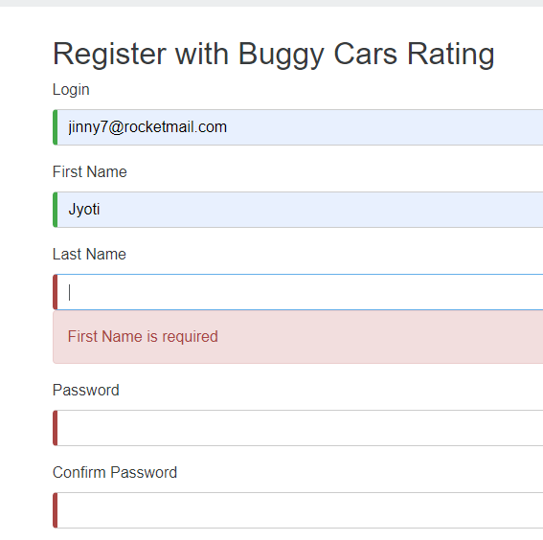

1. While entering details for Register. Left ‘Password’ and ‘Confirm Password’ fields blank.

Actual Result: NO help message displayed

Expected Result:

Help message should have displayed ‘Password is required’

Help message should have displayed ‘Confirm Password is required’

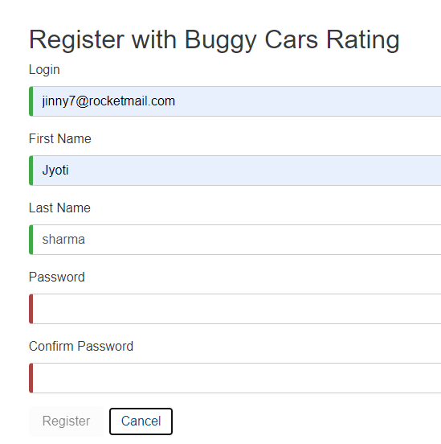

1. While entering details for Register. As soon as I start entering data into ‘Confirm Password’ field.

Actual Result: ‘Password do not match’ help message appears as soon as I start entering data

Expected Result: ‘Passwords do not match’ should appear after user moves out of field and Passwords don’t match.

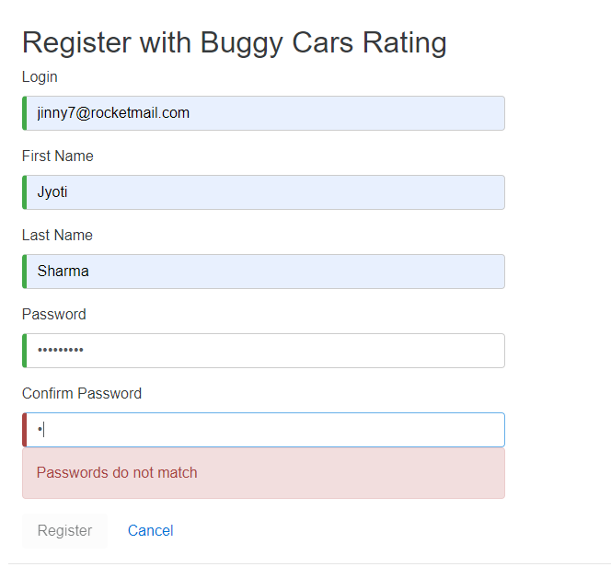

4.

While changing password, help message appears as soon I enter first letter into New password.

Actual Result: ‘Password do not match’ help message appears as soon as I enter one letter into New Password field

Expected Result: ‘Passwords do not match’ should appear after user moves out of Confirm password field and password don’t match.

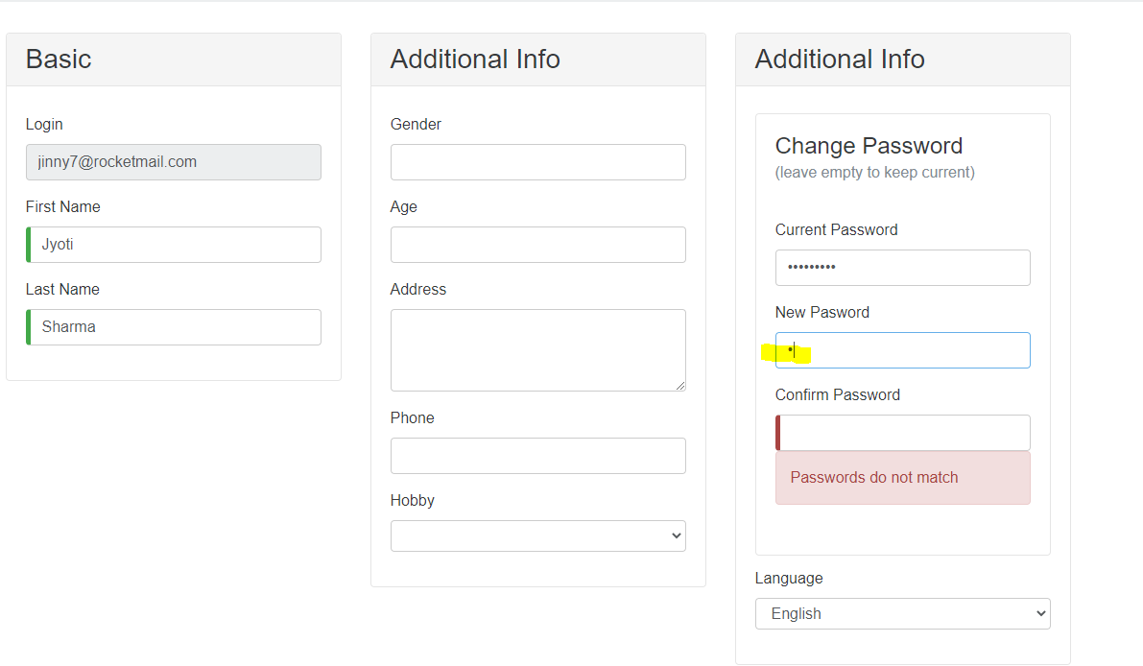

5.

While changing password, error appears

Expected Result: Error message should clearly define number of chars in password and requirement of number and special char.

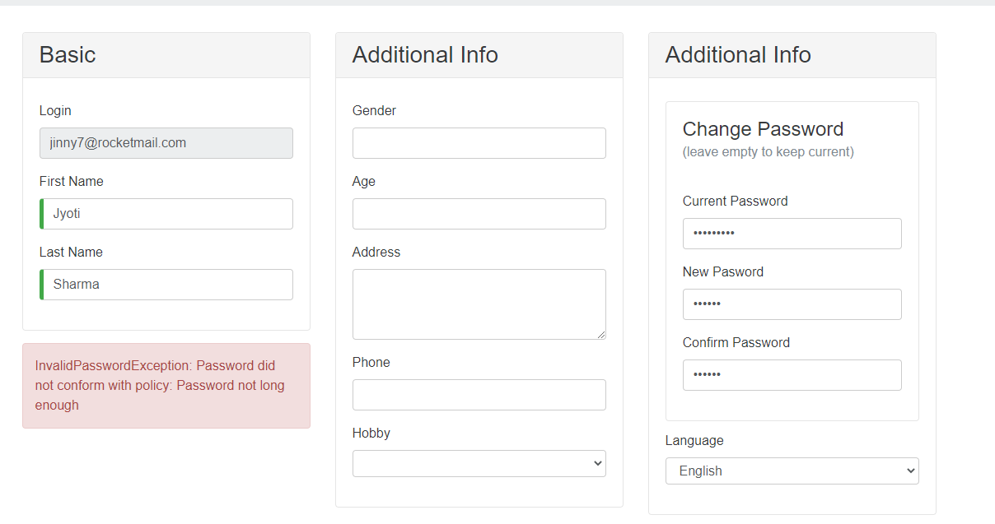

6.

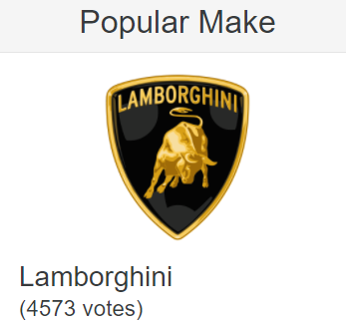

When Rank is decided by number of votes then models having same votes should have same ranking.

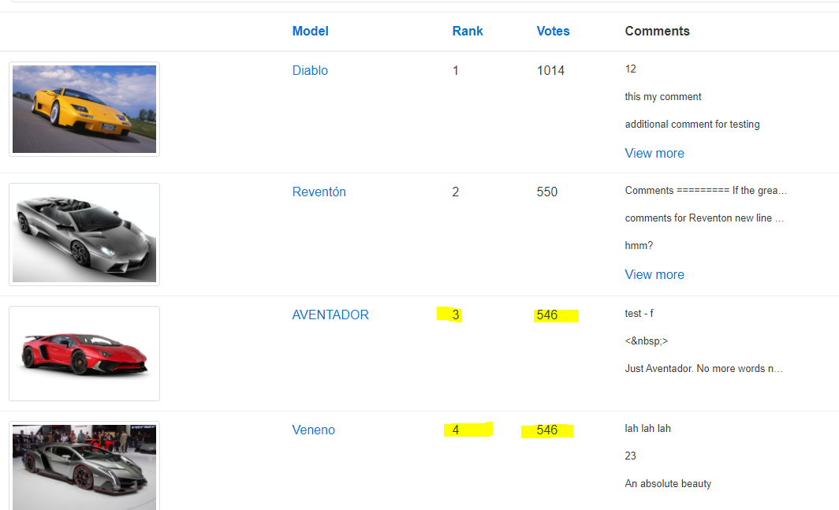

7.

a. Click on [Popular Make] page.

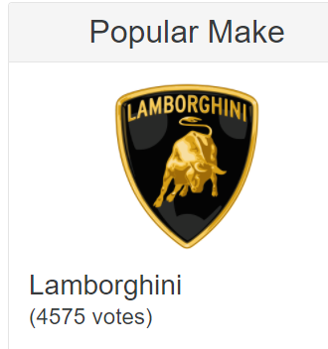

Displays all models.

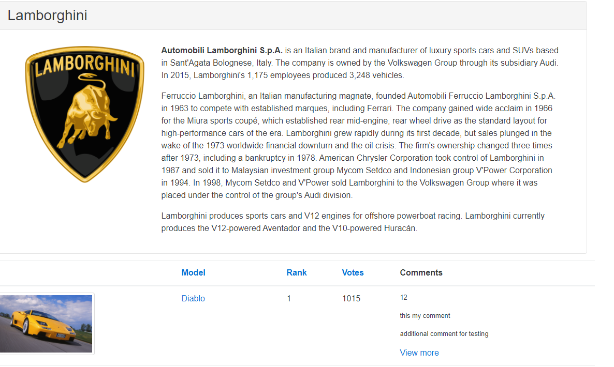

b.

Click on any Model.

Takes you inside the Model page.

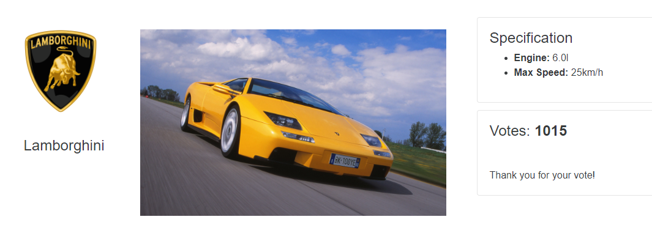

c. When the user clicks again on Model page, it takes the user out on home page

Expected Result : user should move back to [Popular Make] page instead of home page

8. Inside [Popular Make] page data

Actual Result: Data is being sorted only on votes, not on Model & Rank

Expected Result: Data should be sorted on Model and Rank as well

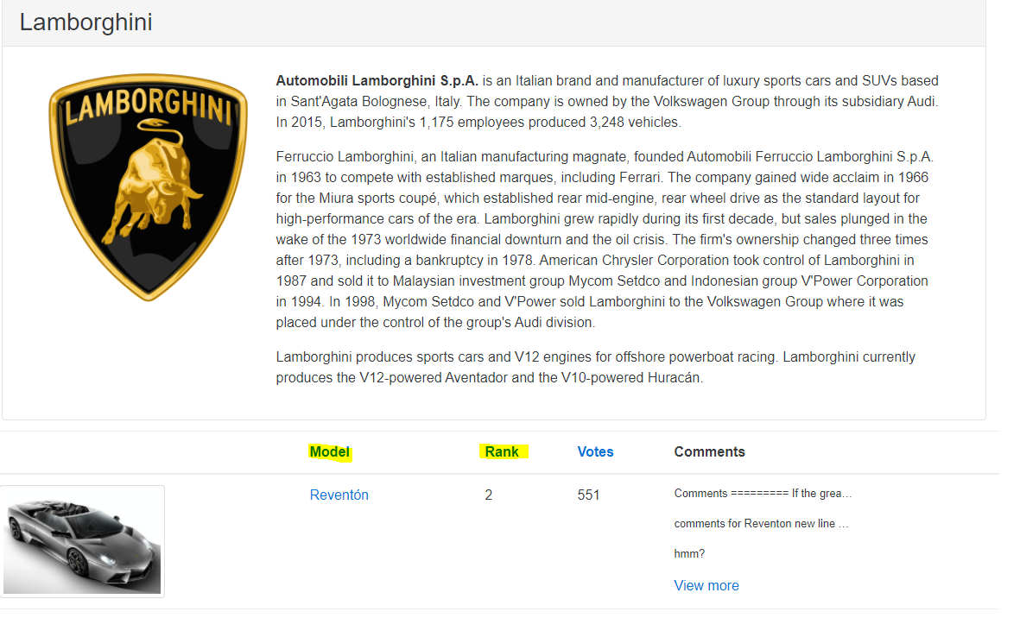

9. Inside [Popular Make] page data

Actual Result: Votes data is not sorted correctly.

Expected Result: Votes data should be sorted based on number field but is not

