Architecture
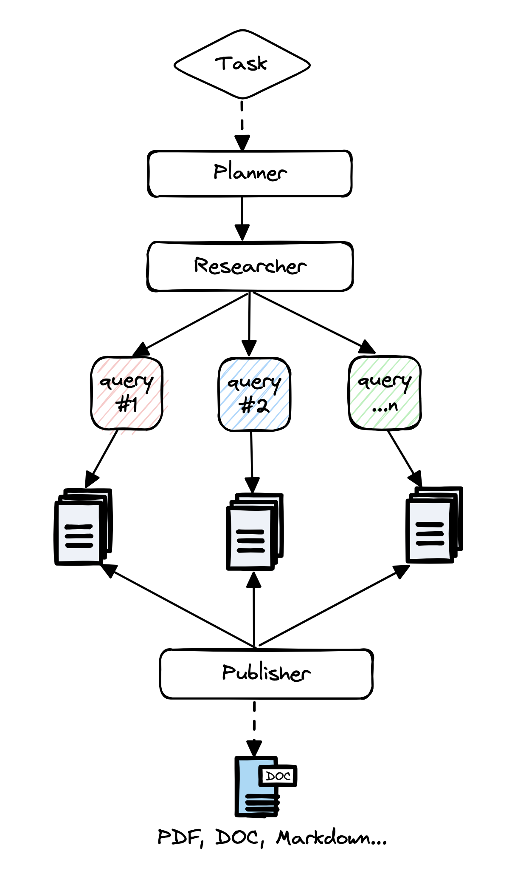

- So, let's discuss now how GPT researcher is built and what's the architecture and the flow that our in-depth research is being comprised of.
- So, this will also give us a great intuition of the generative AI development life cycle over the past year.
- So, we start with a research task. So, this is the query that we give to the GPT researcher.
- And then what's happened we have here a planner which actually dynamically generates a research agent depending of what we're searching on. For example, when we asked about Graph-RAG and GPT researcher actually created us a dynamic agent that is called a technological agent. So, this agent is tailor made for researching on technological subjects like Graph-Rag. And to simplify things, you can think about this technology agent as an elaborate prompt that gives the agent the role and the persona of somebody who is very keen to technology and who knows how to code. Now, the cool thing about it that this is actually dynamically created. So, what GPT researcher does actually is to take our subject that we were looking for to dynamically choose what kind of agent do we want to use. So this can be any type on any given topic. It can be something about agriculture or about technology or about finance, and the possibilities are endless. It's then going to send this information to an elaborate prompt. And now the LLM is going to give the persona of our agent.
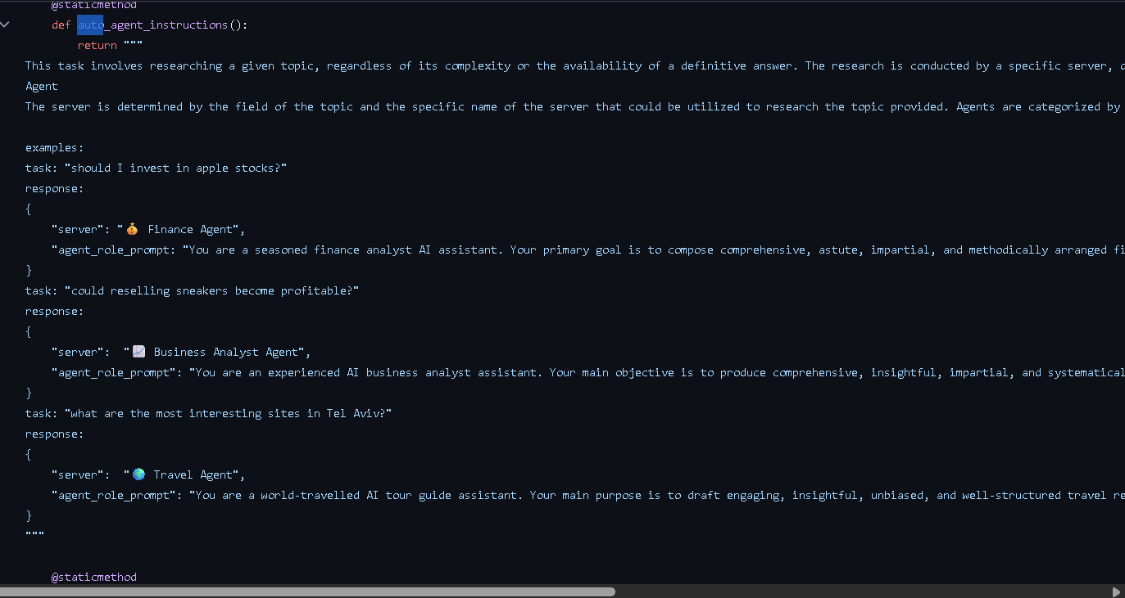
The response that we get back from the LLM is going to be the kind of research agent. And the prompt that gives it the persona super cool idea.
And this actually improves performance and to give us a better output.
- So, once our persona for our agent is generated, we then want to create some research queries that we want to search online for. So we're going to take the original topic, and we want to make our research more in depth. So we're going to get in this step some extra search queries that we want to look for online.
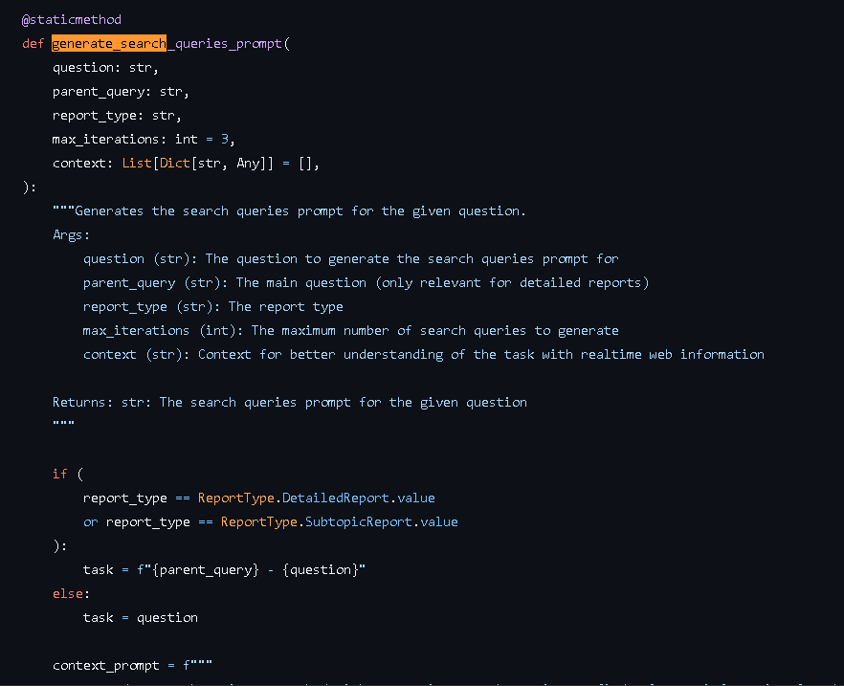
(If you remember the example from our demo, then you can see that we searched for Graph-Rag technology overview, Graph-Rag use cases and applications, Graph-Rag reviews and comparisons. So this will actually give us a much more elaborate response, because we're going to search for different topics or different aspects of a given topic, and this will yield us data that is going to be processed that will eventually give us better results.)
- Once we have the search queries, then the GPT researcher now triggers search with search engines to find the data for our research report. And this can go and get information from tens of sites to hundreds of sites depending of our configuration, So depending how deep we want our research to be. And for every site, the researcher actually scrapes the site's information and parses it and handles all of the processing of the website, which can be a very challenging task because parsing and processing web pages, whether it's HTML Readme files or JavaScript code, then it's a very hard task to do.
- After we have the information from the site that the GPT researcher scraped, then what it does actually is use a vector store and it's going to chunk all of this information and it's going to fetch only the relevant information for that research task that we gave it in the beginning. So that way we're only getting the top-k relevant information that we want to use for our research report.
- Now, I remind you, everything is dynamic. And what I mean by that is, depending on our search query and the agent that we get and the dynamic
system prompt that the researcher generates, then this is going to accompany our entire journey of our research. So when we search for the search queries, then when we create them, then we have a special system
prompt that was auto generated dynamically depending of our research task.

