https://github.com/assafelovic/gpt-researcher/tree/master/multi_agents
We can integrate GPT researcher within a multi-agent system.
We will integrate GPT researcher as a node (all the architecture we saw right before of Researcher as a single node) under our lang-graph graph. So, this Agentic architecture has got a lot of hype on Twitter and over the web, because it really shows the composability possibilities that we have with multi-agent systems.
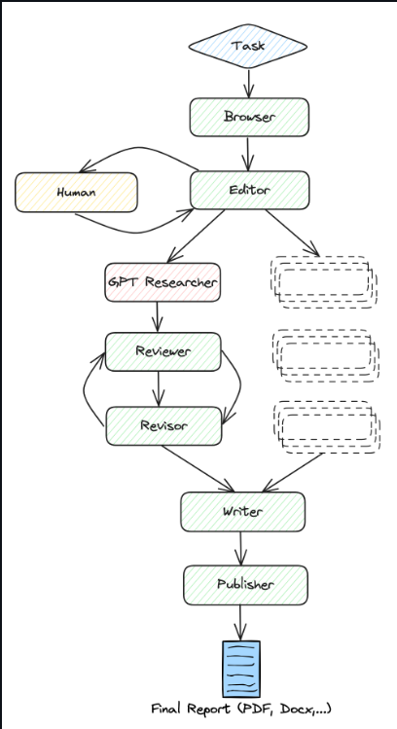
Implementing a team of agents which are going to create a cohesive research with some reflection techniques. After Researcher, the reviewer is going to give feedback on the research paper, while the reviser is going to fix it. And then it's going to reiterate until we get a final product that we like.
Understanding the code in Github
There is reviewer and reviser agent. There is researcher agent, this has an instance of GPT-Researcher. Okay, so we simply see here the definition of a node that is going to do our research with our input query. And all of that logic is going to be under the GPT researcher object of the GPT researcher class.

