https://langchain-ai.github.io/langgraph/#core-benefits

Lang-graph-Studio/Lang-graph IDE
- https://github.com/langchain-ai/langgraph-studio?ref=blog.langchain.dev
- https://blog.langchain.com/langgraph-studio-the-first-agent-ide/
- It enables us to first watch the execution of the nodes and to get in real time what node is being executed. We can set breakpoints and check what's the state before and after we execute a node. And with the graph IDE we can go to our IDE, whether it's PyCharm or VS-Code, and we can change the logic there and it's automatically reflected in the graph IDE. And to summarize, the real value here is to give us, as developers, fast iterations when developing those land graph agents.
Steps:
- Install it from the github and make langsmith account.
- In vs code, make langgraph.json: 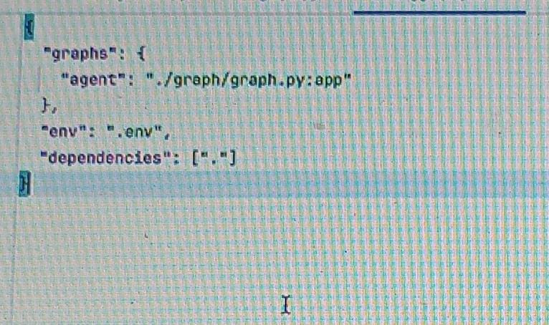 The goal of this JSON is to tell LangGraph Studio what graph are we debugging and working on, and how do we need to run it. Dependencies = . means take the dependencies from the root directory.
:app is the name of the compiled graph->app = builder.compile()

- 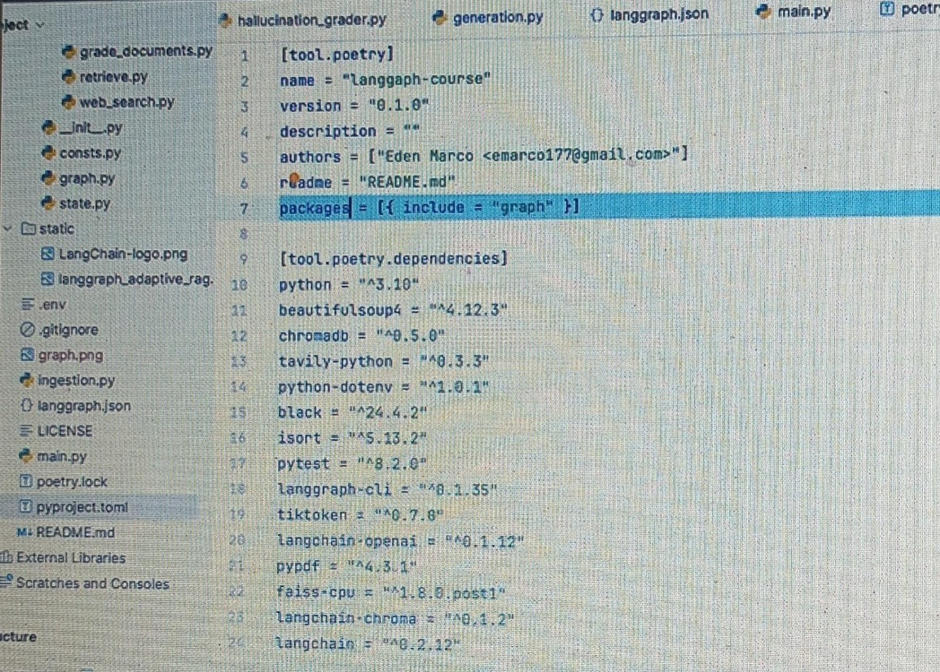
line number 7
- Basically the langgraph IDE is a Docker container running in your machine.
- Go to langgraph IDE, select the project and start it.
- What's actually happening is that Langgraph studio is downloading an image of the langSmith debugger. And it's actually creating a container of the length smith debugger, and it takes our application, it dockerize it so it builds an image file, and then it runs a container containing our langgraph graph.
- When we run the graph provided with the input, it runs same as in langsmith, but in live. In the middle, we can re-edit the steps and fork (update it). And this will create a new thread ID different from the current thread ID, and resume the graph's execution.
- How is this happening? It is also running the Postgres container. Langgraph is persisting our state after every node execution. So we have all of this data of our nodes executions and state and which node ran after which node
- We can also add interrupt before a particular node.
- We can change the code in vs code and this will be reflected in the langgrapg IDE execution also.

Lang-graph cloud API
- LangGraph Cloud API is for basically taking our compiled lang-graph graph and creating for us a web server, which exposes this graph in a very nice and very well-defined interface, which we can use when we interact with other applications, like for example, a front-end application.
- We are going to run it locally on machine.
- https://langchain-ai.github.io/langgraph/cloud/quick_start/
- https://langchain-ai.github.io/langgraph/concepts/langgraph_server/
- Langsmith -> deployment -> langgraph cloud
- Steps:
- Write the JSON file.
- Pip install langgraph-cli
- Langgraph CLI:
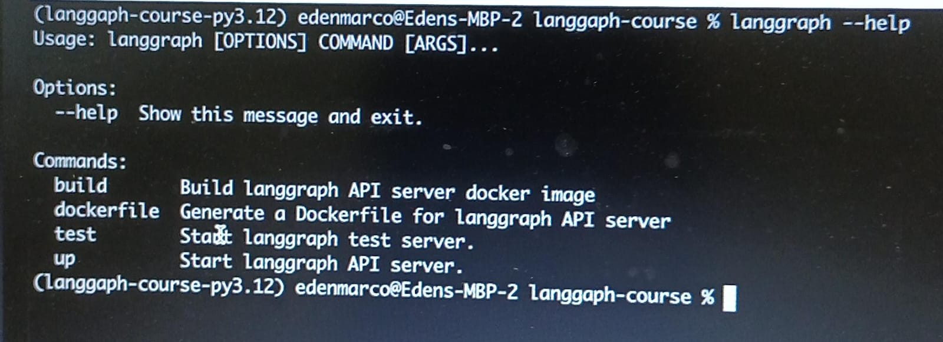
- langgraph dockerfile dockerfile_name
- langgraph up
- We can see we are ready and we have our API in localhost port 8123.
- Then we'll have our application locally running inside a container.
- See it in docker: docker ps
- 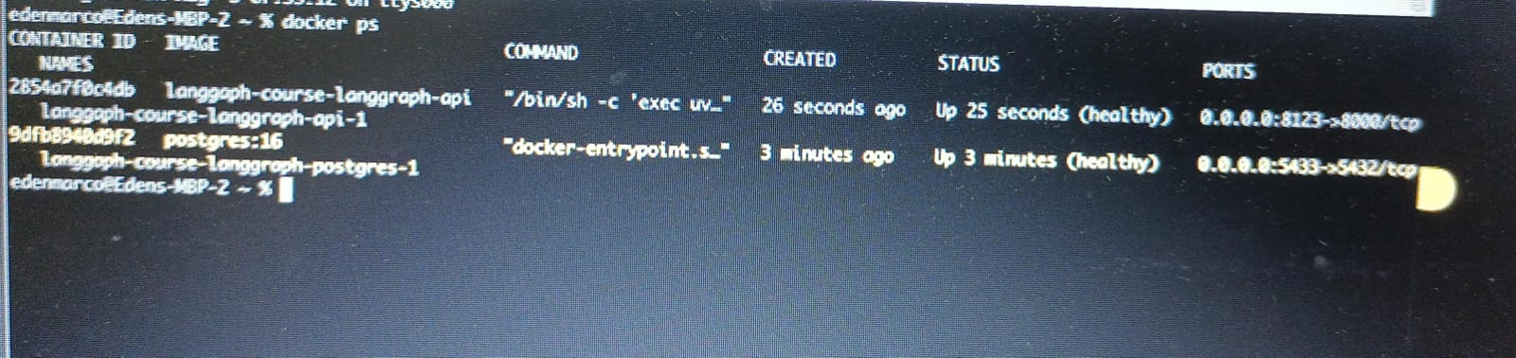
- Langchain only created us our API web server, they also created a very nice doc file that we can use now. It's built with the OpenAI API specification, and the API we're reviewing right now is called the Langgraph cloud API.
- 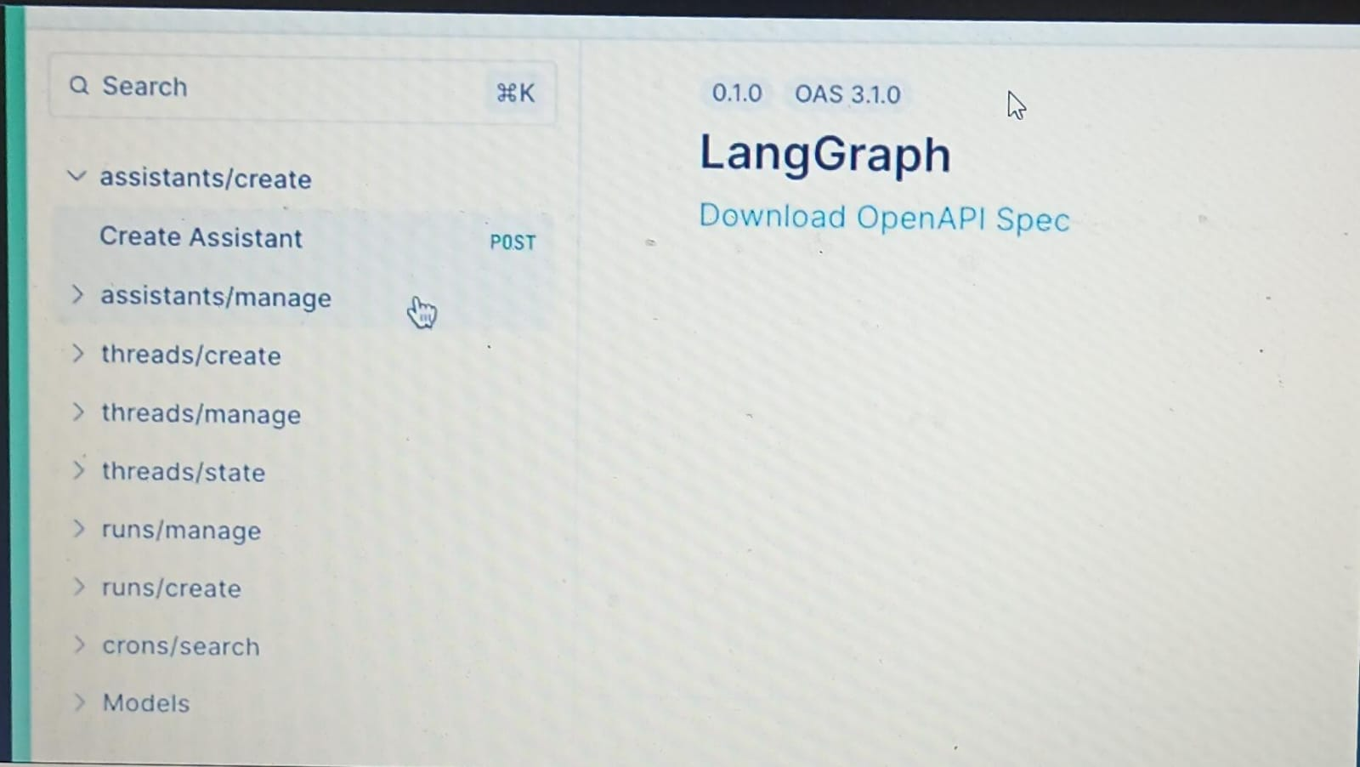
- And it's comprised of a couple of data models. One is assistance, the other is threads. We have also runs and we have also cron jobs.
- Now langchain took the compiled graph that we created and automatically created for us those endpoints which will use our compiled graph.
- Assistant API: Here we can create assistant. The assistant is basically an abstraction of our instance of our compiled graph. And it's going to help us run it later. We can create a couple of systems which are going to use the exact same graph with the exact same configuration. We can use the exact same graph but with different configuration. And then each assistant would be a bit different. And we can have assistance even point to different graphs. You have a lot of flexibility here. Create an assistant:
- Send JSON request to /assistant: {
Graph_id: “agent”,
Config:{},
Metadata:{}
}
- We got assistant id in response.
- All of these informations are saved in the Postgres containers that Langgraph Cloud API created for us when we ran the command ‘Langgraph up’. So, the Postgres container is going to hold all of these data.
- Threads: Eventually we're going to run and invoke this compiled graph that is currently abstracted in this assistance object. And a thread is an abstraction that is going to contain the accumulated state of a group of invocations, so of a group of runs. So when we invoke a compiled graph, then we can attach to it a thread id. And once we do that, if we have persistence enabled with checkpoints, then we can pretty much know the state. At every given point of time, we can rerun things, we can reiterate over certain nodes and steps, and we get a lot of information about our graphs execution. And we have all the information of how the state changes across different executions of nodes. Create a thread:
- Request on /threads without assistant or thread ID as a thread can be shared across many assistant.
- This will give the thread_id in response.
- Run: A run is actually the invocation of our graph with some input we provided. Create a run:
- It will receive the thread ID as an optional field. However, I like to attach a thread for each run and in the body it needs to receive assistant ID, and this is a required field. The assistant ID, because we need to know which graph do we need to execute and to invoke. And it also can receive a checkpoint ID in case we are continuing a graph execution of an interrupted graph.
- Give thread id in path: /threads/session_id
- Give assistant id in body or payload. This assistant ID has all of the information of where is our compiled graph stored, which is the file and what variable it exists in (agent name in langgraph.json). So basically it's an executable.
- Tags are used to filter in langsmith.
- Configurable parameter: we are not sending the thread_id in this, So Landgraaf cloud API is going to do this propagation for us, because we are going to invoke this graph with a configurable object with the thread ID that we sent in the path above.
- And when we send this request, we get a lot of information like run_id. But the status is showing pending.
- To see the status of that run: thread/run_id: status is success. This means we finished running the compiled graph with our relevant input.
- But the answer resides within the thread, not run. because the thread has all of the aggregation of the states of our runs.
- So, to see answer, go to get thread, threads/thread-id, we can see our state under “values".

Lang-graph cloud
- Langgragh cloud does exactly the same as langgraph cloud API, but it does so on the cloud.
- This is used for deploying the application.
- And eventually we're going to get a production ready endpoint, which we can interact with and expose for our front-ends.
- Steps to deploy the previous application on cloud:
- Open lang-graph cloud console
- Click on new deployment
- The first step of deploying our Lang-graph agent to Lang-graph Cloud is to first connect our repository containing our Lang-graph graph to the console right over here. And now Lindsmith has access to all of my repositories.
- Give the location of langgraph.json
- So we are going to deploy a development Langgraph cloud instance. And it will be able to serve up to 50 requests per second with no backups or storage. However, if we want to go to production and to have more reliable and larger compute, we can go and select other types of deployment types so we can have the production deployment type, which will allow us more.
- Mention the environment variables. Langgraph cloud is going to save the value of those environment variables in a dedicated secret manager storage, cloud based.
- Remove the env like langsmith api key or tracing because the Landgraph cloud is going to take it from our user.
- Click on submit
- Now we are redirected to our deployments page. And we can see now we have a deployment of a revision which is in progress.
- And what's Langgraph Cloud is going to do under the hood? It's going to do pretty much the same as we saw locally. And the first step will be to build a Docker image from our repository that we connected to Langgraph cloud. Now this is probably going to be with the Langgraph Dockerfile command which is going to create the Dockerfile. And then it's going to build the image from the Dockerfile and it's going to store it in an artifact registry for the Docker images, which is cloud based. So this is the first part of the deployment. And the second part will be deploying and running the container in the cloud and letting us interact with it by getting a URL.
- So, after the deployment is done, it will provide the link or url that will redirect us into our application, which is public, deployed in the cloud and open to the internet.
- /docs: redirects to the documentation api (same as locally)
- And we can even go and click Langgraph Studio. And we can see here our graph exactly like we saw in the Langgraph IDE. Let's write here for example ‘what is agent memory’ exactly like we did locally.
And now we can see our Langgraph graph running in real time in the cloud and publicly accessible.

