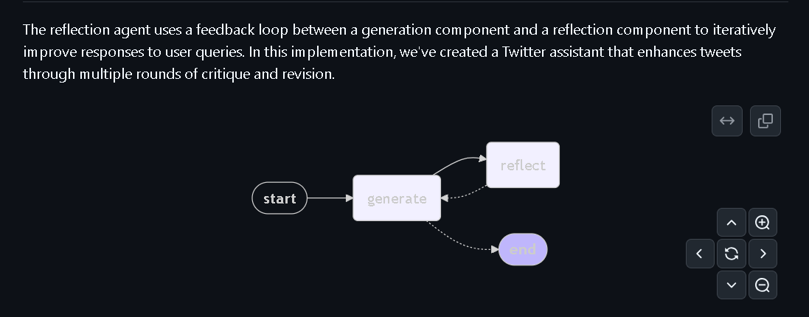
Reflection agents are powerful tools that are used to enhance the quality and success rate of AI systems. They prompt the LLM to reflect on its past actions, allowing it to learn and improve over time.

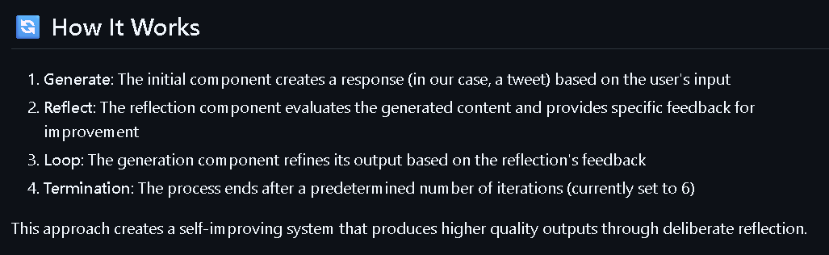
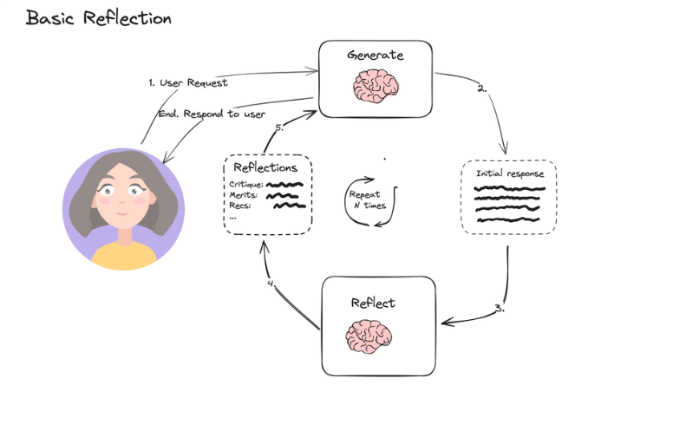
It's going to take the original tweet, and it's going to give us critique with a reflection step. It's going to give us this feedback and criticize our Twitter post. Then we're going to take this feedback and feed it back to an LLM again and ask it to revise it. So we have revision number 1 after the feedback. Then we're going to continue and iterate through this process again and again and again until we finally get a Twitter post that is decent and hopefully would go viral.
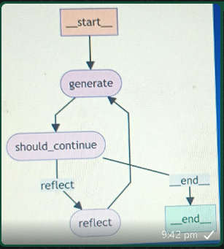
Link: https://blog.langchain.dev/reflection-agents/

