**Comparison of data before and after using Streamable HTTP**

1. 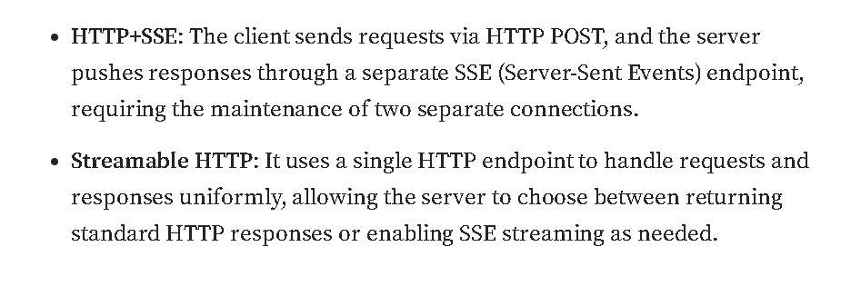
2. 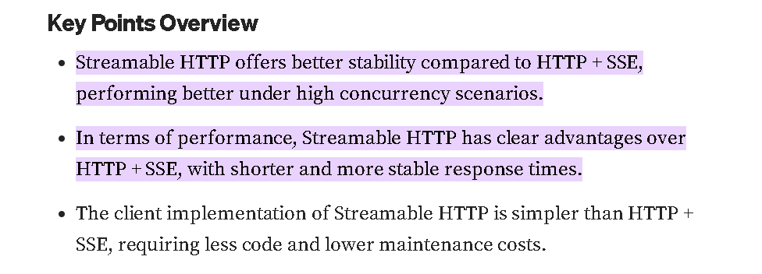
3. 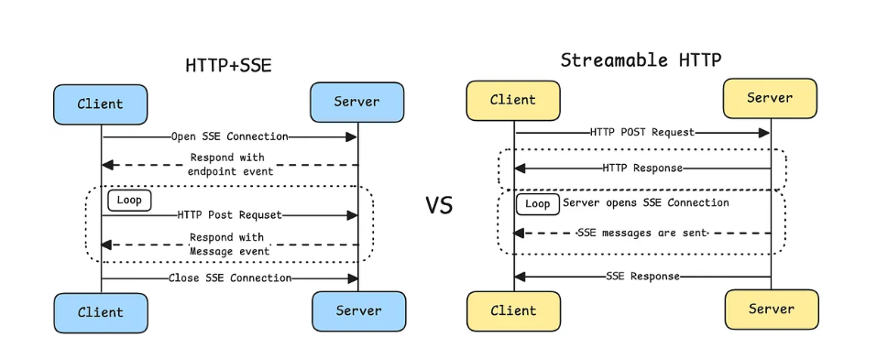
4. **Problems with HTTP + SSE**
5. **The server must maintain long connections**, which can lead to significant resource consumption under high concurrency.
6. **Some responses from the server are just single response, they do not require streaming, or long-live connection to send, they can be sent as just one HTTP response and do not need a stateful connection such as SSE.**
7. **Server messages can only be transmitted via SSE**, which creates unnecessary complexity and overhead.
8. **Infrastructure compatibility**: Many existing network infrastructures may not correctly handle long-term SSE connections. Enterprise firewalls may forcefully terminate timed-out connections, making the service unreliable.
9. **Improvements in Streamable HTTP**
10. 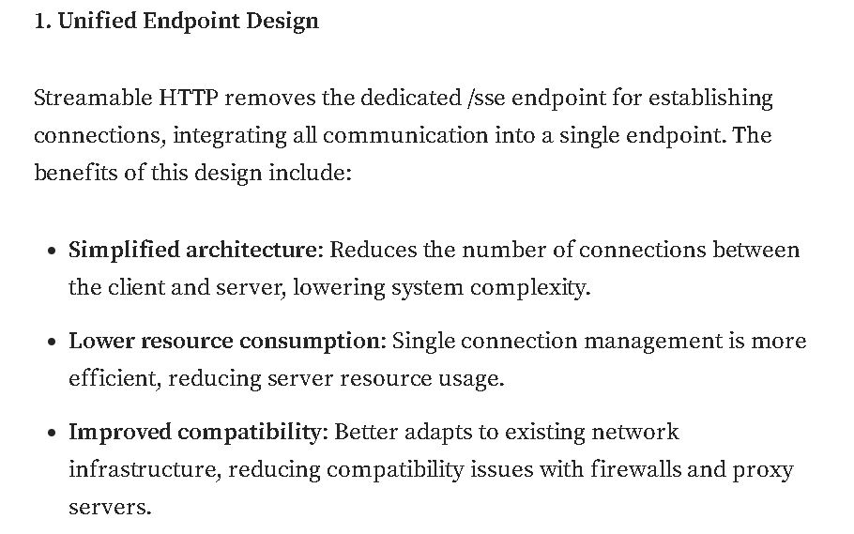
11. 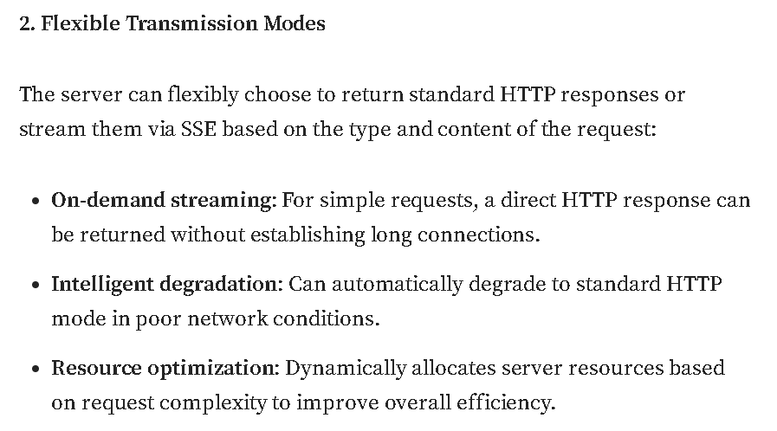
12. 