Nexora Bot

1. Project Overview
This project is a Multi-Agent Question Answering System. It allows users to create projects, upload various types of documents (PDF, TXT, MD, CSV, Excel), and ask questions about them. The system intelligently routes queries to specialized agents based on the nature of the data and the user's question.
Key Capabilities:
- Multi-Format Support: Handles unstructured data (PDF, TXT, MD) and structured data (CSV, Excel).
- Poetry: Using Poetry, which is a dependency manager and packaging tool for Python that ensures project reproducibility.
- Smart SQL Generation: Dynamically converts natural language questions into SQL queries to analyze structured data.
- Simple RAG: User can choose Simple RAG in settings. This agent focuses purely on retrieving information from your uploaded project documents.
- Agentic RAG: User can choose Agentic RAG in settings. This agent has the "brain" to decide whether to route your question to the RAG tool (for internal docs) or the Web Search tool (for external info).
- Safety Guardrails: Checks user inputs for toxicity, PII, and prompt injection before processing.
- Advanced Retrieval Architecture: In setting according to the requirements of the project, the user can select any one of the retrieval techniques.
Vector Search: Semantic similarity using embeddings.
Hybrid Search: Combines Vector search and Keyword search.
Multi-Query Vector: Enhances recall by generating multiple query variations.
Multi-Query Hybrid: Combining query expansion with hybrid ranking.
- Topic-Aware Chunking Strategy: Documents are split topic-wise.
- Multimodal PDF Processing: Extracts and processes all content types from PDFs:
Text: Standard text extraction.
Images: Images are converted to base64 format.
Tables: Tables are converted to structured formats (HTML).
- User Authentication: Integrated with Clerk for secure sign-up, login, and session management.
- Scalable Database Design:
User Data: Stored in Supabase (PostgreSQL).
Vector Store: Uses pgvector for high-performance embedding storage and retrieval.
Keyword Matching: Uses PostgreSQL's built-in Full-Text Search (tsvector).
2. Database Design (ERD)
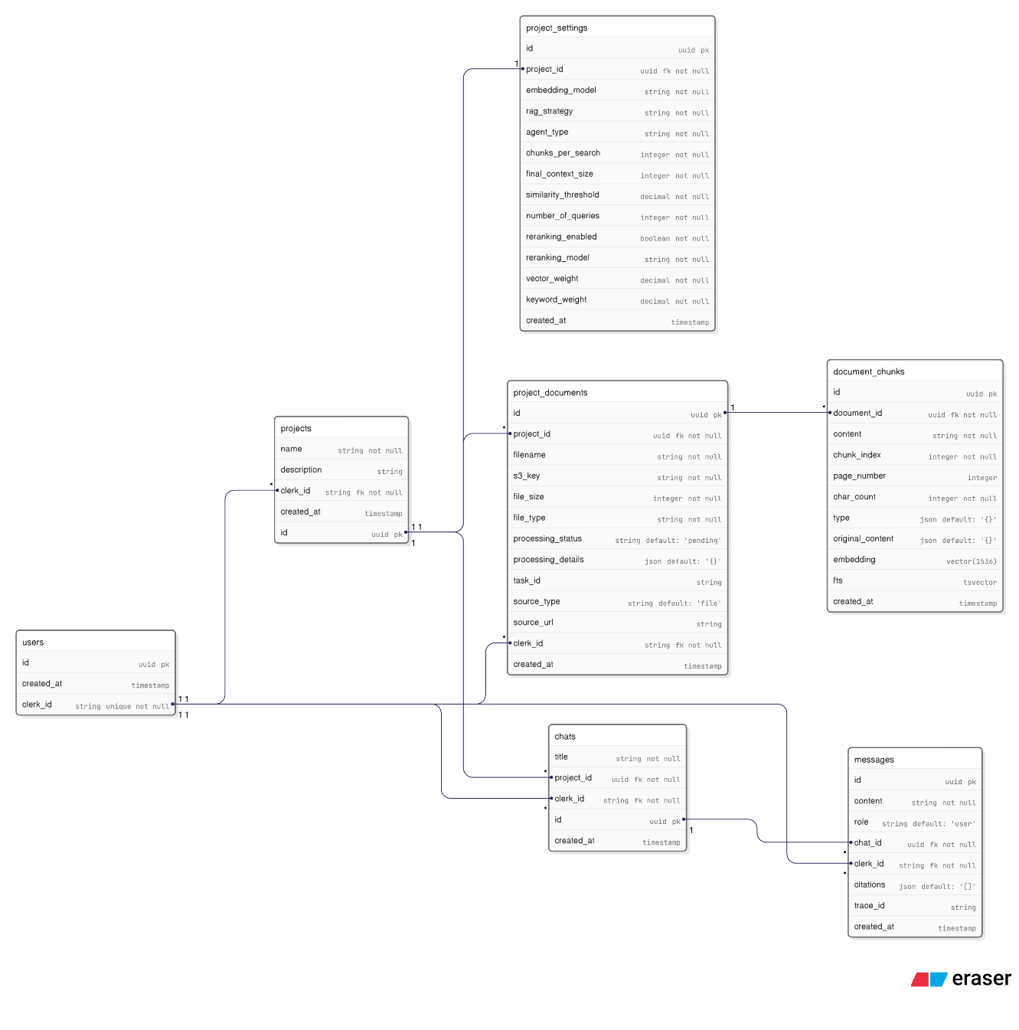

2. System Architecture
The project follows a modern client-server architecture:
Frontend (Client)
- Framework: Next.js (React)
- Styling: Tailwind CSS
- State Management: React Hooks
- API Communication: Custom apiClient wrapping fetch.
Backend (Server)
- Framework: FastAPI (Python)
- Database:
  - Supabase (PostgreSQL): Stores user data, projects, chat history, and vector embeddings (via pgvector), Full-Text Search (tsvector).
  - SQLite (In-Memory): Used temporarily by the Smart SQL Agent for analyzing CSV/Excel files.
- Object Storage: Tigris S3 (for storing uploaded documents).
- Presigned URLs: For faster uploads.
- LLM Orchestration: LangChain & LangGraph.
- AI Models: OpenAI GPT-4o (primary reasoning model), Text Embedding 3 Large (embedding).
3. Agents & Components
The system is composed of several specialized agents and services:
3.1. Supervisor Agent (Activates only if use choose Agentic RAG in settings)
- Role: This agent decides whether to route your question to the RAG tool (for internal docs) or the Web Search tool (for external info).
- Input: User query + Chat History.
- Logic:
  - Guardrails: Checks input for safety.
  - Routing: Decides whether to use:
    - rag_search: For questions about the uploaded project files.
    - search_web: For general knowledge or current events (if enabled).
- Tools: Wraps the RAG and Web Search capability as tools.
- Implementation: Built using LangGraph.
3.2. Smart SQL Agent
- Role: The "Data Analyst" Handles structured data files (CSV, Excel).
- Logic:
  - Schema Loading: Reads a JSON schema file defining table structures.
  - Data Loading: Loads CSV/Excel files into an in-memory SQLite database.
  - Schema Filtering: Uses LLM to identify which tables represent the data needed for the query.
  - SQL Generation: Generates a raw SQL query.
  - Execution: Runs the SQL against the temporary SQLite database.
  - Formatting: Returns the results as a formatted text table.
3.3. Simple RAG Agent
- Role: A streamlined agent for direct document QA.
- Logic: Directly queries the RAG pipeline without the routing complexity of the Supervisor, effectively forcing a "docs only" mode.

RAG Pipeline
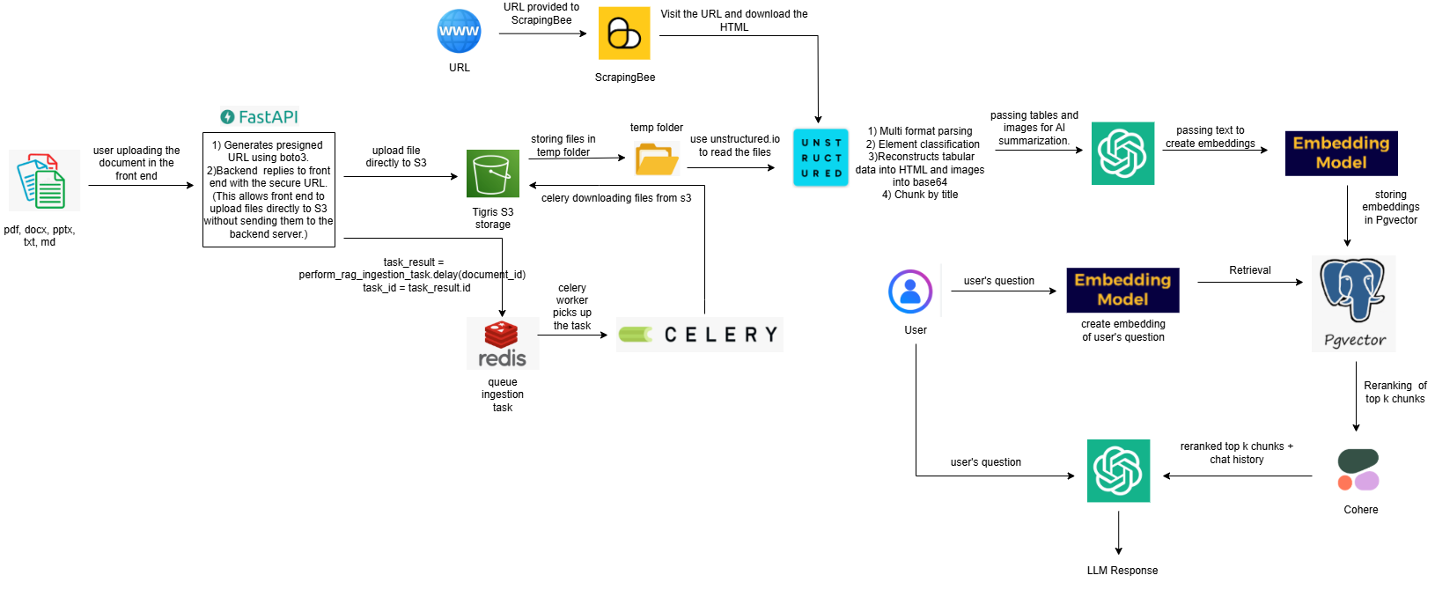

3.4. RAG Retrieval Engine
- Role: Finds relevant text chunks from uploaded documents.
- Strategies:
  - Vector Search: Finds semantically similar text.
  - Hybrid Search: Combines Vector search and Keyword search.
  - Multi-Query Vector: Generates multiple variations of the query and performs vector search for each, fusing results.
  - Multi-Query Hybrid: Generates multiple variations of the query and performs hybrid search for each, fusing results.

4. User Query Lifecycle
This section details the complete flow from the moment a user asks a question when they receive an answer.
Phase 1: Frontend Interaction
- User Input: User types a question (e.g., "What is the total revenue?" or "Summarize the PDF" in the Chat Input component.
- API Call: The front end sends a POST request with the message content and user authentication.
Phase 2: Server-Side Routing
- Authentication: The server verifies the user's identity via Clerk.
- Message Storage: The user's message is saved to the Supabase messages table.
- Pipeline Determination: The server checks the types of processed documents in the project:
Structured Files: Checks for .csv, .xlsx, and a json schema.
Unstructured Files: Checks for .pdf, .md, .txt, etc.

Phase 3: Execution Pipelines
The server executes two parallel pipelines and merges the results.
Pipeline A: Structured Data (If CSV/Excel exists)
- Preparation: The server downloads the Json schema and relevant .csv/.xlsx files from S3 to a temporary directory (/tmp/csv_agent/...).
- Agent Initialization: The SmartDataAgent is initialized with these local files.
- Processing:
  - Agent creates an in-memory SQL database.
  - Agent generates a SQL query based on the user's natural language.
  - Agent executes the SQL query.
- Output: Returns a text answer derived from the data (e.g., "The total revenue is $50,000").
Pipeline B: Unstructured Data (RAG)
- Selection: Based on project settings, executes either a simple RAG agent or supervised RAG agent.
- Context Retrieval:
  - The Agent calls the rag_search tool.
  - The system embeds the user's query (text-embedding-3-large).
  - It calls for Supabase RPC functions (vector_search_document_chunks) to find relevant document chunks.
- Generation:
  - The retrieved text chunks are fed into the LLM (GPT-4o) as context.
  - The LLM generates a natural language answer.
  - Fallback: If no relevant chunks are found, the agent returns "No relevant chunks found" to prevent hallucinations.
Phase 4: Response Synthesis
- Merging: The server checks outputs from both pipelines.
  - If both found info: Combines them: **Analysis from Structured Data: ** ... **Analysis from Documents: ** ...
  - If only one found info: Returns that specific response.
Phase 5: Delivery
- Saving: The final AI response (text + citations) is saved to the Supabase message table.
- Response: The API returns the userMessage and aiMessage objects.
- Display: The Frontend receives the JSON response and updates the chat UI to show the new message.

5. Project Logging System

The application uses **structured logging** (JSON) via `structlog` and Python's `logging` module.

Format: JSON logs with automatic context injection (`request_id`, `user_id`, `project_id`, `filename`, `lineno`).
Configuration: `server/src/config/logging.py`.
Output:
Console (stdout)
File (`logs/application.log`)
File (`logs/worker.log`)
Key Components:
Middleware: `LoggingMiddleware` generates a unique `X-Request-ID` for every request and logs performance metrics (duration, status code).
Context: `contextvars` are used to track request/user context across async calls.
Celery Workers: Background tasks share the same structured logging config, tracing async operations like `task_started` and `processing_document`.

