Talent Acquisition Buddy - Project Documentation
1. Project Overview
Talent Acquisition Buddy is a comprehensive Streamlit-based application designed to assist HR professionals and recruiters in automating the screening and ranking of candidate resumes against specific Job Descriptions (JDs).
The application leverages Generative AI (Google Gemini) to:
- Extract key information from resumes.
- Analyze and match keywords between the Resume and JD.
- Generate personalized outreach emails and cover letters.
- Rank candidates based on a weighted scoring system of matched keywords.
2. Key Features
- Batch Processing: Upload and process multiple resumes (PDF/DOCX) simultaneously.
- Smart Document Conversion:
  - Automatically converts PDF resumes to Word, and then to clear Markdown format.
  - Flattens complex tables in resumes into readable text for better AI analysis.
- Interactive Keyword Prioritization:
  - Extracts keywords from the Job Description.
  - Allows the user to interactively categorize keywords into High, Medium, and Low priority.
- Weighted Scoring: Calculates weighted_score based on keyword matches (High=3x, Medium=2x, Low=1x).
- Content Generation:
  - Cover Letter: Generates a custom cover letter for each candidate.
  - Recruiter Email: Drafts a professional interview invitation email.
- Candidate Extraction: Automatically extracts Email, Contact Number, and Current Location.
- Location Scoring: Adds scoring bonuses for preferred locations.
- Exportable Results: Download the final ranked list as an Excel file.
3. Project Structure
Detailed File Description
File | Purpose
app.py | Main Application Entry Point. Contains the Streamlit UI logic, session state management, and the main processing pipeline. Handles user uploads, priority selection, and result display.
functions3.py | Core Business Logic. Contains functions for file processing (file_to_md), keyword extraction prompting (key_word_extraction, though app.py uses its own extract_keywords_from_text), and regex-based extraction (Email, Phone, Location).
utils.py | Utilities & Configuration. Initializes the Google Gemini model (llm_model), loads environment variables (.env), and contains helper functions for calculating similarities and generating cover letters.
pdf_to_word.py | PDF Conversion. Uses pdf2docx to convert PDF files into Word (.docx) format as an intermediate step for text extraction.
word_to_md.py | Markdown Conversion. Uses spire.doc to convert Word (.docx) files into Markdown (.md), preserving structure for easier LLM processing.
table_flattener.py | Table Processing. A utility to detect Markdown tables and "flatten" them into simple comma-separated text lines, ensuring table data is not lost or malformed during LLM analysis.
requirements.txt | Dependencies. Lists all Python libraries required to run the project.
.env | Configuration. Stores sensitive API keys (e.g., GOOGLE_API_KEY).
4. Installation & Setup
Prerequisites
- Python 3.10 or higher.
- A Google Cloud API Key for Gemini (Generative AI).
Step-by-Step Installation
- Clone the Repository (or download source code).
- Create a Virtual Environment: python -m venv venv
- Activate the Virtual Environment:
  - Windows: .\venv\Scripts\activate
  - Mac/Linux: source venv/bin/activate
- Install Dependencies:pip install -r requirements.txt
- Configure Environment Variables:
  - Create a file named .env in the root directory.
  - Add your Google API Key:GOOGLE_API_KEY=your_google_api_key_here
5. Usage Guide
- Run the Application: streamlit run app.py
- Upload Resumes:
  - In the "Upload Files for Batch 1" section, upload one or more Resume files (PDF or DOCX).
  - (Optional) Specify the "Days Available" for each candidate if known.
- Upload Job Description:
  - Upload the JD file (PDF or DOCX).
- Prioritize Keywords (The Wizard Step):
  - Step 1: The app extracts keywords from the JD. Select which ones are High Priority.
  - Step 2: From the remaining, select Medium Priority.
  - Step 3: Review the lists (remaining are Low Priority) and confirm.
- Process Batch:
  - Click "Process Batch with Weighted Score".
  - The app will process each resume, convert it to text, extract details, and compute scores.
- Review & Edit:
  - View the interim results table.
  - Manually adjust "Location Score" if necessary.
- Final Results:
  - Click "Done Editing" to see the final ranked table.
  - Click "Download Excel Results" to save the report.
6. Technical Architecture & Workflow
1. Document Conversion Pipeline
To ensure high-quality text extraction (especially from complex resumes with columns/tables), the system follows a multi-step conversion process:
- Input: PDF or DOCX.
- PDF -> DOCX: If PDF, it is first converted to DOCX using
pdf_to_word.py (pdf2docx).
- DOCX -> MD: The DOCX is converted to Markdown using
word_to_md.py (spire.doc).
- Table Flattening: The Markdown is processed by
table_flattener.py to turn grid tables into linear text.
- Output: Clean, linear text ready for the LLM.
2. Scoring Logic
The application uses a deterministic scoring model based on keyword presence:
- High Priority Keyword Match: 3 Points
- Medium Priority Keyword Match: 2 Points
- Low Priority Keyword Match: 1 Point
Weighted Score= (number of keywords with high priority * 3) + (number of keywords with medium priority * 2) + (number of keywords with low priority * 1)
- Location Score: A bonus score (default 0.1) is added if the candidate is located in target regions (e.g., Telangana, Andhra Pradesh).
3. LLM Integration
- Model: Gemini 2.0 Flash (configured in
utils.py).
- Prompting: Used for extracting keywords (JSON mode), writing cover letters, and drafting emails.
7. Snippets from Streamlit application:
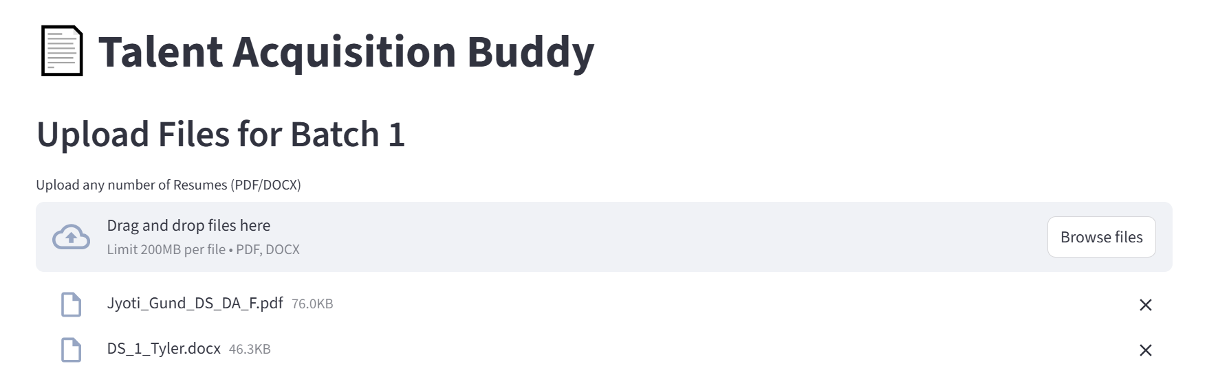
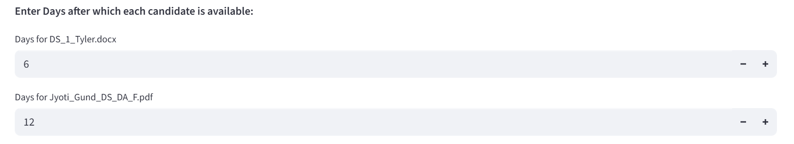
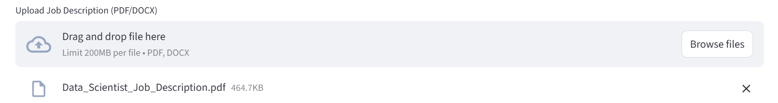

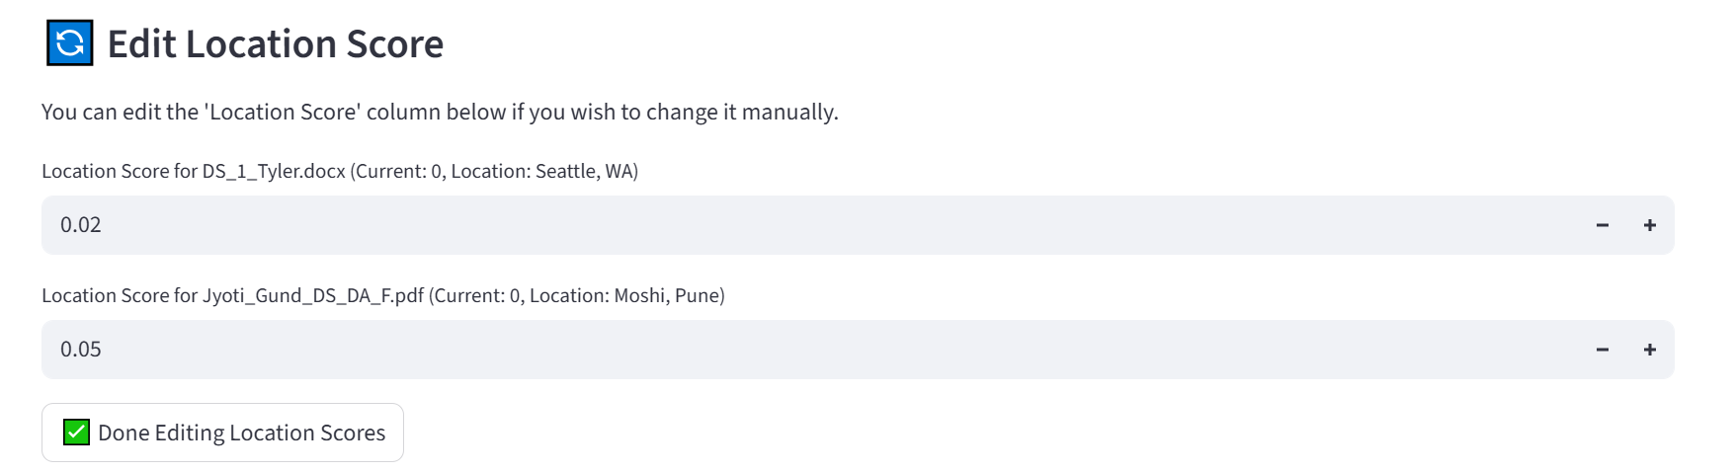
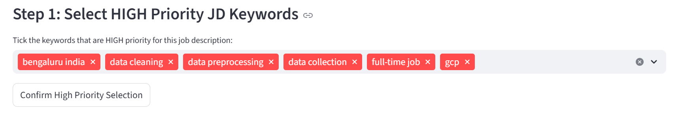
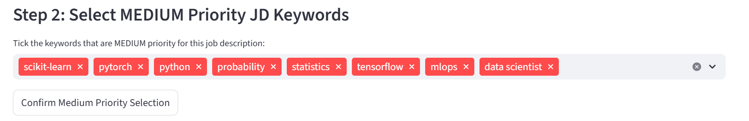
Remaining keywords (Keywords which are not in high and medium priority) are automatically added in low priority.
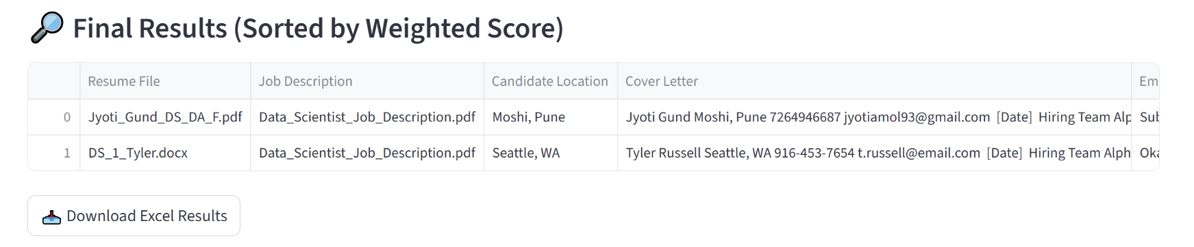

8. Flow Diagram:

