1. L1 - In EC2 Ubuntu Instance Create a new user and SSH Key pair with an authorized key

In EC2 ubuntu added user devuser

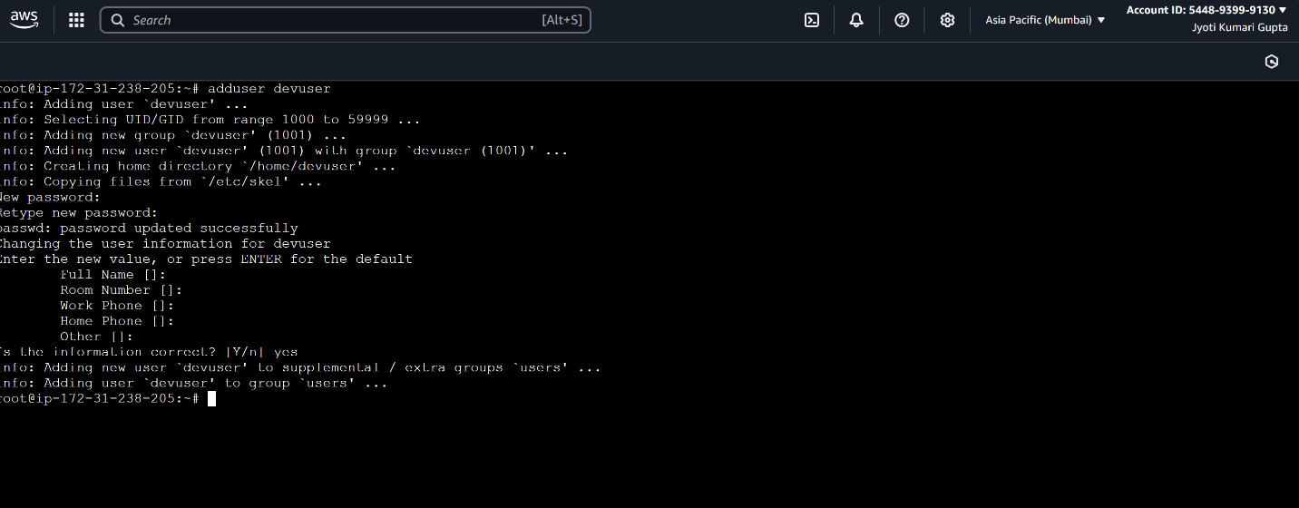

SSH Key pair with an authorized key

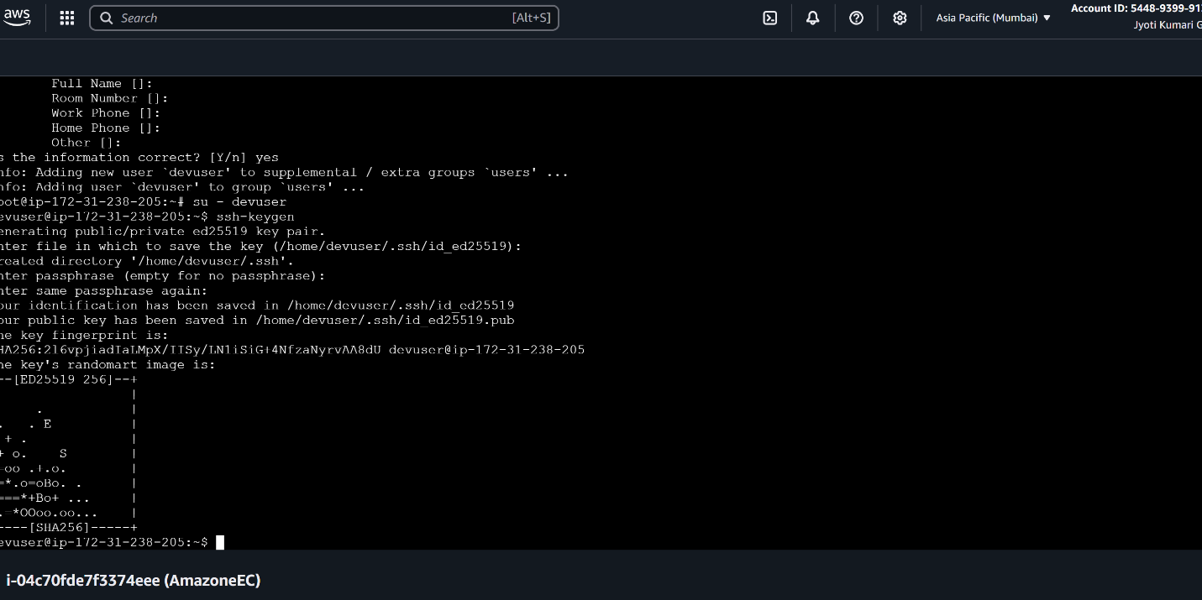

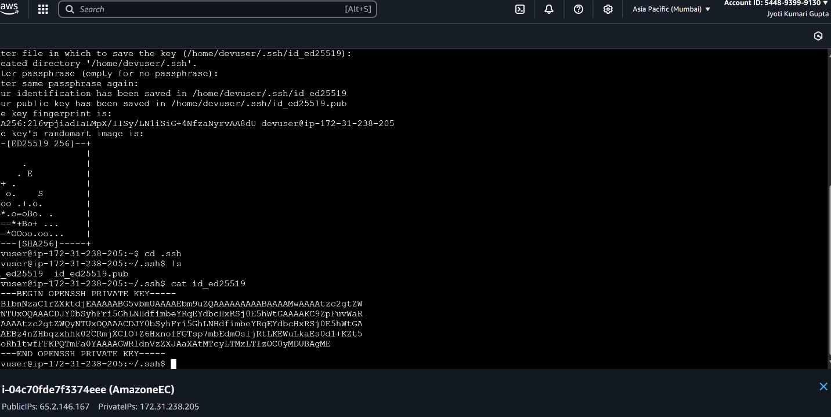

2. L2 - As a Linux root user Create Files/Directory in the same Instance and change the ownership to a new user

Created file.txt and Myfolder in devuser

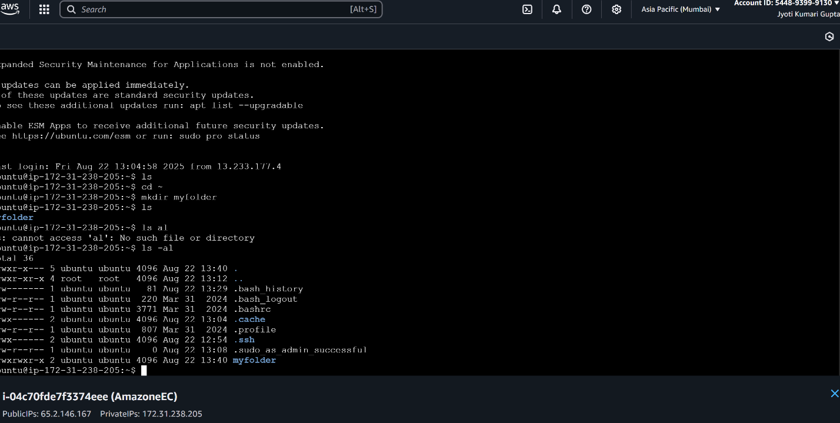

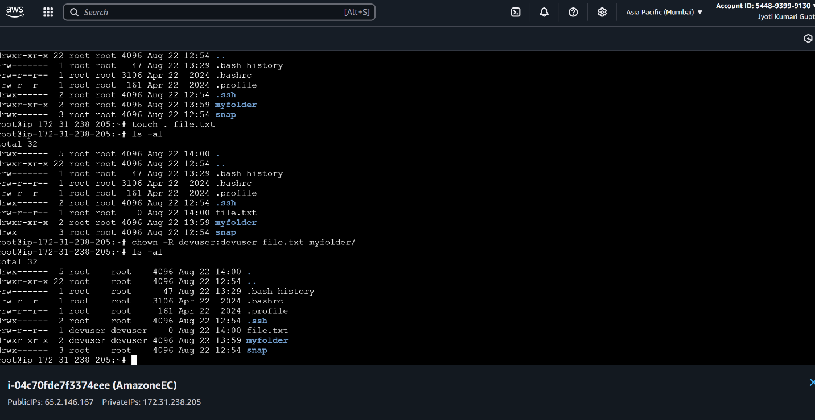

L3 - In EC2 Ubuntu Instance Create Files and Directories and Grand R/W/X Access only to the Owner and User Group

rwxrwx--- grand R/W/X of file.txt to owner and user group

drwxrwxr---grand R/W/X of directory to owner and user group

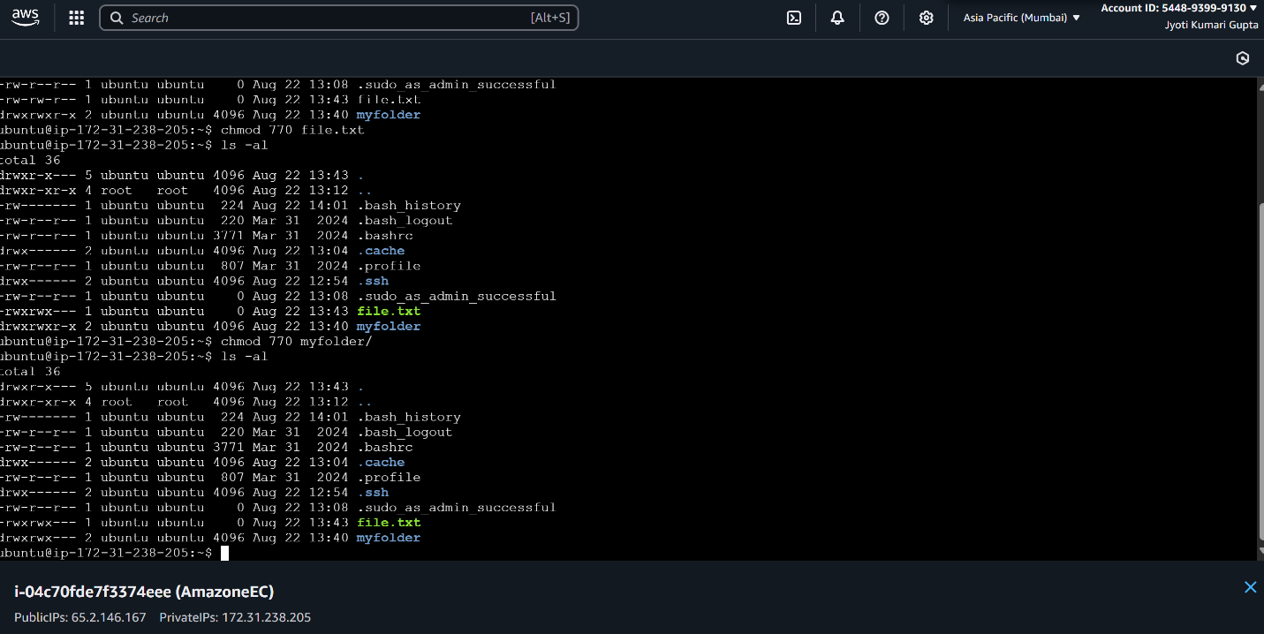

. L4 - In EC2 Ubuntu Instance install JDK and setup JAVA_HOME path environment variable

In AWS copied the link and echo $ JAVA_HOME ,cd~, go to nano.bashrc, paste the path with (JAVA_HOME= Copied path, PATH =$PATH:$JAVA_HOME)

Type in instance terminal source .bashrc and then echo $ JAVA_HOME

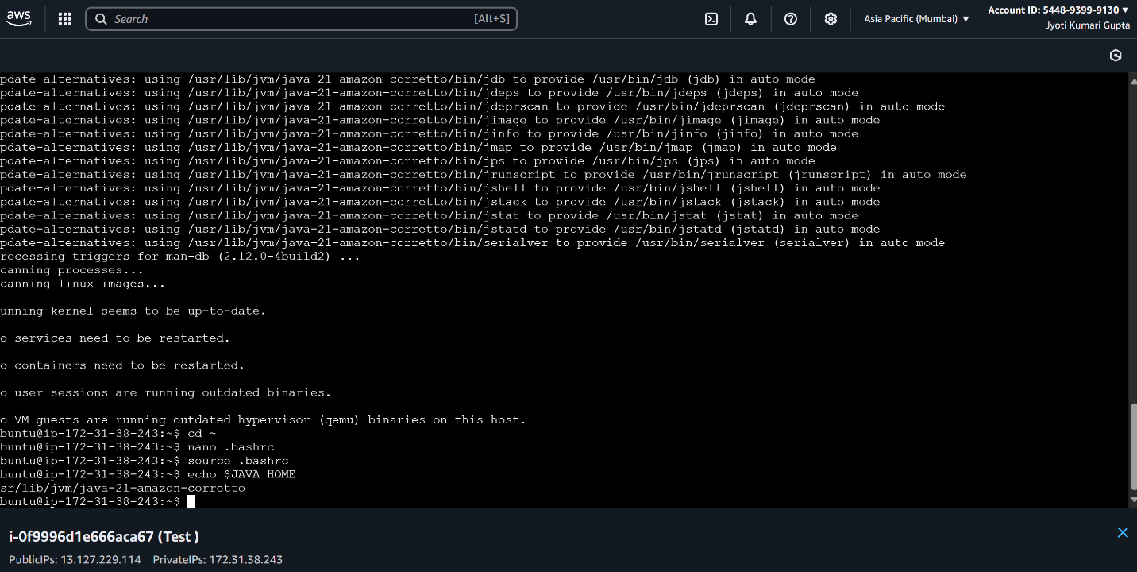

5. L5 - Create two AWS EC2 Ubuntu Instances to establish SSH Connection and SCP the files from one Instance to another instance

After connect 2 instances , do update with apt update command, in 1st instance write

Ssh-keygen -t rsa -b 4096 , after enter given command cd .ssh , ls , copied the private id from 1st instance then , ls , cat id_rsa.pub enter copied key , in 2nd instance ls -al, cd .ssh, ls, nano authorized_keys paste key in 2nd line ,exit n enter,

Give command of chmod 600 authorized-keys

Go to 1st instance - ssh ubuntu@private id

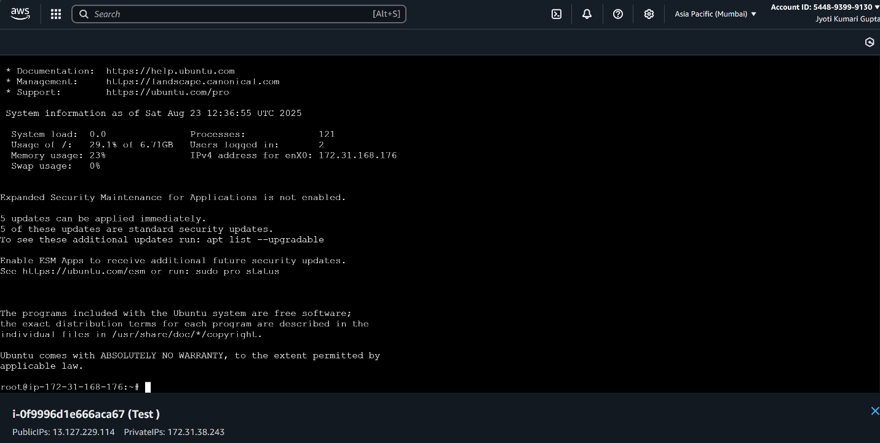

After that copied the file from 1st instance to 2nd instance

Add file with this:

Give command cd ~ , ls , touch myfile.txt, ls

Copied : scp myfile.txt root@private id :/home/root

Go to 2nd instance : cd ~ , ls – myfile.txt

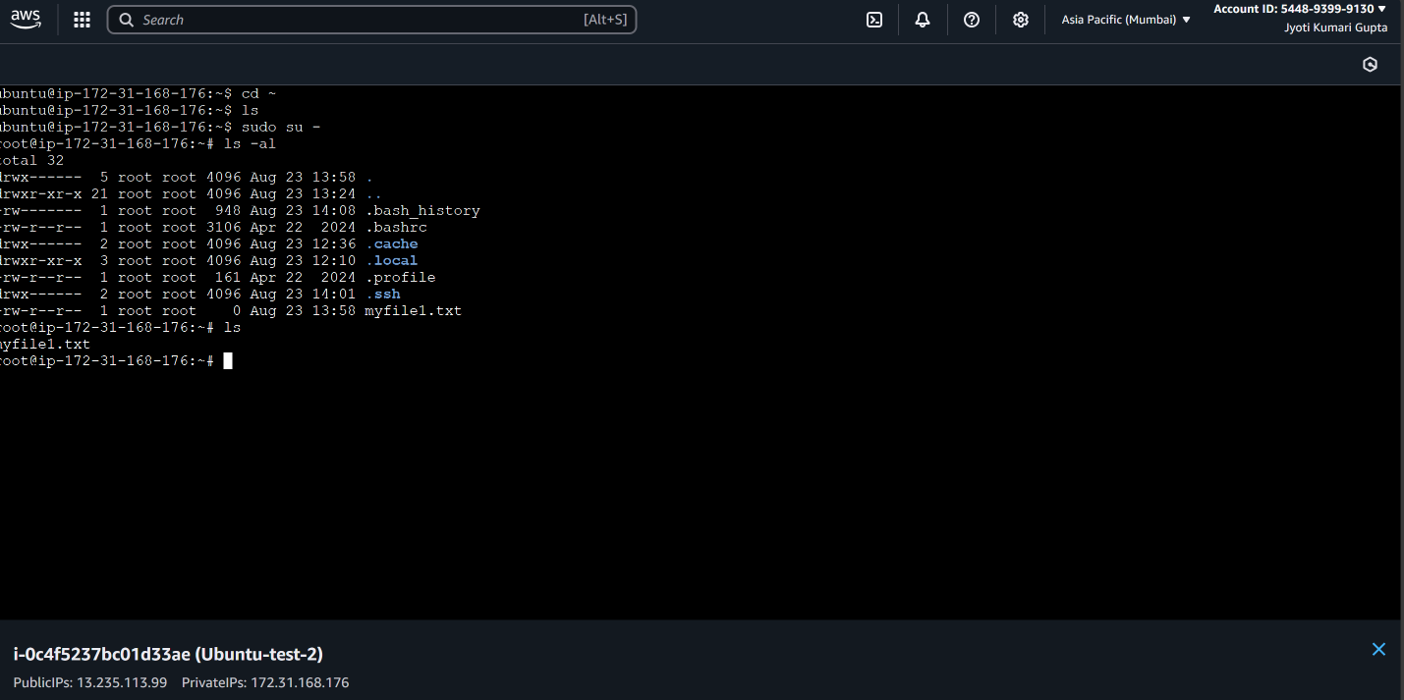

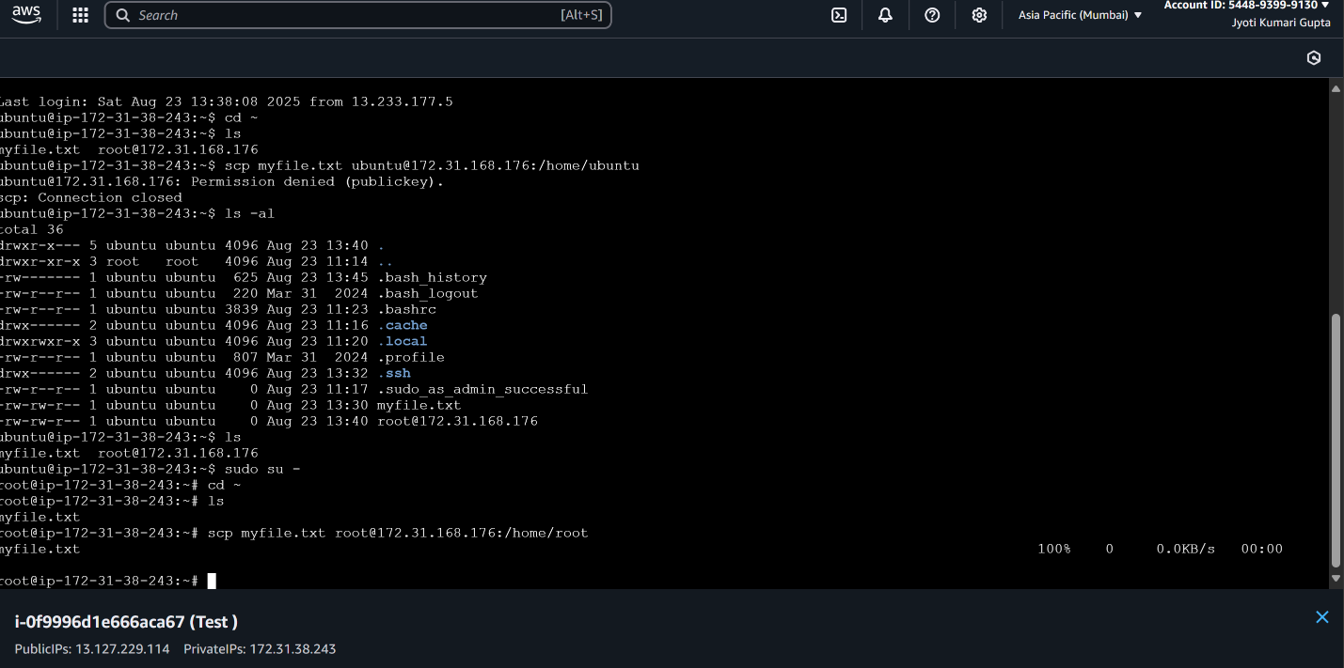

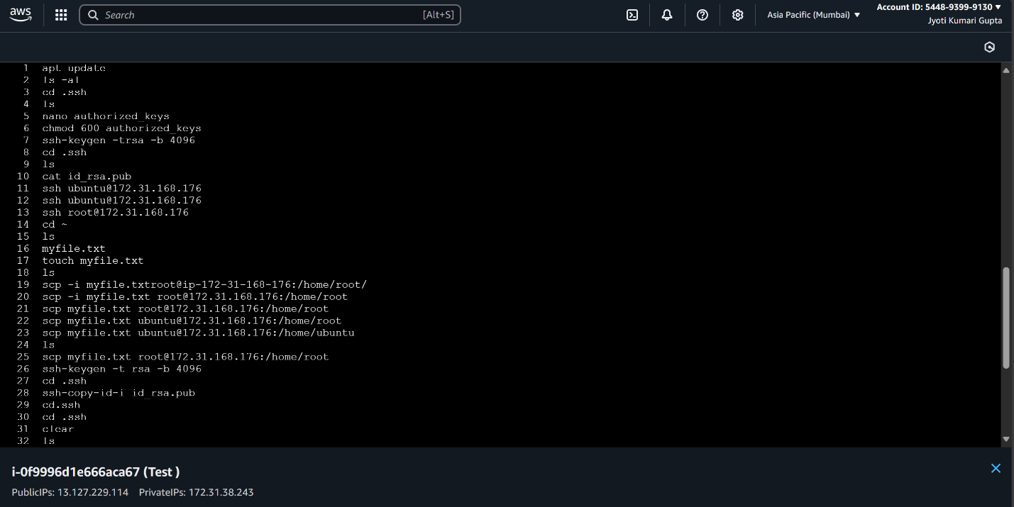

6. L6 - Write a Linux Shell Script to Install Git, JDK, Maven in EC2 Ubuntu Instance

Write a command ls , vi install.sh ,

In vi – write a command –

#!/bin/bash

Echo “updating ubuntu using apt update”

Sudo apt update -y

Echo “install git”

Sudo apt install git -y

Echo “install java jdk11

Sudo apt install -y openjdk-11-jdk

Echo “install maven”

Sudo apt install -y maven

Echo “installation complete..!”

Echo “show me installed version”

git --version

java –version

mvn –version

:wq!

Then chmod 760 install .sh to give permission ,ls -al

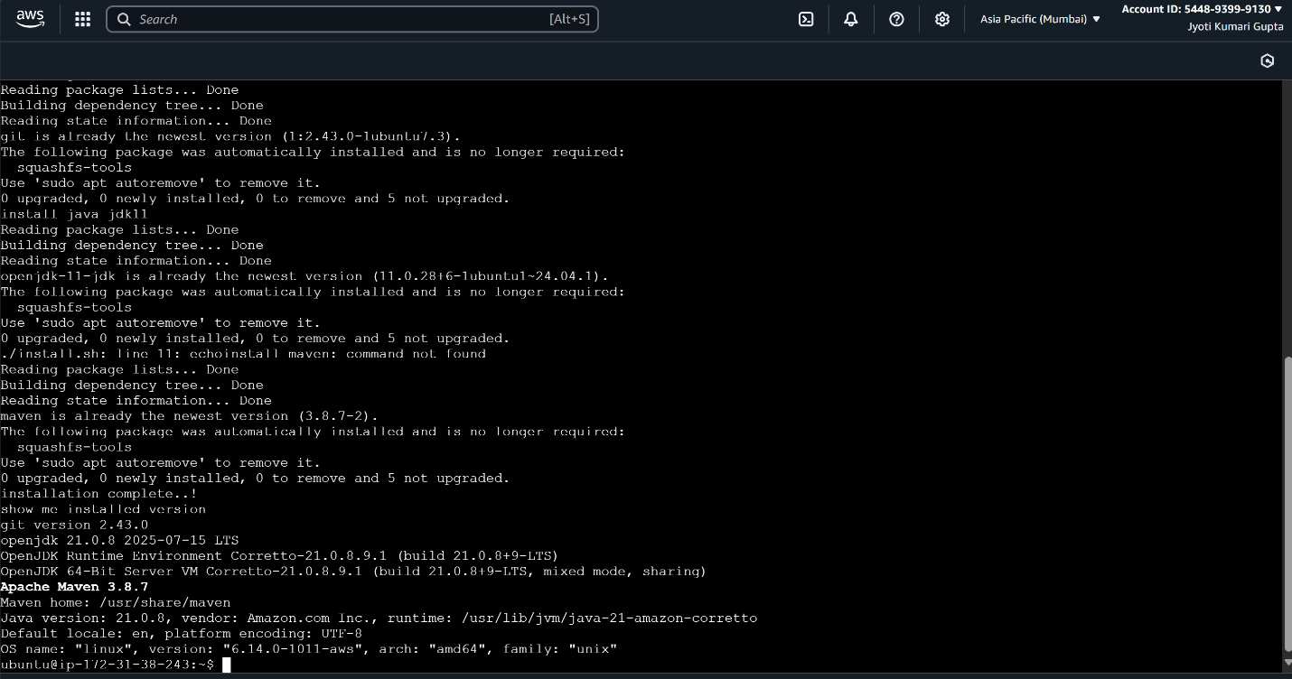Give commwnd ./install .sh